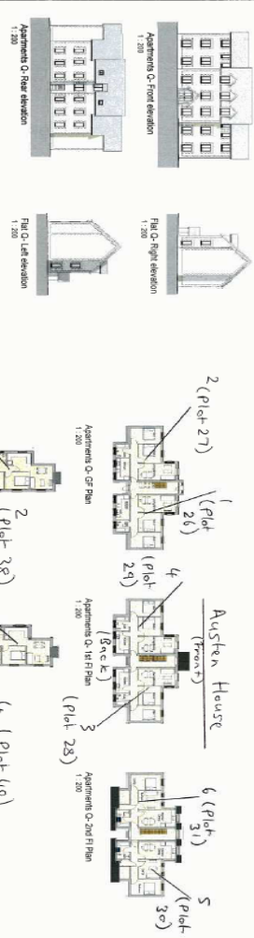

Austen House, Abrams Way, Havant, Hampshire. PO9 1FJ
(Block Q):
Plot 26 -1, Austen House. (Ground Floor Flat).
Plot 27 - 2, Austen House. (Ground Floor Flat).
Plot 28 - 3, Austen House. (First Floor Flat).
Plot 29 - 4, Austen House. (First Floor Flat).
Plot 30 - 5, Austen House. (Second Floor Flat).
Plot 31 - 6, Austen House. (Second Floor Flat).

