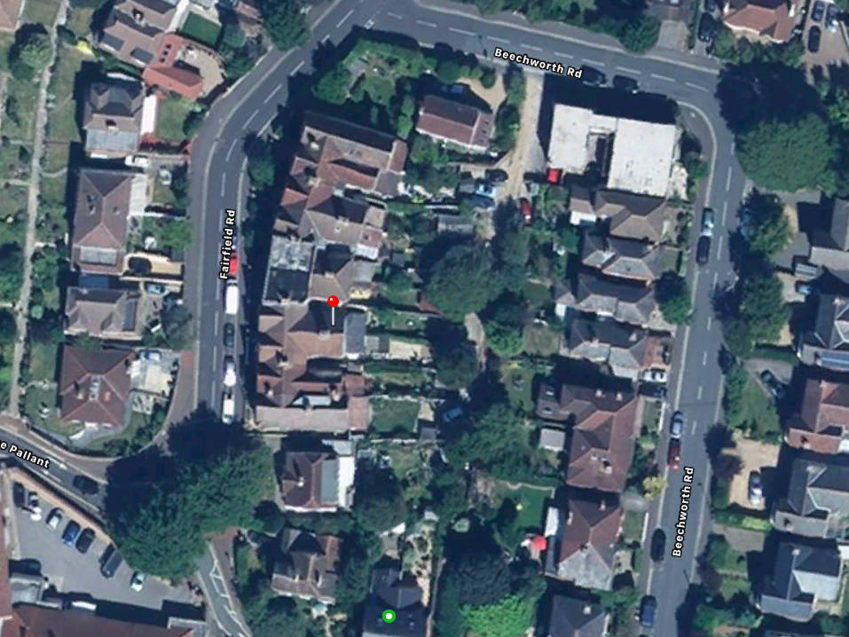
This is the front of the property.
Silver birch is located at rear of property alongside an access road, it is at the very end of the garden.

