27 CORHAMPTON CRESCENT, HAVANT, PO9 3BX.
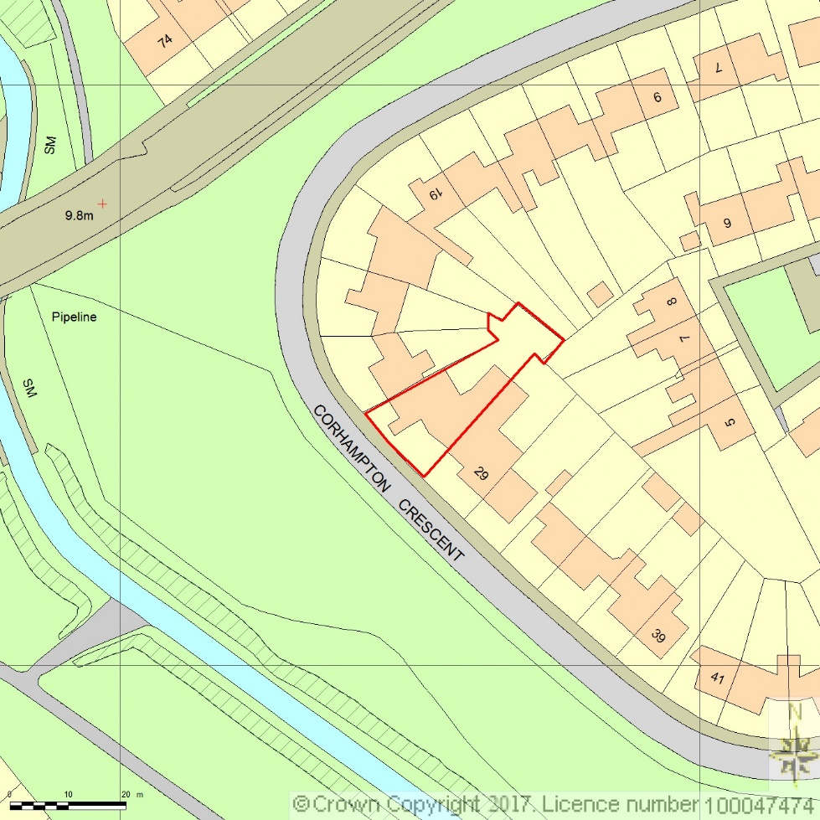
SITE
LOCATION PLAN
AREA 2 HA
SCALE 1:1250 on A4
CENTRE COORDINATES: 470950, 107644



Supplied by Streetwise Maps Ltd
www.streetwise.net
Licence No: 100047474
25/09/2017 14:07

