Emsworth Slipper Sailing Club
Quay Mill, Emsworth PO10 7EQ

DESIGN AND ACCESS STATEMENT FOR AN APPLICATION FOR LISTED BUILDING CONSENT

This report describes the design and access for a proposal for the installation of CCTV cameras on Quay Mill at Emsworth for monitoring activity for the Emsworth Slipper Sailing Club and Chichester Harbour Conservancy that should be read in conjunction with the heritage statement.

1 BACKGROUND

1.1 Chichester Harbour is an Area of Outstanding Natural Beauty (AONB) and is managed by Chichester Harbour Conservancy (CHC). The CHC are the only Statutory Harbour Authority with responsibility for managing an AONB and aims to conserve and enhance this beautiful environment and work closely with a wide range of stakeholders, from landowners and local businesses to Local Authorities.

1.2 Chichester Harbour has a resident fleet of over 12,000 leisure vessels, representing about 25% of all the recreational craft in the Solent. Combined membership of the 14 sailing clubs amounts to 12,000 people and each year an estimated 25,000 enjoy the Harbour’s waters for racing, cruising and fishing. In turn, Chichester Harbour supports a large number of marine-related businesses, providing jobs and making a valuable contribution to the local economy.

1.3 Quay Mill is situated in the Emsworth Conservation Area at the point where South Street meets the shoreline. The mill dates from the 18th century when the mill pond walls were first constructed and originally served as a tide mill. However by 1977 when it was bought by Emsworth Slipper Sailing Club (ESSC), the building had become largely dilapidated. With new owners and a new use, an extensive programme of refurbishment was undertaken, with the buildings robust industrial architecture making it an ideal clubhouse.

1.4 The majority of Sailing Clubs, business premises and buildings and offices owned by the CHC are monitored by CCTV, including the Itchenor Harbour Office, Bosham Quay, Dell Quay Education Centre and Westlands Hard and dinghy boat house. The Emsworth hard, foreshore and channel together with the ESSC are not currently covered by CCTV.

1.5 There have been a number of issues in and around Emsworth, including criminal damage, anti-social behaviour, arson, theft of outboards, illegal use of dinghies and vandalism, obstruction and abusive behaviour by youths on the Emsworth Jetty, particularly in warm weather and evening tides. In addition, there have been two incidents in the past year that have involved UK Border Force with border security issues and an attempted break in on Quay Mill and a near miss accident on the jetty. In order to reduce those risks and as a health and safety approach of injury on the jetty, theft of equipment and vessels and general anti-social behaviour, a number of strategies are being deployed by the Conservancy including patrols at relevant times, trialling of body worn cameras, working with the Police and the Community and signage. These strategies appear to be working, however there are times that incidents are occurring when Conservancy staff and Police are either off duty or unavailable on other duties.

1.6 As an additional strategy the Conservancy and ESSC are keen on implementing CCTV as a monitoring, security and control measure. The Conservancy already deploys CCTV at the Harbour Office at Itchenor that monitors the building exterior, jetties and vessels and the hard. CCTV is a proven overt method that complies with legislation and guidance that not only provides compelling supportive evidence and the most obvious benefit of deterring crime but can furnish other benefits such as;

• Raise standards of service
• Reduce criminal behaviour
• Augment opportunities for evidence capture
• Reduce complaints
• Reduce insurance premiums
• Enhance community confidence

The introduction of a CCTV system would be beneficial to both the CHC and ESSC and not only monitor areas of concern for the Conservancy but the Clubs compounds and premises.

1.7 The installation of CCTV as described in this report has been approved by the Full Committee of the ESSC on 6 November 2017 and CHC.

2 THE SITE

2.2 Quay Mill - The property is Grade II listed, and has the following list description:

Former tide mill in use as a sailing club. C18, C20. A plain rectangular structure of brick with a tile roof. Symmetrical east elevation of 2 storeys and attic, 5 windows. Red brickwork in Flemish bond, rubbed cambered arches, casements. In the north gable there are upper and lower doorways. To the west is a lower building, once containing the power machinery. Associated with the mill is a sea wall, extending across the shallow valley, with sluices, which encloses a mill pond, fed by a stream, but once also by a high tide (via the sluices). The building has recently been modernised (with new dormers) for use as a sailing club.

3 PROPOSALS

3.1 The proposals presented herein stem from the desire to install CCTV coverage for the Emsworth Slipper Sailing Club (ESSC) and for the Chichester harbour Conservancy (CHC) hard, foreshore and jetty. This will provide security for the Clubs bar, clubroom facilities, dinghy and vessel compounds and outbuildings. The installation will also provide huge advantages for health and safety as a wider area of the harbour can be visualised at any one for the CHC’s hard at the Southern end of South St, the foreshore and moorings in the vicinity and include a pan tilt zoom camera for Emsworth Jetty along the slipper wall and channel.

3.2 This is a joint initiative by the CHC and ESSC. The proposed cameras will be installed on the Quay Mill and recording equipment housed within the ESSC.

3.3 It is proposed to install 7 cameras on the external walls of the Quay Mill. 4 cameras to provide monitoring for the ESSC’s entrances, carpark and compounds and 3 cameras for the CHC’s hard, foreshore, moorings and jetty.

4 DESIGN

4.1 Components – the following table demonstrates the make and model of the cameras proposed to be used. The 7 cameras are the only components to the installation that will be fixed to the exterior of the Quay Mill. The recorder will be installed in the office area.

Qty | Model | Detail
1 | Uniview HD8/IP | IP CCTV recorder. 4TB hard drive memory. 8 channel. To be fitted in the Sailing Club office on the first floor. Suggest secure cabinet. Power from adjacent mains.  No viewing monitor needed as system will be networked.
1 | Uniview IP HD PTZ | High power PTZ camera mounted on south facing elevation above centre window. Cable to run inside building.  This camera will be set to cover the whole front area including beyond the sea wall. It will be operational remotely from the Emsworth office.
2 | Uniview IP HD V/F  Bracket mount | High Definition IP cameras to cover the mooring areas and main slipway and road access to the east of the site.
4 | Uniview IP HD V/F  Dome mount | Four cameras to cover areas for the sailing club: Side and rear boat compounds. Below canopy to the south to cover the sea wall and gate areas. These cameras can be mounted and adjusted as required.

4.2 A drawn plan of the camera locations (not to scale) can be located in Annex A

4.3 The following photographs of the various elevations of the Quay Mill can be located at the end of this report in the annexures.

- Picture 1 – Front elevation of Quay Mill Annex 2
- Picture 2 – Rear elevation of Quay Mill Annex 2
- Picture 3 – Eastern side elevation of Quay Mill and carpark Annex 2
- Picture 4 - Eastern side of Quay and public walkway Annex 2

4.4 CCTV signage will be placed in the vicinity and on the CHC Jetty

5 ACCESS

5.1 There is no access issues associated with this installation and in particular to the public walkway to the eastern side of Quay Mill

6 IMPACT

6.1 There will be no actual alterations to the Quay Mill building. All cabling will be internal and cameras are unobtrusive and will coloured to blend in with the existing walls and tiles and would have a negligible impact on views of the building.
7 CONCLUSION

7.1 The installation of 7 CCTV cameras would have a ’de minimis’ impact on the appearance of the building whilst providing a host of benefits. Quay Mill is a historic building of a robust nature which has seen much change over the years. The proposed installations will enhance the security of the sailing club and have no detrimental impact on either the character of the Conservation Area or the listed building itself.

IAN JONES, CHC, MAY 2018

Annex A
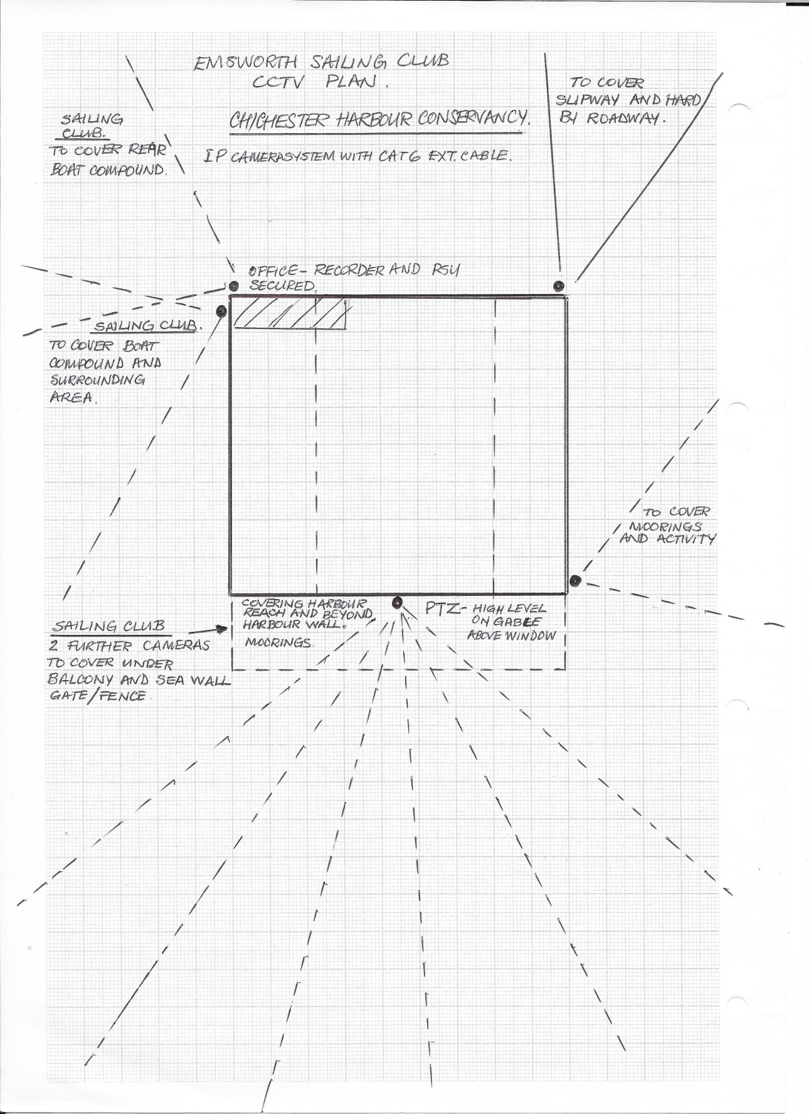

Annex 2
Picture 1 – Front elevation of Quay Mill Picture 2 – Rear elevation of Quay Mill
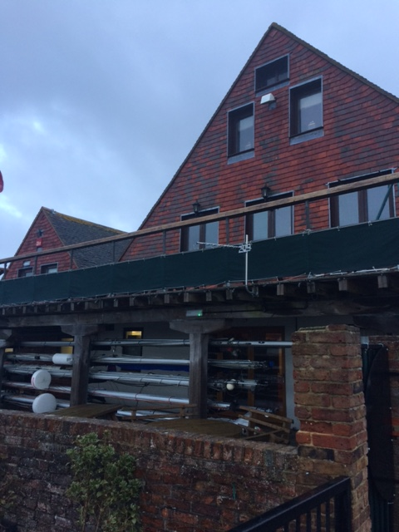
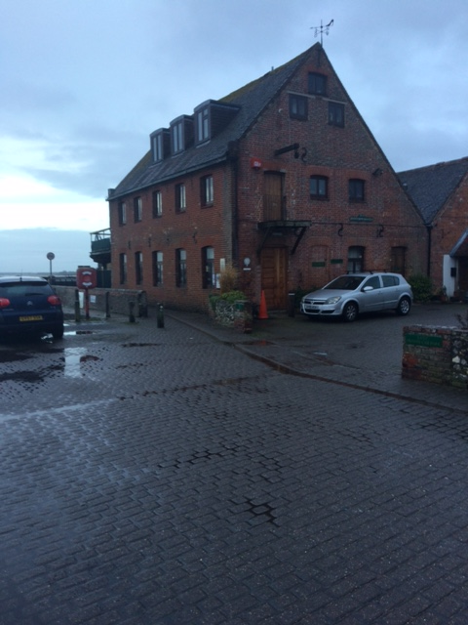

Picture 3 – Eastern side elevation of Quay Mill Picture 4 - Eastern side of Quay and
and carpark public walkway
