


South Hayling Beach Management Plan – Beach Management Activities
Construction Environmental Management Plan (CEMP)
Date: 25/05/2017
Version: V4



Document Information

Project | South Hayling Beach Management Plan – Beach Management Activities
Technical subject | Construction Environmental Management Plan (CEMP)
Department | Eastern Solent Coastal Partnership
Project Manager | Clare Dolan

Document History
Date | Revision | Prepared
11/05/17 | V1 | LS
12/05/17 | V2 | CD
22/05/17 | V3 | LD
25/05/17 | V4 | LS

Contents

Introduction 2
CEMP General Statements 2
General Description of the Works 3
Requirements of Tender and Pre- Construction Meetings 7
Specific activities and precautions required 9
Tracking on the beach with dumper trucks 9
Depositing material on the beach/carpark/storage 10
Moving material on the beach – reprofiling with a bulldozer 11
Transporting material from the Beach to Ferry Road Car park to resolve a localised erosion problem. 12
Transporting plant to site 12
Transporting aggregates to site 12
Extracting Material from the beach 13
Pollution Prevention Measures 13
Other considerations 14
The Local Community 14
Reduction in pedestrian access 14
Disturbance to residents 14
Archaeological interest 14
Tidal Working 15
Temporary effect on amenity and recreation 15
Emergency Information 16
Hospital 16
Munitions Disposal Procedure 16
Oil Spill 16

Introduction
The scope and requirements of the Construction Environmental Management Plan (CEMP) covers the Beach Management Works to be undertaken in September 2017 only. This will incorporate recycling from the open beach (BMP Units 2 to 7) back to Eastoke and possible import via road if additional material is required to maintain the beach height and profile at Eastoke. There will also be localised shingle movement to resolve a localised issue of erosion within BMP Unit 8 (Ferry Road). See Figure 3 for the location of the BMP Units.
This CEMP covers all activities and operations undertaken by the whole project team including the Eastern Solent Coastal Partnership (ESCP) on behalf of Havant Borough Council, the contractors and any sub- contractors during all aspects of the beach management works.
The CEMP forms one component of the Project Management Plan and should be read in conjunction with the Contractor’s Method Statement and the Contract documentation.
The aim of the CEMP is to consider and mitigate for all environmental risks, as identified in the scheme Environmental Statement. The CEMP is also a mechanism that can address any potential concerns or requirements of statutory consultees to prevent harm to the environment from the Beach Management Activities on the South Hayling Island frontage. Compliance with the CEMP is one of the ways that the works can ensure that they are compliant with the Planning Permission and Marine Licence.

CEMP General Statements
There are a number of key principles to successful environmental management; one of the key components is good communication, which is vital between all members of the team including the Eastern Solent Coastal Partnership supervisory team, contractors and sub- contractors. It is crucial for all members of the team to be aware of the key issues, have the relevant information available and to be aware of who and how to deal with them. This will ensure that all risks are minimised and any potential issues are identified early.
Other principles of successful environmental management include;
- Following good house keeping practices
- Ensuring there is good security in place
- Materials and equipment should be safely and securely stored
- Follow pollution prevention measures (detailed later in this CEMP)
- Monitoring the site and reporting any concerns
- Ensure that all staff are aware of emergency procedures, where emergency equipment is stored and who to contact in the event of an environmental incident

General Description of the Works
The works to take place as part of this Contract S. Hayling BMA 2017-22, in September 2017 will only include;
- Recycling of material from areas of the open beach (BMP U3 – U7) back to Eastoke (BMP U2 and U3).
- Import of marine sourced material by road, if additional material is required.
- Possibility of a small movement of shingle to resolve an isolated localised erosion problem in BMP Unit 8.
Exact quantities of shingle required will be specified before works commence by the ESCP team. Quantities required are determined through detailed monitoring and are dependant on how much sediment is a) required at Eastoke to maintain the beach levels and profile and b) how much sediment available from each source, this is dependant on a number of safeguards: b.i) results of the vegetation shingle survey to ensure that the vegetation and the seed bank are protected ( in the September 2017 campaign the survey will take place in July/ August 2017) ; b.ii) the bird monitoring report recommendations are followed to ensure that all bird species are adequately protected.
- Recycling of beach materials along the open coastline from areas of accretion to areas of depletion: Recycling of sediment from the Open Beach on the south of Hayling Island, to the Eastoke frontage at the east of the Island (Figure 1).This will enable us to maintain critical beach levels along the full open coastline, when there is enough beach material in the system to enable this.
Extraction will take place using an excavator, transported along the beach by dumper truck along a designated haul route (Figure 4) and then re-profiled by bulldozer at Eastoke. The exact location of the haul route will be demarcated according to the results of the vegetated shingle surveys (see Figure 3 for location of the surveys ). In the campaign of September 2017 the exact haul route will be dependant on the survey to be undertaken in the vegetated shingle survey in July/ August 2017. The haul route will be along the upper beach, over the groynes as shown in Figure 4. Access around the bottom of groynes will not be permitted unless absolutely necessary.
It is proposed that in the campaign of September 2017, small scale isolated works will take place within BMP U8, where there is a localised erosion spot near a public carpark. To resolve the issue, the contractor will transport a small quantity of material from either Gunner Point or the Open Beach area, where material has accreted and will be transported by road, using road legal trucks. Then material will then be deposited in the area adjacent to the carpark to prevent the carpark itself being eroded (see Photo 1).

- Recycling of beach materials from Gunner Point to Eastoke: Recycling of sediment from the Open Beach on the south of Hayling Island, to the Eastoke frontage at the east of the Island (Figure 1).This will enable us to maintain critical beach levels along the full open coastline, when there is enough beach material in the system to enable this.
Extraction will take place as in other areas. The exact location of the haul route of the excavator and the dumper truck will have to be determined after additional surveys for both vegetated shingle (Figure 3) and beach stability.
- Recharge of shingle from offshore marine based sources, by road: Marine aggregate may be imported by road and stockpiled at Eastoke Corner car park. This material will be sourced from a local wharf in Portsmouth and delivered to site via the road network.
  - Any imported beach material will be clean marine dredged gravel. Although the existing beach shingle and the imported shingle include a degree of natural variability, the grading of the import material is specified at 20-63mm – to be placed on the upper beach only.
  - It is currently estimated that the proposed works will require approximately 100 lorry loads based on a 20 tonne truck load. This would provide 2,000 tonnes of shingle to the stockpile in the car park to be used for beach replenishment.
  - The aggregate (if required) will be deposited on to the beach using 2x 30t dump trucks, and profiled using 1x tracked bulldozer.
  - The haul route will be along the upper beach, over the groynes (Figure 4). Access around the bottom of groynes will not be allowed unless absolutely necessary.

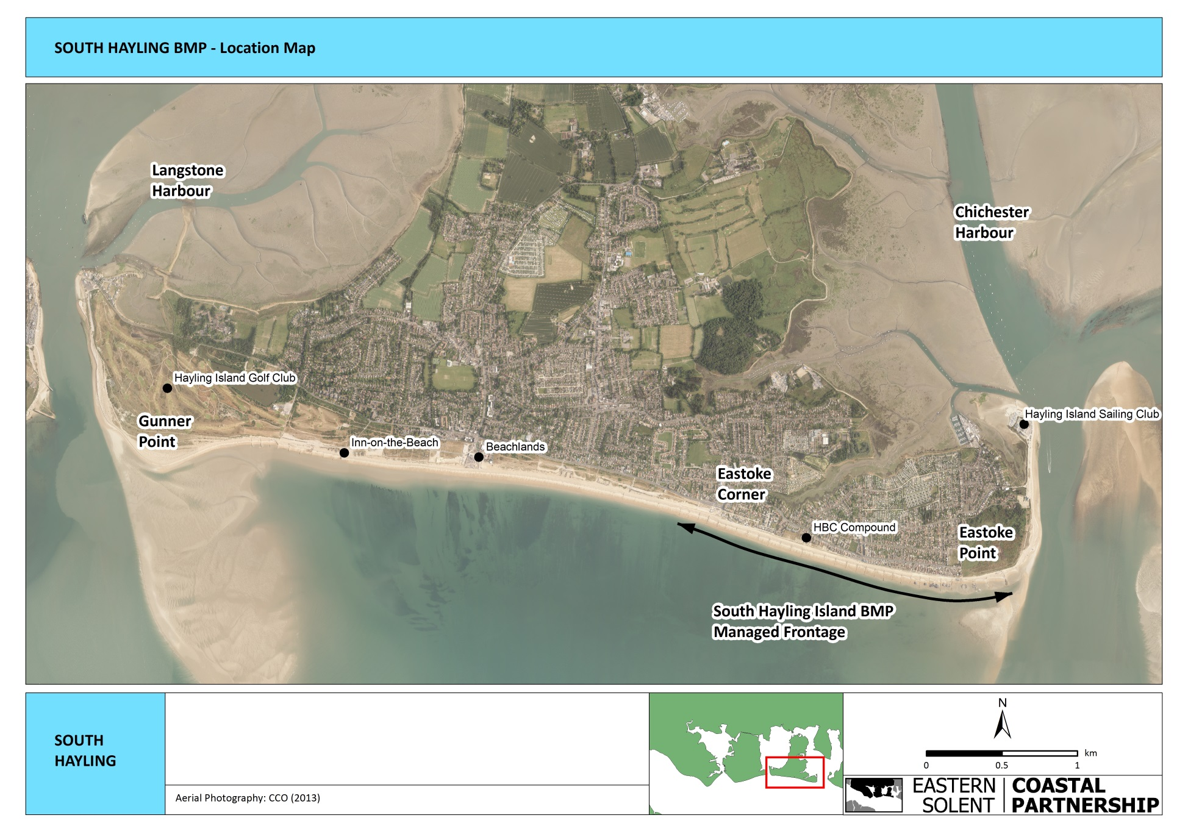

Figure 1: Location Plan of South Hayling Island frontage
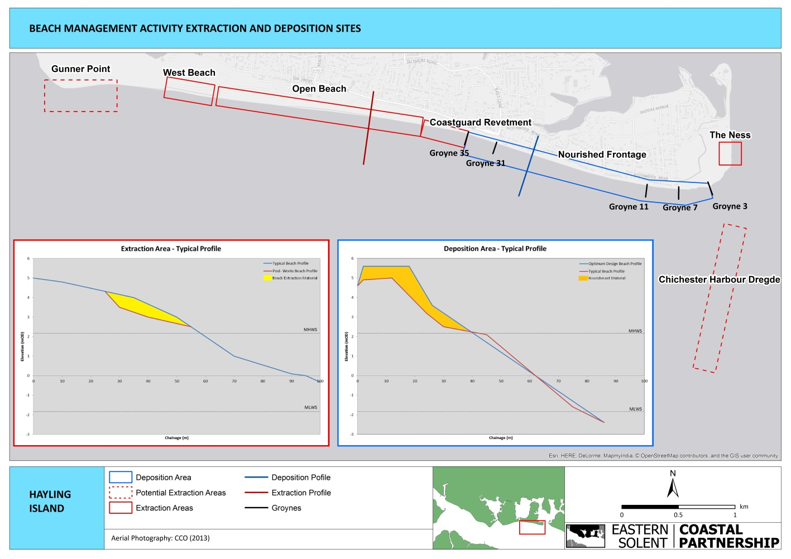
Works under this CEMP will include West Beach, Open Beach, Coastguard Revetment and Gunner Point, but will NOT include Chichester Harbour Dredge or the Ness.

Figure 2: Extraction and deposition sites

Requirements of Tender and Pre- Construction Meetings
Pre- construction meetings/toolbox talks will take place to ensure the entire workforce is aware of all environmental issues on site. This information will be reiterated in site briefings and site inductions and will include:
- Who (named person) is responsible for the Environmental Management on site.
- Procedures that need to be followed in the event of an emergency.
- Consents, constraints and conditions of consents and licences.
- Environmental issues and sensitivities on site (including time/noise/ habitats and species constraints)
  - Including protected species and habitats. The risk of impacting them and the legal consequences of damaging these habitats and species.
- The ornithologist with a watching brief, or environmental representative from the ESCP will explain the issues related to the disturbance of birds, and restrictions linked to the works on site
- How good house keeping practices will be maintained, for example:
  - Vehicles will not be left unattended in the intertidal zone;
  - Keep the site clean and tidy;
  - Ensure that material and plant storage are properly managed;
- How materials and machinery are to be safely and securely stored;
- What refuelling procedures will be followed these should include:
  - All fuels (petroleum spirit, within the meaning of the Petroleum Consolidated Act 1928, as amended by the Dangerous Substances and Explosive Atmospheres Regulations 2002), shall be stored in approved, double lined or bunded containers
  - Fuel spill kits are to be stored on- site and in other locations which will need to be specified by the contractor, due to the nature and shape of the site.
c. Equipment which leaks any fuel, lubricant or hydraulic fluid shall not be used. Checks will need to be carried out prior to machinery entering the site.
d. Biodegradable hydraulic fluid shall be used
e. Equipment shall be maintained to ensure efficiency and to minimise emissions
f. Equipment shall be steam cleaned before delivery to the site
g. Fuel and oil storage shall be away from the marine environment, fully bunded to 110% of the volume stored and maintained in a secure and clean manner. Delivery and vent pipes shall terminate within the bund
- Refuelling or servicing of equipment shall be carried out in designated locations away from the beach area. Spill Kits will also be kept near refuelling area and will need to be clearly visible.
i. Spill kits suitable for the marine environment (including booms for potential leaks directly in to the marine environment) should be kept on site at all times during operation. These should be located at a number of suitable locations; at a very minimum at both compounds. Consideration and justification should be provided for not including intermittent locations along the beach due to the size of this site. Any spills/leaks reported to ESCP and the Contractors Environmental Contact. Any major spills may also need to be reported to the EA, MMO and Natural England see section on oil spill section on emergency information.
j. Refuelling shall be supervised and shall be carried out by pumping through a trigger type delivery nozzle.
k. An adequate supply of oil absorbent materials shall be readily available on site at all times (e.g., in cab of equipment)
l. It is recommended that all equipment is specified to be fuelled with bio- diesel
m. Any spillage shall be immediately contained, removed from Site and disposed to a licenced tip, with the Project Manager being promptly informed
n. Follow pollution prevention practices (see section on pollution prevention measures)
9. Detail how the contractor will monitor site and report concerns
10. How best to achieve good communication practices with site workers, contractors and visitors
11. How to ensure all staff are aware of the location of emergency equipment and who to contact on site in the event of an environmental incident. The following people/organisations will need to be contacted immediately:
  - Emergency Planners at Havant Borough Council – Stuart Pinkney
  - ESCP on- site Project Manager
  - Environmental Team at Eastern Solent Coastal Partnership – Gavin Holder, Laura Denham, Lucy Sheffield, Ed Rowsell
  - Marine Management Organisation
  - Environment Agency
  - Natural England
  - Coastguard
12. Detail how this CEMP will be accessible, revisited if appropriate and communicated to all staff
13. How lessons learnt will be recorded for any future works.
14. How all monitoring that is required by the consent or by the contracting team (ESCP/Havant Borough Council) will be recorded to ensure that procedures are being followed, and to identify where improvements can be made
15. How to ensure that if members of the public or any stakeholder have any issues there is a named individual who will follow up/action and then feedback any changes, as a result, to that individual. This must all be recorded in the Issues Log.

Specific activities and precautions required

Tracking on the beach with dumper trucks
The haul route will be maintained as required by a bulldozer to ensure that it is safe at all times. Typical equipment may include 4x 30t dumper trucks tracking along this designated haul route, transporting approximately 30t each per trip (west to east), with the amount of trips per day varying depending on the haul distance required.
Precautions Required
1 | Landward extent of the haul route will be marked out using cones, every 50 meters to protected vegetated shingle. A vegetated shingle survey will be carried out by the ESCP (late July / August) to determine where the vegetation is located and to guide works. The vegetation may not be present at the time of operation as it will be dependant on time of year, the demarcation line will be where the vegetation was at the time of survey with an additional buffer. No equipment or machinery will be permitted to travel landward of these cones to protect the habitat.
2 | All efforts must be taken to minimise the width of the haul route and to be kept to a single track with only an appropriate number of designated passing areas. To minimise the impact on habitats and species and also the impact on coastal processes
3 | In order to further reduce the risk of damage to vegetated shingle habitats, biodegradable fuel is to be used in all equipment
4 | It will be the contractors’ responsibility to maintain the cones in the correct locations on a daily basis.
5 | Limiting vehicles to 10mph on site will minimise noise disturbance.
6 | Delivery of shingle to site by road and tracking on the foreshore with machinery: 6am to 10pm Monday to Friday (unless there is an emergency response required which could require 24 hour working).
7 | To avoid damage and disturbance to breeding and ground nesting birds: an ecological walkover will be carried out immediately prior to works in nesting season only BMP units 1 to 5 (March to August inclusive). Provide exclusion area if nesting birds discovered (minimum of 5 metre buffer distance). Additional surveys will be carried out if required to ensure that birds have not nested in the meantime. No works to take place in BMP units 6 to 8 between March and August inclusive, as a known nesting site.
8 | To avoid disturbance to roosting birds: Undertake activity outside of overwintering bird period where possible. If recycling undertaken between October and March inclusive, stop works 1.5 hours before and 1 hour after high tide along eastern Eastoke and Gunner Point frontages only (BMP Units 1, 2 (eastern half), 6, 7 and 8).  Extraction and stockpiling may still occur during high tide, outside of the sensitive bird areas. This tidal restriction will not apply between April and September inclusive, noting that BMP units 6 to 8 will not be worked on at all between March and August.
9 | A banksman will be used where views for drivers is limited, for example between beach huts and around Funlands. The haul route in front of the properties at Eastoke will be along the beach crest and over the top of groynes. No vehicle movements will be permitted on the foreshore area, unless required for extraction and profiling of material.
10 | Banksmen will be placed along the beach at the busiest areas as required during all works.
11 | All equipment is required to be tracked along the beach crest. This may lead to some compaction of the crest due to the weight and quantity of truck movements. As the beach is naturally a dynamic environment, widespread compaction of material is unlikely. Should the compaction of the haul route in the deposition area become an issue, the contract Works Information contains a method for removing a quantity of compacted material from the beach crest and replacing it with unconsolidated profiled material (see below).  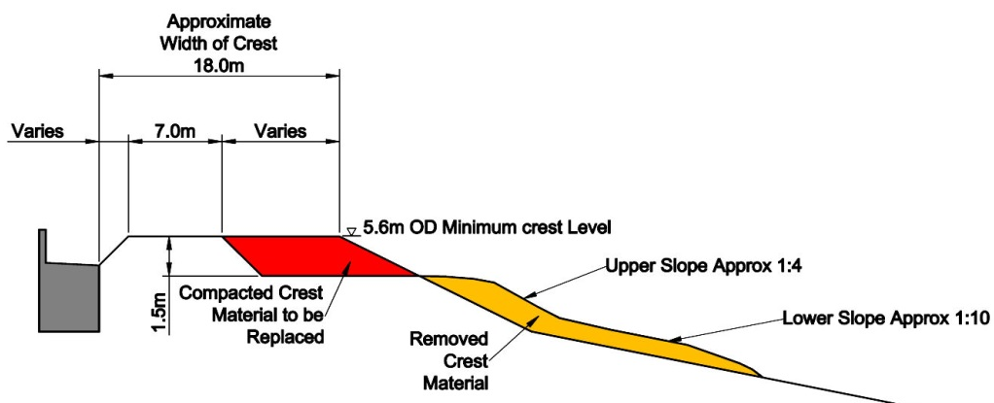
12 | The main impacts of the beach management works revolve around the potential increase in dust levels and exhaust emissions. These impacts are minimal and temporary due to the short timescale of the beach management works and other than good practice working / using well maintained equipment, no additional mitigation has been identified.
13 | For both recycling and recharge work may be stopped during extreme weather events ( e.g. frozen ground for a length of time greater than 1 week), which will reduce the pressure of feeding for over wintering birds under these weather conditions.

Depositing material on the beach/carpark/storage
Beach – the deposition of material on the beach will be carried out by dumper trucks only. These will also be used to collect any stockpiled material from the car park and move on to the beach.
Precautions Required
14 | Restrict drop-height to a minimum when loading the dump-truck hopper from an excavator bucket (or conveyor). Minimising drop height would also serve to minimise noise from initial filling of a steel dump-truck hopper with course pebble aggregate, which is likely to be a noisy operation and so that dust generation is minimised

Car park – the material will be deposited in the car park (if required) by road lorries. These carry approximately 20t each. The amount of deliveries to site will vary depending on the rate of supply to the Contractors wharf, and the quantity of material required on site. On average in the past there have been 18-20 loads per day.
Precautions Required
14 | The dropping height from the dumper to the beach is to be kept to a minimum to ensure that both noise and dust generation is minimised
15 | Restrictions on time of working will be dependant on those under the Planning Permission.

Storage – the material will be stored in Eastoke Corner car park. The plant will be stored in the Plot 74 Southwood Road compound. During works at West Beach, some plant may be stored in a small compound with welfare facilities in West Beach car park. This is due to the long distance haul route to return each night.
Precautions Required
15 | Restrictions on time of working will be dependant on those under the Planning Permission.
16 | Any plant stored within the Plot 74 compound will be stored to the southern end of the area to reduce any vibration felt in adjacent properties. Vibrations will also be reduced on site by a maximum speed limit of 10mph being enforced at all times.

Moving material on the beach – reprofiling with a bulldozer
The re- profiling of material on the beach will be carried out by a bulldozer. 2x bulldozers are expected to be on site. One will be stationed at the extraction area to re- profile the beach. The other bulldozer will be stationed at the deposition site. This machine will work to profile the deposited material to the design profile. Both bulldozers will maintain the haul route as required.
Precautions Required
15 | Restrictions on time of working will be dependant on those under the Planning Permission.
17 | Delivery of shingle to site by road and tracking on the foreshore with machinery: 6am to 10pm Monday to Friday (unless there is an emergency response required which could require 24 hour working).
18 | No machinery shall be left unattended on any part of the beach.
19 | Refuelling will only take place in the designated areas, away from the beach / watercourses
7 | To avoid damage and disturbance to breeding and ground nesting birds: an ecological walkover will be carried out immediately prior to works in nesting season only BMP units 1 to 5 (March to August inclusive). Provide exclusion area if nesting birds discovered (minimum of 5 metre buffer distance). Additional surveys will be carried out if required to ensure that birds have not nested in the meantime. No works to take place in BMP units 6 to 8 between March and August inclusive, as a known nesting site
8 | To avoid disturbance to roosting birds: Undertake activity outside of overwintering bird period where possible. If recycling undertaken between October and March inclusive, stop works 1.5 hours before and 1 hour after high tide along eastern Eastoke and Gunner Point frontages only (BMP Units 1, 2 (eastern half), 6, 7 and 8). See figure 3.  Extraction and stockpiling may still occur during high tide, outside of the sensitive bird areas. This tidal restriction will not apply between April and September inclusive, noting that BMP units 6 to 8 will not be worked on at all between March and August.
13 | For both recycling and recharge work may be stopped during extreme weather events ( e.g. frozen ground for a length of time greater than 1 week), which will reduce the pressure of feeding for over wintering birds under these weather conditions.
20 | Any photographic evidence of changes in suspended solids in the water column should be captured and provided to the Construction Environment Management Plan manager.

Transporting material from the Beach to Ferry Road Car Park to resolve a localised erosion problem
A small quantity of material will be taken from an area of accretion on the beach and transported by road using road legal machinery to deposit on the upper beach adjacent to the carpark (BMP U 8) (see Photo 1).
Precautions Required
14 | The dropping height from the dumper to the beach is to be kept to a minimum to ensure that both noise and dust generation is minimised
15 | Restrictions on time of working will be dependant on those under the Planning Permission.

Transporting plant to site
Plant will be delivered to site on the back of low loaders. Restrictions on times of delivery will be dependant on planning conditions however current conditions restrict plant movements can only take place between 9:30am and 15:30pm Monday to Friday. All plant must be delivered to western side of Eastoke Corner car park, and tracked along the beach crest to the HBC Compound. Any plant delivered outside of these hours must remain on the low loader until working hours begin. This machinery will be moved twice per campaign; once on to the Island at the start of the works and then off at the end. All equipment will be left on site for the duration of each campaign.
Precautions Required
15 | Restrictions on time of working will be dependant on those under the Planning Permission.
16 | Any plant stored within the Plot 74 compound will be stored to the southern end of the area to reduce any vibration felt in adjacent properties. Vibrations will also be reduced on site by a maximum speed limit of 10mph being enforced at all times.

Transporting aggregates to site
Occasionally material from outside of the cell will be required to build the beach back up to a healthy profile. This material will match the existing shingle size already present on the beaches. Aggregate will be transported to site in non-articulated lorries to site. On average in the past these lorries have contained 20t each. Restrictions on times of delivery will be dependant on planning conditions however current conditions only permit deliveries between 9:30am and 15:30pm Monday to Friday. All material will be deposited in the western side of the car park, in the coned off area. Trucks should not turn in the eastern side of the car park as this will remain open to the public.

Precautions Required
15 | Restrictions on time of working will be dependant on the Planning Permission.
21 | Delivery by non articulated lorries only

Extracting Material from the beach
Material will be extracted from areas identified on Figure 2. This extraction will take place using an excavator, with the volume to be removed identified from surveys carried out prior to works. The excavator will extract the material down to a pre- identified beach level. The material will be loaded in to bulldozers at this location, and moved to the deposition site. The extraction site will then be profiled using a bulldozer to ensure that a natural beach profile is maintained at these locations.
In order to avoid interruption to coastal processes, ongoing monitoring of beach levels will continue along the entire South Hayling frontage. This monitoring will inform on existing beach levels, and where material is moving to and from. The recycling will maintain the movement of shingle along the frontage to Gunner Point. This movement of material is a benefit to Gunner Point as it reduces the risk of erosion at this site and the loss of vegetated shingle and drift line habitats. The preferred management option will be to recycle material already existing on the beaches of South Hayling. This will reduce the need for importing material additional sediment from outside of the sediment cell.
Precautions Required
22 | Recycling works will take place outside of the water body, to further minimise already low risk of increased turbidity due to the large size of the beach material.
7 | To avoid damage and disturbance to breeding and ground nesting birds: an ecological walkover will be carried out immediately prior to works in nesting season only BMP units 1 to 5 (March to August inclusive). Provide exclusion area if nesting birds discovered (minimum of 5 metre buffer distance). Additional surveys will be carried out if required to ensure that birds have not nested in the meantime. No works to take place in BMP units 6 to 8 between March and August inclusive, as a known nesting site
8 | To avoid disturbance to roosting birds: Undertake activity outside of overwintering bird period where possible. If recycling undertaken between October and March inclusive, stop works 1.5 hours before and 1 hour after high tide along eastern Eastoke and Gunner Point frontages only (BMP Units 1, 2 (eastern half), 6, 7 and 8). See figure 3.  Extraction and stockpiling may still occur during high tide, outside of the sensitive bird areas. This tidal restriction will not apply between April and September inclusive, noting that BMP units 6 to 8 will not be worked on at all between March and August.
13 | For both recycling and recharge work may be stopped during extreme weather events ( e.g. frozen ground for a length of time greater than 1 week), which will reduce the pressure of feeding for over wintering birds under these weather conditions.

Pollution Prevention Measures
Pollution control measures will be implemented to safeguard all habitats and species in the vicinity including those on land and in the marine environment. Good work management practices would be employed to ensure that there are no significant residual impacts. The relevant codes of practice for construction sites will be implemented, to protect water quality during works from disturbance of sediment and potential spillage of construction material. This will include adherence to all relevant legislation including the water pollution prevention measures set out in the Environment Agency’s Pollution Prevention Guidelines: PPG1 (General Guide to the Prevention of Water Pollution), PPG5 (Works In, Near or Liable to Affecting Watercourses) and PPG6 (Working at Construction and Demolition Sites); for example, the use of spill kits and biodegradable hydraulic oils.

Other considerations
The Contractor will employ a tidy site policy to further reduce any impact of works. There is to be no working during weekends, bank holidays or main holiday seasons (except in emergency conditions).

The Local Community
The local community (residents, commercial owners and property owners) will be kept informed about the nature and timing of any construction activities prior to each campaign. All seafront properties will receive a letter; a notice will be placed in the local newspaper and posters will be displayed at all coastal noticeboards, and in the Tourist Information office. Following discussions, it has been suggested that Havant Borough Council Tourism department should use the following websites to inform the public when the works are going to take place.
- http://www.havant.gov.uk/
- http://www.hayling.co.uk/
- http://www.visithavant.co.uk/

Reduction in pedestrian access
During the majority of the works, pedestrian access to the beach will be maintained. During times of truck movements, plastic barrier fencing will be installed over steps in the timber splashwall at Eastoke Corner to reduce the amount of pedestrian movements in the area.
The works will be relatively short term and will be carried out at a time of year outside the main holiday periods, except in an emergency.

Disturbance to residents
The works on site are a key benefit to residents who live along the Eastoke frontage. Although any construction works may have a temporary adverse effect on residents, the works are short term in nature (approx. 2 – 4 weeks per campaign). Engagement with stakeholders will be maintained to ensure that they are aware of all planned beach management activities. A log of any complaints will be kept by the Contractor and reported to the ESCP Project Manager on a regular basis.

Archaeological interest
Although the likelihood of unearthing archaeological features on site is very low, a precautionary approach will be undertaken. Although only the active beach material will be moved, equipment will be operated to avoid impacting any potential buried artefacts by disturbing the lower levels of beach material. If any archaeological artefacts are uncovered, all site work will be stopped and The County Archaeologist will be contacted to determine whether the finds are of sufficient merit to take further action. If finds are of sufficient merit, they may need to be recorded and left in situ, or if the finds are of sufficient merit to be recorded and excavated, to be preserved in an alternative location. Machinery working on site will avoid beach defence structures and military structures, if they are on the line of tracking. Equipment will also either be tracked or have wide tyres to spread the weight of the equipment and reduce damage. No artefacts will be needlessly impacted upon.

Tidal Working
Prior to starting work each day, the site manager will consult weather forecasts and tide tables. In extreme weather conditions work activities are to be re- evaluated and works will only continue if it is deemed safe to do so.

Temporary effect on amenity and recreation
In order to reduce the negative effect of reduced access to the beach on amenity and recreation, the length of construction works will be limited to as short a time as possible. No working will take place over weekends or recognised pubic holidays. Works will also be restricted to outside the main tourist summer season. This will limit the impact of works on visitors to the area. Works will only be carried out during the main summer season in emergency situations. A tidy site policy will be enforced by the Contractor to reduce any residual impacts on the recreational use of the beach.

Emergency Information

Hospital
In the event of an accident:
- Call 999
- The nearest accident and emergency ward is at Queen Alexandra Hospital -Southwick Hill Road, Cosham, Portsmouth

Munitions Disposal Procedure
In the event of suspected munitions i.e. wartime explosive devices/flares found on the beach pre/post- nourishment:
- DO NOT TOUCH anything that may seem suspicious.
- CALL 999 and ask to speak to the Coastguard.
- Give a description of the item/s and the exact location (nearest Groyne number or street name).
- CORDON OFF A 20m AREA around the suspected item.
- Wait until munitions have been removed from the beach before opening the beach again.

Oil Spill
In the event of an oil spill on the beach:
- Contact Havant Borough Council’s district oil pollution and chemical officer
- Any fuel, oil or chemical spill within the marine environment will be reported immediately to the Environment Agency, Marine Management Organisation, the Supervisor and Project Manager

The Contractor will specify what procedures would take place to prevent any plant getting stuck in the intertidal and also what procedures they would follow should this happen.
All fuels (Petroleum spirit, within the meaning of the Petroleum Consolidated Act 1928, as amended by the Dangerous Substances and Explosive Atmospheres Regulations 2002) shall be stored in approved, double lined or bunded containers. Fuel spill kits (suitable for a coastal location) are to be stored on-site storage locations need to be as close to where they may be needed as possible at a very minimum at both site compounds. Consideration will be given to locating them at other locations along the beach due to the size of the site. All fuelling operations, servicing of equipment and fuel storage to take place away from the beach and watercourses, in accordance with agreed method statement.
All contact details will be provided during the site induction by the Employer’s Representative.

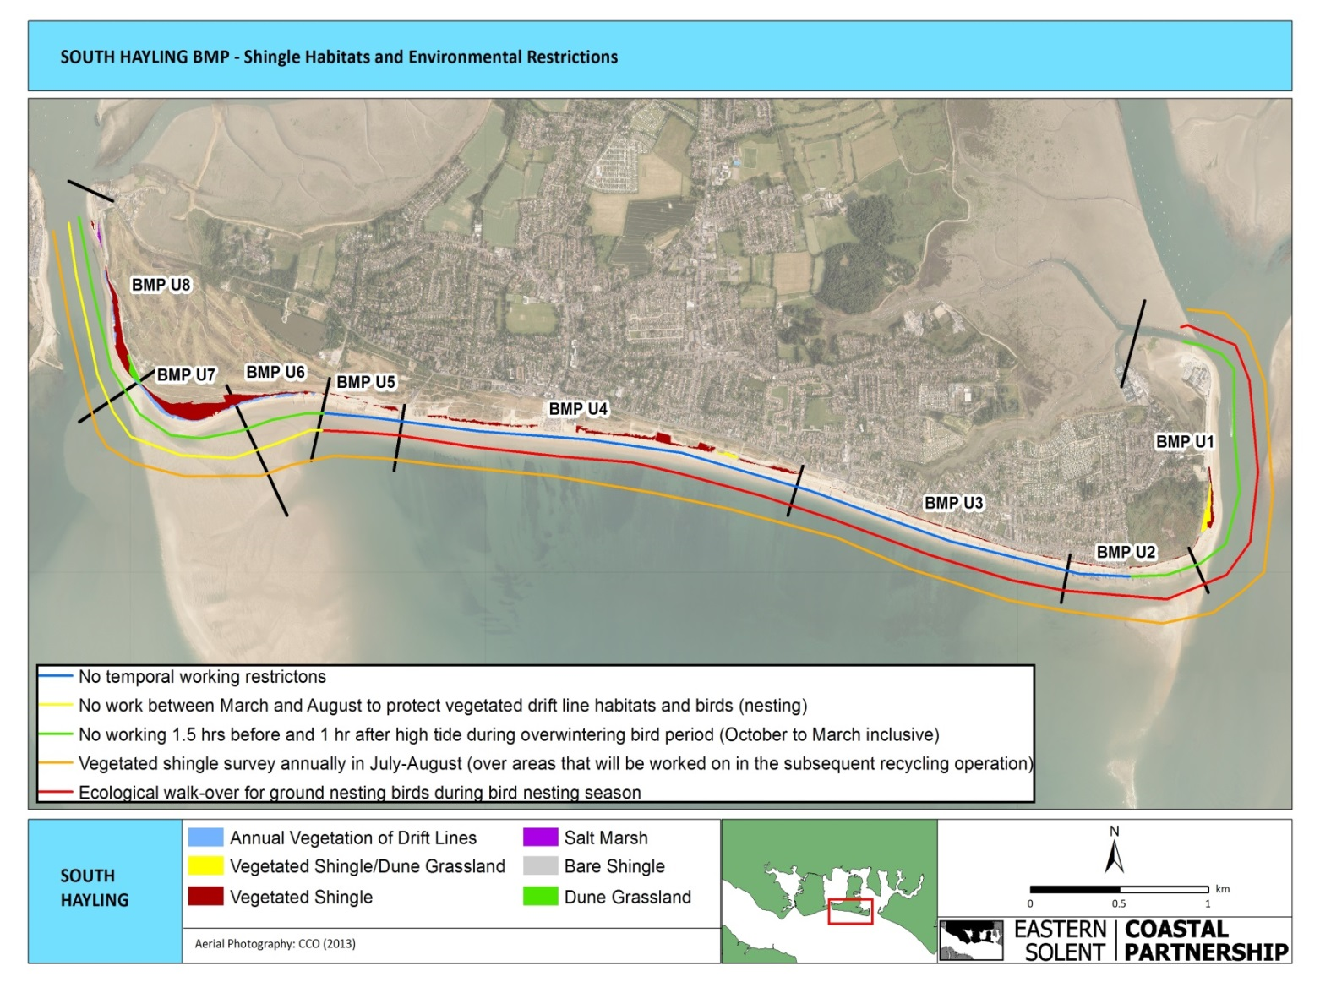

Figure 3: Environmental restrictions on working along the South Hayling frontage

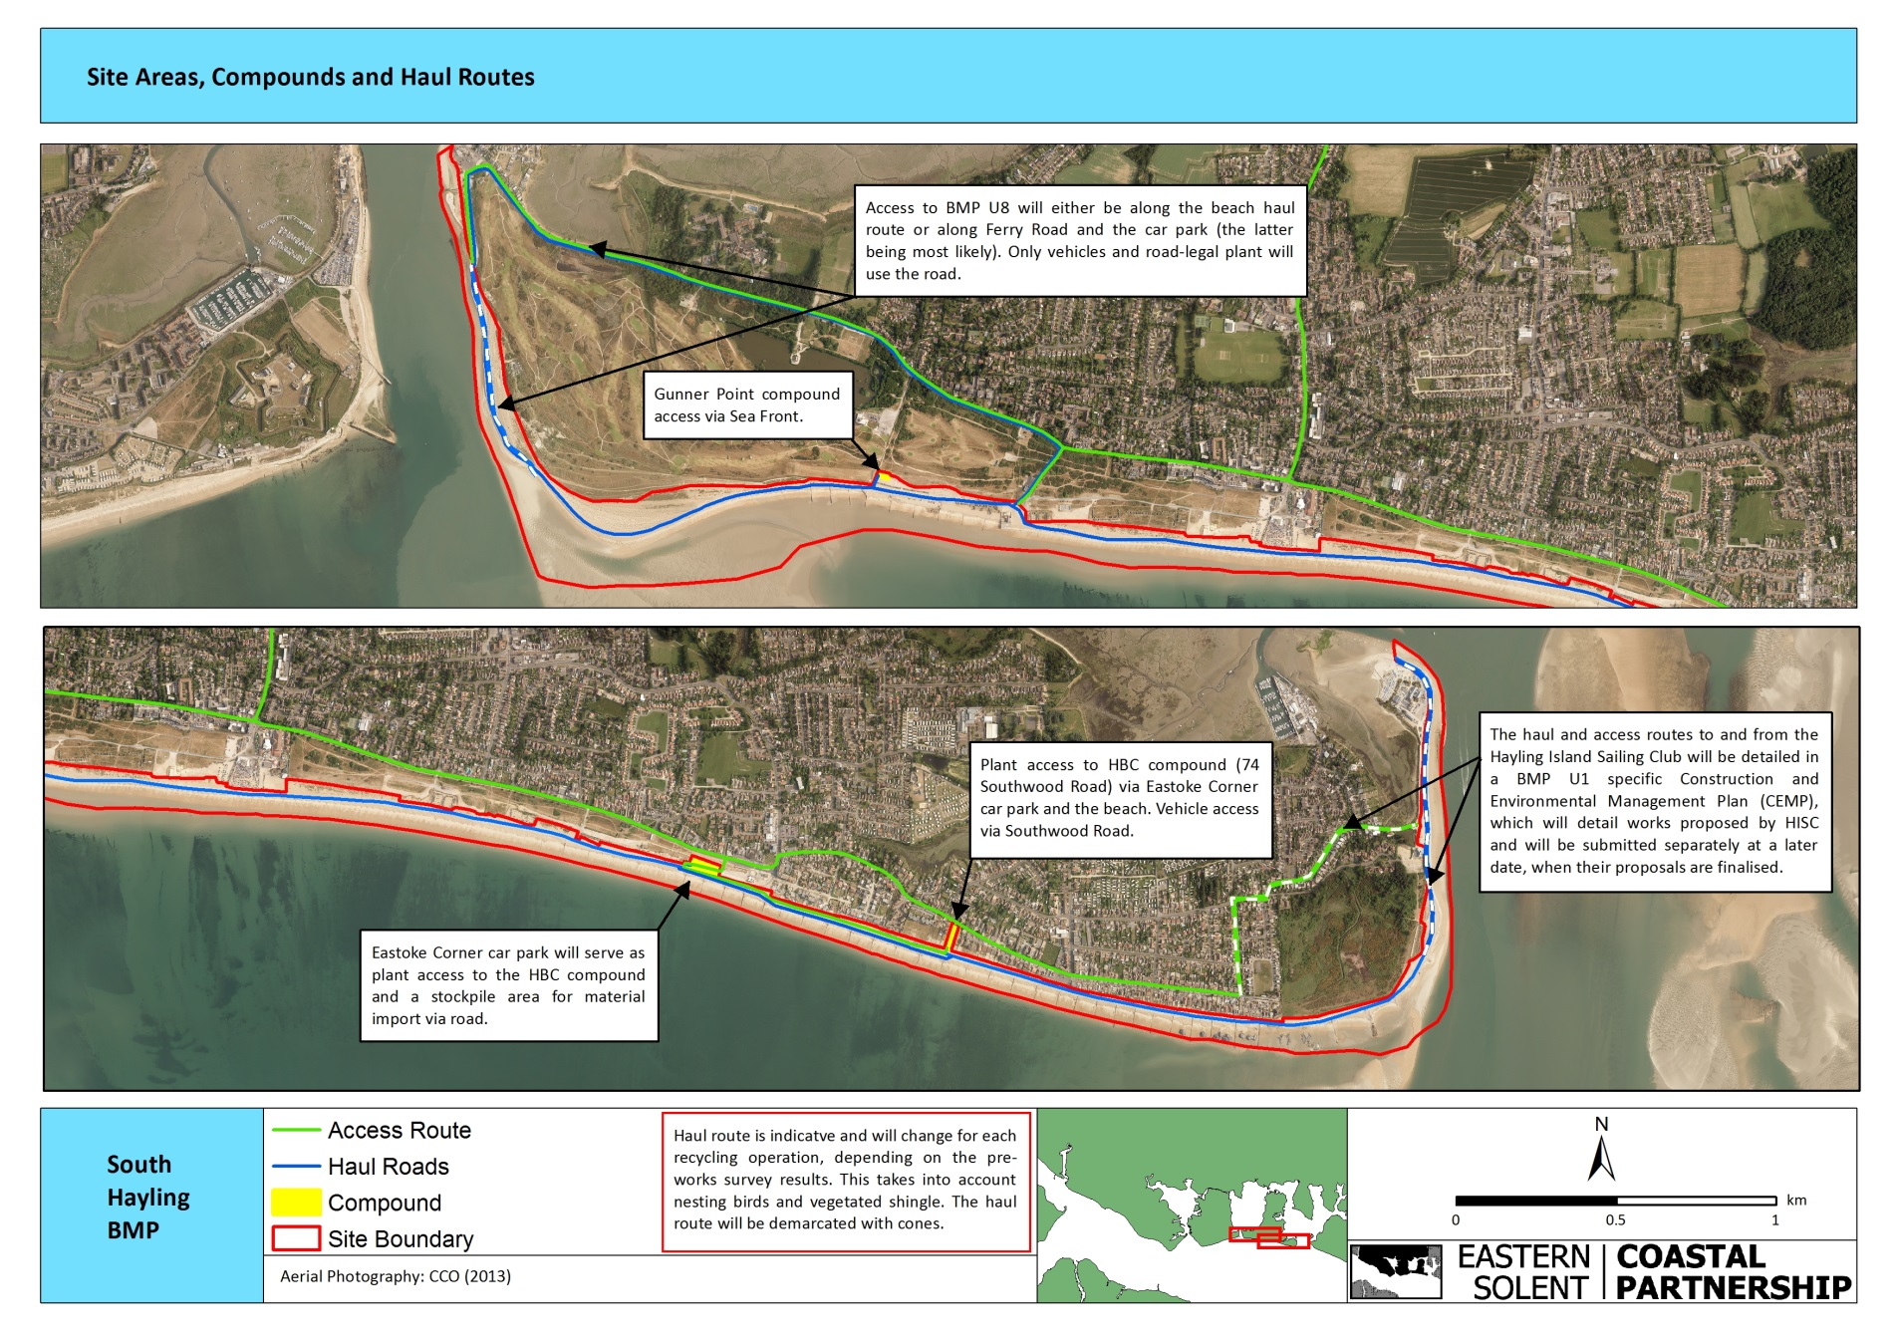

Figure 4: Information on access & haul routes along the site

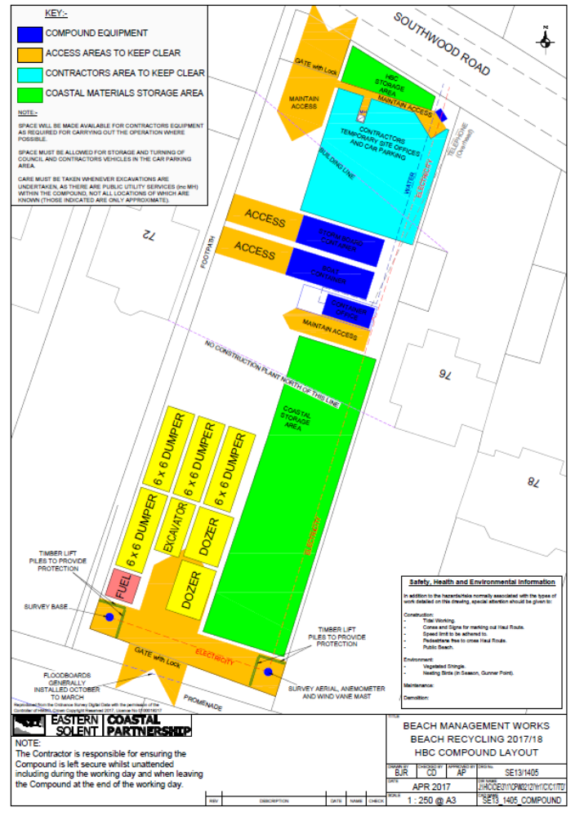
Figure 5: Plot 74 Southwood Road: Compound Layout

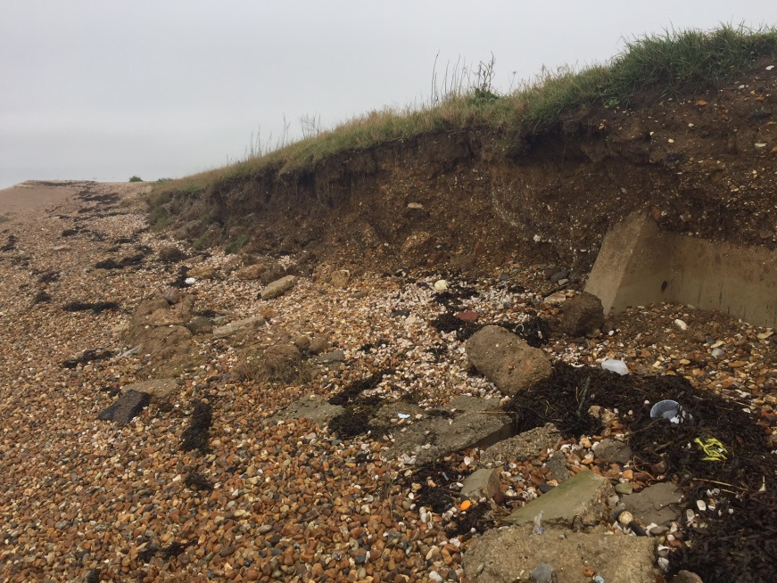
Photo 1: Localised erosion issues at Ferry Road car park, Hayling Island

