Status of Back Garden at Purchase – September 2009
Pre-existing concrete hardstand with flagstones on left hand side (side with steps).
The land on which the house is built slopes from the front to the rear of the property and from the left hand side to the right hand side of the property.
The hard stand sits 1.2m below the damp course layer and the grass sits 0.4m below the hardstand (therefore grass level is 1.6m below damp course level). Stairs are positioned by the rear door to allow access to the rear garden.
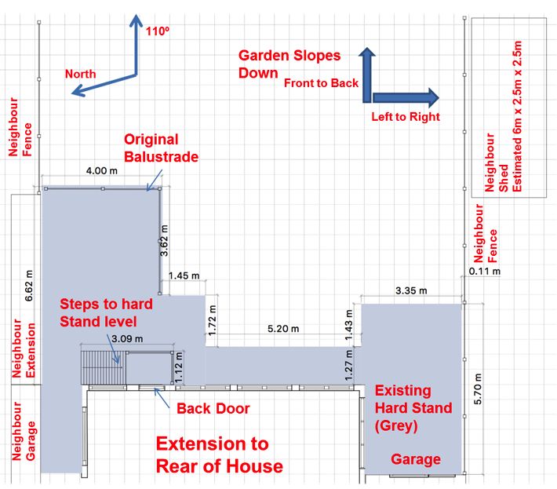
The Garden faces approximately 100 degrees (relative to true north). The sun rises at the rear of the garden, transitions around to the left and sets to the front of the house. Sunlight for the neighbour to the right is not obstructed by objects situated in our garden.
The Garage, positioned to the left of the house sits at a lower level from the house. The floor level in the house is approximately 1.0m below the damp course layer.

The boundary to the right is provided by the neighbour’s garage, a further extension followed by 2m wooden fence (1.8m panes sitting on 0.2m gravel boards) this fence slopes down as it extends toward the rear of the garden
The boundary to the left is provided by the neighbour’s fence which begins at our garage and slopes down as it extends toward the rear of the garden. This fence is also 2m high (1.8m panes sitting on 0.2m gravel boards), however, this height is taken from their side, which is lower than our own side

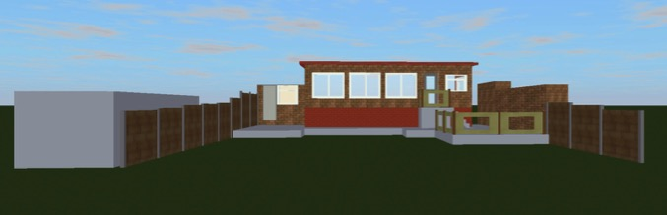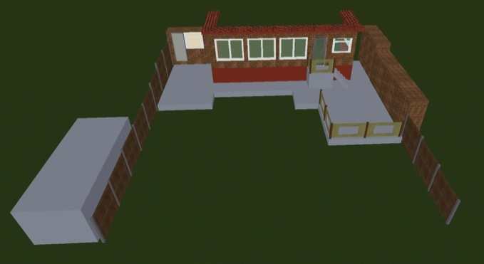
Neighbour to
the left
Neighbour to
the right

Replacement Decking
The pre-existing hard stand and flagstone area were in a poor state of repair when we purchased the house so over time we have built over with decked areas.
In 2015 the decking to the left hand side was added, including new steps down to grass level. To ensure a consistent level the new decked area is suspended approximately 0.3m above the old hard stand. A section of the decked area now extends beyond the original hardstand. Balustrade was added standing a further 1.0m above the height of the new decked area. A 1.8m fence was added to the left hand flank for the full length of the decked area (approximately 11.4m).
The remainder of the decking was added in two phases in 2016. The decking to the right hand side has also been extended beyond the original hardstand. No balustrade has been added to this side.
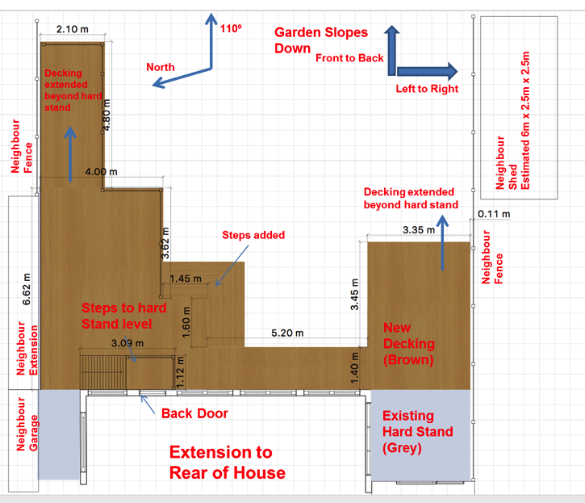
The decking remains an unfinished project with plans to complete the decked area to the right hand side by extending rearward up to the garage and by adding a fence on the right hand flank to sit 1.8m above the decked area.
The phases of build are shown below.
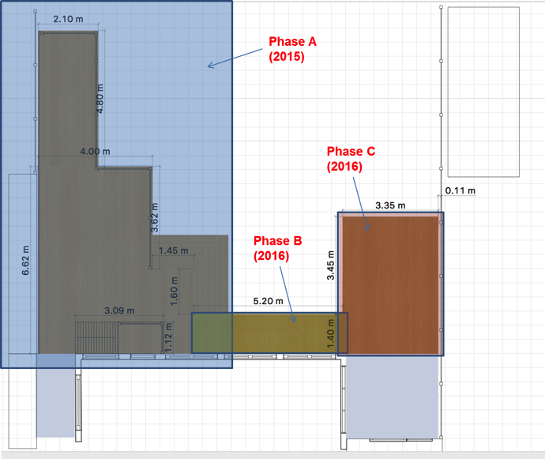

Side Views
Looking to the right
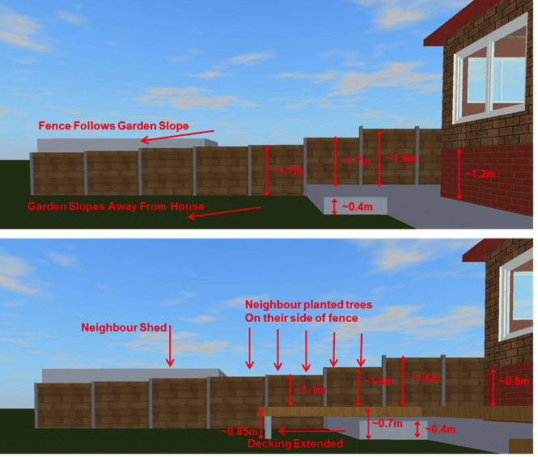
The new decked area sits approximately 0.3m above the pre-existing hard stand.
The decking has been extended beyond the extent of the pre-existing hard stand and remains level with the remainder of the decking. The addition of this raised decked area has shortened the height to the top of the neighbours fence – this is most pronounced at the furthest extent of the decking.
There is potential for loss of privacy for this neighbour from this part of decked area. This is alleviated partially by the position of their extensive shed and will be further alleviated when the trees they have planted gain height. Nevertheless, it was always intended to complete this decked area with further fencing (as was the left hand decked area). The effect of the fence can be seen in the next picture.
There is no impact to sunlight for this neighbour from any object erected in our garden.

Side Views
Looking to the left (Section A Decking)
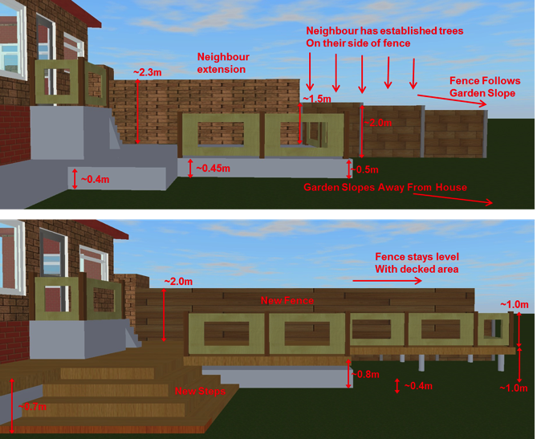
The new decked area sits approximately 0.3m above the pre-existing hard stand.
The decking has been extended beyond the extent of the pre-existing hard stand and remains level with the remainder of the decking. The addition of this raised decked area has shortened the height to the top of the neighbours fence – this is most pronounced at the furthest extent of the decking.
A new fence has been added for the full length of the decked area (~11.4m) at a height of ~1.8m alleviating any potential loss of privacy. The neighbour has a large extension to the rear of their property with runs for half the distance of the decking followed by established trees along the right flank of their garden. This neighbour was consulted prior to building the fence and checks were made to ensure no or acceptable loss of sunlight.
We cannot see into either neighbour’s garden from this decked area (Section A).

Side Views
Looking to the right (completed)
The addition of the fence to the raised decking area will alleviate any remaining issues with privacy. This will be erected this year.

