Design & Access Statement

35-37 South Road
Hayling Island PO11 9AE

Proposed hip roof to replace flat roof

May 2017

CONTENTS

1. Introduction

2. Design Objectives

3. Site Analysis

4. Site Concept

5. Landscaping

6. Building Concept

7. Access Statement

1.00 INTRODUCTION

This design & access statement is aimed at articulating a replacement roof to the south elevation of the property which would replace the current flat roof with a new hip roof.

The site
The site lies at 37 South Road, Hayling Island, and is accessed via a driveway to the front. The area is residential in nature with a medium density and the surrounding area is made up of a one and two storey properties or varying ages and styles.

The proposal
The proposal is for a hip roof to be built on the single storey side of the property replacing the current flat roof.

2.00 DESIGN OBJECTIVES

2.01 To provide a more in keeping looking property with the surrounding area & importantly the current terrace of three which the property is part of.

2.02 To provide a design of architectural and environmental quality that integrates as much is possible with the existing building and its terrace.

3.00 SITE ANALYSIS

3.01 The site is flat & offers easy access for contractors to get to the roof that requires building

3.04 All major services are currently available in the main house.

3.05 In climatic terms, the site is protected.

3.06 The site does not lie in a flood risk area.

4.00 SITE CONCEPT

4.01 To improve the visual appearance of the current property.

5.00 LANDSCAPING

5.01 There is not a requirement for this.

6.00 BUILDING CONCEPT

6.01 The roof structure will be a hip roof to match that of the existing building.

  - The roof will be tiled in a similar colour tile to that on the exiting building to ensure it matches as much as possible

  - Traditional construction is envisaged using timber for the roof structure, breathable felt & batons to accommodate the roof tiles.

Existing views

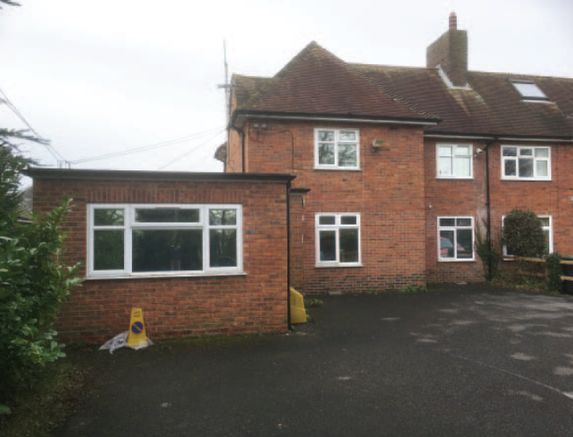

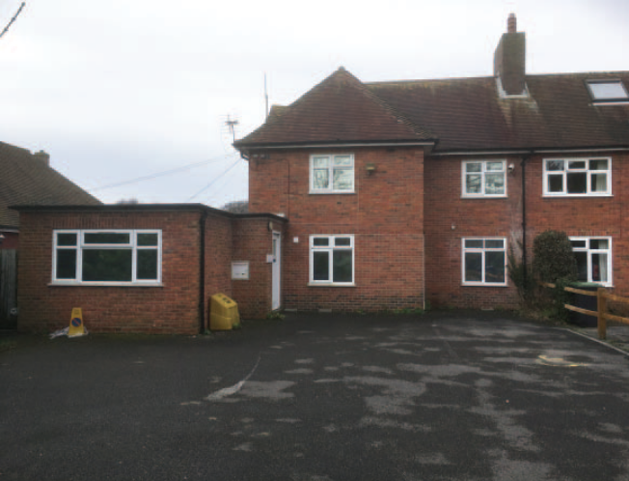

Proposed views

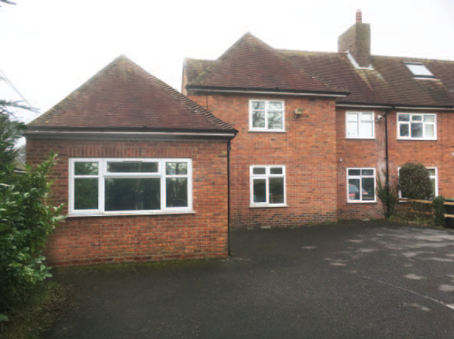

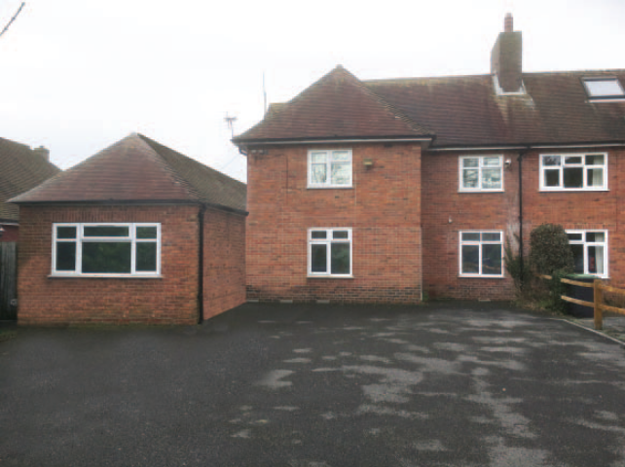

7.00 ACCESS STATEMENT

7.01 Design Principles

The site can adequately support the proposed development. By nature of its scale, the site is protected from possible visual intrusion from all vantage points.

7.02 Access Principles

Safe pedestrian access to the site is provided to the site from the east, and lies within walking distance of both community facilities and Public Transport Links. A pedestrian link and bus stop is within walking distance of the site.

