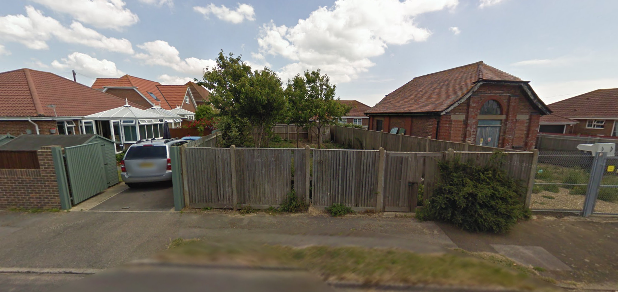

DESIGN STATEMENT

The site on Nutbourne Road offers potentials and limitations, which I have attempted to address in the design of a 2-bedroom single story dwelling. The level nature of the site allows flexibility for placing the building, which is useful as the decaying substation is somewhat of an eyesore beside the site. The design turns its back on the substation, with the outer wall up against the boundary fence on the south side.

The dwelling is based around a small internal courtyard, (as can be seen in section A) blurring the distinction between internal and external space, and creating a private, internal oasis in the sprawling residential area. It also helps to define spaces for cooking, eating and relaxing, within the open plan “front of house”.

With new developments in the local area adopting modern technologies, there is opportunity to move away from the traditional clay tile roof and red brick buildings, which characterise the surrounding residences. By introducing a zinc cladding system, as is implemented in some of the marina buildings, it is possible to achieve a higher level of insulation and energy efficiency whilst reducing wall and roof thickness, maximising the internal volume of the dwelling.

The zinc roof, which wraps around the building, becoming the outermost walls, on the North and South sides of the dwelling encloses and frames the building whilst a providing a covered entranceway to the front door. The front and rear facades are a combination of red brick, in keeping with surrounding buildings, and glass, bringing light into the dwelling. The large glazed roof area, a continuation of the glazed internal courtyard also allows light to flood into the open plan living space, whilst a smaller one provides light into the bathroom. Glazing has been placed with thought to framing views within the garden, whilst not impinging on the privacy or internal spaces. The planting of shrubs in the garden will also enhance this.

The two bedrooms and bathroom are placed to the rear of the building, separated from the main living area by a small hallway. Storage space has been achieved throughout the dwelling with built in cupboards and wardrobes.

I believe the design achieves an open plan, bright home whilst retaining a sense of privacy and tranquillity from the street.

