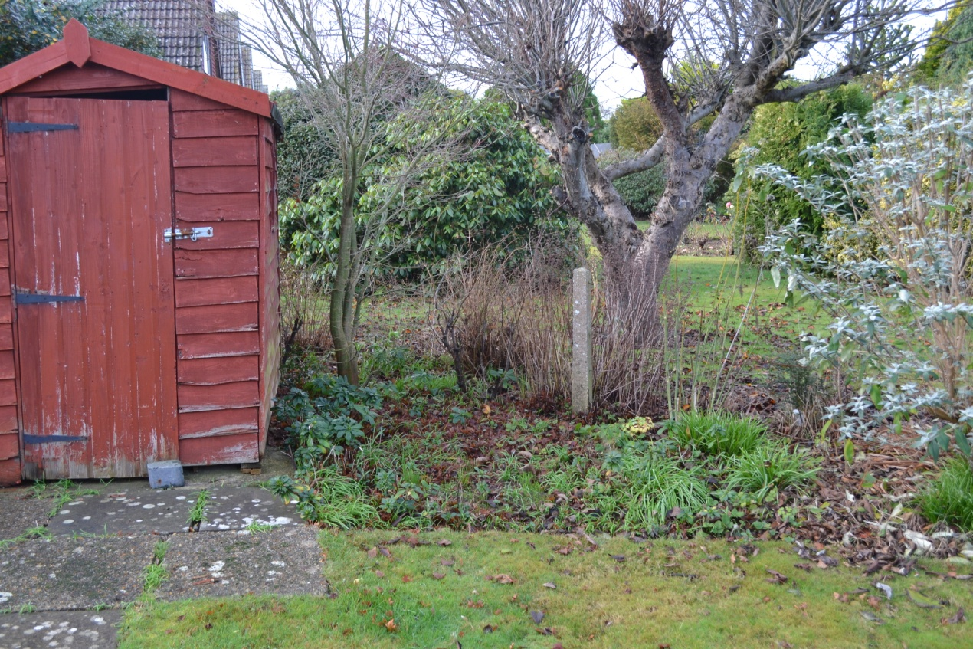

Photo 1. View of my shed showing lack of hedge to the north

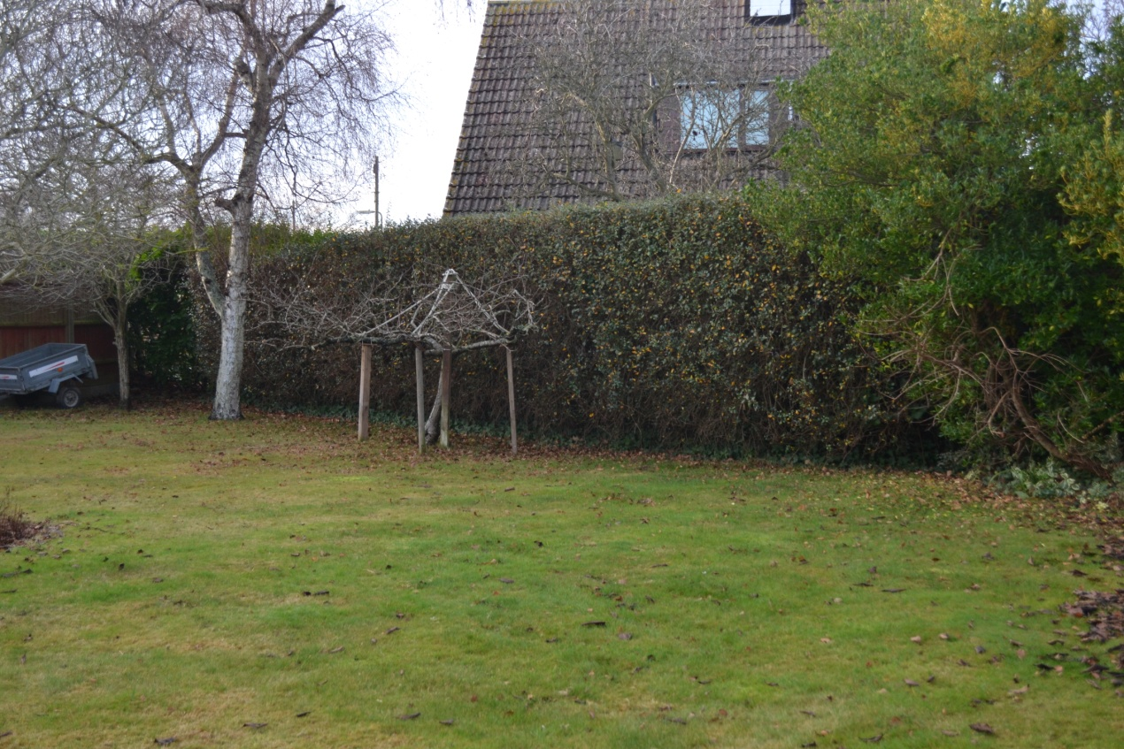

Photo 2. View looking west from my property showing escalonia hedge

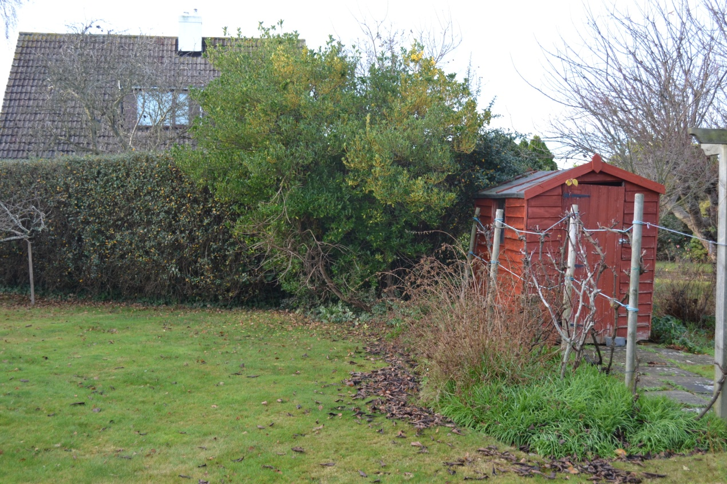

Photo 3. Similar to 2, showing hedge ending at the shed

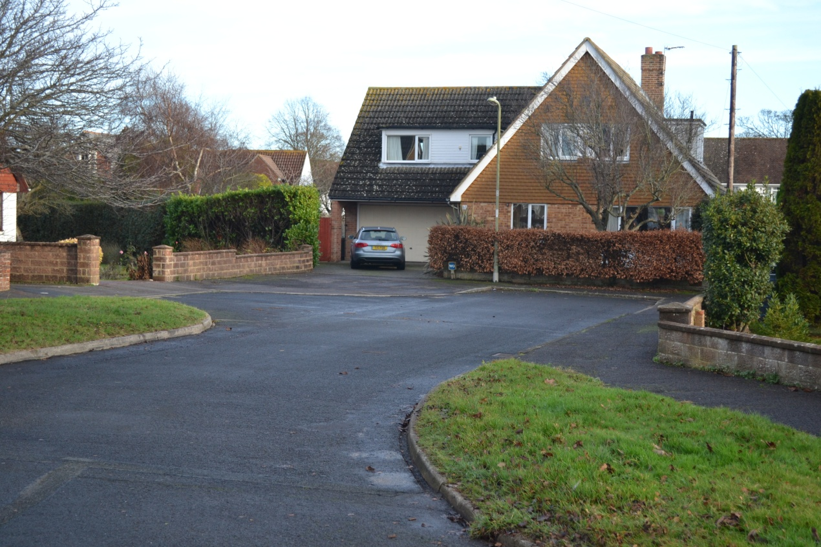

Photo 4. Blind exit from proposed drive and my drive due to established hedge

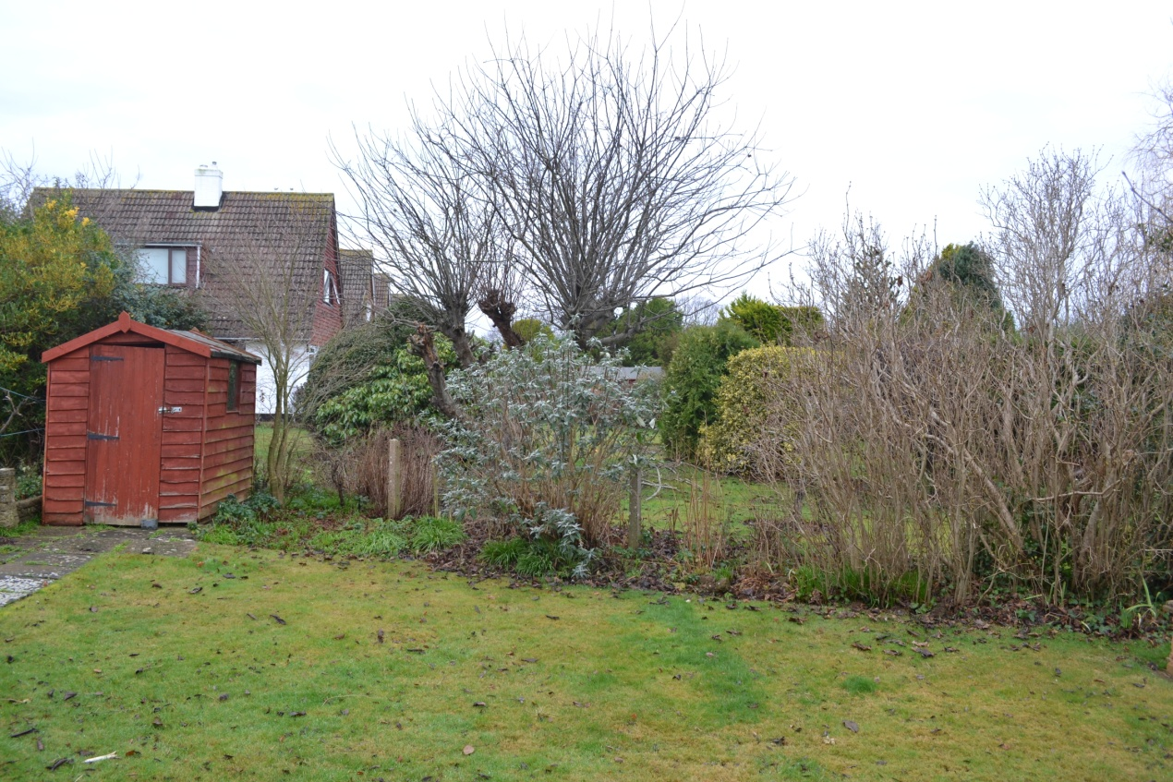

Photo 5 Extended view of open boundary north of shed

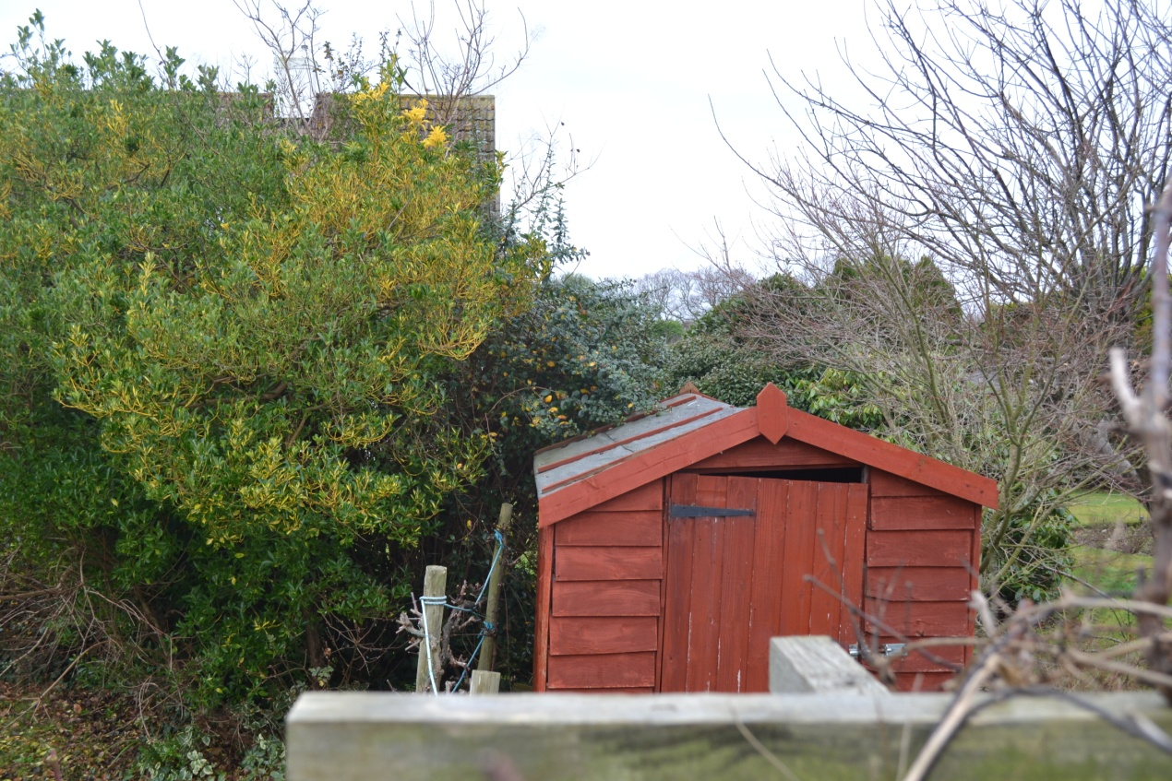

Photo 6 Position of shed established by transit along rear of numbers 89 & 87

