

MANAGEMENT PLAN

GUIDE TO THE LIFETIME MANAGEMENT AND MAINTENACE OF & THE
COMMUNAL PARTS ON LAND ADJACENT TO KINGSCLERE AVENUE, HAVANT

Rev - A

April 2017

1.0 INTRODUCTION

1.1 PURPOSE AND SCOPE OF DOCUMENT
The purpose of this document is to schedule all required maintenance regimes, operations and works necessary for the satisfactory management of the common parts of the site for the lifetime of the development. The document is intended for the use of the Portsmouth City Council staff that will be responsible for managing and maintaining them.

1.2 THE SITE

1.2.1 Location
The site is located between Kingsclere Avenue to the west, Brockenhurst Road to the north, Dunsbury Way to the east and Riders Junior School to the south in a predominantly residential area of Havant.

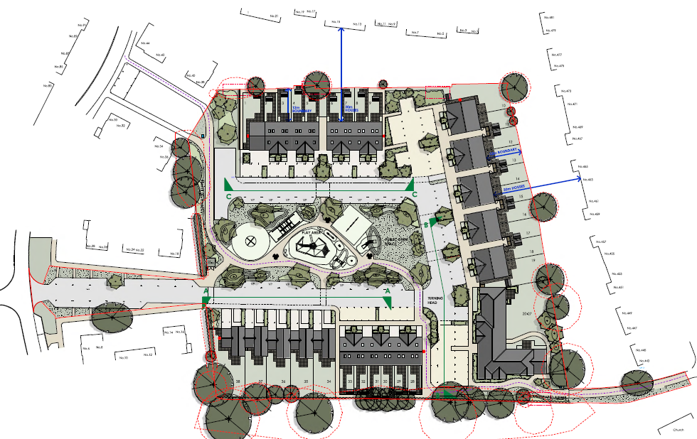

The site is a large open space with two informal footpaths running across the site between Kingsclere Avenue and Dunsbury Way. The site has a level difference of 3.5m from the north east corner to the south west corner and covers an area of approximately 1.32ha. of amenity grassland that is predominantly used for dog walking and access route to Riders Junior School.
The north and west boundaries of the site are denoted by the fences and vegetation of the neighbouring residential properties (1 - 21 Brockenhurst Road and 443 - 475 Dunsbury Way). The western edge of the site is defined by two grassed verge areas and the fences of neighbouring residential properties (16, 18, 36 & 38 Kingsclere Avenue). The southern site boundary is marked by a number of tall mature trees and an iron railing separating the site from Riders Junior School.

A new shared-use foot and cycle path will cross the site in place of the informal paths and will be offered up as a dedicated route for Hampshire County Council to include in the Definitive Map.

1.2.2 Accommodation
The site when completed will consist of 5 no 4 bed houses, 25 no 3 bed houses and a block of 8 no 2 bed flats.

1.2.3 Car Parking
Car parking has been provided on the following basis;

4 bed houses - 3 no spaces per house on curtilage and garage
3 bed houses - 2.5 no spaces per house
2 bed flats - 2 no spaces per flat
16 no visitor spaces
Total spaces = 91

1.2.4 Site Topography
The site slopes from the north east corner to the south west corner with a difference of 3.5m.

Landscaping
1.2.5 The landscaping has been planned to add life, colour and texture to the grounds for the benefits of the residents and the surrounding population. The design offers a diverse mixture of sensory attractive planting, in consideration of the surrounding areas. At the same time the design offers a practical and useable outdoor space suitable to the new homes.

Common Parts
1.2.6 The common parts of the site are the areas which are to be maintained by Portsmouth City Council and include the play area, the communal areas of the flats, unadopted road surfaces, parking areas, footpaths, cycle ways, landscaped areas and the water attenuation storage and culvert.

1.3 RECITALS

1.3.1 The Developer/Land Owner
This term refers to Portsmouth City Council (PCC) who will be responsible for the ongoing management and maintenance of this site.

1.3.2 The Local Planning Authority (LPA)
This term shall refer to Havant Borough Council (HBC) and its Planning and Landscape officers who are involved in the process of examination and approval of this documentation. This documentation has been issued for the satisfaction of the s106 covenants attached to this development.

1.3.3 The Contractor
This refers to the construction company who is to undertake the building works of the residential units, access road and associated external works, which in this instance is Feltham Construction Limited.

1.3.4 The Landscape Contractor
This is Kennett Landscaping Solutions who will be undertaking the landscape works and the initial 12 month maintenance period from practical completion.

1.3.5 Green & Clean Service
This refers to the Portsmouth City Council Green & Clean Service team which will be responsible for carrying out the management and maintenance works on site in accordance with this Management Plan.

1.3.6 Hampshire County Council
This refers to Hampshire County Council (HCC) who as the local highways authority will adopt and maintain the new access road in perpetuity after the initial 12 month warranty period has passed without issue.

1.3.7 Southern Water
This refers to Southern Water who as the statutory water authority will adopt and maintain the surface water and foul sewers in the new access road, the estate road and the surface leading to Dunsbury Way (excluding the surface water attenuation storage and the private foul sewer connections) in perpetuity after the initial 12 month warranty period has passed without issue.

1.3.8 The Play Area
This refers to the proposed play area in the open space of the development site which will be constructed once the housing site has been completed. The Contractor for these works has still to be confirmed.

2.0 ANNUAL WORKS

2.1 AIMS

2.1.1 To Ensure Health and Safety of All Visitors to the Grounds
Portsmouth City Council as landowner will uphold its duty of care that the landscape elements, both hard and soft, are safe, clean, and that all reasonable steps have been taken to minimise risk of injury and damage to persons and property. This is important for the play area, communal corridors of the flats, pedestrian paving and planting for the avoidance of trip hazards and injury.

2.1.2 To Achieve a High Standard of Maintenance
To maintain the hard and soft landscape elements in good condition, state of repair and clean, free from snags and hazards. To this end, these areas will be inspected regularly and any works that become necessary in respect to the condition, cleanliness and soundness of features, facilities, vegetation and surfaces will be carried out. These works shall include sweeping, wiping, washing, staining, painting, tidying and other such ancillary works in respect of hard landscape elements. Maintenance shall include weed control, pest control, watering, pruning, fertilising, grass cutting, ad general lawn care, such as spiking and scarifying and any other such ancillary works in respect of soft landscaping.

2.1.3 To Ensure that the Character of the Common Parts are Maintained as Proposed on the Planning Approved Drawings The planning approved drawings proposed a level of maintenance and intent which is required to be maintained during the lifetime of the development.

2.2 OBJECTIVES

2.2.1 Shrubs
To define spaces and enhance visual amenity of spaces and to soften buildings and structures. To ensure sustainable health and growth of shrubs to natural shape and functional size. To prevent leggy growth from presenting Health and Safety problems and from holding litter.

2.2.2 Trees
To provide an attractive visual amenity by defining space and through creating a sense of height and scale. Proposed trees shall be maintained to ensure survival and health and open growth. To achieve typical heights, spreads and characteristic density of foliage common to the respective specie without compromising safety or access issues.

2.2.3 Amenity Grass
To maintain healthy, hard wearing grass with a consistent colouring. To ensure freedom from pests and diseases, water logging, drought and excessive wear that might cause degradation and failure. To ensure safe and comfortable use of amenity spaces.

2.2.4 Hard Surfaces and Block Paving
To maintain in good order free from dilapidations, trip hazards, pot holes, and subsidence. To ensure that the paving is safe and free from weeds, litter, debris, animal excrement and gum.

2.2.5 Attenuation Tank
To maintain in good order free from blockages. To ensure that the tank can function as required, free from leaves, silt and debris.

2.2.6 Communal Corridors/Refuse Store
To maintain in good order free from dilapidations and trip hazards. To ensure clean and safe non-slip surfaces, free from spills and litter.

2.2.7 Bat Boxes and Hibernacula
To encourage ecology and attract a variety of bats and reptiles to the site in line with National and Local policy.

2.2.8 Play Area/Street Furniture
To be maintained in good order. To ensure these elements are safe, functional, clean and free from dilapidations.

2.3 METHOD

2.3.1 Planted Areas
Areas to be litter picked on every visit. Remove all weed growth by hand as necessary to ensure weed free and tidy planting beds. All weeds shall be removed from site. Planting to be pruned and shaped as required, in accordance with good horticultural practice. Traffic site lines, paths and windows to be kept clear at all times. Dead-heading of herbaceous plants shall be carried out regularly; plant die-back shall be removed at the end of winter. Light clip over plants where required. Cut back flowering shoots after flowering, remove suckers, dead, discoloured, weak or damaged stems. Prune to reduce size of specimen if suppressing adjoin species. Several visits will be required during the growing season, with an extra visit outside of the growing season in December or January to inspect the condition of the beds. Visits should occur fortnightly in the growing season, subject to weather conditions, from March to October and monthly from November to February. The schedule may need to be flexible to account for seasonal variations, and with regard to good horticultural practice.

2.3.2 Herbiciding: Planted Areas
Persistent perennial weeds shall be controlled in planted areas. For planting beds containing herbaceous plants and shrubs, apply a suitable herbicide. Herbicide to be applied by qualified operatives and in suitable conditions as specified by the manufacturer.

2.3.3 Hedges
All hedges to be pruned and tidied twice per year. This work only to commence once established. Attention should be paid to vehicle site lines and windows, so if necessary, additional pruning may be required.

2.3.4 Amenity Grass Areas
Amenity grass areas to be regularly mown with hand mowers, ride on mowers and strimmers as appropriate. All machinery to be well maintained and suitable for the operation involved. All litter to be removed prior to cutting. All arisings to be collected and removed from site. Boundaries and obstacles to be strimmed before mowing operations commence. Grassed areas to be cut/strimmed to a maximum height of 40mm. Paths to be kept free of all arisings and swept after mowing operations. Failed areas of grass should be re- sown with grass seed, ideally in spring and autumn. Weeds to be hand weeded in order to maintain the visual amenity of the area.

2.3.5 Newly Planted Trees
A 500mm radius from the base of each tree shall be kept free of grass and weed growth. Slow release fertiliser shall be applied annually at the start of the growing season, at the discretion of the maintenance contractor. Be sure to prevent chafing and damage to the bark of the trees, caused by rubbing against stakes. It should be planned to remove the tree stakes in the third year after planting, although the final assessment should be made by the maintenance contractor on the suitability of this time frame. The failure of any trees should be investigated and similar species should be checked and appropriate action taken to prevent disease or other problems re-occurring. Failed trees should be re- planted at the next planting season.

Formative pruning may be appropriate on young trees where selective removal of branches competing with the main leader would lead to improved timber quality and reduce the likelihood of crown splitting in the future. It is recommended that the trees on site be inspected on an annual basis by the PCC arboricultural officer.

All new trees planted in areas of grass are to be provided with black strimmer guards to prevent damage any maintenance equipment (strimmers, lawn mowers etc.) may cause.

2.3.6 Existing Mature Trees
Following the annual arboricultural assessment, works recommended for each tree shall be carried out by PCC's approved arboricultural contractor. Arisings from such works shall be removed from site.

2.3.7 Hard Surfaces and Permeable Paving
Brushing and vacuuming surface areas should take place once a year after autumn leaf fall, or reduced frequency as required based on site-specific observations of clogging or manufacturer's recommendations. Pay particular attention to areas where water runs onto previous surface from adjacent impermeable areas, as this area is most likely to collect the most sediment.

Stabilise and mow contributing adjacent areas as required. Removal of weeds or management using glyphospate applied directly into the weeds by an applicator other than spraying as required (once a year on less frequently used pavements). Remediate any landscaping which, through vegetation maintenance or soil slip, has been raised to within 50mm of the level of the paving. Remedial work to any depressions, rutting and cracked or broken blocks considered detrimental to the structural performance or a hazard to users, and replace lost jointing material. Rehabilitation of surface and upper sub-structures by remedial sweeping every 10 to 15 years or as required (if infiltration performance is reduced due to significant clogging).

Inspect three-monthly, 48 hours after large storms in the first 6 months for evidence of poor operation and/or weed growth - if required take remedial action.

Annually, inspect silt accumulation rates and establish appropriate brushing frequencies and monitor the inspection chambers.

2.3.8 Surface Water Storage (Attenuation Crates)/Culvert
Monthly for 3 months, then 6 monthly, inspect and identify any areas that are not operating correctly and take any remedial action as required.

Monthly remove any debris from the catchment surface (which may cause risks to performance).

Annually or as required, remove sediment from the pre-treatment structures - silt traps and gullies, and clean as required.

Inspect and check all inlets, outlets, vents and overflows annually to ensure that they are in good condition and operating as designed.

2.3.9 Communal Corridors/Refuse Store
Sweeping, mopping and wiping as required to maintain the communal corridor and refuse store in satisfactory condition.

2.3.10Bat Boxes
Bat boxes shall be inspected annually for loss, damage or obstruction during winter (non-invasive inspection). Lost or damaged boxes shall be replaced with an identical product. Bat boxes shall be cleared every 3 years by a bat licensed ecologist.
2.3.11Watering
Watering may be required during dry periods and until the planting is fully established, for a period of 3 years after completion. This may be required on a weekly basis.

2.3.12Monitoring
Inspection and monitoring of the landscape management is recommended on an annual basis, preferably accompanied with the PCC landscape architect and arboricultural officer, to monitor and guide the success of the management objectives and to identify and additional or revised management needs, focused on the strategic landscape objectives. Specific programmes for monitoring the trees, particularly the established and mature trees already on the site should be scheduled on an annual basis with the PCC arboricultural officer. Plant or other failures arising during the management period should be replaced within the appropriate preceding season, unless the result of circumstances requiring an alternative response, such as replacement of trees with a different species due to a pest or infection.

3.0 PLAN OF MAINTAINED AREAS

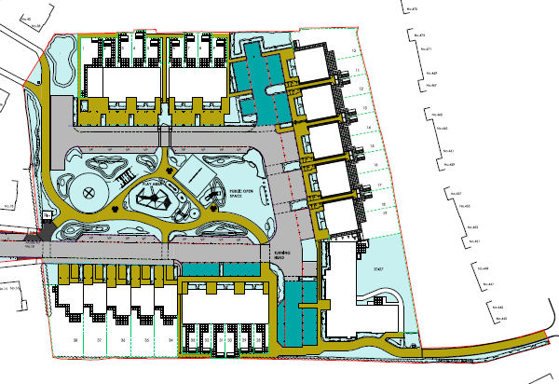

4.0 SCHEDULE OF MAINTENACE OPERATIONS
Maintenance Operation | Number of Visits (to be dependent on season - where not dependent on season |  |  |  |  | Total number of visits per year | Additional Comments
Maintenance Operation | Jan - Mar  (13 weeks) | Apr - May  (9 weeks) | Jun - Aug  (13 weeks) | Sep - Oct  (9 weeks) | Nov - Dec  (8 weeks) | Total number of visits per year | Additional Comments
GENERAL
Cleaning | As required | As required | As required | As required | As required |  | Cleaning of the communal flat areas to be undertaken on a needs basis.
External Litter Picking | Once per month | Once every 2 weeks | Once per week | Once every 2 weeks | Once per month | 24
PAVING
Inspection, brushing |  |  |  |  |  | 1 | Once a year after autumn leaf fall or reduced frequency as required. Pay particular attention to areas where water runs onto previous surface from adjacent impermeable areas, as this area is most likely to collect the most sediment.
Maintenance Operation | Number of Visits (to be dependent on season - where not dependent on season |  |  |  |  | Total number of visits per year | Additional Comments
Maintenance Operation | Jan - Mar  (13 wks) | Apr - May  (9 wks) | Jun - Aug  (13 wks) | Sep - Oct  (9 wks) | Nov - Dec  (8 wks) | Total number of visits per year | Additional Comments
Weeding |  |  |  |  |  |  | As required. Once per year on less frequently used areas.
Remedial works |  |  |  |  |  |  | As required. Rehabilitation of surface and sub-structures by remedial sweeping every 10-15 years or as required (if infiltration performance is reduced due to significant clogging).
Monitoring - initial inspections |  |  |  |  |  | 3 | Monthly for first 3 months post installation.
Monitoring - poor operation |  |  |  |  |  | 4 | 3 monthly. 48 hours after large storms in first 6 months.
Monitoring - silt accumulation and inspection chambers |  |  |  |  |  | 1 | Once a year
Maintenance Operation | Number of Visits (to be dependent on season - where not dependent on season |  |  |  |  | Total number of visits per year | Additional Comments
Maintenance Operation | Jan - Mar  (13 wks) | Apr - May  (9 wks) | Jun - Aug  (13 wks) | Sep - Oct  (9 wks) | Nov - Dec  (8 wks) | Total number of visits per year | Additional Comments
CULVERT / SURFACE WATER STORAGE
Inspection |  |  |  |  |  | 2 | Monthly for 3 months, then 6 monthly.
Debris removal |  |  |  |  |  | 12 | Monthly
Sediment removal from pre-treatment structures - silt traps and gullies |  |  |  |  |  | 1 | Once a year or as required.
Repair inlets, outlet, overflows and vents |  |  |  |  |  |  | As required
Monitoring - ensure operating as designed |  |  |  |  |  | 1 | Once a year and after large storms.
BAT BOXES
Inspection, clear of obstructions (non-invasive) |  |  |  |  |  | 1 | Once every year for bird boxes and once every 3 years for bat boxes.
Maintenance Operation | Number of Visits (to be dependent on season - where not dependent on season |  |  |  |  | Total number of visits per year | Additional Comments
Maintenance Operation | Jan - Mar  (13 wks) | Apr - May  (9 wks) | Jun - Aug  (13 wks) | Sep - Oct  (9 wks) | Nov - Dec  (8 wks) | Total number of visits per year | Additional Comments
PLAY AREA
Inspection and cleaning | Once per month | Once per month | Once per month | Once per month | Once per month | 12 | Document any defects.
LANDSCAPING
Grass cutting | Twice a month in March | Twice a month or more if required | Twice a month or more if required | Twice a month |  | 18 | Grass areas to be regularly mown with hand mowers, ride on mowers and strimmers as appropriate. All machinery to be well maintained and suitable for the operation involved. All litter to be removed prior to cutting. All arisings to be collected and removed from site.
Grass - leaf removal | Once per month (Jan-Feb) |  |  |  | Once per month | 4
Weeding planted areas |  | Once per month | Once per month | Once per month |  | 7 | Weed by hand and remove arisings off site.
Maintenance Operation | Number of Visits (to be dependent on season - where not dependent on season |  |  |  |  | Total number of visits per year | Additional Comments
Maintenance Operation | Jan - Mar  (13 wks) | Apr - May  (9 wks) | Jun - Aug  (13 wks) | Sep - Oct  (9 wks) | Nov - Dec  (8 wks) | Total number of visits per year | Additional Comments
Spot herbiciding of planted areas | Once in late March |  | Once in late June, once in mid-August | Once in mid-October |  | 4 | To occur at approximately 6 week intervals only if required
Watering shrubs and trees |  | Once per month | Once every 2 weeks | Once a month (to end of Sep) |  | 10 | Watering frequency should be adjusted by the Green & Clean team depending on climatic conditions. Increase watering during hot and dry weather until plants have established.
Tidying beds |  |  |  |  |  |  | At each visit as required.
Fertilising trees and shrubs |  | Once in early May |  | Once in mid-Sep |  | 2
Pruning of trees and planted areas |  |  |  |  |  |  | As required to sound horticultural practice between October and March.
Replacement of trees and planted areas |  |  |  |  |  |  | As required
Watering amenity grass areas |  |  |  |  |  | 5 | Watering frequency should be adjusted by the Green & Clean team depending on climatic conditions.

