Proposals for the replacement of bin stores at Chichester House, Langstone House & Solent House on Lockerley Road & Swarraton Road, Havant.
Chichester House, Solent House & Langstone House are 3 x 9 storey general needs blocks with 56 flats in each block.
There are major issues with ASB relating to bulk rubbish, fly tipping and arson.
Late 2016 there were 2 arson related incidents that led to Hampshire Fire & Rescue Service requesting improvements to the current conditions to help prevent and maintain fire safety at these schemes.
The current bin stores are open timber fenced areas adjacent to the entrance of the blocks with no secure areas for refuse bins to be stored. As an interim measure bins have been chained to the timber fence to help prevent arson related incidents.
The Guinness Partnership are proposing to redevelop the current bin store areas to a purpose built fire proof sustainable structure which will be fully enclosed with lockable doors. The structures have been designed to accommodate the no. of bins at each block and to make better use of the area. The structure will be made from recycled plastic products which have been broken down and moulded into panels. The structures will require little to no maintenance.
The highest point of the structure will be at the front – the roof will be max 2.4m. There will be lockable double doors to the buildings which will be on a code. The buildings will have lights internally on sensors for residents/waste management.
The bin store areas will require a redesign in the floor area and ground works prior to installation.
In order to provide suitable space the footprint at the blocks will need to increase in size – at Chichester House & Langstone House it will result in the footpath being redirected around the new bin store.
Consultation has taken place on site with TGP, bin store manufacturer, ground works contractor and Norse (waste management) to ensure that all parties had the opportunity to identify their requirements.
TGP hope that the installation of secure and improved bin stores will help to reduce the level of arson/fly tipping incidents.
The photos below indicate where the bin stores will be located (red lines) and the footpath being redirected (yellow lines).
Also attached are the dimensions and information relating to the new proposed bin stores which have been designed by Affresol.

Chichester House
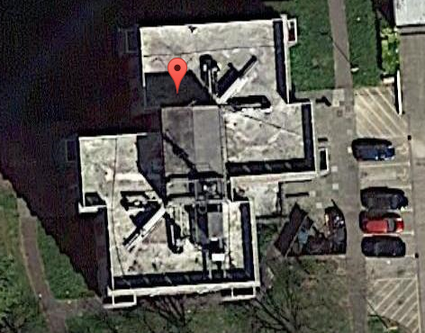

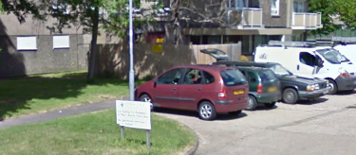
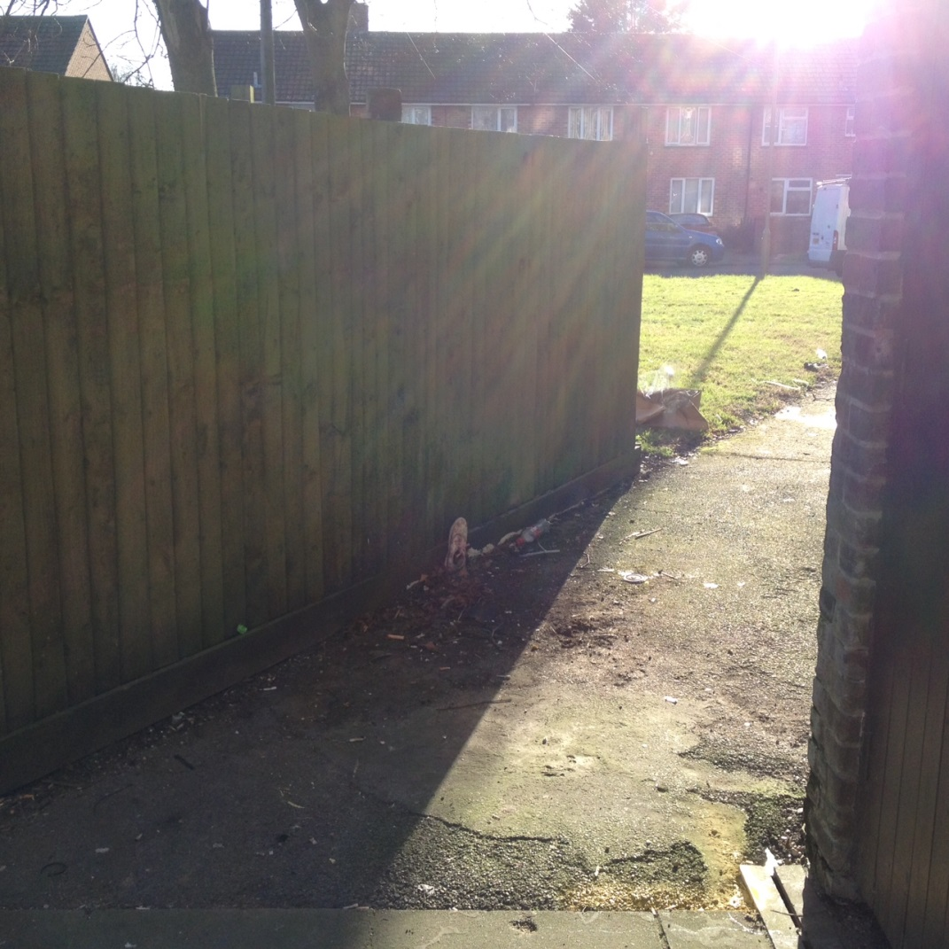
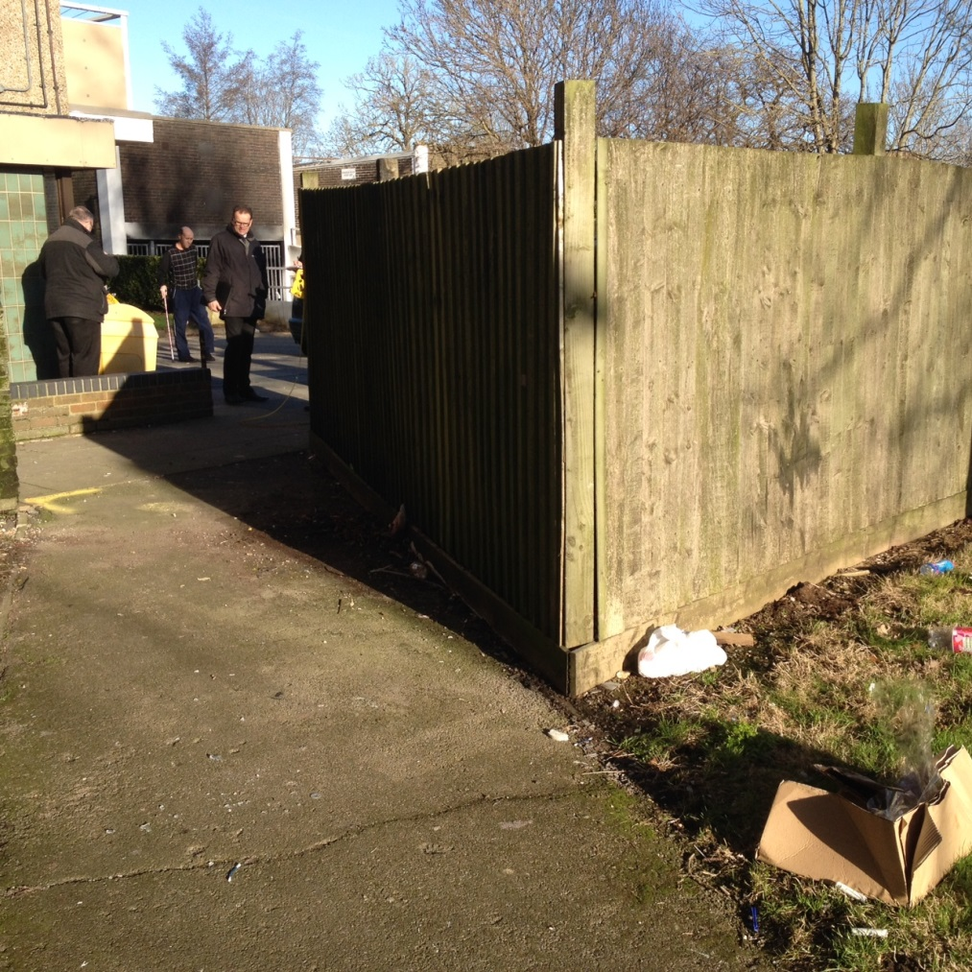

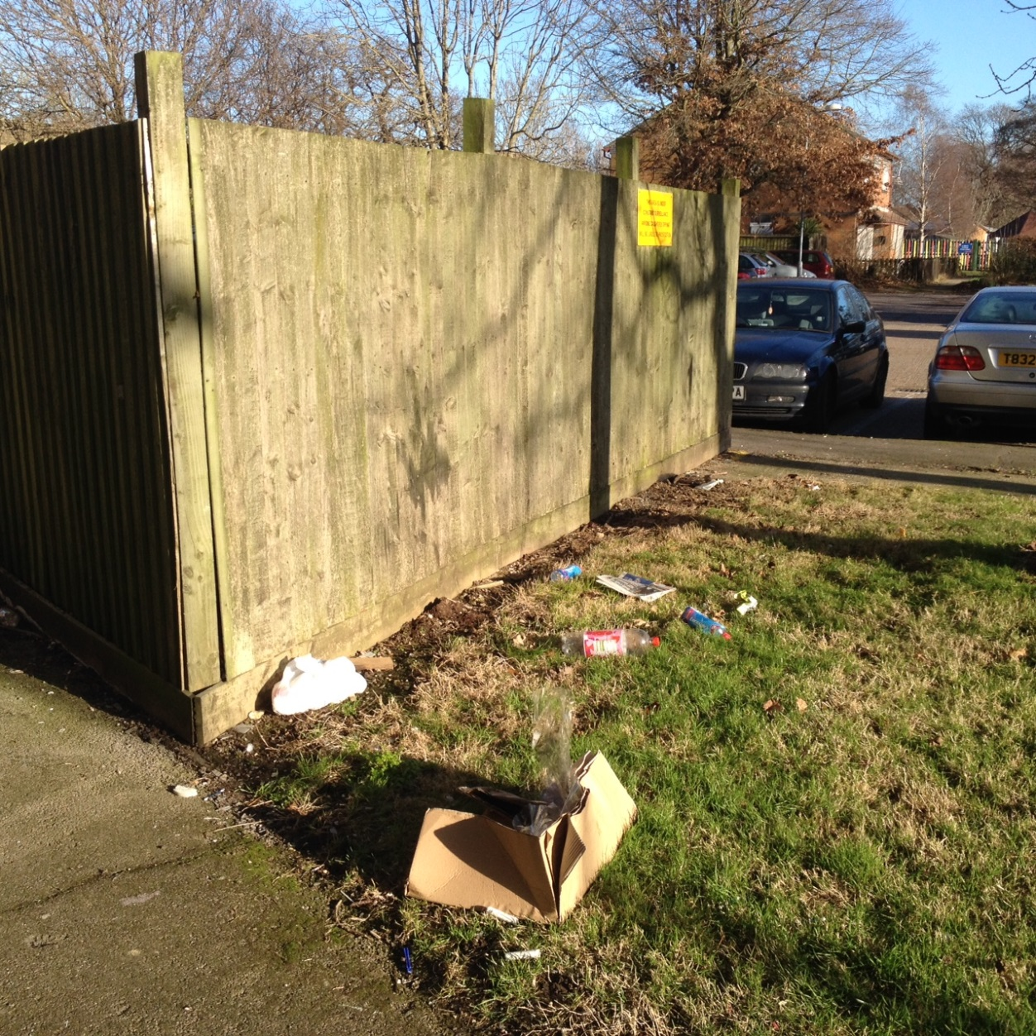
At Chichester House the current triangle design means that 2-3 wheelie bins are left outside the bin area inviting people to fly tip outside of the timber fencing – the new bin stores will adequately store all wheelie bins and in turn we hope will help to reduce fly tipping and bulk waste. TGP are proposing to remove the tree stump in the centre of the bin area at Chichester House and will remove all timber fencing.

Langstone House
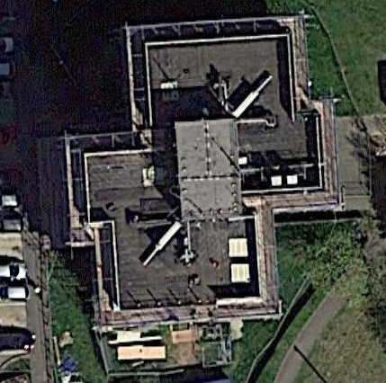

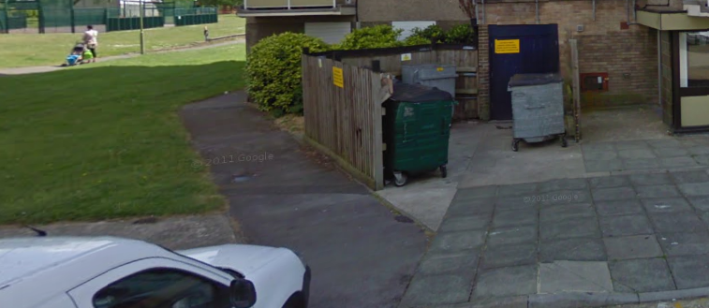

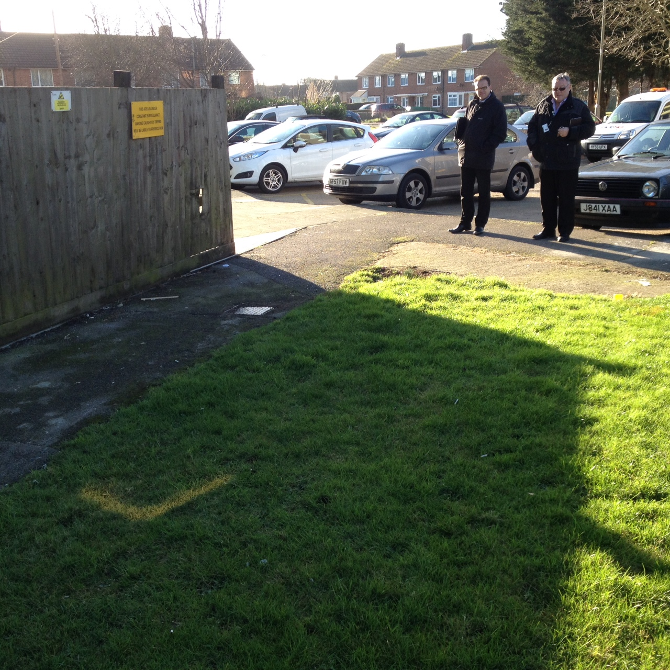
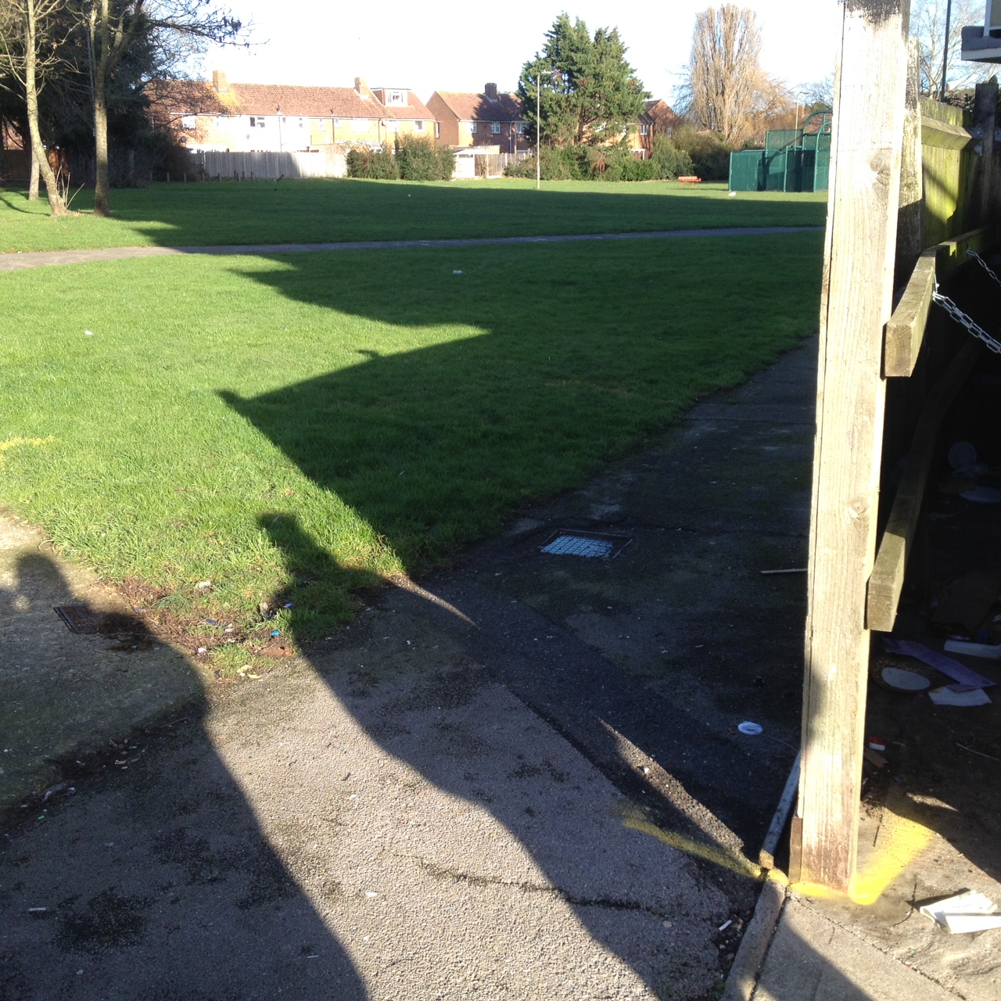
The footpath around the building at Langstone House will need to be redirected around the bin store.

Solent House
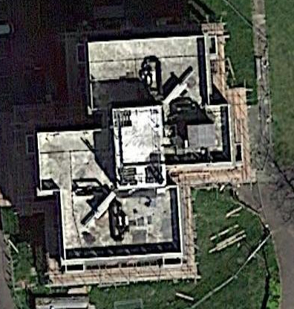

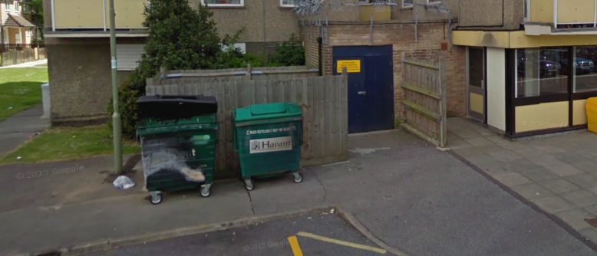

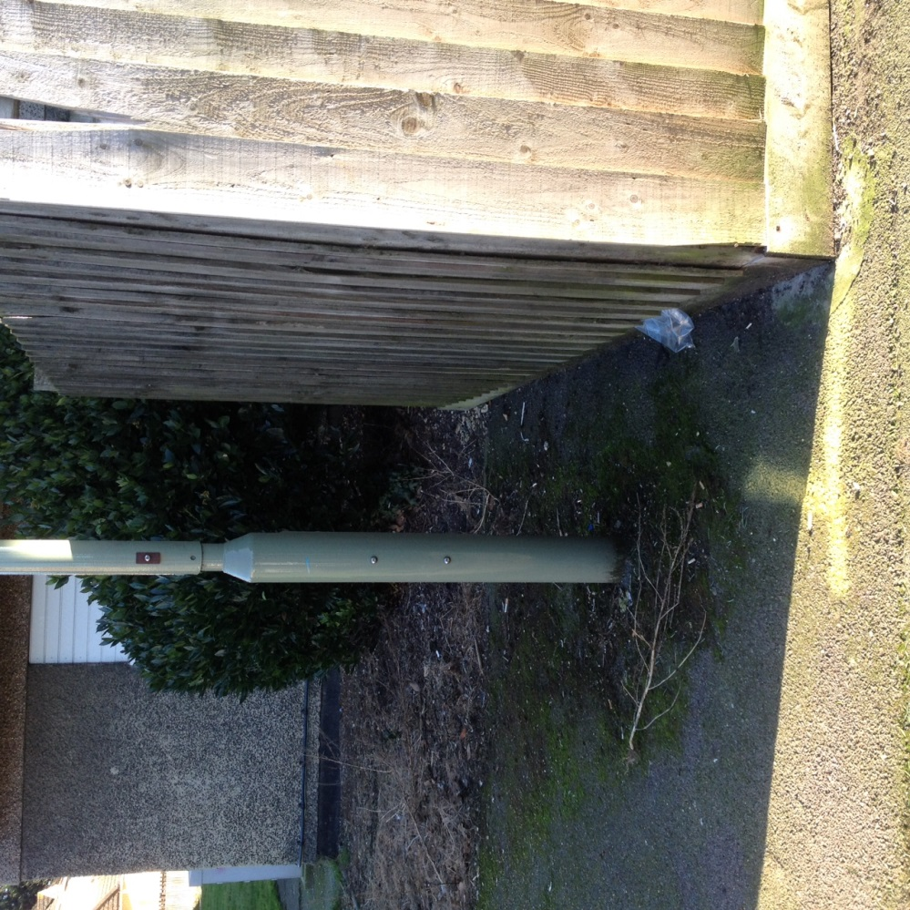
There is a small increase in the footprint at Solent House and there will still be enough room to access the light for servicing etc.

