Construction Environment Management plan

For

Change of Roof Profile and change to external wall treatments doors and windows

At

13 The Kench
Hayling Island PO11 0DF
Application APP/23/00993

Introduction

This CEMP is for a householder refurbishment project within the Kench community owned by the applicant

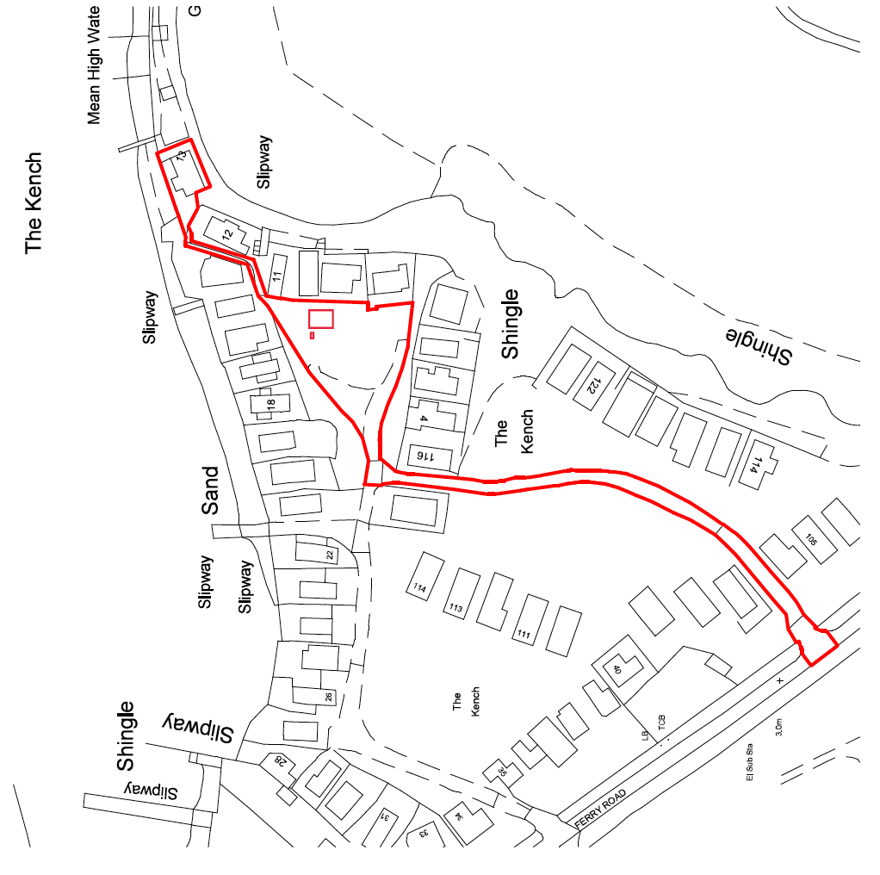
Skip
Compound

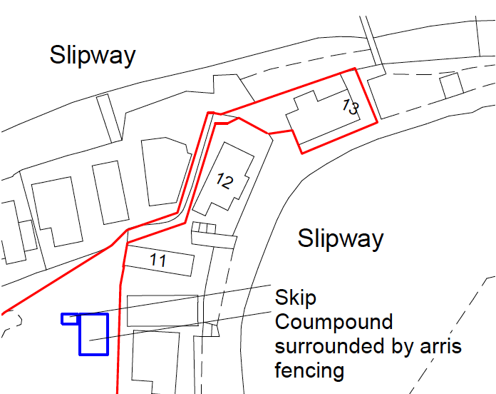

Project description

The project is to refurbish the existing single storey flat roofed building including replacing the roof, windows and external surface treatments

Environmental impacts and management

The build work is expected to take around 8- 12 weeks during that time the following measures will be put in place to address the concerns listed

Use of fences and barriers to protect adjacent land
The extent of the materials compound will be secured with fixed Heras fencing. This will make the area safe secure and avoid possibility of vehicles and residents straying into this area.

Building Safety and security
The building will be safely secured and protected against the weather when operatives are not on site to ensure materials don’t escape and no one or thing enters the construction area

Storage of Materials
Materials will be stored in the indicated secure compound This will allow direct access for deliveries which will be accessible via the existing concrete driveway thus avoiding vehicles gathering mud, generating dust and taking it onto the highway.
It should be noted that this same communal area has been used for the same purpose on previous projects including the recent refurbishment of number 10 the Kench and has been shown to cause minimal disruption and environmental impact.

Movement of Materials
When being moved from the storage area to the construction area materials will be moved by the required number of operatives to undertake the job safely and without the risk of materials being lost or dropped. With larger items a banksman will be provided to ensure the safety of residents.
Any unused materials not stored in the building will be returned to the compound at the end of each working day.

Dust reduction
Particular care will be taken to maintain dust emissions at a practicable minimum when working in this environmentally sensitive area. Best practice mitigation will be followed during dry conditions,
Dust reduction measures will include:
- careful management of materials so they are delivered to site on an as needed basis
- sheeting of all loose materials on site
- ensure all delivery vehicles stay on the concrete driveway as far as is practically possible
- ensure that any area where dust generating machinery is working is dampened in dry conditions
- visual monitoring will be carried out on a daily basis
- No construction will commence on site before a suitable and adequate water supply has been provided & made available for use in the mitigation of construction impacts.
Toilet facilities,
A working toilet within the dwelling will be provided for use by the construction operatives whilst work is in progress.

Management of construction waste on site

A covered (netted) skip will be provided at all times to contain construction waste, this will be replaced whenever full.
Waste will be moved from the construction area to the skip in sealed bags to ensure no loose material escapes.
Waste will not be left un attended on site unless bagged or in the skip.

Noise and vibration
Measures will be employed to control the emission of noise & vibration especially during the construction phase, there will be no piling or use of percussive tools.

Conclusion.
We believe the listed measures will ensure the project has minimal impact on the surrounding land and natural environment.

