Design, Access and materials statement for 192 Sea Front Hayling Island PO119HR

This proposal is for the remodelling of a dated dwelling, The design aims to create a modern design which takes advantage of the sea views and re organises the internal spaces with additions to all larger bedroom sizes and a 2nd floor to take advantage of the sea views.

Materials
The roof will me Alwitra Evalon single ply membrane

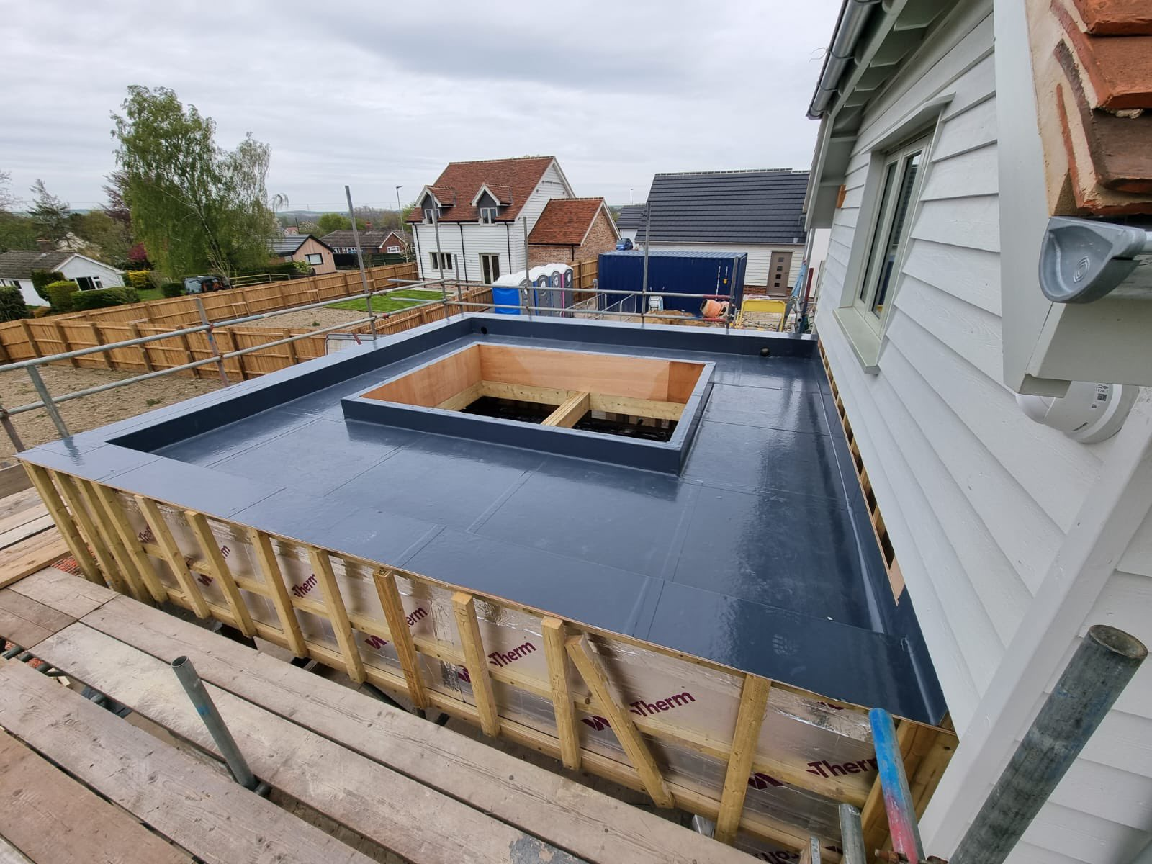

The walls will be in five materials as per the images provided on A113 and A115-7

White K render

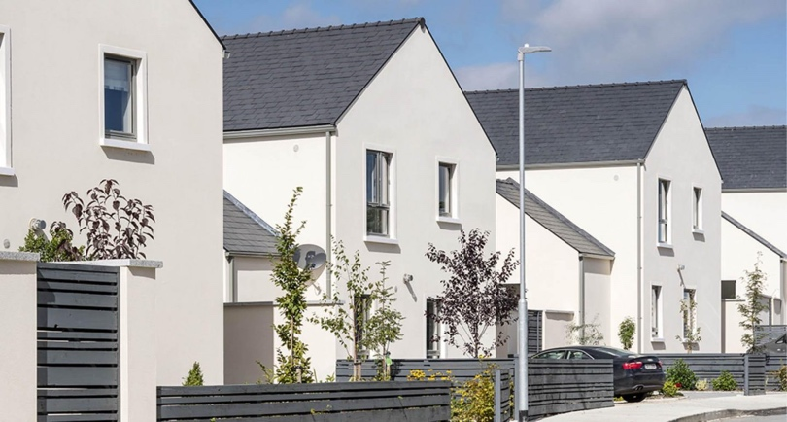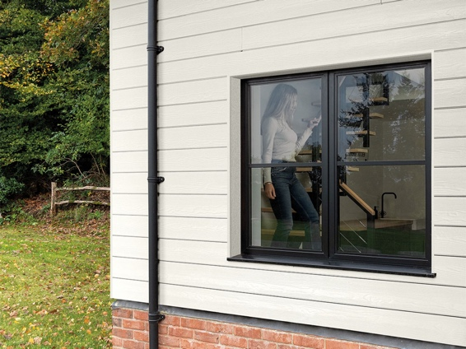

Ecoscape argent grey and spiced oak composite slatted cladding
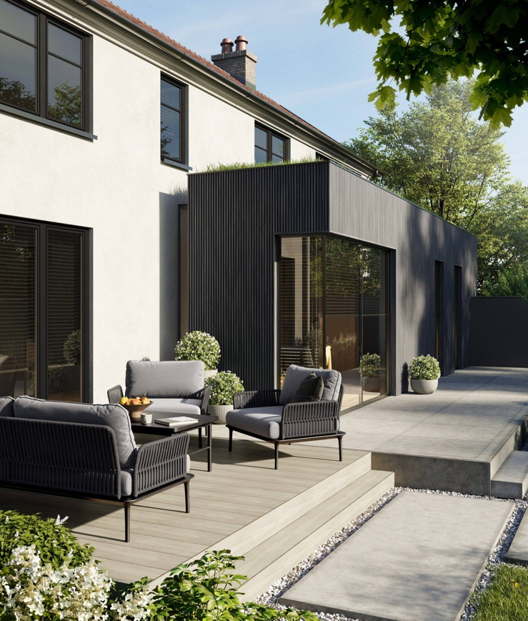

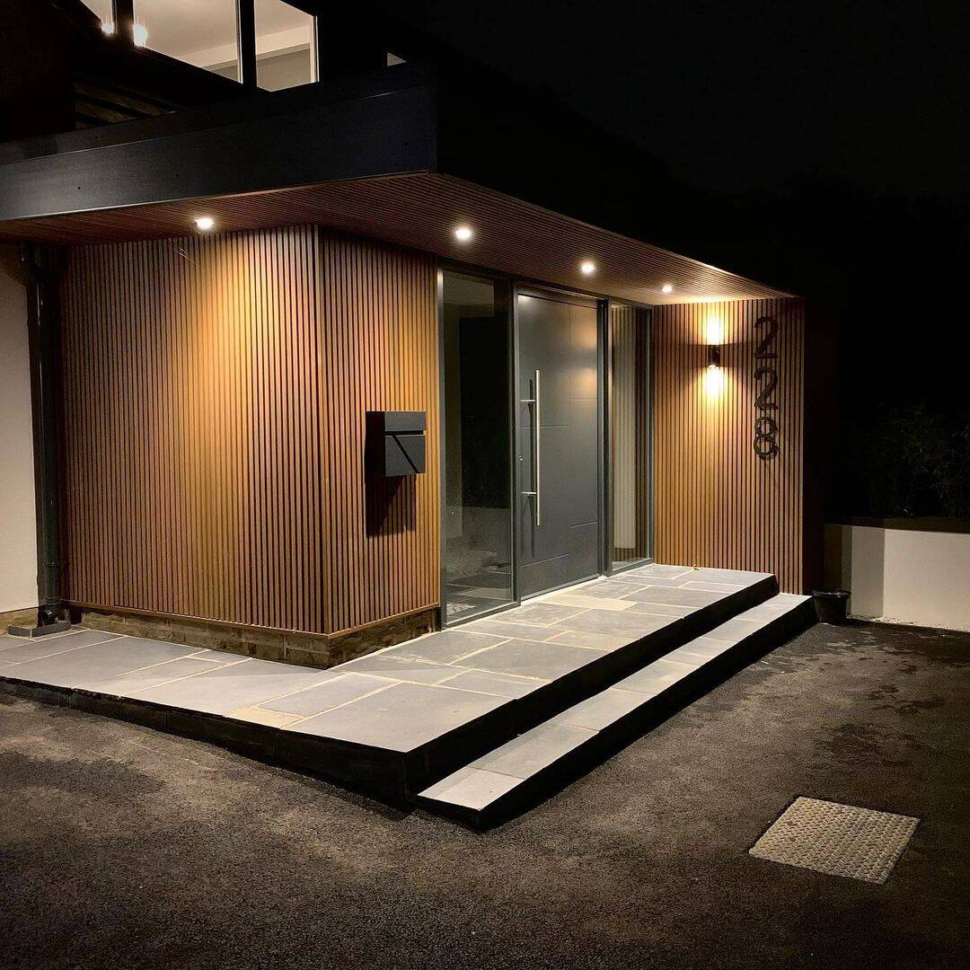

Real stone cladding Knossos Natural stone
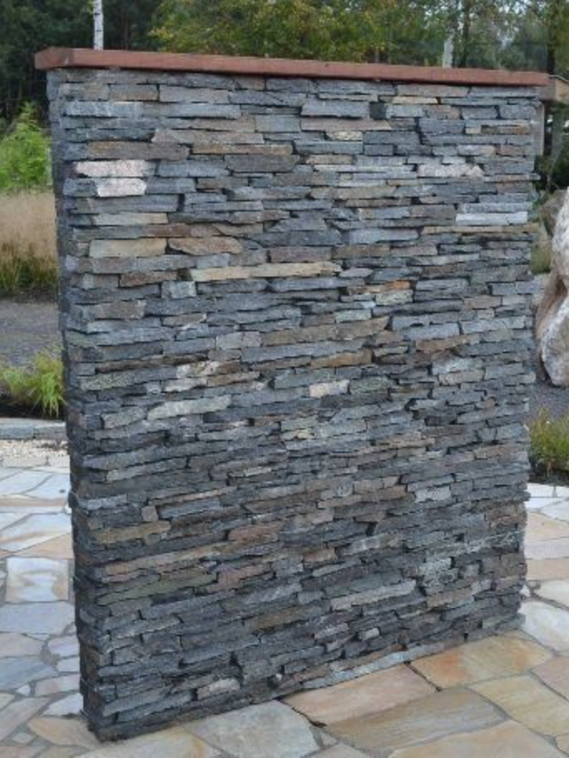

Windows and doors and facias will be dark Anthracite
As per the doors in the picture below
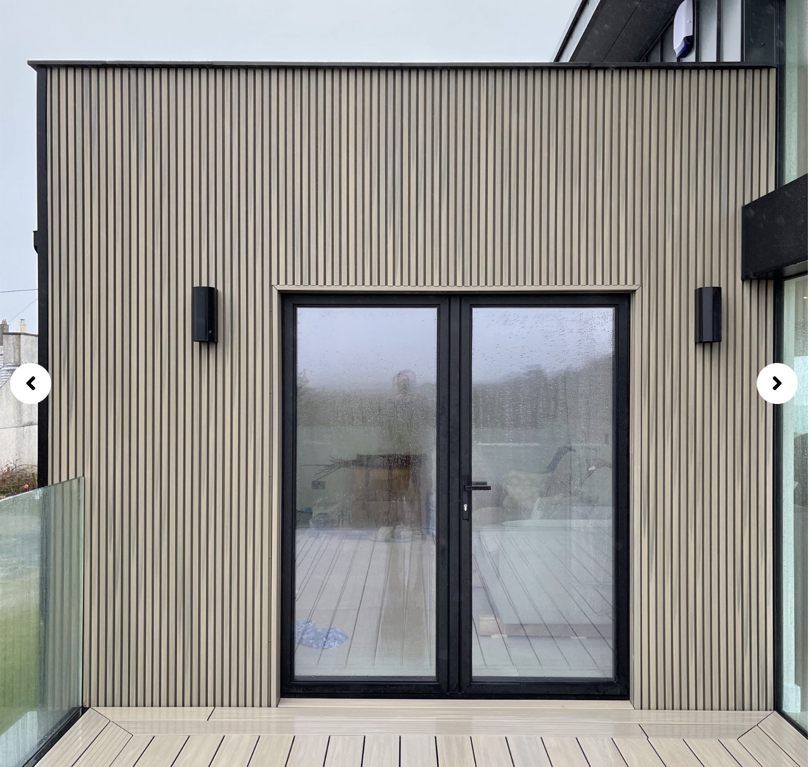

Conclusion
We believe this modern design with clean lines and a modern pallet of materials will be appropriate for the Seafront location and would ask for the councils approval

