Planning Department  Havant Borough Council  Public Service Plaza  Civic Centre Road  Havant  Hampshire  PO9 2AX | Our Ref: | H-237-JP
 | Your Ref: | n/a
 | Email: | justin@southernplanning.co.uk
 | Date: | 28/10/22
 | Status: | Submitted by E-mail

Dear Sir / Madam

Re: Demolition of existing rear extension and erection of replacement single storey rear extension (revised scheme, retrospective) at 26 Manor Close Havant, PO9 1BD

We act on behalf of Ms S Sullivan and have been instructed to prepare a householder planning application in respect of the above development.

The application is submitted via the Planning Portal and is accompanied by the following:

- Site Location Plan, Block Plan, Elevations, Floor Plan, 3d Model (ref: 21.008.SP 02C1), and
- Design, Access and Planning Statement (Incorporating Heritage Statement) – October 2021

This letter comprises the applicant’s Planning Statement Update and should be read alongside the applicant’s originally submitted Design, Access and Planning statement (Incorporating Heritage Statement) from October 2021. A copy of that statement is included with this submission.

Planning Statement Update

This Planning Statement Update will contain a summary of the site location, relevant planning history, a description of planning proposals, a summary of planning policy, a planning justification for the proposals and conclusions.

Site and Location

The property is situated in Manor Close on the eastern edge of Havant Town Centre and within the St Faith’s Conservation Area.

Manor Close is a set piece residential development dating from the 1930’s and ‘40s. The layout of the residential properties is unusual in that the two residential frontages facing each other but are divided by a pedestrian walkway rather than a road. The gardens and the carparking and gardens face outward to the rear. It is understood that the dwellings to the east were constructed prior to the second world war and the dwellings to the west following the second world war (including no. 26).

No. 26 comprises a semi-detached dwelling situated broadly halfway along the Close with its garden and car parking facing the town centre. Immediately to the north of no. 26 are a number of other residential properties on Manor Close with the residential street of Waterloo Road to the north. Fairfield Road to the east comprises a number of residential properties and Fairfield Infant School. To the south is ‘The Pallant’ with East Pallant Car Park beyond. To the west is Prince George Street which backs onto the Town Centre.

No. 26 is semi-detached dwelling of brick construction which features a hipped roof and double bay windows. The front elevation also features a lean-to porch. To the rear and side is a modest ‘wrap around’ extension.

Many of dwellings within Manor Close have been extended and altered over the years. Both numbers 25 and 27 have loft conversions, number 27 includes significant dormer windows to the rear and side. No. 30 has a significant side extension and front dormer window. The extensions. modifications and embellishments to each dwelling form part of the character of the area.

Planning History

Of most relevance to the current planning application is application APP/21/01149 submitted in October 2021. The application sought consent for:

Demolition of existing rear extension and erection of replacement single storey rear extension.

The application proposed a flat roofed rear extension and whilst the design was not considered ‘wholly in keeping with the traditional character of the main property’ it was concluded that it would not be highly visible from the public realm and would have no adverse impact on the Conservation Area.

The approved rear extension had a flat roof with a parapet and a maximum height of 2.8m.

Consent was granted under delegated powers on 01/12/21. The decision notice had three planning conditions, none of which were ‘pre-commencement’ conditions. The consent was lawfully commenced earlier this year (2022).

Details of relevant planning records relating to other sites can be found within the previously submitted Design, Access and Planning Statement (Incorporating Heritage Statement). The statement is included with this submission.

Application Proposals

During the course of constructing the extension the contractor built the parapet roof 35cm taller than the consented scheme. This has resulted in a maximum ridge height of 3.15m instead of 2.8m. In all other respects the scheme built out is identical to that approved. The materials match those of the existing dwelling as required by conditions 3 of the consent.

A photo showing the approved scheme as build can be found overleaf.

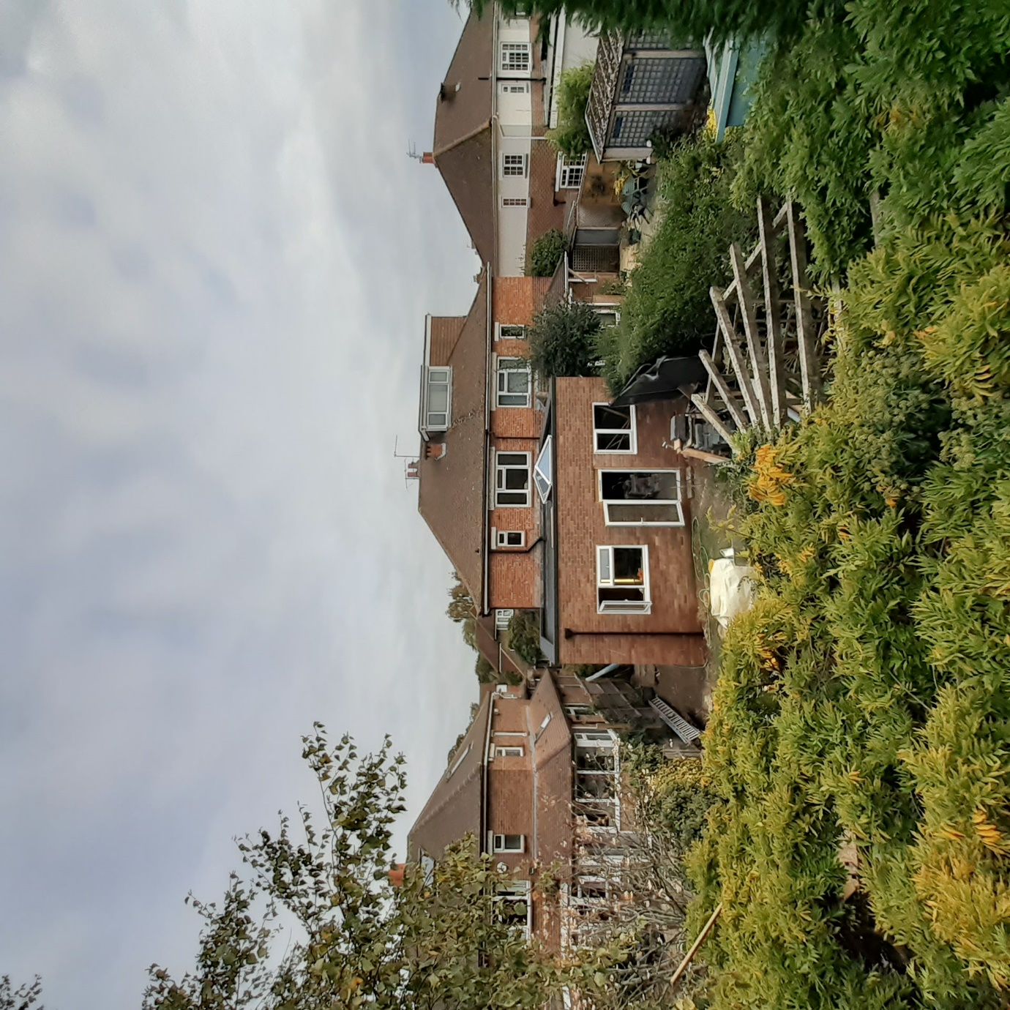
Photo from the rear of the property showing the extension as built

A detailed explanation of the design can be found within the previously submitted Design, Access and Planning Statement (Incorporating Heritage Statement).

Relevant Planning Policy

Section 70 of the Town and Country Planning Act 1990 (as amended) and Section 38 (6) of the Planning and Compulsory Purchase Act 2004 require that planning applications should be determined in accordance with the development plan unless other material considerations indicate otherwise.

There have been no material changes in national or local planning policy since the previous application was determined.

The development Plan for Havant Borough remains:

- Havant Borough Core Strategy (March 2011), and
- Havant Borough Local Plan (Allocations) (July 2014).

Within the Core Strategy of greatest relevance is Policy CS16 (High Quality Design) states that Planning permission will be granted for development that is designed to a high standard, which helps to create places where people want to live, work and relax. CS16 requires all development to:

- Respond to, draw inspiration from and respect local context;
- Produce a positive relationship between buildings, street and spaces both existing and proposed;
- Contributes to the improvement of the public realm, and
- Is inclusive by considering the needs of those with disabilities.

Further details about other relevant policies and details of the St Faith’s Conservation Area Appraisal can be found within the previously submitted Design, Access and Planning Statement (Incorporating Heritage Statement).

Planning Justification

The proposal remains minor in scale. The floor area of the extension is smaller than the ground floor footprint of the house. The scale of the extension therefore remains proportionate. As the extension is entirely ground floor development, it does not give rise to any overlooking.

The extension is only 35cm taller than that approved under consent APP/21/01149. The flat roof structure of the extension as built is lower than the tallest part of the wrap around roof structure on the adjacent extension to the north.

Despite its increase in height, the extension remains difficult to appreciate from the street scene and wider Conservation Area. It is therefore considered that, like before, the proposals will have little or no impact upon the public realm and will not in any way adversely impact upon the special qualities of the Conservation Area or impact upon any other heritage assets.

Conclusions

The changes to the scheme are very minor in nature comprising simply a modest height increase. All other aspects of the scheme are the same. Therefore, the application should be determined in the same way as before and consent granted under delegated powers.

If you have any queries in respect of the submission, please do not hesitate to contact me.

Yours sincerely


Justin Packman, MPlan (Hons) MRTPI
Associate Director

