Addendum To FRA
Former Substation
Nutbourne Road
Hayling Island
Confirmation of Enrolment in Flood Warning Alerts:
We confirm that we will sign up for Flood Warning Alerts, and the property will not be let during times of flood warnings. Additionally, a flood warning and education plan will be readily available on the property at all times.
- Update on the Evacuation Section:
It is noted that an evacuation route cannot pass through a current Flood Zone area. Regrettably, it is not feasible to establish an evacuation route that entirely avoids Flood Zone 2. However, it's essential to highlight that the site benefits from flood defenses, and there will be a 24-hour flood alert system in place. This will afford ample time to evacuate the property. Moreover, the time required to reach a safe area outside the flood zone is less than 10 minutes on foot.
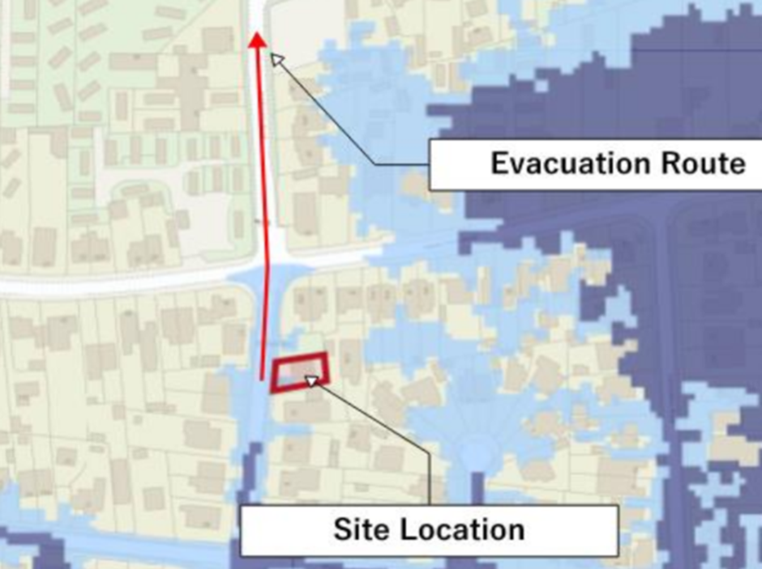
- Completion of Flood Resilience Measures Table:
Please refer to the attached document for the completed table outlining the flood resilience measures to be implemented. Additionally, detailed information on these measures is provided in section 6 of the flood risk assessment report.

Section 6 Extract:

There are not changes to the levels of the building neither major
changes to the fabric of the building.
12 of 19

Flood Risk Management 6
use ceramic, stone or concrete-based tiled surfaces to floors and
skirtings (with cement-based adhesive and water-resistant grout) ideally
draining to a floor sump pump; paint timber skirtings on the reverse
before fitting; avoid concrete screeds above insulation; damp-proof
courses and membranes should be durable (minimum 1200 gauge for
polythene) with laps, and use closed-cell insulation.

6.8 The design water depth for this site is 0.82m. The building should utilise
building materials that are suitable for a ‘water exclusion strategy’.
Materials classified as “Good” (highlighted in red) in the Figure below
shall be used for construction upto the water depth.

Flood Risk Management 6
In areas where new walls are being installed – use closed-cell insulation
below predicted flood level in external walls; specify water-resistant
walling materials such as pressed-face or engineering brick or rendered
blockwork.
In new walls use extended periscope subfloor ventilators or fit
removable airbrick covers; fix plasterboard sheets horizontally rather
than vertically, or split sheets mid-height with a dado rail, to reduce the
extent of replacement; specify lime- or cement-based renovating
plasters or renders rather than gypsum-based, with water-resistant paint
finishes. The use of water-proof, water-resistant or micro-porous surface
coatings on masonry should be avoided as they can inhibit the drying out
of the building fabric.

Services and fittings (communications wiring, hearing systems, electrical
services, water, electricity and gas meters) should be placed at above
the flood level. Where possible, all service entries should be sealed (e.g.
with expanding foam or similar closed cell material). Closed cell
insulation should be used for pipes which are below the predicted flood
levels. Sealed PVC external framed doors should be used. Should
wooden doors be used then a good fit and sealed to the frames must be
obtained. Hollow core timber internal doors should not be used unless
sufficient flood warning is given, butt hinges, can be used to allow
internal doors to be easily removed and stored.

Fittings should be designed to be replaced after a flood, it is advisable to
specify durable fittings that are not appreciably affected by water and
can be easily cleaned (e.g. use of plastic materials or stainless steel). The
cost of these units may need to be balanced against the predicted
frequency of flooding. Avoid wood fibre based carcases and use easily
removable solid wood drawers.

