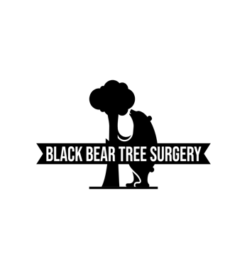
7th October 2024

Tree Survey
The Granary
Wade Lane
Havant
PO9 2TB

All trees are located within a conservation area as well as being in a TPO group. A visual inspection has been carried out from the ground and work has been recommended for the safety of the public and the longevity of the trees.
Permission must be granted by Havant Borough Council prior to any work being carried out.

The site map showing the locations of the trees on the survey is on page 3.

Trees bordering Wade Lane
T0165 Horse Chestnut – Seems to be in good health. Recommended work is to reduce the Eastern sector of the canopy by 2-3m. This is to alleviate weight to r5educe the risk of limbs failing in the future.
T0166 Beech – Seems to be in good health. The tree has grown tall, without much canopy, due to competition from neighbouring trees. Recommended work would be to reduce the canopy by 2-3m in height.
T0167 Sycamore – Seems to be in good health. The very top of the canopy seems to have died. The eastern sector has grown out over the road with long laterals which is normal for a sycamore, especially when growing in close proximity to other trees. Recommended work is to remove deadwood, carry out arial inspection and reduce the eastern sector by 3-4m. This will reduce the risk of limbs failing.
T0168 Horse Chestnut – Mature tree in good health. Recommended work is to reduce the eastern sector by 2-3m. this is to alleviate weight over the road to reduce the risk of any limbs failing.
T0169 Horse Chestnut – Seems to be in good health. Has been very heavily reduced around 3 years ago. No work recommended.
T0170 Sycamore – Healthy. Minor deadwood in lower canopy. Recommended to remove deadwood over road.
T0171 Pine – Healthy. No work recommended.

Other trees in garden
T0172 Lime – Healthy, mature tree. Very tall. If a canopy reduction is desired, a 3-4m reduction is recommended.
T0173 Horse Chestnut – Seems to be in good health. Minor cavity on base of main stem. No work recommended.
T0174 Beech – Healthy. No work recommended
T0175 Horse Chestnut – Healthy. No work recommended
T0176 Yew – Healthy. Large mature tree with large canopy. If a canopy reduction is desired, then a reduction of 3-5m Is recommended.
T0177 Beech – Healthy. No work recommended.
T0178 Sycamore – Dying/diseased. Very little leaf coverage in canopy. Bark peeling off at points. Recommended to remove to ground level as soon as possible after receiving permission from the council.
T0179 Sycamore- Healthy. Top has broken out at some point in the past. If a canopy reduction is desired, then a canopy reduction of 2-3m is recommended
T0180 Sycamore – Healthy. Minor deadwood in canopy. Recommended work is to remove deadwood.
T0181 Beech – Healthy. No work recommended.

Trees are living organisms and therefore are constantly changing and unpredictable. This document is the opinion of an arborist and does not guarantee that the trees are 100% safe.

Ivan Shaw
29 Littlecote
Petworth
GU29 9PQ

07521733871
www.blackbeartreesurgery.com
blackbeartreesurgery@outlook.com

