Design and Access Statement.
Park Lane Service Station, Bedhampton, Havant, PO9 3HQ
CProject
44 Fox Dene, Godalming Surrey. GU7 1YQ
Issued 26th February, 2024
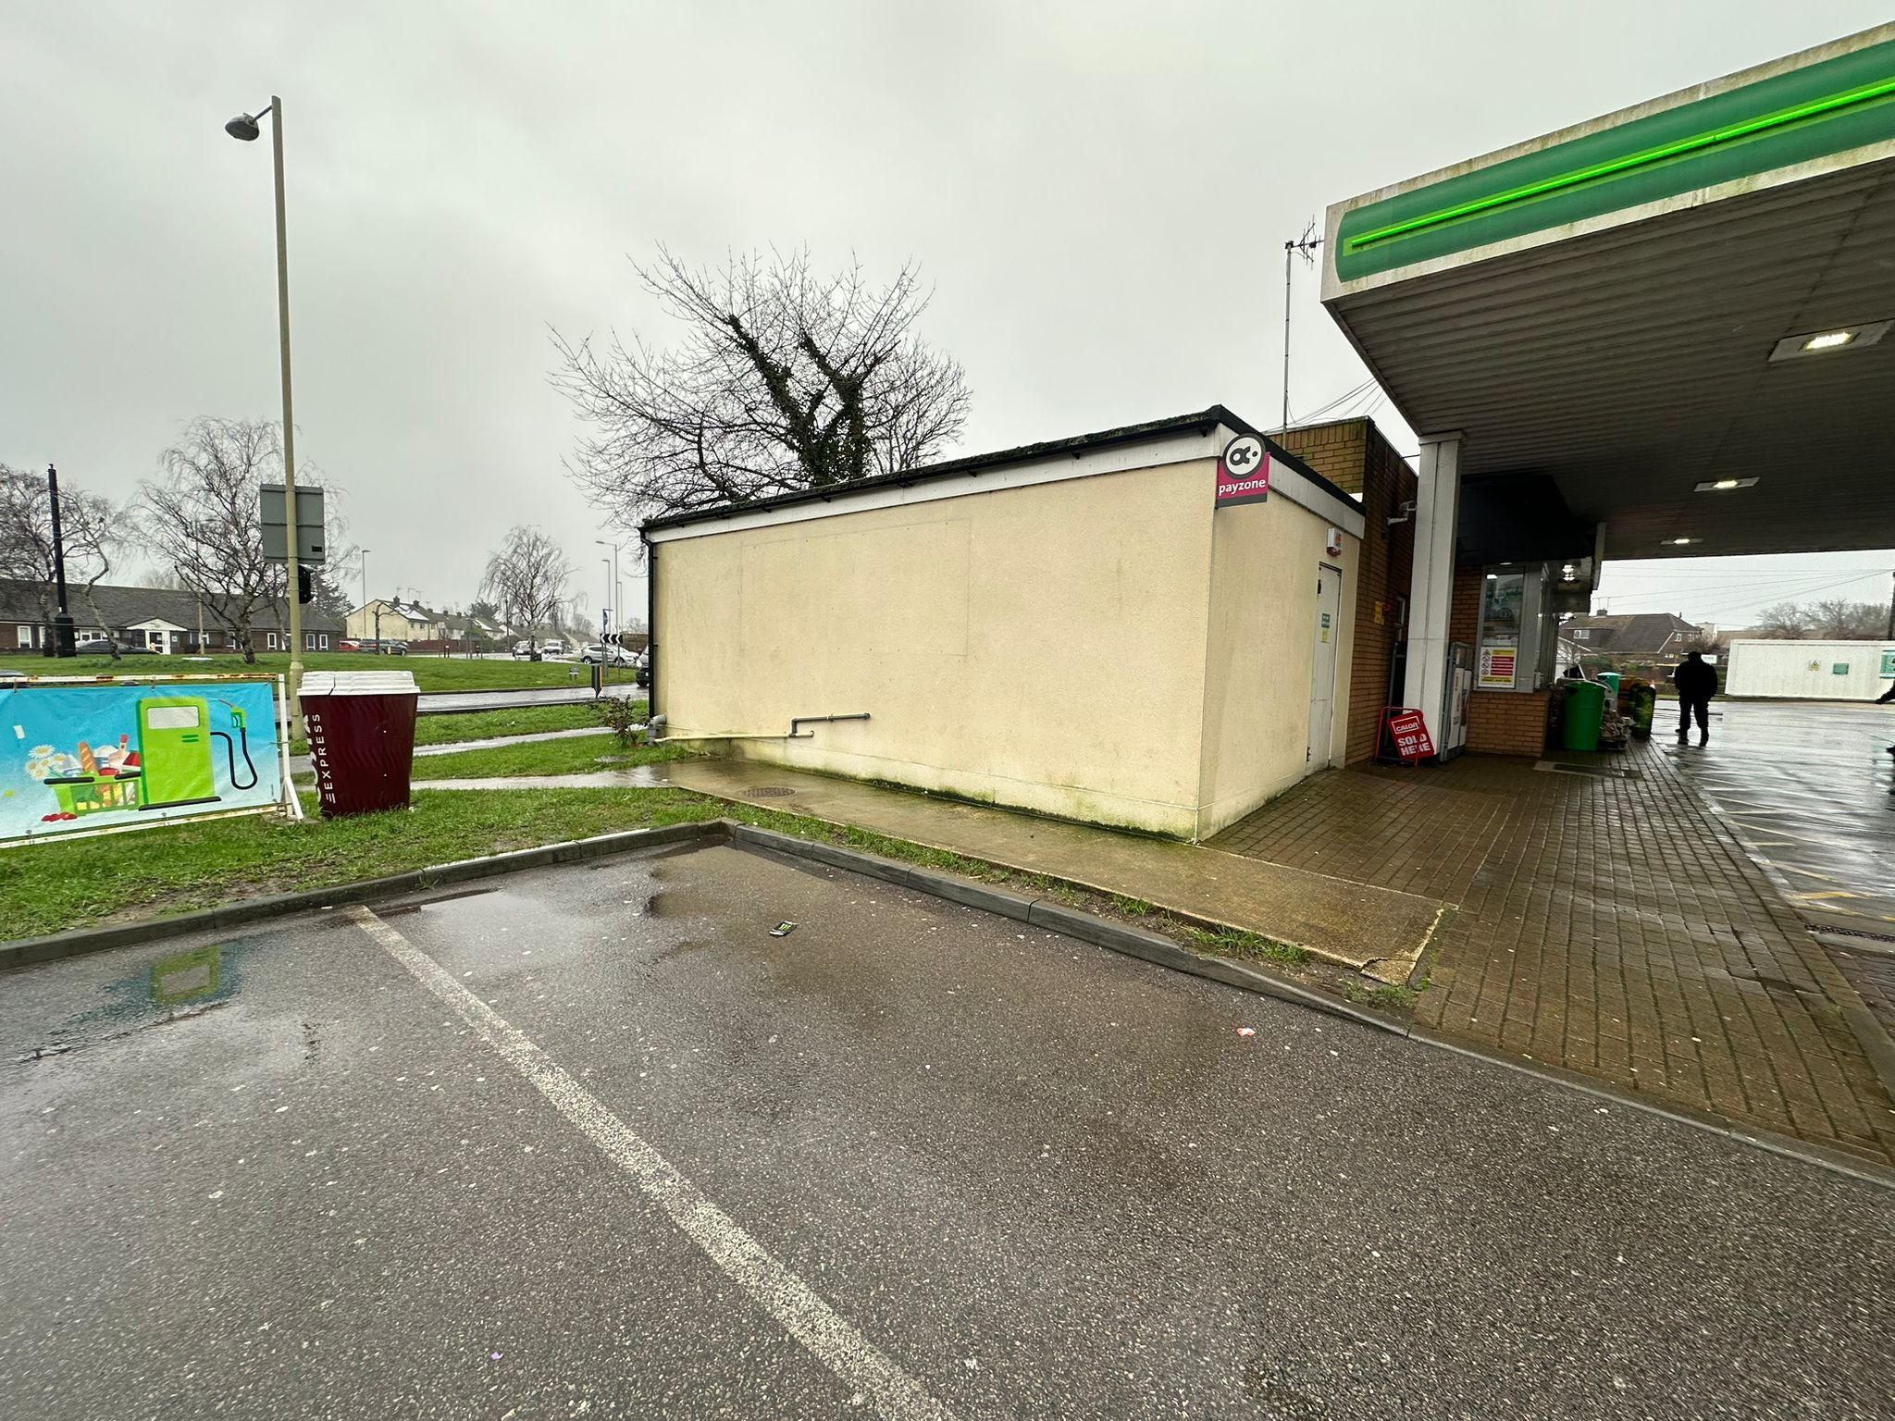
Design and Access Statement for the installation of 2No. Jet wash bays, and minor carparking changes.
HISTORY:
There has been a service station together with shop on this site for many years.
There are many applications relating to the site, dating back to 1990, including new petrol station in 1998, the most recent being as follows:
The present forecourt building was extended in 2015, planning reference APP/15/00067 which included the revised parking arrangements which at that time were not implemented.
In 2021 permission was granted for 'Sui Generis' (A5) use, Reference APP/20/01213
EXISTING USE:
The layout of the existing forecourt building is shown on drawing 1413/025 and 026, petrol filling station with Car and Jet Wash facility with retail shop and hot food facility.
THE FUTURE:
This application is for the addition of 2 No. Enclosed Jetwash bays. It is intended to continue to use the existing car jet wash facilities as condition 3 of the above approval, 0700 to 1900 hours.
DESIGN COMPONENT:
The external appearance of the service station will not change, the new jet wash bays will impact the site to the north of the shop building as shown on the drawings. The design of the units is a standard prefabricated type with a modern appearance.
APPRAISING THE CONTEXT:
The context of the site will not change in relating to the building in the local surroundings.
THE ACCESS COMPONENT:
The access component will not change
ADVERTISING:
Any changes to the present Advertising consent will form a separate application.

VALIDATION REQUIREMENTS
Biodiversity Assessment - Not required for this application as property does not meet any of the criteria discussed in the guidelines issued by the local Authority.

Environmental Statement – not required for this application.

Flood risk assessment – Not required, as within Flood zone 1 as defined on the flood zone mapping for the area, attached.

Foul sewerage, surface water drainage & utilities assessment – The site is an existing facility with only minor changes to the site drainage, any waste water will be treated via appropriate separators before any discharge into the existing system.

Heritage Statement - This application has no heritage implications.

Land contamination - The site is an existing petrol service station with all aspects of land contamination having been previously dealt with.

Landscaping - Landscaping is not applicable to this application, Glass screening will be added to cater with any over spill of sprayed water.

Lighting Assessment - not applicable to this application, the site is already approved for 24 hr operation, with limiting hours for the car wash as above, 0700 to 1900 hours daily.

Noise Assessment - not applicable to this site as the new facility is next to the highway with significant background noise greater than the jet wash processes.. However, a noise assessment will be undertaken and submitted under separate cover.

Parking Provision – It is intended to establish parking bays which were approved in approval ref APP/15/00067

Planning Obligations - Not applicable to this site as proposals are all within the existing Service station forecourt.

Issued 23/02/2024

