Construction Environmental Management Plan (CEMP) -

Planning Reference: APP/24/610

Site: 66 Bath Road, Emsworth, PO10 7ES

Project Overview
On 9th April the sea breached Emsworth promenade which was entirely covered by the sea to an approximate depth of 0.35 metres. The water level at this time was within 0.075 metres / 75mm / 3 inches of the top of the flood wall surrounding Swan House. If it had breached this flood wall the house would have flooded to a depth of 0.65 metres or over 2 feet.
This application is to raise the height of the existing flood wall by 330mm via a mixture of glass and rendered blockwork to match the existing flood wall.
The work is expected to take approximately 4 weeks to complete.
The work involves adding 3 courses of concrete blocks along 14 metres at the North end of the property and then rendering the outside and inside of the face of these blocks. The work also involves adding 63 metres of aluminium channel supporting flood glass. The additions will add a total of 330mm to the existing height of the flood wall.

Site location
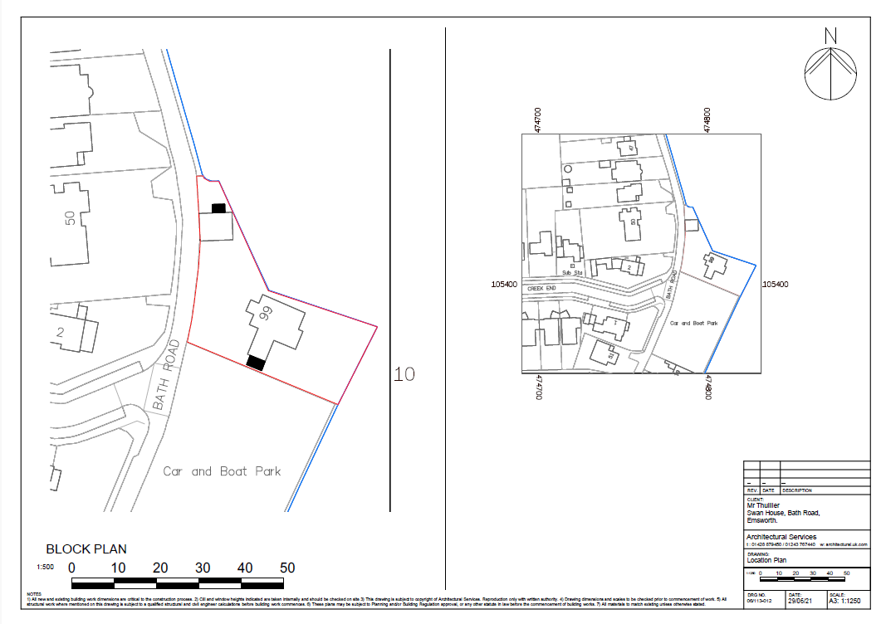

Regulatory Framework
The proposals to raise the existing flood wall to mitigate against future tidal flood risk are in
alignment with the recommendations set out in the overarching North Solent Shoreline
Management Plan to 'Hold the Line' (maintain or upgrade the existing standard of protection provided by defences) for this frontage.

Legislative and Policy Context
When assessing the proposal, the following legislation and policy context is taken in consideration.
- Section 72 of the Planning (Listed Buildings and Conservation Areas) Act 1990 requires planning authorities, when considering whether to grant planning permission for development which affects a Conservation Area, to have special regard to the desirability of preserving or enhancing the character and appearance of that area.
• NPPF (December 2023) – Chapter 16
• Local Plan Policies: CS11, CS16, DM20
• Emsworth Neighbourhood Plan

The Emsworth Neighbourhood Plan has now been adopted and has relevant policies which are applicable to this application:

- Policy H1 – Design and Heritage
- Policy H2 – Locally Listed Buildings

Roles and Responsibilities
One Company would be responsible for fitting the aluminium channel and supports on top of the existing flood wall. A second Company would be responsible for all blockwork and rendering.
Each Company would be fully aware through briefing of the environmental concerns on this site. It is understood that the works are immediately adjacent to areas of ecological importance and it is essential that construction works avoid/minimise potential impacts.

Construction Methodology
There is no site preparation or security required for this site. It is fully enclosed on all sides.
The property is accessed off Bath Road. Bath Road will remain accessible to vehicles and pedestrians
at all times. All materials will be stored on site at all times.

The works to the existing retaining wall to the Mill Pond will not require any heavy plant or any
machinery for the construction, nor will any heavy plant or any machinery enter the Mill Pond. All the work will be done by hand. The only machinery required is a concrete mixer to enable a total of c 240 concrete blocks to be laid. Glass panels will be inserted into the aluminium supports by hand using suction devices.

There will be no excavation on this site as there are no foundations required. All building is on top of what exists already.
The construction of the wall is using dense concrete blocks 440mm * 215mm * 100mm which is how the existing wall is built. These blocks are laid flat and bedded on 10mm concrete having first removed the existing coping stone. After all three course are complete the coping stone is replaced on top. The exposed faces of the concrete blocks are then rendered in concrete.
Any materials which are residual to this process will be carefully removed from site with specific regard to locations next to the willow tree and also next to the Millpond. Note that there is a wide ledge on the outside of the existing wall which will prevent any materials from falling into the Millpond.

Environmental Management Measures
There is a Weeping Willow to the North East of the site. A detailed survey has been undertaken by
Encompass Surveys that has established the exact location of this tree. The Willow at its closest to
the boundary is 2.7m. The wall repair around the tree will not be taken below ground level,
therefore the roots will not be damaged.
It is understood that the works are immediately adjacent to areas of ecological importance and it is essential that construction works avoid/minimise potential impacts. There are two potential risks;
- Damage to tree roots
No work will be carried out near or on the roots of any tree including the Willow tree, and no materials will be stored on or near the roots of any tree including the willow tree

- Spill of materials into the Millpond during construction
There is a wide ledge on the outside of the existing wall which will prevent any materials from falling into the Millpond.

There are no specific measures that need to be taken to mitigate potential environmental impacts due to noise or vibration. Drilling for fixings will be inside the centre of the existing wall.
Working Hours will be limited to between 08:00 and 16:30 Monday to Friday
Any cutting that is required of concrete blocks will be on the existing gravel drive, a good distance from any tree. It is considered that cutting will be minimal.

Dust Management
Water will be used to suppress dust in the event that a number of concrete blocks need to be cut.
All work with the aluminium channel and glass will be carried out off site other than fitting it onto the existing wall
Materials such as sand and concrete will be covered what not being used

Waste Management
All waste will be carefully segregated and disposed of noting the need to recycle materials wherever possible.

Soil and water protection
It is not considered that any erosion of soil will take place and therefore no sediment control measures are necessary
No liquids other than water will be used on site, so spills do not need to be considered

Monitoring and Reporting
Regular site inspections will be made by the project manager to ensure that all points detailed above will be adhered to.
In addition Environmental performance will also be monitored with particular reference to ensuring no material whatsoever finds its way into the Millpond.
Any incidents will be reported and investigated in a timely manner.

Review and update
The CEMP will be reviewed and updated on a weekly basis to ensure its effectiveness.

