West Hayling Local Nature Reserve Seabird Habitat Restoration CEMP
1.0: Introduction to the site and restoration Project
The purpose of this project is to carry out partial restoration of an important breeding and roosting site for designated coastal bird species as outlined in the shadow HRA.
At the heart of the West Hayling local nature reserve are two lagoon islands formed from rubble topped with marine shingle. Since the site became a Local nature Reserve in the late 1990’s, these islands have become an important breeding seabird site and roosting wader site, and support a significant part of the Solent breeding population for Black-headed Gulls and Common Terns. The site has become increasingly degraded since the last shingle top up in 2008, and the habitat is in dire need of restorative work in order to maintain its function. The RSPB have a management agreement covering the site and have secured external funds to carry out a shingle top of the islands here.
An opportunity exist immediately (Nov 2024-Feb 2025) to carry out these works whilst the adjacent Billy Trail access route is closed for upgrading works, carrying out both sets of work at the same time for maximum public and environmental benefit.
This is an opportunity to assist the West Hayling LNR on its journey back into a thriving nature reserve, slightly raising and recapping the key shingle islands within the lagoon. By strategic placement of different grades of shingle, as well as providing for the development of vegetated shingle in certain locations, the project aims to be able to initiate a better outcome for the wildlife using the site and partially address the present annual threat of total or near-total colony failure due to tidal flooding. Due to the access challenges, we will use up to 400 tonnes of shingle, only 17% of the originally permitted amount, in more targeted placement.
1.1: Planning Reference Number:
APP/22/00850
1.2: Site Address:
West Hayling Local Nature Reserve,
Off Victoria Road,
Hayling Island,
Hampshire,
PO11 0LG
1.3: Site Description:
The West Hayling Local nature reserve is a designated Local Nature Reserve on Hayling Island within Havant Borough. Road Access is via the A3023, with site management access then utilising the Hayling Billy Trail which runs adjacent to the reserve. The reserve is a mix of open coast, lagoons and scrub. Works will be limited to access along the Billy Trail and placement of shingle on the lagoon islands for shorebird/seabird habitat restoration.
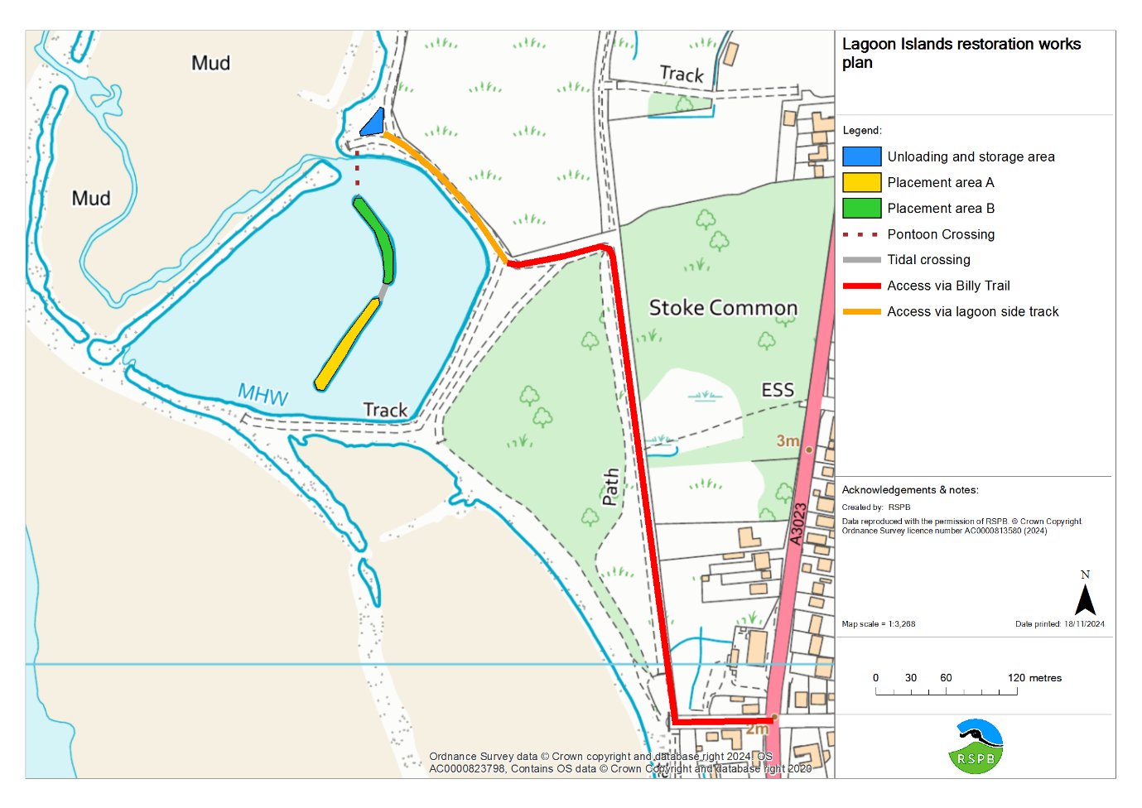
2:0 Site Management
2.1: Site Personal
Delivery of the shingle restoration project will be carried out by 3 Counties Civil Engineering. Risk Assessments and method statements, outlining personnel with site supervisory roles, is included separately as supporting information.
2.2: Development site layout and welfare arrangements.
A site layout plan is included above. Welfare arrangements already in place for the Billy Trail upgrade work being delivered by the same contractor will be utilised with no added impact. Parking will likewise be shared at the available parking spaces and in the closed area of track.
As the access route is currently closed to the public for the delivery of the Billy trail upgrade work, and this CEMP is for carrying out works within the same period, no further closure on the Billy Trail will be needed.
2.3 Managing materials, site storage, and good housekeeping.
400 tonnes (or less) of shingle delivered via road from the A3023, accessing via the carpark adjacent to Victoria Road, travelling along the Billy Trail within the existing closed area, until it reached the access spur to the West Hayling LNR, then unloaded and heaped into a stockpile surrounded with Heras fencing to prevent any ongoing Health and Safety issues. The Heras fencing will remain around the stockpile until the shingle is placed onto the islands.
Approximately 20-30 loads of shingle are expected in total, spread out over 2-3 days, with the delivery of materials within the following hours:
Monday to Friday: 08.00 - 18.00 and Saturday: 08:00 - 13.00.
3:0 Site Operations.
3.1: Planned start date:
The available opportunity to carry out the habitat restoration coinciding with the Billy Trail upgrade requires that shingle delivery takes place in Novemenr. This will then be followed by placement of the shingle on the lagoon islands in Jan-Feb 2025 as per the planning permission and existing consents.
3.2: Working hours:
The working hours on site, including the transport of materials, plant, and equipment for the shingle restoration will only take place during the following hours;
• 08:00 to 18:00 on Monday to Friday
• 08:00 to 13:00 on Saturdays
3.3: Method
Delivery and placement of the shingle will take place in a phased approach as described within the 3 Counties Civil Engineering Method Statement and briefly below.
After the establishment of an exclusion area to allow works, a temporary modular pontoon bridge will be installed, linking the storage location to the nearest island. Once secure, and with bog mats placed to safely distribute weight, a small excavator will cross to the islands and place any further bog mats as needed. A second excavator at the shingle stockpile will then load shingle into a small, 3 tonne tracked dumper, which will travel over the bridge to the needed placement area and deposit the shingle, to be spread as needed by the first excavator. This method will then repeated until all shingle is placed. Once complete, the machinery will be removed from the island, the bridge safely dismantled, and the loading area restored. Plant and equipment will then be removed from site via the same route.
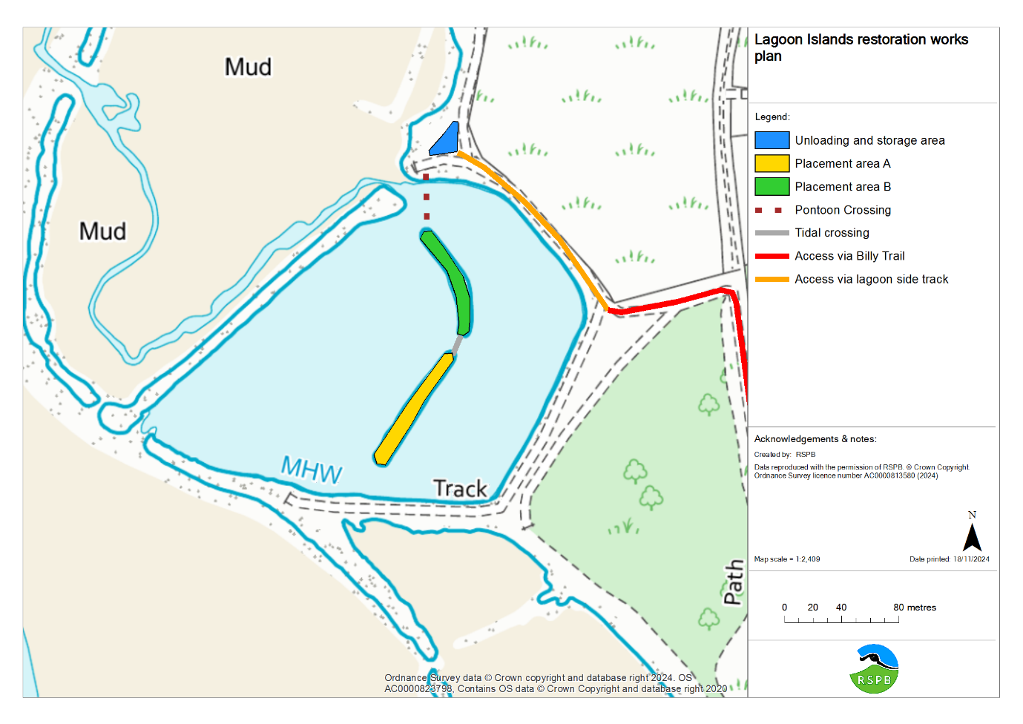
4:0 Environment
The methodology being used has been designed on the principles set out in the shadow HRA in order to minimise any impact during the habitat restoration delivery. By timing delivery with the existing works on the Hayling Billy trail by the same contractor, and by utilising a pontoon bridge and bog matting, the impact during delivery of the works will be minimal, whilst the habitat outcome for the designated species using the site should be significant and allow space for population recovery.
Section 5 of the Shadow HRA report by Exo Environmental identifies the ecological receptors (table 9.1. in section 9 Appendices). The HRA outlines how the works can be undertaken to avoid harm under the screening section and conclusions. The recommendations of the HRA have been reflected in the planning permission and MMO licence conditions and implemented via the method statement. The submitted method statement and CEMP summary table attached at appendix 1 (page 5-6) provides the Construction Environmental Management Plan for these works as required.
4.1:
Further considerations and detail on elements including refuelling, working over water, and working within a site of significant environmental status are detailed within the site Risk Assessments attached separately.
5.0 Supporting information.
Attached are the following supporting documents:
- Method Statement for the placement of shingle on the islands.
- Environmental Risk Assessment
- Working Over/Adjacent to Water Risk Assessment

Appendix 1: CEMP Summary table of potential impacts on receptors and planned avoidance.
OPERATION/ ACTIVITY | RISK EFFECT POSSIBLE ENVIRONMENTAL IMPACTS | MITIGATION MEASURES AND MONITORING DURING WORKS. | RISK RATING/ LEVEL 1=low 3=high | IS PROTECTION OF ECOLOGICAL RECEPTORS ENSURED? | PLANNING AND MMO CONDITIONS MET?
All activities on the lagoon islands to carry out placement of shingle. | Disturbance of breeding seabirds and shorebirds. | Courtship by the designated seabirds and shorebirds using the site begins in March. Works will therefore be undertaken in January/February before the sites designated birds start to carry out courtship. Wintering birds will be present within the SPA, but as the lagoon islands themselves are only used for roosting during extreme spring tides, and no work activity will be undertaken during such conditions for safety reasons, no disturance to bird roosts will take place. | 1 | Yes. To protect identified ecological receptors Ramsar/SPA birds listed in 9.1 of Shadow HRA. | Yes. Condition 7, Condition 8, Condition 9, AP/22/00850/FUL. Condition 5.2.2. L/2022/00422
Import of shingle to site, including compliance with checking materials meet clean materials conditions. | Introduction of invasive non-native species. | The potential for contamination of non-native marine species is extremely low as the material is taken from the same coastal cell and local area, therefore other contaminants are extremely unlikely to be present. When the shingle is removed it is sat out to dry out before use. As per the advice in the Marine Biological Association marine non-native species guide 2020 all personnel on site will be following the clean, check, dry process. | 1 | To protect ecological receptors 1140 mudflats and the Ramsar/SPA birds listed in 9.1. of Shadow HRA. This is low risk due marine shingle being taken from the same coastal cell and clean, check dry process followed as per MBA guidelines | Yes. Condition 7 and Condition 8. AP/22/00850/FUL. Condition 5.2.1, L/2022/00422.
Access across the foreshore and lagoon. | Damage to soft sediment areas by compression or widespread access. | Vehicle access on the foreshore will be confined to a single route on and off from the stockpile location to the lagoon islands. A modular pontoon bridge will be installed in order to avoid contact of equipment or material with the lagoon bed. Bog matting will be placed to cover any soft sediment, and the existing rubble and imported shingle will be utilised to form a ramp onto the pontoon as needed. Any changes will be localised and temporary. | 1 | To protect ecological receptors 1140 mudflats and the Ramsar/SPA birds listed in 9.1. of Shadow HRA. The modular pontoon, bog matting, and use of the rubble already present should mitigate any negative impacts identified. | Yes. Condition 7, condition 8, Condition 10 AP/22/00850/FUL Condition 5.2.3. Condition 5.2.6. Condition 5.2.8. L/2022/00422
Material and equipment transport to and from site. | Potential negative impact on terrestrial site, the Hayling Billy Trail and site users. | Works will be undertaken by the contractor delivering the Hayling Billy Trail upgrade, utilising the existing parking, welfare and other facilities. The route of entry is via the closed area for the Hayling Billy upgrade works, planned in order to allow delivery before the next stage begins. Access along the lagoon edge will be via the existing track, with any impacts expected to last one growing season after exit. Exit will be via the same route, with any tracked machinery being first placed on a flatbed truck. No restorative works to the Billy Trail will be needed, with the contractor removing all equipment as part of their withdrawal from the whole area. As per planning condition 11, works/deliveries will only take place Monday to Friday: 08.00 - 18.00 and Saturday: 08:00 - 13.00 | 1 | To protect ecological receptors 1140 mudflats and the Ramsar/SPA birds listed in 9.1. of Shadow HRA, as well as the Billy Trail and community use. The careful undertaking of works combined with trained operatives, and defined route will prevent damage to receptors | Yes Condition 7. Condition 8. Condition 10. Condition 11. AP/22/00850/FUL. Condition 5.2.3. L/2022/00422.
Appropriate storage of fuel and chemicals | Potential risk for spillage and impact on the natural environment. | As per the environmental risk assessment, when refuelling plant, bunded fuel bowsers & drip trays will be utilised to prevent the risk of spillages contaminating the ground. Daily checks of all plant to identify any leaks or damaged parts with findings being recorded and action taken. | 2 | To protect ecological receptors 1140 mudflats and the Ramsar/SPA birds listed in 9.1. of Shadow HRA. The CEMP will be followed by all personnel who are all trained operatives | Yes. Condition 7. AP/22/00850/FUL. Condition 5.2.4. Condition 5.2.5, L/2022/00422.
Waste management. | Negative impact of waste from works on site. | No waste will be generated by the works and so waste management will be limited to basic domestic necessities of the site team. Any rubbish will be removed from site, and the RSPB team will carry out a sweep of existing marine litter after completion. | 1 | To protect identified ecological receptors 1140 mudflats and the Ramsar/SPA birds listed in 9.1 of the Shadow HRA. There is no risk to receptors as this type of operation will not be carried out. | Yes Condition 7. AP/22/00850/FUL. Condition 5.2.6, L/2022/00422.

