Design, Access and materials statement for 192 Sea Front Hayling Island PO119HR

This proposal is for the remodelling and extension of a dated dwelling, The design aims to stay in keeping with the original dwelling but to update the layout and material finishes and to provide more internal space for the applicants family

Materials
The roof will me slate effect concrete interlocking tiles

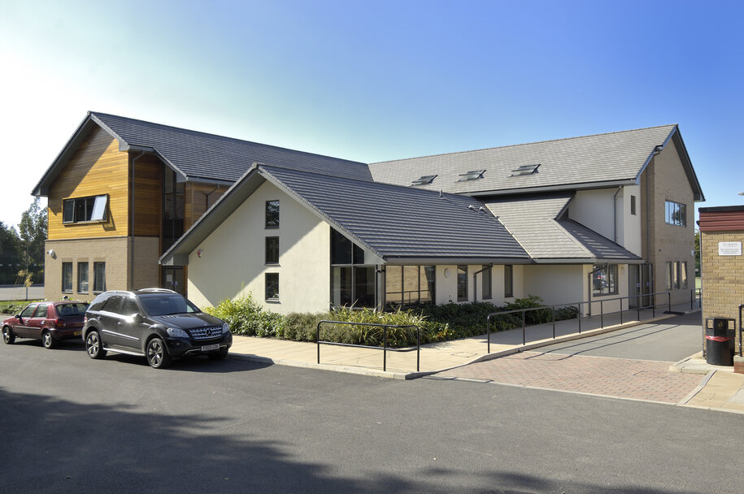

The walls will be in white cedral as below

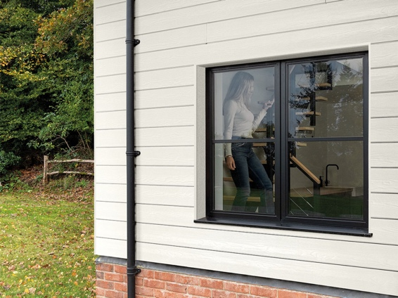
Windows and doors and facias will be dark Anthracite
As per the doors in the picture below
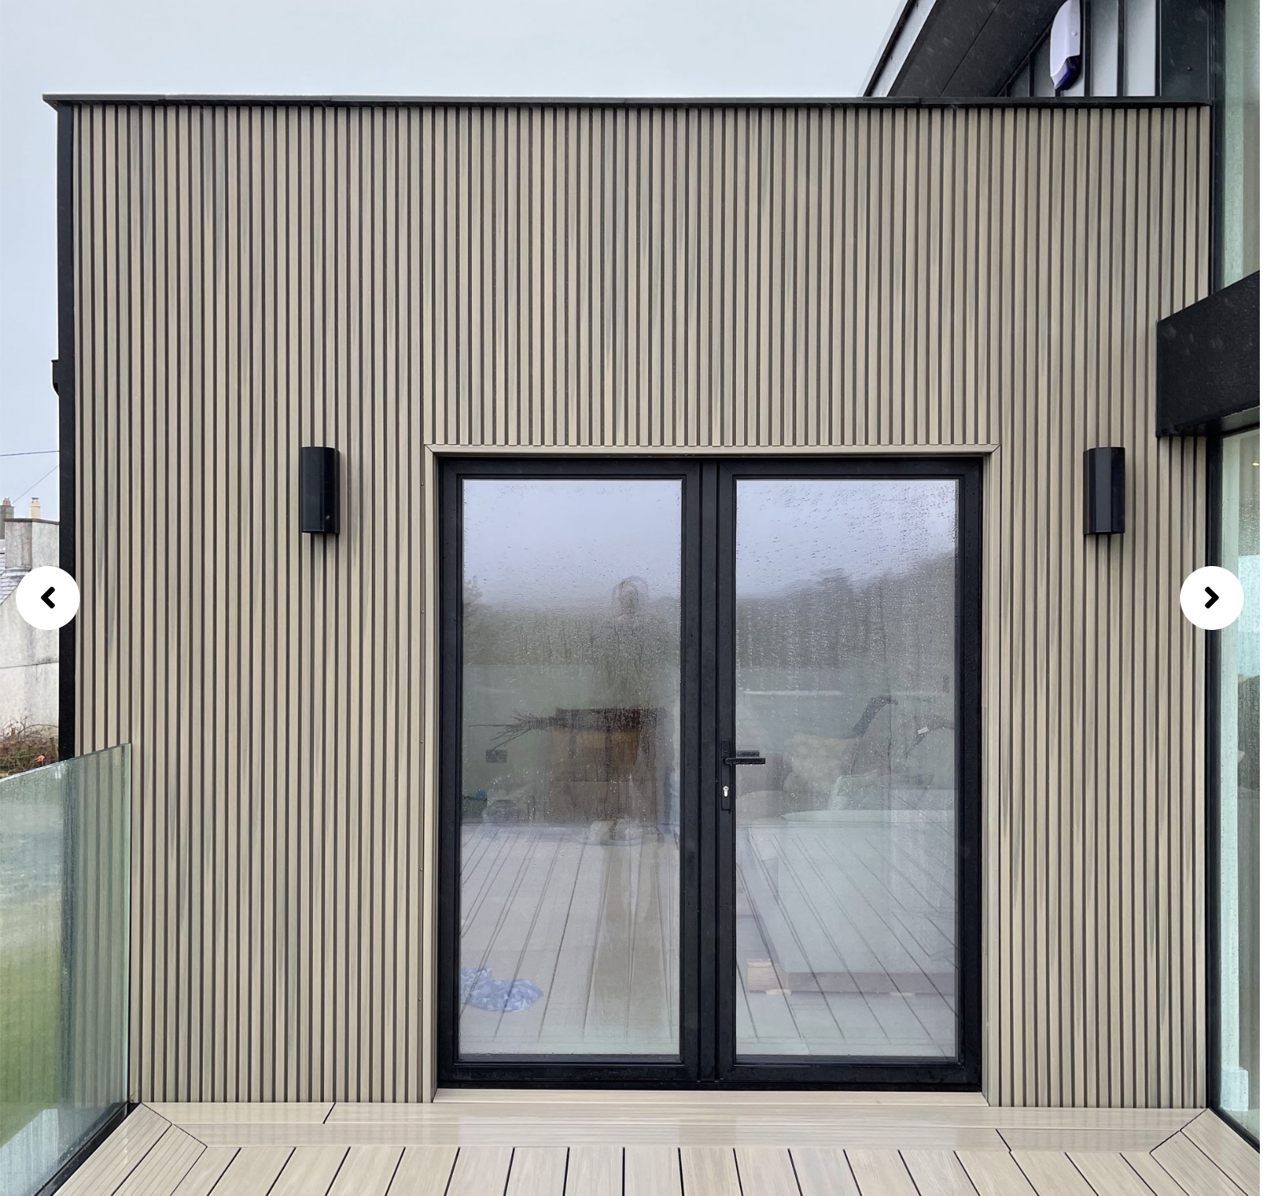

Conclusion
We believe this balanced design with clean lines and a modern pallet of materials will be appropriate for the Seafront location and would ask for the councils approval

