DESIGN AND ACCESS STATEMENT

In Support of Design for

Proposed raised roof, gable ends, front and rear dormers, with
external alterations after removal of hipped roof and box dormer

At
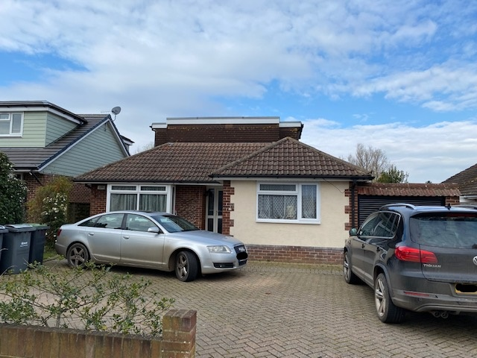

61 Hazleton Way
Waterlooville
PO8 9BP

For

Mr K Hayter
& Miss J Symon

By

BH Architecture Ltd
Heath Cottage
Newlands Lane
Waterlooville
PO7 5SQ

On

28th October 2022

- LOCATION
The site is located in Hazleton Way, Waterlooville on the north western side of the public highway and is a four-bedroom detached dwelling.

The property benefits from a driveway, a front garden with off road car parking for three vehicles, a large rear garden and outbuilding, there is an attached single garage giving direct access onto the driveway.

There is a public footpath immediately to the north of the property which links Hazleton Way with Spring Vale.
The dwelling is chalet bungalow style, masonry construction, facing brickwork with rendered feature walls to the highway elevation, white pvc-u windows and doors with a concrete interlocking tiled hipped roof. There is a flat roofed ‘boxed’ dormer facing both the highway and rear garden.
This area is predominately residential, consisting of detached and semi-detached bungalows, many of the properties in the area have been extended and refurbished over recent years. These include the property adjacent at number 59 Hazleton Way, where similar raising of roof, gable ends, front and rear dormers has been carried out.

To the north east of the site is a row of commercial properties with flats above.

- SITE USE
This detached property is occupied as a family dwelling. There are four bedrooms, two of which are located within the large flat roofed dormer at first floor level, living area, dining, kitchen and bathroom. There is an attached single garage, the rear garden is landscaped with mature shrubs and planting.

We can confirm both our clients predominately work from home with infrequent visits to their places of employment. The sign of modern working and flexibility in today’s society.

- PLANNING HISTORY
We have conducted a search on your website and have found the following relevant planning history:

- Unknown application, no details, Ref: 21218, granted consent, 20th April 1971.

It is relevant for this application that the property at 59, Hazleton Way, the immediate neighbour has the following;

- Single storey rear extension, alterations to roof to provide front and rear dormers with gable lifts, Ref: APP/18/00320, granted consent 5th June 2018.

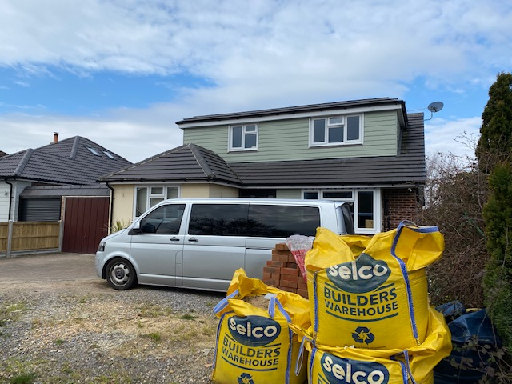

Street view of adjacent property at 59 Hazleton Way recently refurbished in a crown roof / gable end style, fibre cement weatherboarding, concrete interlocking roofing tiles.

- FLOOD RISK
We have conducted a search on the Environmental Agency (EA) website and the property has a very low risk of flooding from rivers and sea, less than 0.1 % each year. (Flood Zone 1)

Likewise, the EA website confirms this dwelling has a very low risk of surface water flooding. Both these maps are on the EA website, see attached link: Your long term flood risk assessment - GOV.UK (check-long-term-flood-risk.service.gov.uk)

- PROPOSALS
Our clients have occupied this property since 1998 and would very much like to redesign the first-floor accommodation. Presently the boxed dormer creates two rather small, cramped bedrooms. We are aware this was constructed during the early 1970’s and is very poorly insulated. It suffers from being rather excessively hot during the summer and pretty cold during the winter months.

The architectural appearance of the box dormer is not very attractive and sits rather awkwardly on the hipped roof. It is not attractive and is in need of general upgrading and refurbishment.

For the above reasons our clients would like to remove the current first floor accommodation and create a new gabled roof with two bedrooms and study space. To compliment the bedrooms a first-floor bathroom will be added.

The design template for the proposals will be taken from the adjacent neighbour at number 59 Hazleton Way, see photograph in item 3 above. This provides a rather attractive chalet bungalow, the style of which sits very comfortably within the street scene.

- DESIGN
The current hipped roof and boxed dormer will be removed. The proposals will involve a new pitched roof, gable ends, utilising the current roof pitch of 35 degrees, this will give an approx. ridge height of 6,000mm off the external ground level.

In conjunction with this front and rear crown roof dormers will be constructed to provide the roof accommodation. As mentioned, this will include two bedrooms, a study and a bathroom. The existing staircase access from the ground floor will remain at its current location.

Architecturally, both these dormers will be set in from the eaves, ridge and gable ends as not to dominate the roof slopes. The front dormer will be considerably set in from the eaves to limit its impact to the street scene, very similar to the design at number 59, the adjacent neighbour. The crown dormers will provide a softer appearance and limit the dominance of a flat roofed design which is not pleasing visually.

The windows to the first-floor accommodation will be located facing directly to the front and rear elevations. There will be no windows positioned in either of the gable ends, this will protect the privacy of the adjacent neighbours. This is an improvement to the current box dormer design which has windows located to the side returns which have the potential for overlooking.

Materials for the proposals will include a concrete interlocking tile to the main roof slopes, slate grey in colour, fibre cement weatherboarding to vertical face of the dormers and gable ends, grey in colour, white pvc windows, very similar but not a direct match to the adjacent neighbour at number 59.

In our professional opinion our proposals will blend seamlessly within the streetscape & improve the architectural appearance of this dwelling. It will not create overlooking issues & will be of similar scale to the adjacent bungalows.

The overall design to be employed will use the template of the neighbour to create a sympathetic addition to this property, see the garden elevation below.

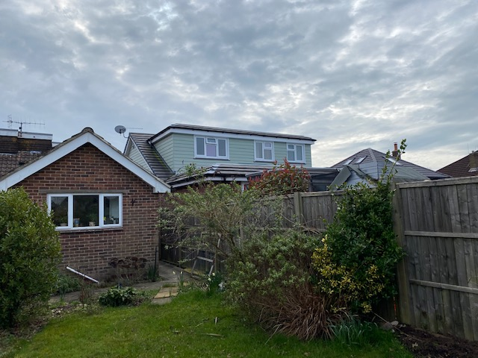

- ACCESS AND CAR PARKING
Access will be unaffected by these proposals. The scheme currently includes three off road car spaces as per Local Authority requirements. (4-bedroom unit)
- CONCLUSION
The proposals, in our professional opinion, will not affect the amenities of the adjacent neighbours. In and around this location there has been much refurbishment/enlarging of similar style dwellings. This design will not be out of keeping with these properties. These proposals will enable this house to be enlarged and modernised for up to date living and for the enjoyment of a family.

We respectfully request Havant Borough Council to support these proposals.

