Reference – PP-115836614

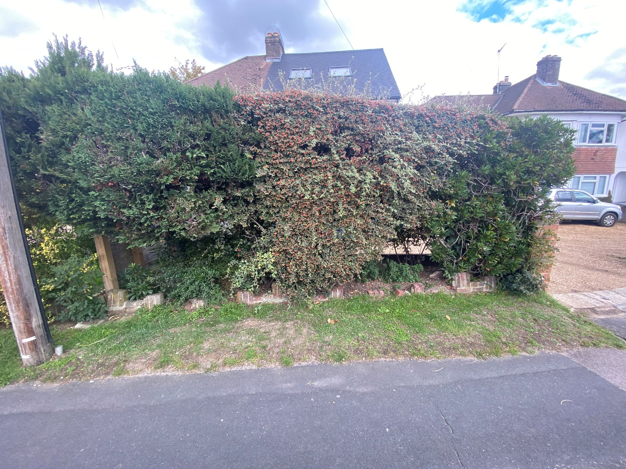

Current Front Hedge, 57 Stakes Hill Road, Waterlooville, PO7 7LD

Andrew McEWAN

