Application No. APP/23/01062
Site Address: Unit 502, Dunsbury Park, Brooklime Way, Havant, PO9 4FF
Proposed Development: Re-fit existing unit as a vehicle service workshop; new external vehicle wash bay and container within existing compound; provision of air intake and extract grills and exhaust extracts on west, east and south elevations.

There is an existing S106 dated 19/02/2014 for this site, modified by two deed of variations, 01/10/2015 and 10/12/2018. If this proposed development affects these agreements a further deed of variation will be required.

Please note: Schedule 6 of the S106 requires an Employment and Skills plan for each unit before occupation can take place, please refer to the extract from the S106 below. Schedule 3 requires a Travel Plan before occupation, this is monitoring directly by Hampshire County Council.

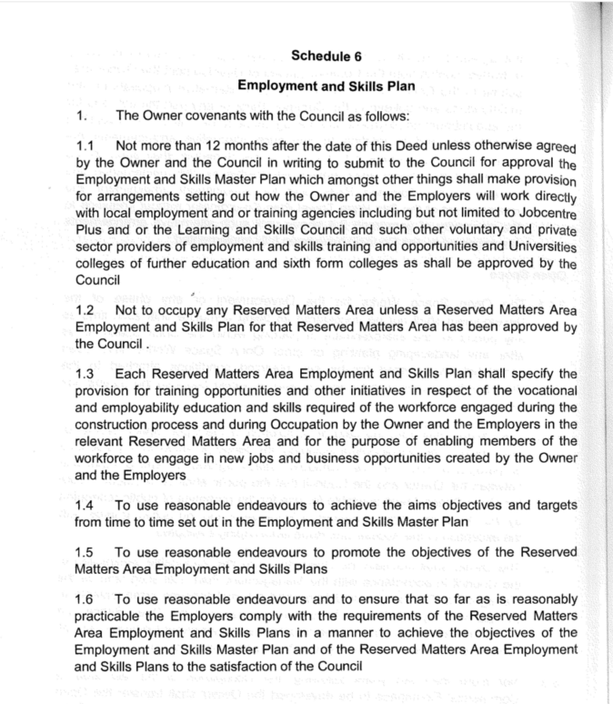

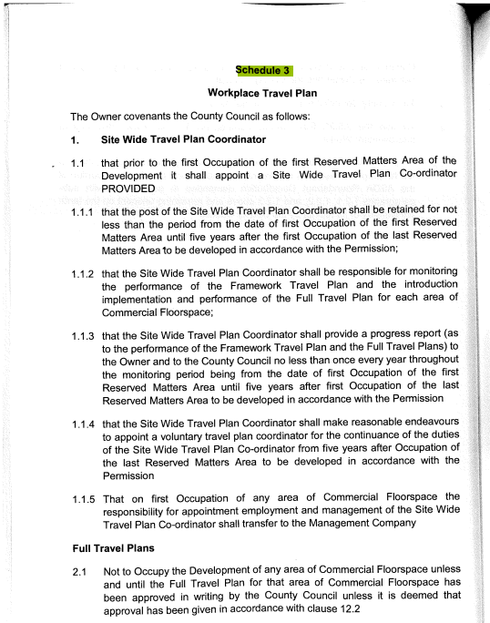
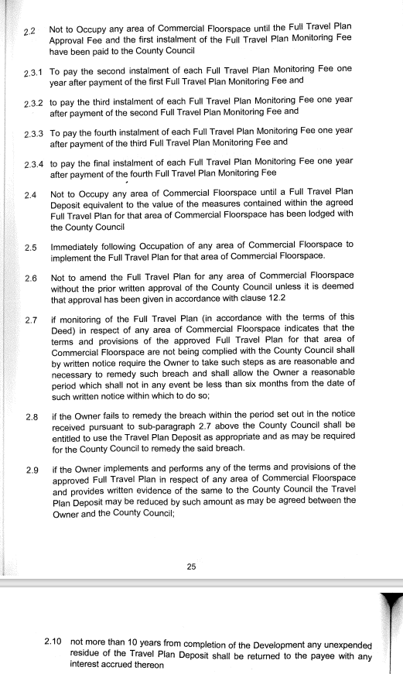

Due to the expiry of the Outline Permission APP/12/00388 a new S106 may be required as part of this application, Heads of Terms should include Employment and Skill plans, Travel Plans, Councils monitoring fees* along with any others arising out of consultee responses

*The sums charged will be increased and apply to S106 agreements drafted after 31/3/24:

- £988 per non-financial head of term (outside the scope of VAT)
- 5% of cost per Havant Borough Council financial head of term (outside the scope of VAT)

Monitoring fees will no longer be capped. This contribution is indexed in accordance with the CPI.

SEE THE HBC DEVELOPER CONTRIBUTIONS GUIDE FOR ADDITIONAL INFORMATION:
Latest version accessible from: https://www.havant.gov.uk/community-infrastructure-levy

