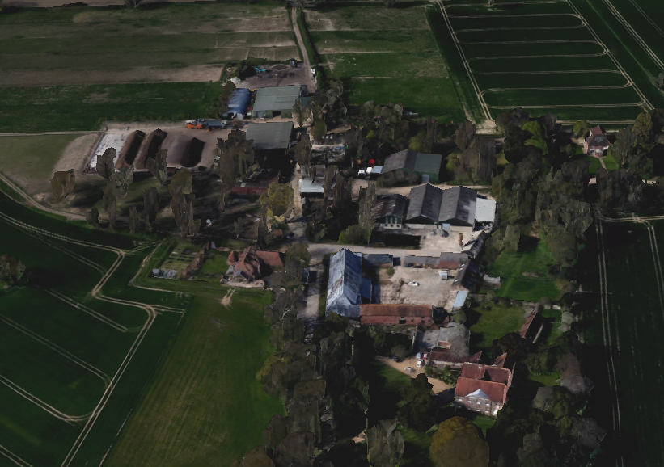

The cart shed in red circle showing relation with other buildings at Manor Farm Hayling Island

