DESIGN & ACCESS STATEMENT

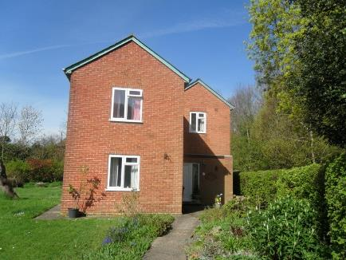

DWELLING EXTENSION AND GARAGE REPLACEMENT

at

32 Langstone Road
Havant
PO9 1RF

for

Mr and Mrs D NICHOLAS

September 2021

- INTRODUCTION

- THE EXISTING SITE

- PROPOSALS

- PRE-APPLICATION ADVICE

- ACCESS

- CONCLUSION

To be read in conjunction with drawings:

- PLA001 Plans & Elevations Existing

- PLA002 Plans Proposed

- PLA003 Elevations Proposed

- PLA004 Outbuilding Proposed

- PLA005 OS Location and Site Plans

- PLA006 Garage Proposed

- INTRODUCTION

  - The property is located within a large plot measuring 1068 sq.m (0.106 ha), and is positioned fairly hard up against the north boundary. There is a detached single garage in the eastern(front) corner of the plot near to a lay-by leading off of Langstone Road (A3023). Pedestrian access to the house is along a path leading directly off of the pavement running along the front of the plot. The property is not listed or in a conservation area, however, the majority of the site is located in Flood Zone 3.

  - Langstone Road and much of the surrounding area is characterised by large detached properties with double garages on large plots, and which vary in style.
32 Langstone Road stands at the end of a line of houses which run from the edge
of the harbour up to the lay-by and the entrance to Mill Lane.

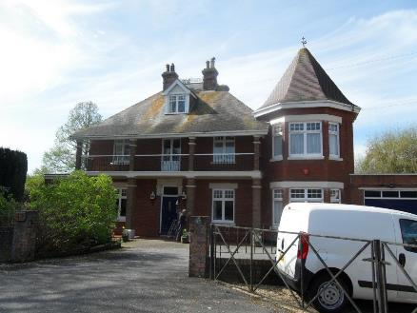

Fig 1. Example of property on Langstone Road.

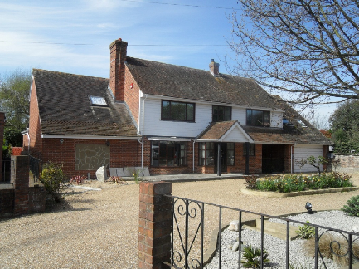

Fig 2. Example of property on Langstone Road.

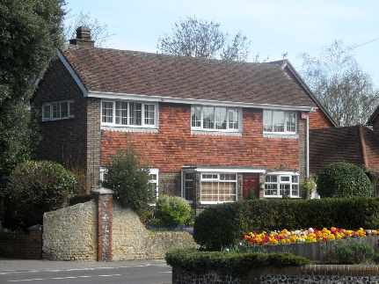

Fig 3. Example of property on Langstone High Street (opposite site).

- THE EXISTING SITE

  - 32 Langstone Road consists of a detached three bedroom house with a detached single garage. The original house was built in 1880 with extensions added over the years culminating in a single story rear extension in 1985. There is a very short driveway to the garage at the front of the property and parking area to the side of the garage with visitors parking mainly in the lay-by. The gross internal floor area of the house is 126 sq.m / 1356 sq.ft. A topographical survey indicates that the internal ground floor level is 3.32 metres AOD.

The property is mainly brick built with some render and wood cladding, slate roof tiles on a 35 degree double pitch roof to the two story structure and a flat roof to the single storey section. The doors and windows are a mixture of White UPVC/Aluminium. The property has an extensive side garden (to the south) which includes a lawn area, shrub borders and a vegetable plot. To the north of the site is an area of woodland consisting mainly of trees and low lying vegetation. To the rear of the plot is a dismantled railway which now acts as a public footpath.

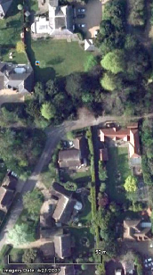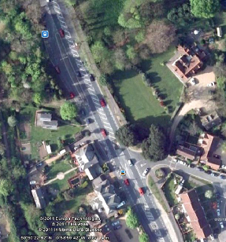

Fig 4. Aerial view of 32 Langstone Road (outlined in red).

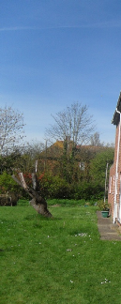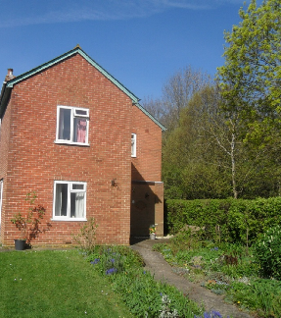
Fig 5. View of 32 Langstone Road (East Elevation).

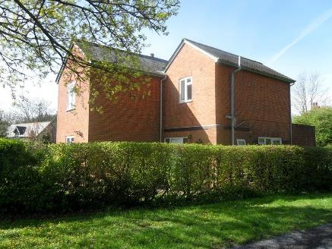

Fig 6. View of 32 Langstone Road (North Elevation).

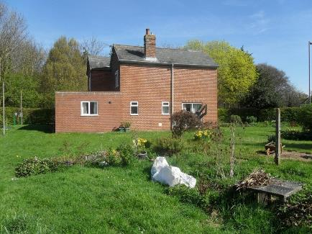

Fig 7. View of 32 Langstone Road (South Elevation).

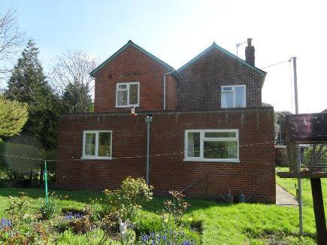

Fig 8. View of 32 Langstone Road (West Elevation).

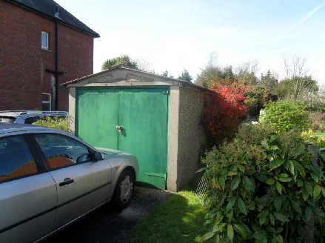

Fig 9. View of 32 Langstone Road detached single garage.

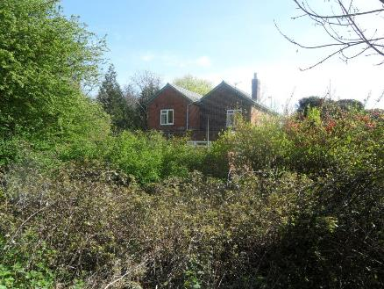

Fig 10. View of 32 Langstone Road (West Elevation) from the ‘dismantled railway’ public footpath to the rear.

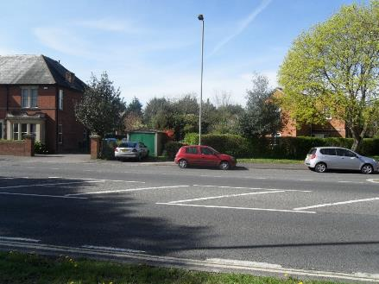

Fig 11. View of site taken from Langstone Road (house on right behind trees and garage in middle of photo), with lay-by in the foreground and No.34 Langstone Road on the left

- PROPOSALS

  - It is proposed to extend the rear of the house at ground floor level and provide a pitched roof to replace the problematic flat roof, extend the front with a small two storey extension adding symmetry to the front elevation with a pitched roof to match the existing and provide a small first floor extension at the rear to again provide symmetry with a roof to match the existing. Windows and doors will be reused where possible for the extensions and new fenestrations will match as close as possible the existing. The gross internal floor area of the house will be 213 sq.m / 2292 sq. ft, and it will be positioned primarily along the north boundary as existing.
The single garage adjacent to the road will be replaced with a double garage set further back of the same size and in the same position as the garage that gained planning permission in 2011 but was never constructed. The garage doors will face north into the property, again as previously permitted, minimizing any impact to the street view of the property. An additional outbuilding will be erected in the South West corner of the property replacing the existing outbuilding. The size and character of the extended dwelling, whilst only increasing in size by 73 sq.m, will complement the larger houses along Langstone Road and the surrounding area.

  - The detached double garage and driveway to the front of the property will allow ample off road car parking within the site, as opposed to occupants and visitors having to use the lay-by as is the current situation. The revised entrance and new driveway will also allow vehicles to exit the site in forward gear. This will be a lot safer than the current situation as Langstone Road is often busy with very fast-moving traffic.

  - The extensions will be constructed of traditional brick and block construction to match as close as possible the original building. The detached double garage will also use the same materials in a similar fashion but will have hip ends to the roof to minimize and soften the appearance and presence. The wall facing the road will be of brick and the doors will be positioned facing north into the property and not visible from the road. Roofs for the extensions and the garage will be finished in slate to match the existing dwelling. The outbuilding (Shed) will be of timber construction with a tin roof.

  - Additional vegetation will also be added to the southerly section of the property to complement the vast array of vegetation on the north boundary of No. 34. It is considered that the properties to the rear are also at such a distance that any overlooking will be minimal and none of the other elevations overlook any other properties.

  - The house appears in proportion to but will not overshadow any neighbouring properties or appear over-bearing. The ridge line is considerably lower than the ridge line of No.34 Langstone Road. The ‘footprint’ of the proposed altered dwelling is considered to be very much in proportion to the size of the plot and represents an improved ratio to many other properties along Langstone Road.

  - It is the intention that the amended dwelling would be renovated to withstand the effects of a flooding to the site far better than the current situation. The Environmental Agency would normally recommend that properties are set 300mm above the 0.5% (1 in 200 years) plus climate change flood level, which in this case would be 4.7m AOD. It is proposed that flood resilient construction methods would be used to help overcome the difference in levels. Specific examples of this would include waterproof flooring and plaster as well as running all new cabling and service pipes downwards from first floor level. All new meters, distribution boards and boilers would be positioned above 4.7m AOD. The existing dwelling is neither a locally nor statutory listed building and is not located within a Conservation Area. The application site is within Flood Zone 3 as indicated on the Environment Agency Flood Maps for Planning.

- PRE-APPLICATION ADVICE

  - We have previously sought pre-application planning advice from Havant Borough Council Planning Department and I met with Karen Wooden to discuss our proposed plans on 19th October 2016. An email response was received from Karen Wooden on 19th October 2016 (see attached excerpts) in which Mrs Wooden confirmed that she had spoken with her team leader. They were satisfied that the plot could accommodate the scale of the proposal but were concerned that the proposed materials may not comply with Policy CS16 of the Havant Borough Council Borough Design Guide 2011, in particular “Identifies and responds positively to existing features of natural, historical or local character within or close to the proposed development site” and “Uses the characteristics of the locality to help inform the design of the new development including heights, massing, existing building lines, plot widths and depths, materials and proportions of windows and doors.”

  - Mrs Wooden advised that the Havant Borough Council’s Landscape Architect would be carrying out a site visit to assess what kind of impact the extensions/materials would have on the character of the locality. Following this visit, Mrs Wooden responded on 9th November 2016 with the below comments from the Landscape Architect.

‘The current dwelling is not deemed of particular merit and the generous area of well screened rear garden is noted – hence there appears scope for enhancement and expansion, provided that the proposals are appropriate to the context in terms of scale and appearance.

Views from Langstone Road to the North / North-East of the site are well screened by existing mature vegetation along Solent Way, but the existing dwelling is clearly visible from the Langstone Conservation Area – notably alongside the attractive Edwardian façade of no. 34 Langstone Road when viewed from the Langstone High Street vista. The large rear garden also appears to be well screened around the site boundary.

Whilst there are no adverse comments regarding the rear extension, I suggest the frontage expansion will require some further elaboration / design development. The existing garage appears to be retained within the scope of the initial sketches, but I suggest there is scope to replace this and recess further into the site to reduce the appearance / improve parking provision (particularly noting there is insufficient space to park a car in front without obstructing the public highway footway).

I emphasise that proposals will need to demonstrate consideration of the existing site context / character and proportionate scale with adjacent built-form.

I note that brick remains the prevalent material within the surrounding built-form context, with render very much less so. Given the context of the adjacent Langstone Conservation Area, it is recommended that the frontage elevation glazing arrangement (and use of any roof glazing) should be appropriately restrained.’

  - Following the initial comments in 2016 the scope of the works were reduced with additional glazing removed to the frontage elevation and the existing garage will also be removed. Additionally a Planning Application was made in September 2020 but this was subsequently
refused. The comments below formed the basis for the refusal.

‘The proposed development, by virtue of the cumulative effect of the changed roof profile, window proportions and use of modern materials would be harmful to the setting of Mill Lane Conservation Area. The proposed garage and car port development, by reason of its size, height, design, bulk and prominent location would be an incongruous feature within the street scene to the detriment of the visual amenities of the area. The use of steel profiled anthracite roofing would also be visually inappropriate to the context of the site and harmful to the street scene and setting of Mill Lane Conservation Area.’

No objections were raised to the proposals in terms of size or scale for the dwelling. We have implemented the appropriate measures in a bid to overcome any concerns regarding design issues from both the pre application advice and the refused application.

Planning permission was granted to previous owners in 2011, Ref: APP-11-01345, for significant redevelopment and part of this was to construct a new garage to the southern boundary of the property set further back than the existing garage. This was to be of brick construction with the doors facing north into the property.
The proposed garage replacement on this application emulates that proposal in both size, position and materials however this proposal has a hipped roof to further reduce visual impact from the street.

- ACCESS

  - Vehicular and pedestrian access to the property will use the existing access in the eastern corner of the plot. All internal layouts of the new dwelling will comply with Part M of the Building Regulation requirements where possible.

- CONCLUSION

  - The proposed amendments to the dwelling have been sympathetically designed to enhance the appearance of Langstone Road and the surrounding area. The size of the amended dwelling and garage are considered appropriate for the size of the plot and whilst increased in size are still somewhat smaller than the majority of the other properties in the area. The extensions and garage have been deliberately positioned within the site so as to prevent any overlooking or shadowing to neighbouring properties.

  - Through implementing the advice and suggestions provided by the Havant
Borough Council both in the pre application advice and the unsuccessful
application, the proposed amendments represent a good opportunity to enhance
an old property, making it one that would include many modern improvements
to help mitigate the damage caused in the event of flooding, and one which is
much more environmentally friendly. As such, we look forward to a positive
outcome to this planning application.

