BJH Property services.

42 Nobes Avenue,

Gosport, Hampshire, PO13 0HT

07787711781

bjhpropertyservices@outlook.com
146 London Road, Tree Report
Survey carried out 23/01/2022

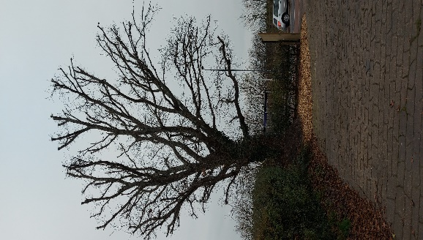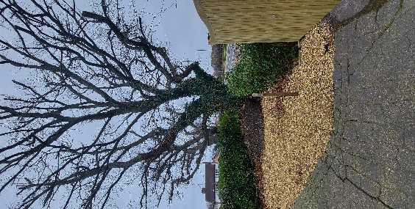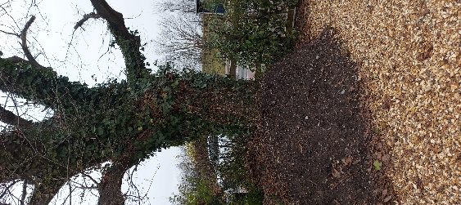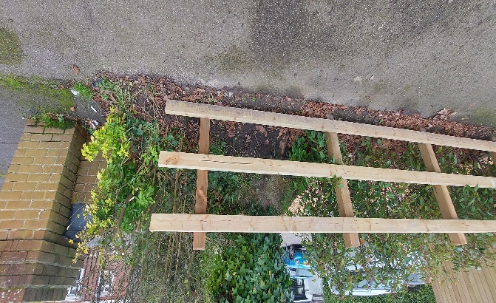

Introduction
Following the Planning application to erect a single garage to the front garden of 146 London Road, Planning ref number APP/21/01331 I have been asked provide a report on the Oak tree on site and how this will be affected and protected during construction works.

Tree Survey
The Oak Tree (Quercus Rubor) is situated on the North West corner of the site approximately 300mm from the front and side boundaries. The tree is situated 1.80m from the concrete driveway in what was previously a raised planter. It is approximately 10-12m in height and has a spread of around 9.0m. Circumference at the trunk is 2650mm at 1.0m from ground level, giving an estimated age of between 85-95 years old. The crown is around 2.60m from ground level and has 4 main boughs mainly stretching out North to South. The base of the tree to the South East is covered with soil to a depth of 800mm which is left over from an historic planter built around the tree but since removed. The north face of the tree where this soil is removed shows the roots penetrating at the lower ground level. There is no evidence of poor health and all boughs and limbs appear healthy and full of bud and the tree has been pruned recently (within last Year) There are no signs of the roots penetrating the ground in any direction and are likely to be of adequate depth to not be within the area of the proposed floor raft. The drive way is of concrete construction 100mm onto compacted hardcore with a pattern embossed into the surface and there are signs of mild fractures likely to be lack of reinforcement and expansion cracks rather than root movement. The tree shares the area with a Laurel Hedgerow boundary to neighbouring property and has a light covering of Ivy (Hedera Helix) from ground to above crown height but this may be thicker during growing months.

Tree Protection.
During construction of the proposed garage the following will be adopted by the contractor to ensure no works or deliveries to the site will affect the tree in any way and that should this arise, any works will be managed to have minimum effect on the tree.
1, The immediate area under the tree will be harassed to prevent any vehicle or plant machinery making contact at any point. And all contractors on site to be made aware of the exclusion zone during induction onto site.
2, All delivery drivers will be made aware of the tree at ordering stage and delivery stage, and if they are driving high sided vehicles or operating cranes or boom arms then this is to be done outside the spread of the tree and with banksmen watching for clearance. Any skips on site will be carefully unloaded and loaded by the driver away from the immediate area around and under the tree canopy although removal of waste via smaller tipper truck would be preferred.
3, The foundation and floor to the proposed garage is to be of Raft type to minimise the impact into the ground. Excavation should be done by hand at the front (North) Elevation at the very least to avoid cutting through roots and any exposed roots be protected as the approved Plan notes. Any excavators should be monitored carefully by banksmen while digging and also moving around the site paying attention to overhanging branches.

4, No spoil, building supplies or extraneous materials are to stored near or against the tree and there will be no use of chemicals on site during the construction time.
5, Once works are complete the entire area is to be cleared of all materials and returned to how it was prior to building works.
6, All new rainwater run of will be to a new soakaway which will be hand dug and situated as far from the tree as rules allow (min 5.0m from any building) see plan. Any roots exposed during the dig will be carefully dug around and have minimum disturbance.
7, If any roots are exposed which may affect the building in a major way, then works should stop and the Architect should be contacted immediately to survey the areas effected and revise the plans to avoid any adverse contact or damage to the tree root system.

A copy of this report will be given to the contractors and agreed with the building owner or Architect prior to starting works. The building owner or Architect is to ensure all protection methods are adhered to before and during the works and a final site inspection once works have finished to be carried by the Contractor Foreman, Building Owner and Architect.
This report and photos were produced in Winter time while the tree is dormant and any obvious ill health may not be clear until the leaves have appeared and the tree is in full growth.

Produced by:
Brian Hindle.
27th January 2022.

