DISCHARGE OF CONDITION NUMBER 4 - APP/21/00632

STATEMENT

Proposed single storey rear extension with roof accommodation and flat roofed dormers, conversion of integral double garage into habitable accommodation with external alterations, hip to gable enlargement with raised roof and replacement dormers.

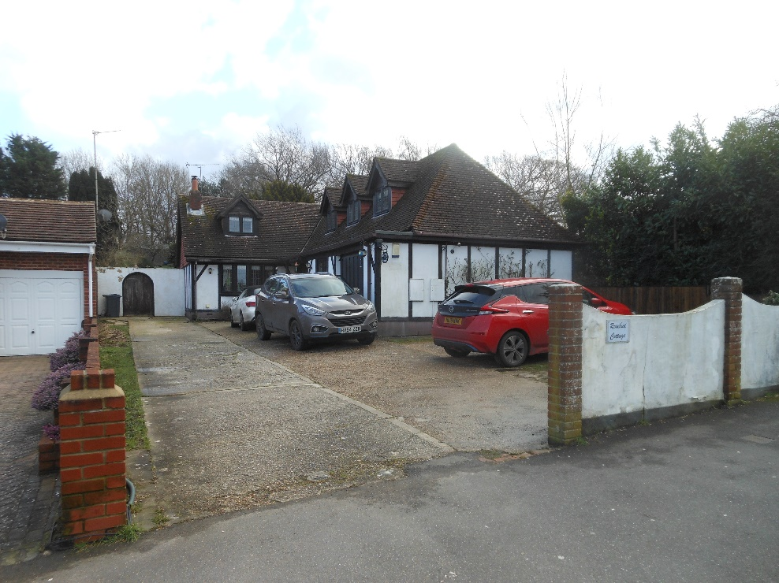
At

Rosebud Cottage
Stakes Hill Road
Waterlooville
PO7 5UB

For

Mr & Mrs S Brewer

By

BH Architecture Ltd
Heath Cottage
Newlands Lane
Waterlooville
PO7 5SQ

On

4th February 2022

- LOCATION
Rosebud Cottage is located to the eastern side of Stakes Hill Road in Waterlooville. This location is mostly residential with a mixture of detached chalet bungalows, two storey semi-detached dwellings and bungalows within the close vicinity of both Oaklands Catholic School to the north and Crookhorn College to the south.

- PLANNING HISTORY
The planning consent APP/21/00632 was approved on 5th August 2021 and was a variation to the original planning consent APP/20/01027 granted on 23rd December 2020. Construction works commenced on site early 2021.

The works to the rear of the property are substantially complete but the works to the front projection have not yet commenced. Our clients wish to construct this part of the approval during the forthcoming Spring.

To enable this to proceed we need to discharge Condition number 4 of the approval Ref: APP/21/00632 the wording of which is as follows:

No development shall commence on the hereby approved front alterations including raising of the ridge, hip to gable enlargement and replacement dormers, unless and until the measures which will be undertaken to protect public sewers have been submitted to and approved in writing by the Local Planning Authority in consultation with Southern Water. The development shall thereafter be carried out in accordance with the approved measures Reason: In the interests of protecting public utility infrastructure and having due regard to policies CS19 and DM10 of the Havant Borough Local Plan (Core Strategy) 2011 and the National Planning Policy Framework

- DISCHARGE OF CONDITION NUMBER 4 / PROTECTION OF PUBLIC SEWER
As part of the Building Regulation process our clients have employed an Approved Inspector, Regional Building Control Ltd (RBC) who are located in Havant.

During this procedure RBC consulted Southern Water as the public utility provider concerning the public sewer located to the front garden of Rosebud Cottage. Their response dated 16th December 2021 indicates that the front projection can be constructed utilising their standard conditions, see Southern Water letter attached with this application.

This confirms the utility provider is satisfied RBC can control the development under Building Regulation Legislation. No further protection measures will therefore be required to protect the adjacent public sewer, the public sewer infrastructure will remain unaltered.

- CONCLUSION
We feel we have provided suitable evidence to allow the discharge of condition number 4 from APP/21/00632.
We respectfully request Havant Borough Council to support this proposal.

