Design and Access Statement 140 Southwood road Hayling Island PO119QH

This proposal is for a second floor addition at 140 Southwood road as shown below
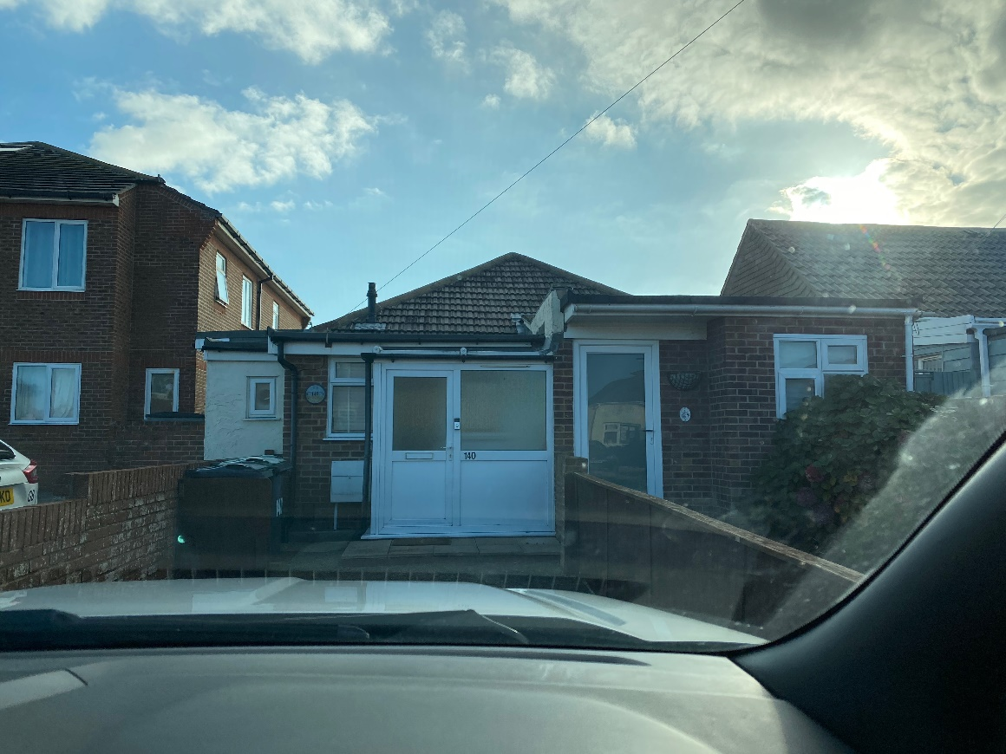
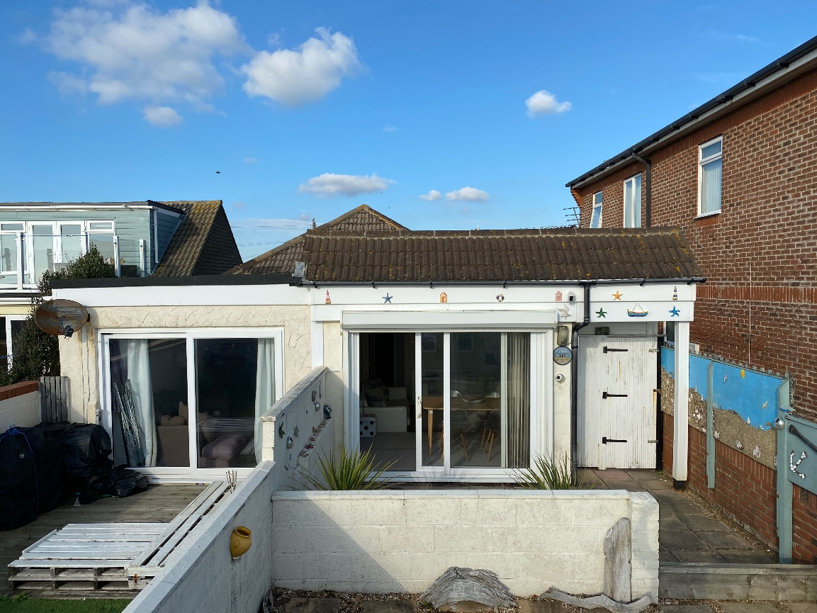
Advice was sort from planning in March 2020 ref Gen/20/00050 and was provided by Miss Selina Donophy.
When preparing the design for the proposed extension this advice has been carefully considered and has influenced the proposals put forward.
Existing street scene and building
The existing street scene is varied mix of styles sizes and building placement with no consistency in any particular areas. The existing building is divided into two semi detached dwellings. The front elevation of both dwellings is dealt with in different ways with random extensions having been added to both properties. Again at the rear both properties have been extended with flat roof structures and different roof treatments.
The overall effect is a building of poor quality that appears ramshackle from both the viewable elevations (North and South)

Design approach
Obviously this is a somewhat challenging design brief as the neighbour does not wish to make changes to their property.
The approach taken was (as discussed by miss Donophy in her recommendations) was to aim to keep the floor addition to the rear of the property and aim to alter the front of the property to closely match the neighbouring property and thus tidy the street scene elevation.
The rear extension also aims to work with the roofline of both the existing dwellings as if they were one and create a building that is substantially improved and bought together within the context of the eclectic street scene, especially the rear street scene as seen from the water and public footpath.
The north street view retains the existing roofline and is extended to replicate the elevation of the neighbouring property. The front part of the existing hipped roof is retained so the building appears consistent as the viewer travels down the road from east to west.
As you face the building in north and south elevation the roofline takes its pitches from the existing roof structure to create an offset pitch which pulls the building together as one.
Conclusion.
We believe the proposal significantly improves the street scene and take a building of poor design and quality and creates something that contributes positively to its surroundings

