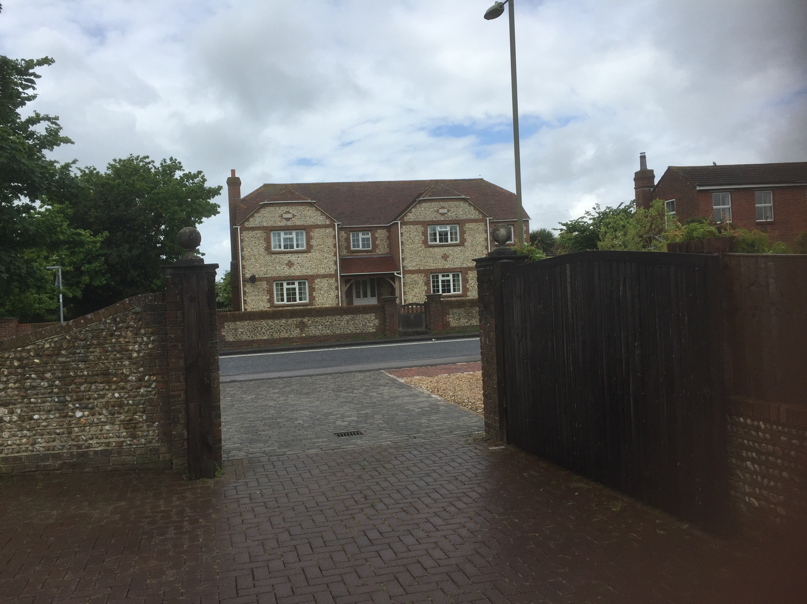

The new building will present its front Elevation to the road in the same way the farmhouse does (see A101) in addition the height and overall dimensions of the proposed property will be similar and in context with the farmhouse. In the planning application a street scene view will be provided to show the new building is in context in both size and design with the farmhouse.
It should be noted that no physical changes will be made to the farmhouse or the land that surrounds it other than the area of the Garden that becomes part of the development. The farmhouse will still retain a garden in excess of 300m2 and keep a substantial distance of over 12m to its new neighbouring property, most importantly there will be no impact what so ever on the west elevation detailed in the listing.

The Granary History

The Granary to the rear of Cotterell farmhouse (no 70 Havant Road) is now in the garden of no 72 Havant road.
The Granary is a grade 2 listed building from the early 19th century
Listed in 1988 with the English heritage building ID 135547
The listing refers to
‘Timber framed granary clad in weatherboard with half hipped roof now covered in asbestos sheeting on mushroom shaped saddle stones. Square building 3x3bays. Entrance by boarded door interior retains grain bin. Included for group value

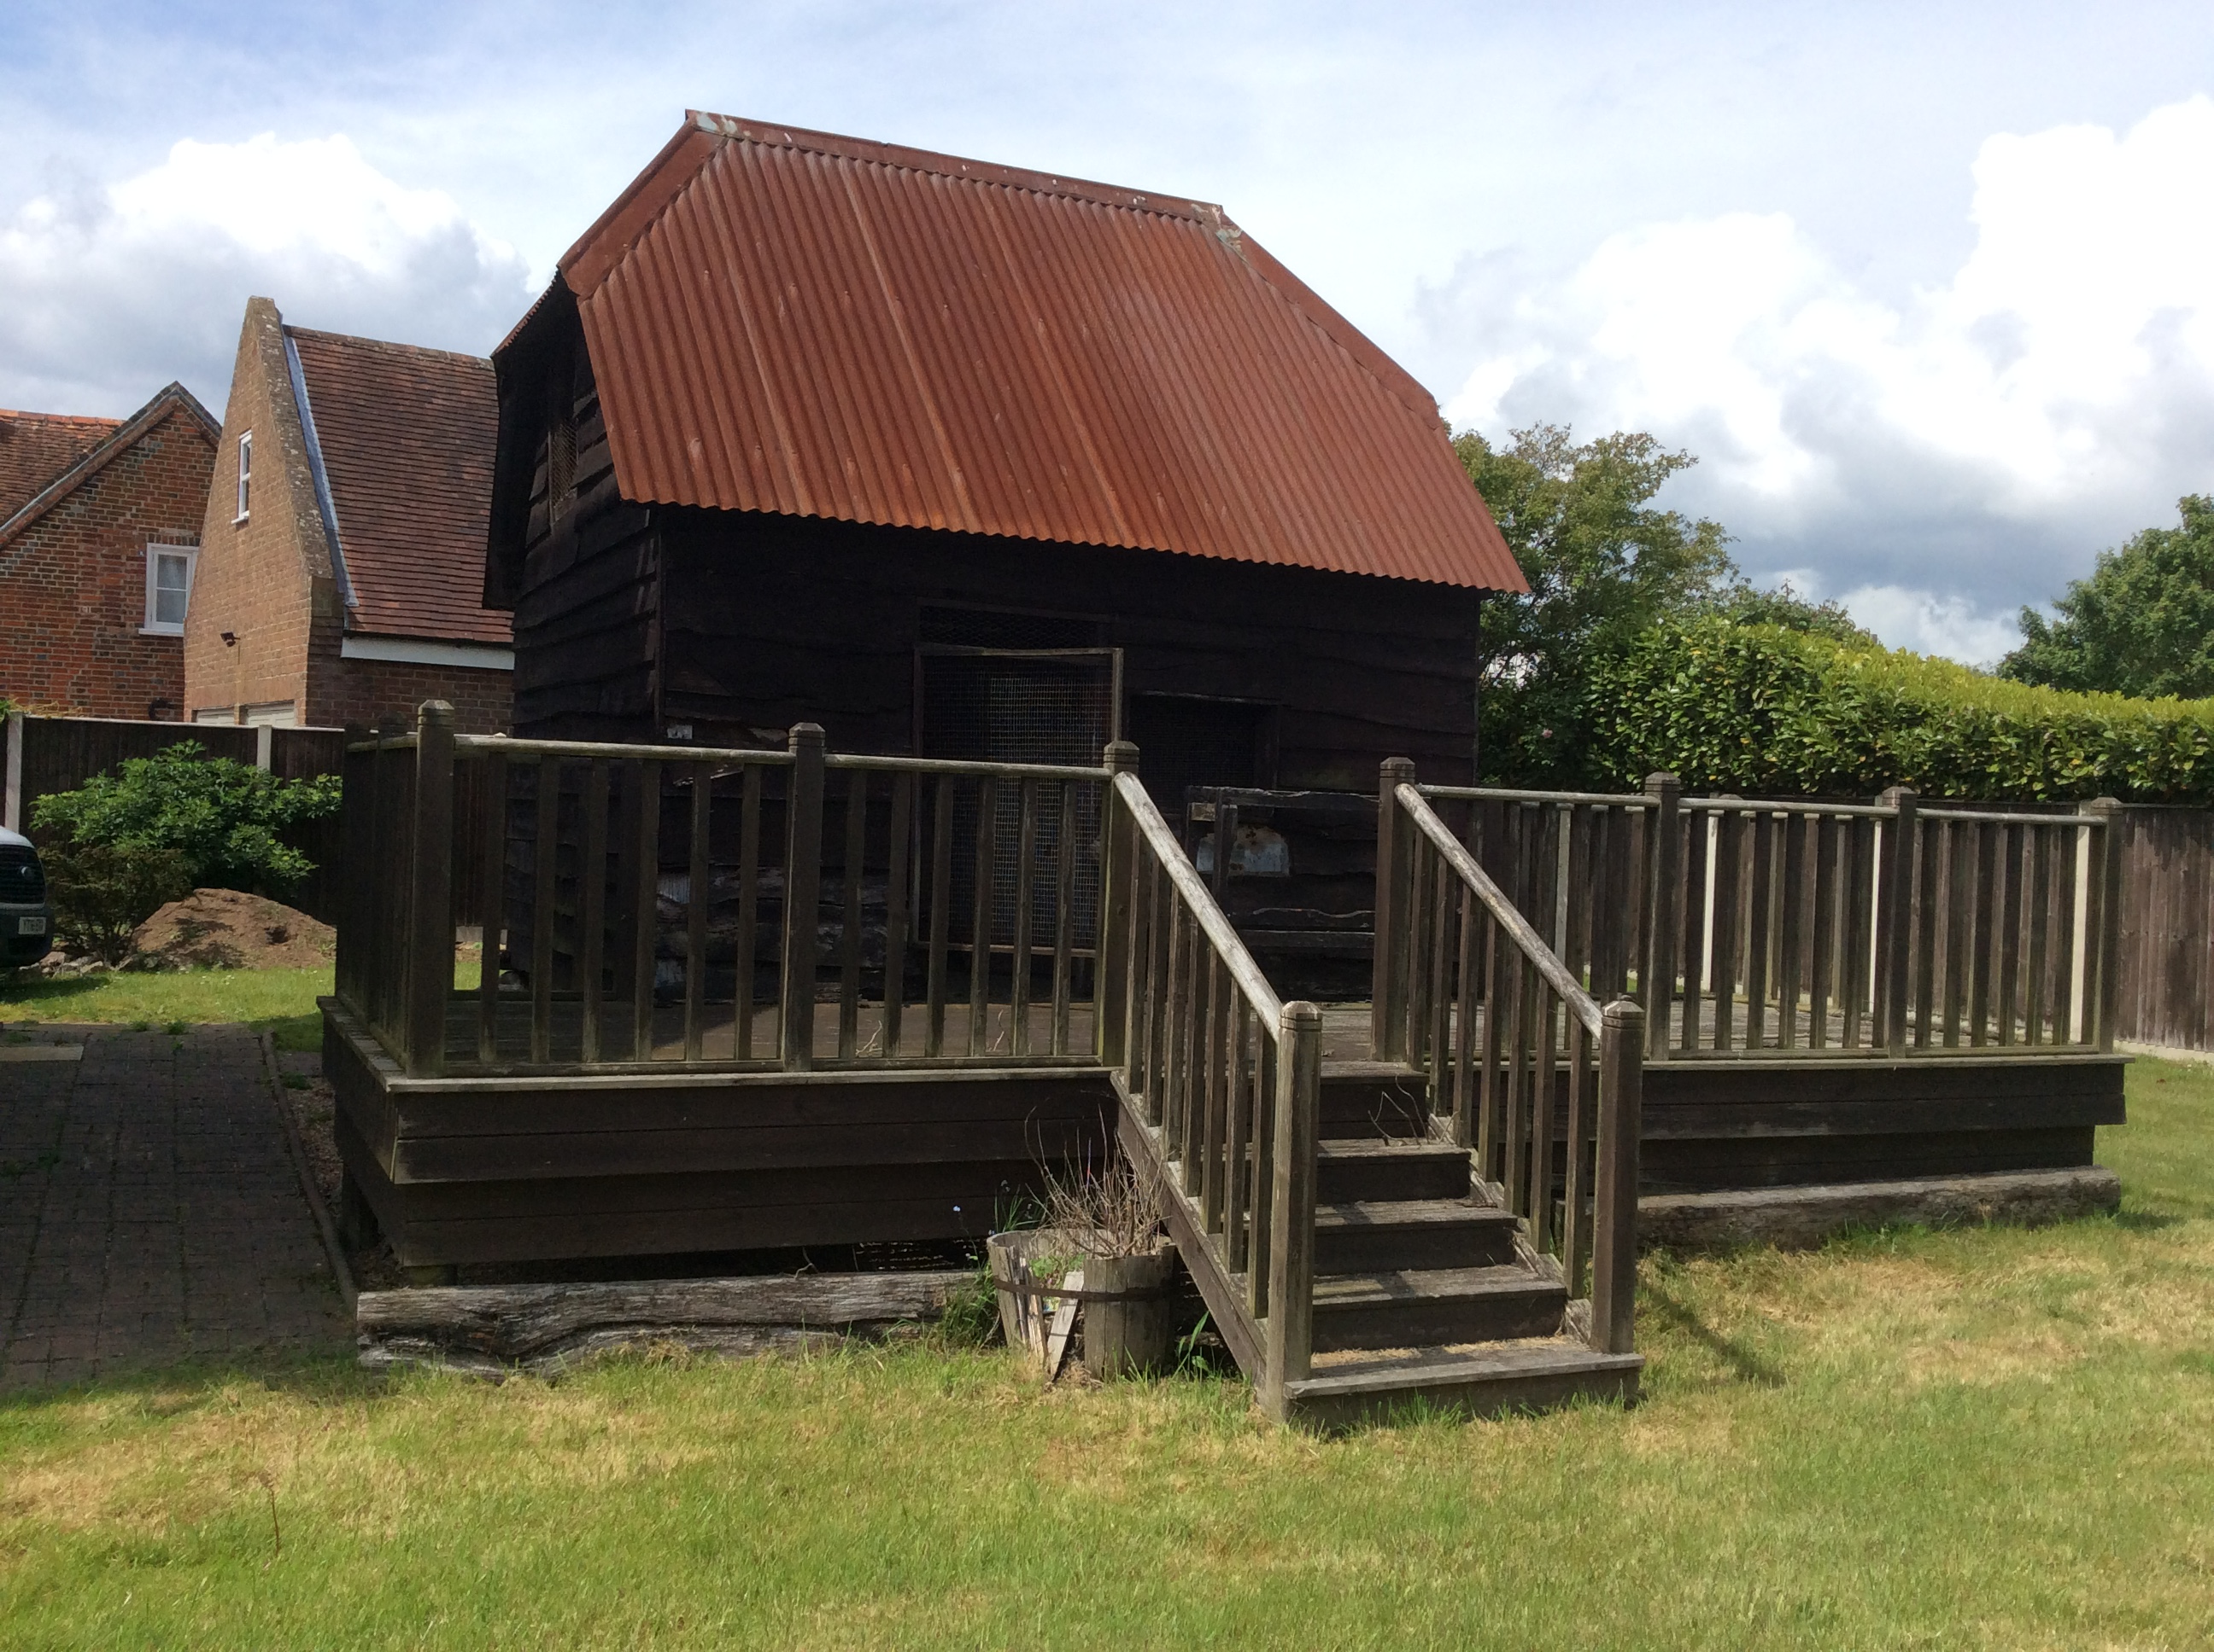

This building is in poor condition and has been close to collapse, the mushroom saddles have had additional support put in place to support the building and avoid its loss
It should also be noted that this was not the original location of the Granary which was re located at some point in the 1970-80s before being listed.

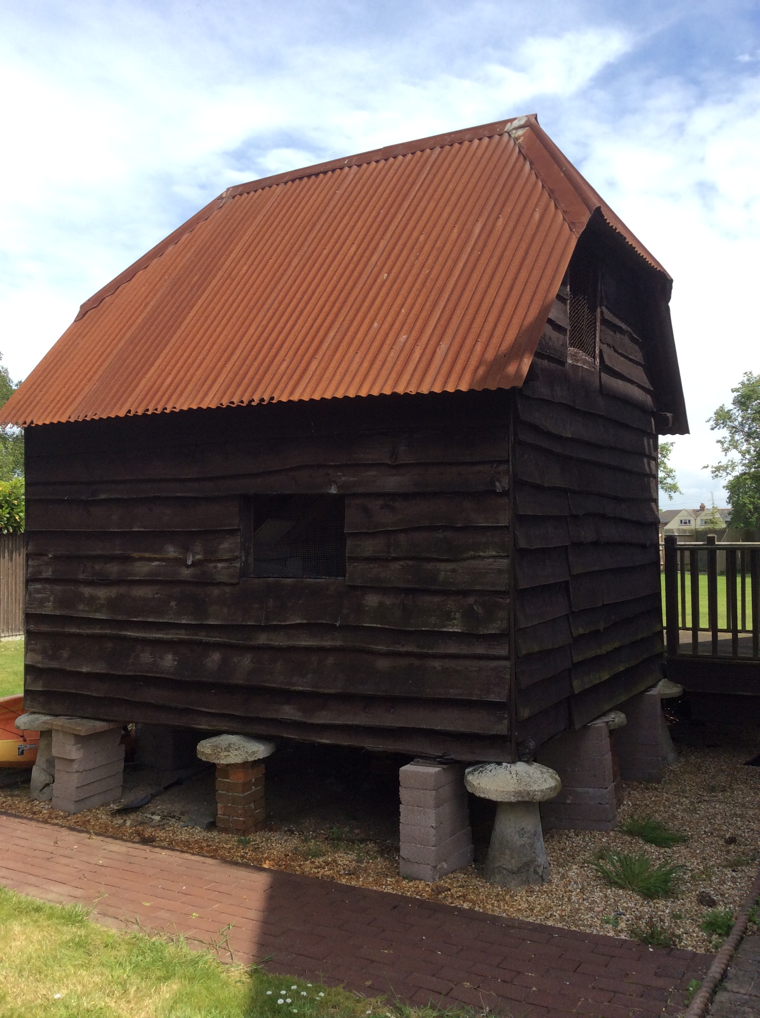
Location and Design
The aim of this proposal would be to relocate the Granary close to its original position. In the process of this relocation the Granary would be restored to its original condition including restoring the structure reinstating the correct roof materials and restoring the mushroom saddles. The aim would be to make the Granary the centrepiece of the new development (see drawing A101, the small building to the north as you enter the development is the Granary) The finished development would be called The Granary and the building would be given a new lease of life for all to see rather than been allowed to crumble in the unseen corner of a garden.
As part of the application a method statement and full specification would be provided for approval before any work commenced.

Conclusion.

We believe this proposal would have little or no impact on Cotterell farmhouse. The building itself would not be effected, the distance to the new building would be substantial and in the context of the street scene, and the new building would match in terms of size and design.
In terms of the Granary, we believe this application could help save this building , it would return it to its former glory and place it back in the public view for all to enjoy. We therefore seek the support of the planning officer with regards to this application

