Construction Environment Management plan

For

Part conversion part extension of large single storey rear garage to form a chalet style two storey annex with dormers

At

129 Havant Road
Hayling Island PO110LE

Introduction

This CEMP is for a householder annex conversion / extension that backs on to horse fields owned by the applicant at 129 Havant Road. The proposal is sheltered from the horse fields by the existing barn structure in front (to the south
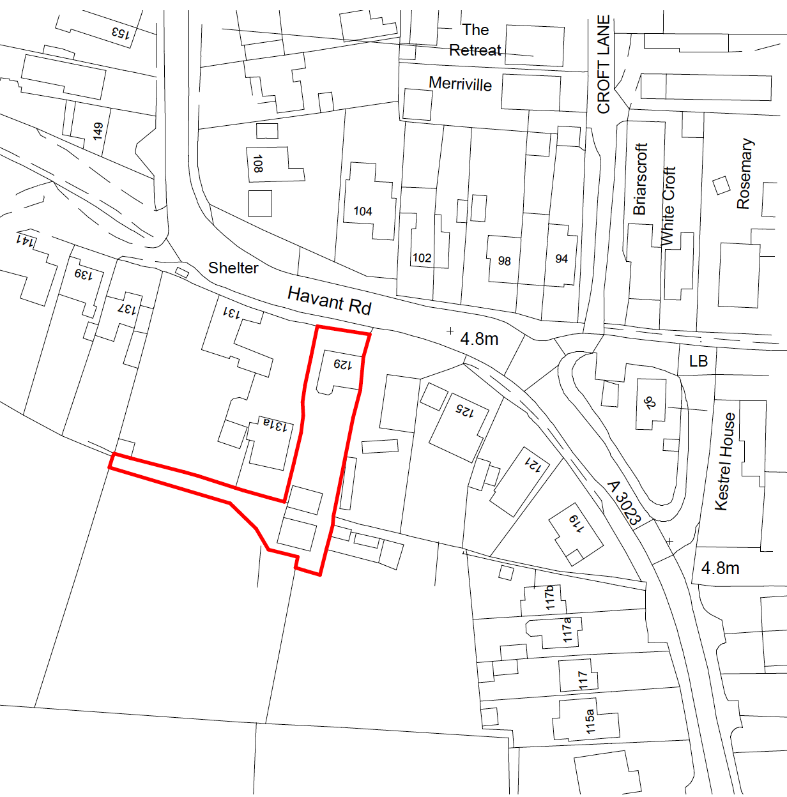

The proposal refers to the more northern of the two buildings at the south end of the site (see below)

Skip
Hedging

Storage area
Storage area

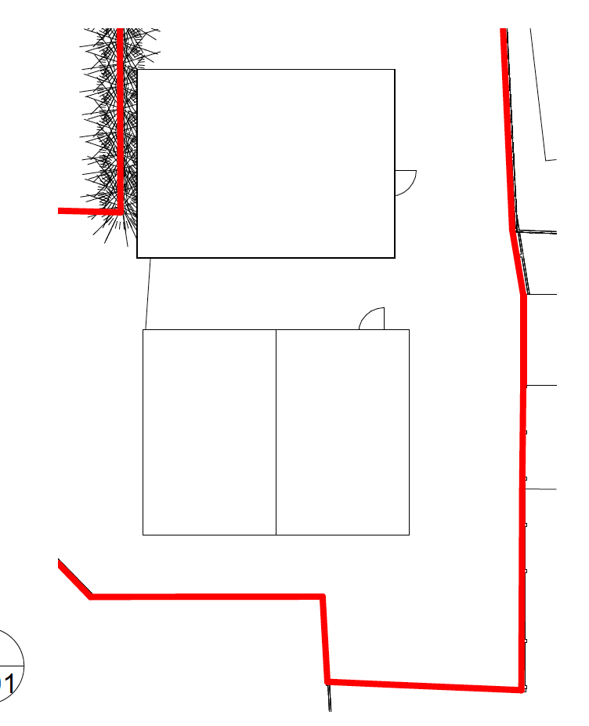
Heras
Fencing
Barn
Proposal
Building

Project description

The project is to turn the existing single storey flat roofed building into a larger two storey chalet style building to provide additional accommodation in the roof space

Environmental impacts and management

The build is expected to take around 6- 8 weeks during that time the following measures will be put in place to address the concerns listed

Use of fences and barriers to protect adjacent land
The extent of the rear perimeter of the site to the horse fields will be secured with fixed Heras fencing. This will make the site safe secure and avoid possibility of vehicles and operatives straying onto this area.

Storage of Materials
Materials will be stored on the existing hard stand area to the north of the proposed annex building This will allow direct access for deliveries all of which will be accessible via the existing concrete driveway thus avoiding vehicles gathering mud, generating dust and taking it onto the highway. This area is also secure

Dust reduction
Particular care will be taken to maintain dust emissions at a practicable minimum when working in this environmentally sensitive area. Best practice mitigation will be followed during dry conditions,

Dust reduction measures will include:
careful management sand soil and gravel so it is delivered to site on an as needed basis
sheeting loose materials on site
ensure all delivery vehicles stay on the concrete driveway
ensure that any area where a mini digger is working is dampened in dry conditions
visual monitoring will be carried out on a daily basis
No groundworks or construction will commence on site before a suitable and adequate water supply has been made provided & made available for use in the mitigation of construction impacts.
Toilet facilities,
A working toilet will be provided for use by the construction operatives whilst work is in progress.

Management of construction waste on site

A covered (netted) skip will be provided at all times to contain construction waste, this will be replaced whenever full.

Noise and vibration
Measures will be employed to control the emission of noise & vibration especially during the ground works and the construction phase, there will be no piling and no use of percussive tools. The only plant on site will be a mini digger at the early stages of the project
In addition the work will be undertaken between April and September to avoid disturbance to the Winter Bird Migration areas

Conclusion.
We believe the listed measures will ensure the project has minimal impact on the surrounding land and natural environment

