

Design & Access Statement

D0704 204 NatWest Leigh Park Havant ADV

Planning Portal Reference Ref: 05579266
Styles & Wood Ref: D0704-204 NatWest Leigh Park Havant ADV

Advertisement Consent

Date: 31.10.2016
Author: JL Version:1.0

Styles & Wood Ltd
Cavendish House, Cross Street, Sale, Trafford, M33 7BU T: +44 (0)161 926 6146

Contents

- Introduction
- Policy Context
- Statement of Significance
- Impact Assessment of the Proposed Development
- Response
- Need and benefit of the proposal.
- Conclusion

Registered in England No.1568060

Introduction

  - This design and access statement has been prepared by Styles and Wood Limited on behalf of The Royal Bank of Scotland (RBS), (the applicant) and is submitted in support of an application for advertisement consent for the installation of two new ATM and ATM surrounds at Leigh Park, Havant, 2 Park Parade, Hampshire, PO9 5AF.

Policy Context
    - NPPF

- Statement of significance

    - Leigh Park, Havant
      - Leigh Park is a large suburb (population 27,500) of Havant, in Hampshire, England. It currently forms the bulk or whole of four electoral wards: Battins, Bondfields, Barncroft and Warren Park

The site
        - The property is located at 2 Park Parade, Leigh Park Havant.

Immppaacctt AAsssseessssmmeenntt ooff tthhee PPrrooppoosseedd DDeevveellooppmmeenntt

  - Thhee ffoolllloowwiinngg sseeccttiioonn aasssseesssseess tthhee iimmppaacctt ooff tthhee pprrooppoosseedd ddeevveellooppmmeenntt uuppoonn tthhe buuiillddiinngg aanndd wwiiddeerr ccoonnsseerrvvaattiioonn aarreeaa.. VViissuuaall iimmppaacctt, ssccaallee,, ddeessiiggnn,, mmaatteerriiaallss,, ppoossssiibbllee hhaarrmm aanndd rriisskk ttoo tthhee bbuuiillddiinngg..

  - Thhee pprreemmiisseess pprroovviiddeess aan ATTMM sseerrvviiccee.. TThhee pprrooppoossaallss ddoo nnoott aalltteerr tthhee eexxiissttiinngg uussee.. TThhee oovveerraallll ssccaalle ooff tthhee buuiillddiinngg wwiillll rreemmaaiinn uunncchhaannggeedd bbyy tthhee pprrooppoossaallss.. TThhee pprrooppoossaallss mmaakkee n no cchhaannggee ttoo tthhee eexxiissttiinngg fflloooorr ssppaaccee.. TThhee pprrooppoosseedd ddeevveellooppmmeenntt sshhaallll hhaavvee nnoo aaddvveerrssee immppaacctt oonn tthhee cchhaarraacctteerr aanndd aappppeeaarraannccee ooff tthhee aarreeaa ttoo wwhhiicchh iitt iiss ssiitteedd.. TThhee prrooppoosseedd ddeevveellooppmmeenntt hhaass rreessppoonnddeedd ttoo tthhee nneeeedd ttoo pprreesseerrvvee tthhee cchhaarraacctteerr aanndd sseettttiinngg ooff tthhee bbuuiillddiinngg aanndd tthhee wwiiddeerr aarreeaa.

  - TThhee llooccaattiioonn ooff tthhee AATTMMcollars hhaass bbeeeenn ddeessiiggnneedd ttoo eennssuurree tthhaatt tthhee iimmppaacctt ooff tthhee pprrooppoosseedd ddeevveellooppmmeenntt oonn tthhee bbuuiillddiinngg iiss mmiinniimmiisseedd bbyy wwoorrkkiinngg wwiitthh tthhee eexxiissttiinngg aappeerrttuurrees ..

  - TThhee iimmppaacctt oonn tthhee eelleevvaattiioonn bbyy tthhee pprrooppoosseedd AATTMM wwiillll nnoott bbee ddeettrriimmeennttaall ttoo tthhee eexxiissttiinngg cchhaarraacctteerr ooff tthhee eelleevvaattiioonn.. TThhee vviissuuaall iimmppaacctt iiss aaiimmeedd aatt hhiigghhlliigghhttiinngg tthhee pprreesseennccee ooff tthhee AATTMM ttoo ppeeddeessttrriiaannss aanndd rreeiinnffoorrcciinngg tthhee cclliieennttss pprreesseennccee wwiitthhiinn tthhee sare aanndd uuppggrraaddiinngg tthhee eexxiissttiinngg oobbssoolleettee AATTMM.. TThhee pprrooppoossaallss iimmppaacctt oonn tthhee aappppeeaarraannccee ooff tthhee bbuuiillddiinnggss eelleevvaattiioonn wwiillll bbee minimal anndd wwiillll nnoott mmaatteerriiaallllyy aalltteerr tthhee ssiizzee aanndd ssccaallee ooff tthhee bbuuiillddiinngg,, iinncclluuddiinngg iittss ffoooottpprriinntt.. TThhee pprrooppoossaall wwiillll nnoott aalltteerr tthhee ddeessccrriippttiioonn ooff tthhee ddeevveellooppmmeenntt oorr tthhee oowwnneerrsshhiipp aarreeaa ooff tthhee aapppplliiccaattiioonn.. TThhee AATTMM wwiillll bbee aacccceessssiibbllee ttoo tthhee vvaarryyiinngg ddeeggrreeeess ooff mmoobbiilliittyy..

5.. RReessppoonnssee

a) Thhiiss AATTMMadvert pprrooppoossaall sseeeekkss ttoo ssuussttaaiinn tthhee asssseettss bbyy mmaaiinnttaaiinniinngg aan ATM service in this location.

b) Thhiiss pprrooppoossaall wwiillll nnoott hhaavvee aann aaddddiittiioonnaall aaddvveerrssee iimmppaacctt uuppoonn tthhee vviieewwss wwiitthhiinn tthhee arreeaa..

c) Thhee pprrooppoossaall ddeemmoonnssttrraatteess tthhee ccoommmmiittmmeenntt ooff tthhee ooccccuuppiieerr ttoo pprroovviiddiinngg aa hhiigghh quuaalliittyy ddeessiiggnn ttoo tthhee rreessppeeccttiivvee eelleevvaattiioonn ooff tthhee bbuuiillddiinngg..

- Need and benefit of the proposal.
  - Presently RBS are undertaking an extensive rebranding programme throughout their entire branch and stand alone ATM vending networks. This is to improve and reinforce their presence on the high street, providing a quality aesthetic to the town and cityscapes in which they are based, reassuring the customer that they care about their overall banking experience. RBS’s intention is to renovate the existing tired shopfronts, replacing the external shopfront signage and replacing some ATM modules so that they are accessible for all.

  - At this location the banking group wish to install two new ATM and signage to two existing ATMs.

  - RBS proposes to increase the height of the existing ATMs to ensure maximum user accommodation relative to the UK design Guidelines “ACCESS to ATM’, published by the centre for Accessible Environments in the UK (CAE), the ATM must be installed with the middle of the number 5 key on the key board, no higher that 900mm from the sidewalk level.

- Conclusions

  - The site benefits from existing planning permission granted for the existing ATM.
  - This proposal provides and highlights the availability of financial services to the immediate and wider community.
  - The provision of financial services uses in that location is supported. The proposed development will not affect the features of public amenity and public safety and will therefore not result in significant harm or impact.
  - Therefore, it is considered that advertisement consent should be granted for the proposed development and the proposal is recommended to the Council for approval.

- Appendices - see planning application supporting document.

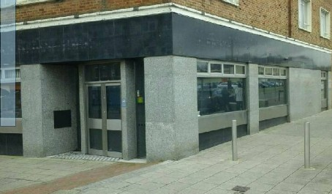
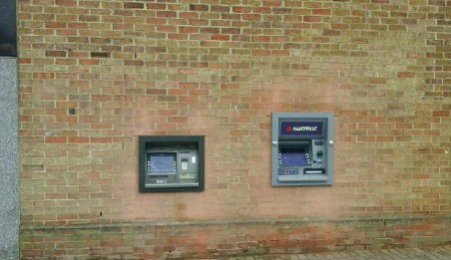
- Photo

Registered in England No.1568060

