Design Access & Heritage Statement for the impact of back land development on 70 Havant Road Hayling Island and the Granary Havant Road Hayling Island.

Background
Hayling Island is separated from the mainland by a narrow channel, traditionally know as Sweare Deep. It is accessible from Havant via a bridge at Langstone. Hayling Island is situated to the south of Havant. It lies between Chichester Harbour to the east and Langstone Harbour to the west. it can be accessed from Portsea Island by foot ferry.
Havant Road is the main road on to Hayling Island that runs north south for two thirds of the Islandof the island. As the name suggests, the coast is immediately to the south.
The site is located on the south side of the stoke area which is mainly residential and to either side of the Havant road.
Site Access
We believe access to the site can be achieved within the parameters of the highway authority guidelines as per drawing A102 attached to this application
Hedging and Trees
It should be noted that no trees will be effected by this application and also a minimal amout of hedging will be removed with most been retained as the boundaries to the new properties

Cotterell Farmhouse History

70 Havant Road, Stoke, Hayling Island PO11 0LH known as Cottrell Farmhouse is a Grade 2 listed building . Listed in 1976 it has the English Heritage Reference Building ID of 135364.
The House is listed as a late 18th century brick building with tiled roof
The listing refers to the front elevation

‘Symmetrical front (west) of 2 storeys 2 windows Brick walling in blue headers with red flush dressings eaves fascia, rubbed arches(openings narrowed), vertical bands and quoins (projecting ) first floor band, cill height plinth. Early 19th century sashes canopy on brackets above a plain doorway’

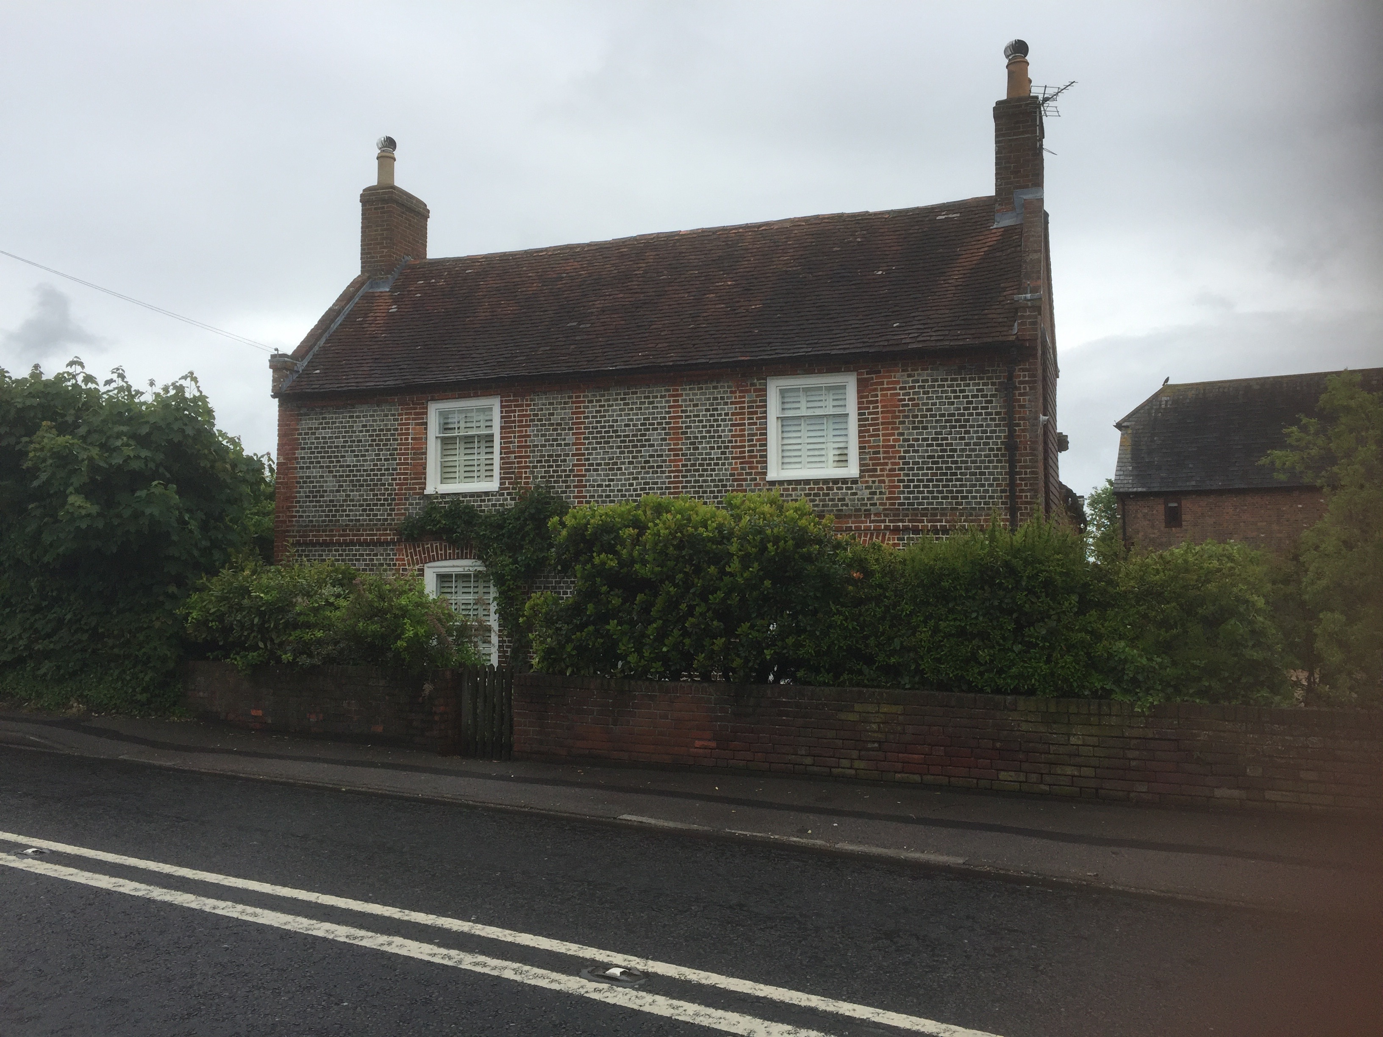

Location and Design

The proposed development will be to the side (north of the property) as per Plan A101 and the photo over

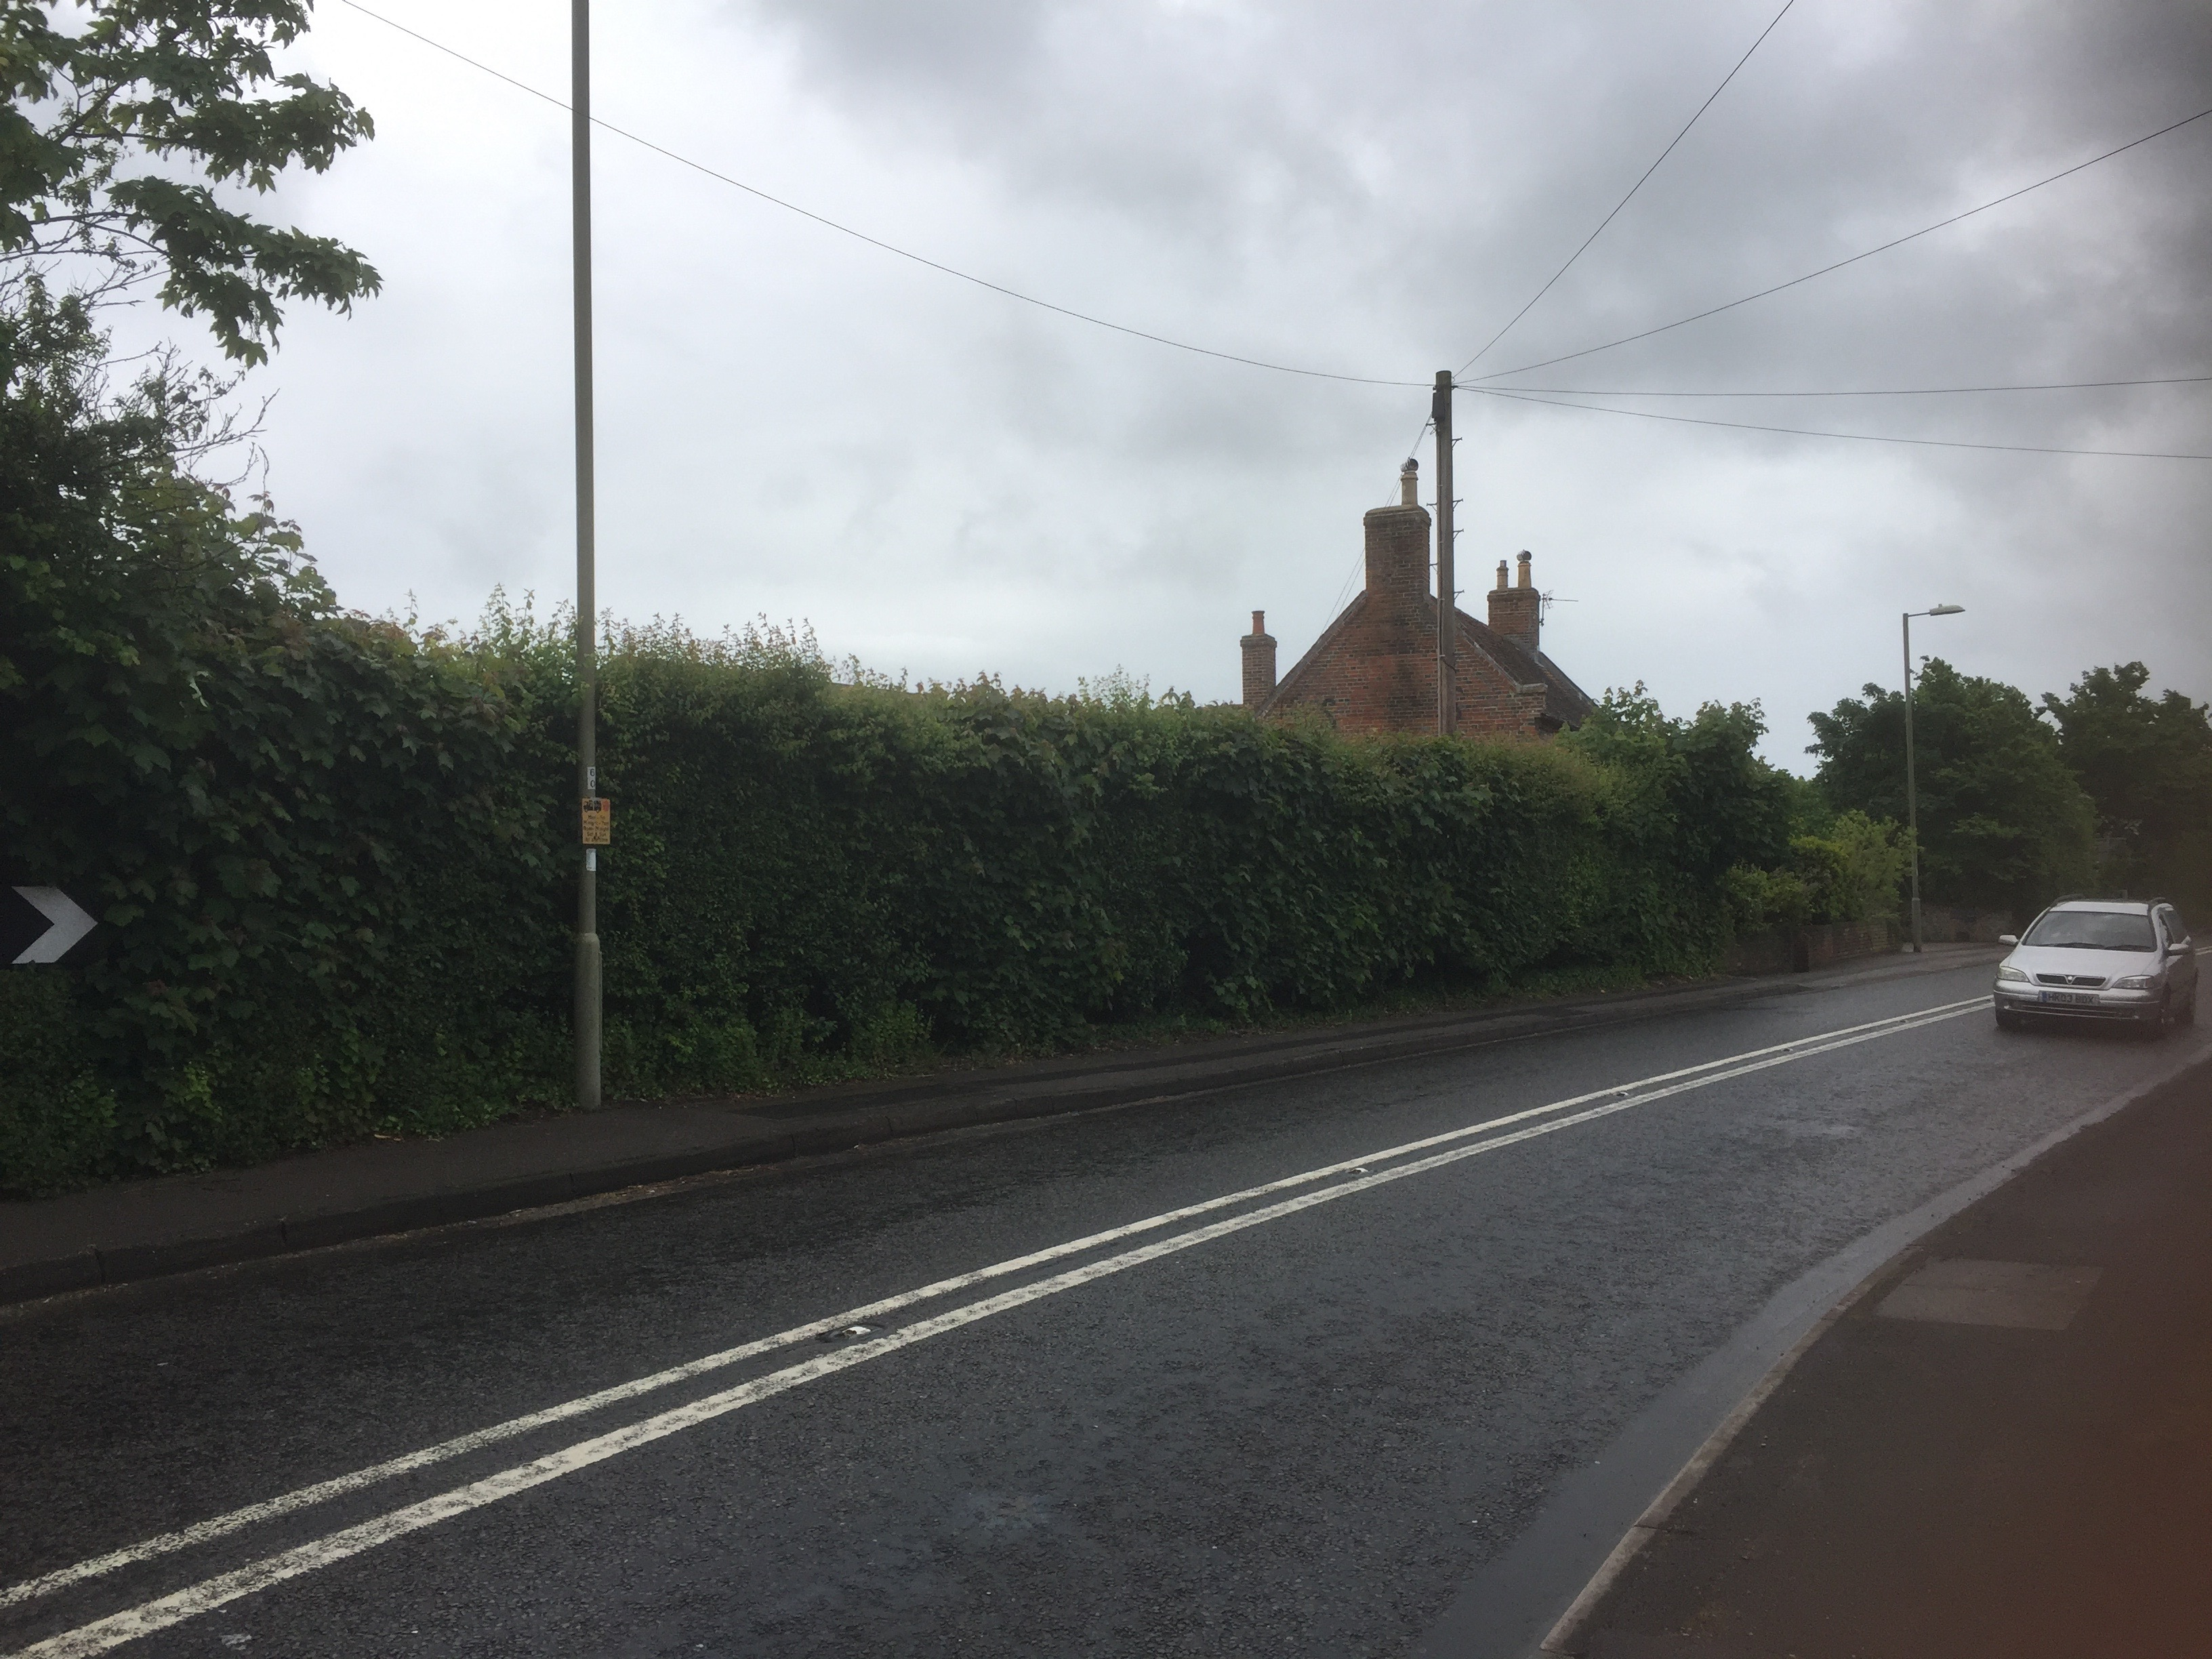

The development will only have one property that is visible from the Havant Road and thus has an impact on Cotterell Farmhouse. The garden of the farmhouse is to the side /north of the Property and is in excess of 33m long, once the development is in place the garden of the farmhouse will still be in excess of 10m long and thus the closest the new building will be is 12.6m to the farmhouse.

The proposed building that faces Havant road and is to the side (north) of Cotterell farmhouse will be designed in the style of the farm house using decorated brick and a gable to gable tiled roof as per the property opposite (see photo over)

