H.M. LAND REGISTRY |  |  |  | TITLE NUMBER
 |  |  |  | HP429450
ORDNANCE SURVEY PLAN REFERENCE | sz 7498 | HA |  | SECTION H | Scale  I/ 1250 Enlarged from 1/2500
COUNTY HAMPSHIRE DISTRICT |  | HA | VANT |  | © Crown copyright 1976

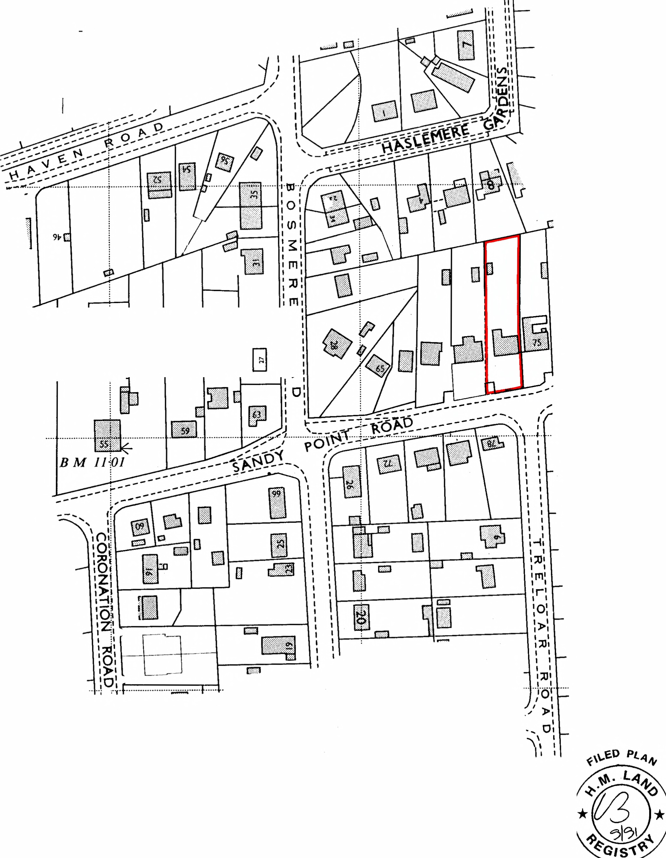,,
,1
II
_JL II
II
11 II II

--

Tennis lJ
Co~rt
0
),

This is a copy of the title plan on 4 AUG 2015 at 22:19:54. This copy does not take account of any application made after that time even if still pending in the Land
Registry when this copy was issued.

This copy is not an 'Official Copy' of the title plan. An official copy of the title plan is admissible in evidence in a court to the same extent as the original. A person is entitled to be indemnified by the registrar if he or she suffers loss by reason of a mistake in an official copy. If you want to obtain an official copy, the Land Registry web site explains how to do this.

The Land Registry endeavours to maintain high quality and scale accuracy of title plan images.The quality and accuracy of any print will depend on your printer, your computer and its print settings.This title plan shows the general position, not the exact line, of the boundaries. It may be subject to distortions in scale. Measurements scaled from this plan may not match measurements between the same points on the ground.

This title is dealt with by Land Registry, Weymouth Office.

© Crown Copyright. Produced by Land Registry. Further reproduction in whole or in part is prohibited without the prior written permission of Ordnance Survey. Licence Number 100026316.

