Design and Access Statement for 3 Burgess Road Hayling Island
PO11 9QT

This application if for the extension and conversion of this 3/4 bedroom dwelling into two number two bedroom homes.
The property is in Burgess road off Eaststoke avenue on the south eastern point of hayling island. The area is mainly residential and whilst Burgess close is at present all detached dwellings the area as a whole is a mix of detached and semi detached dwellings with some flats closer to the seafront.
The existing house sits on a wide plot with land to either side of the house .
The proposal is to add a side extension to the North elevation of the property which would come to just over 1m from the existing boundary this would create the same relationship with number 2 Burgess close as is already in place between numbers 3 and 4 Burgess close. (see photo)
The new rear garden to both properties would retain their existing length of 6.65m and would be 70m2 for the northern property and 78m2 for the southern property.
Parking to the properties would be to the front of the buildings with the Northern property having two parking spaces and the southern property utilising the existing drive and garage.

Pre application advice was sort for this application. As per the attached letter Ref GEN/16/00289. In the response reference was made to the National Planning policy framework and to the presumption in favour of sustainable development. Especially in terms of the re use of previously developed land.
The response also refers in some detail to the quality of design being part of sustainable development.
The response is then broken down into several areas which are dealt with separately below
The impact on the character and appearance of the street scene
This paragraph recognises that there would be little impact on the street scene although it does make reference to the increased hard stand for the northern property. This seems somewhat harsh considering that number four burgess close next door to the property has almost all its frontage laid to hardstand and number 7 burgess close does have its whole frontage as parking. The response does go on to say however that this concern would not warrant a refusal of the application.
Nature of Development
This paragraph refers to the layout of the properties being cramped and congested and highlights the borough design guides recommendation for a minimum garden length of 10m, it then goes on to say that the parking in front of the building would appear cramped
This section seems to be key to the concerns the officer has with the proposal however we feel this viewpoint is again somewhat harsh
With regards to the length of the rear garden yes it is short of the design guides recommendation of 10m however it is in context with all the gardens in that row of houses all of which are the same depth. The proposal does not shorten the length of the garden in any way and does not involve an extension to the rear wall of the existing property. In addition the size of the gardens (70m2 for the property to the North and 78m2 for the property to the South) fall at the top end of recommended minimum garden sizes across UK borough councils which seem to range between 50 and 70m2 for a 2 bedroom property. It is interesting to note that the council have recently approved a development for 76 properties on station road in Hayling (app/15/00919) which offers gardens as little as 40m2 for two bedroomed properties falling well below accepted design practice.
Whilst we feel the garden is suitable for the property within its context we recognise that it would not be desirable for any extensions to be built to the rear of the properties in the future and as such would be happy to accept a restriction on any permitted development rights to the rear elevation of the building.
The reference to the site being congested is somewhat confusing as the garden can be accessed from the pavement by a meter wide path down the side of the house, we have however adapted this part of the design to allow front entry to the porch giving clear access to both the front door and the rear gate and allowing space for parking.
In addition it should be noted that other properties within the street scene have parking areas to the front of the buildings and garages and as can be seen by the street scene views, we do not believe this is to the detriment of the street scene.
The officers comments in this section with regard to the cramped appearance had already been discussed in the impact on the character of the street scene and as such did not warrant a refusal of the application.
Impact upon residential amenity
This section again talks about cramped nature of the site and bleak outlook for the residents of the site and failure to provide sufficient passive private recreational space.
Again we feel this is an excessive and harsh point of view, all the existing gardens in the row of houses have the same length gardens and the houses to the rear are single storey low pitch dwellings so light to the existing gardens is ample. The proposal would not bring any buildings closer together and the proposed gardens meet the minimum garden size recommended by the councils that stipulate a minimum size in their design guides. As such therefore we strongly disagree with the comments made in this section of the officers response.
We would however offer the additional condition of the existing 1.5m fencing being replaced with 1.8m fencing to provide increased privacy to the surrounding dwellings
Highways requirements
The proposal does provide two parking spaces for each dwelling and the hard stand areas have been discussed extensively earlier in this document

Conclusion
We believe this application offers good use of the site providing much required smaller two bedroomed properties, it has little impact on the surrounding properties as the length of the gardens is not shortened and the overall size of the gardens are within recommended design sizes. The fact that properties to the rear are low pitch single storey bungalows ensures that the gardens are not heavily overlooked and would be no more overlooked than they are at present.
The properties would fit well within the street scene and would not be out of context with surrounding properties. In reality we believe this application sits well with the NPPF recommendations of presumption in favour of sustainable development and do believe it offers a good design which is in context with its surroundings, and as such would ask the council to support the application.

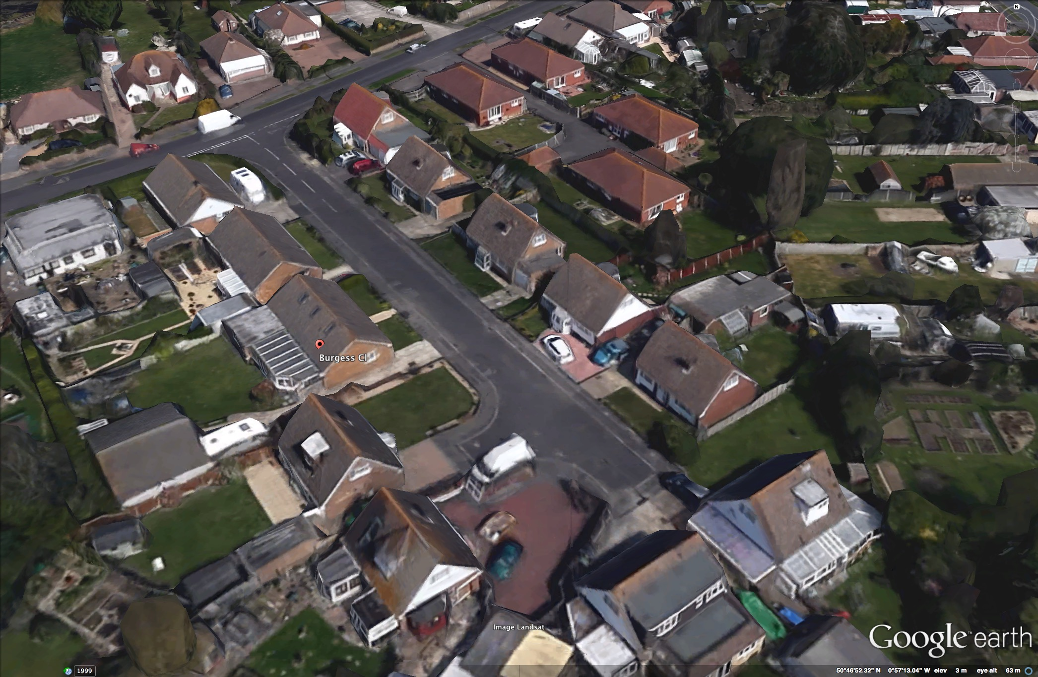
No 3

No 4
No 7

