

JACOBS FOREMAN
PROPOSED
RESIDENTAIL DEVELOPMENT

AT

Land South of Ranelagh Drive,
Havant. PO9 1NR.

CONSTRUCTION MANAGEMENT
PLAN

OCTOBER 2014

Prepared by:

Michael Avery
Jacobs Foreman Rev. A Jan 2015
01489 553384

INDEX

- Construction Lorry Routing

- Contractors Parking, turning and Deliveries

- Compound and Material Storage

- Welfare Facilities

- Wheel Cleaning Facilities

- Construction Programme

- Dust Suppression

- Burning On Site

- Hours of Work

- Management of Open Space and SUDS Scheme.

- Construction Lorry Routing.

A lorry routing plan has been prepared for the site as shown below.

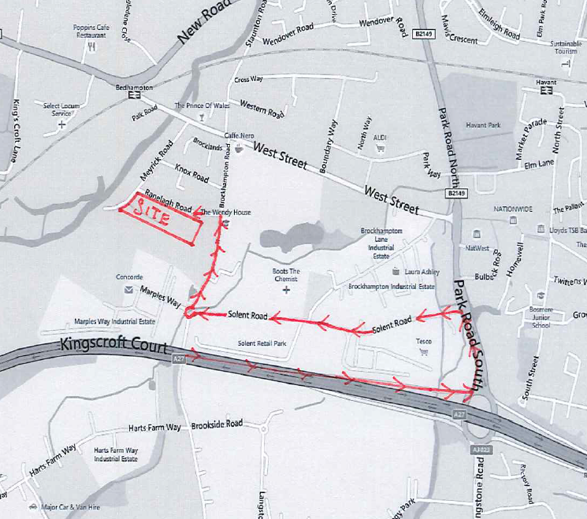

The proposed route for all deliveries is to be from Park Road South, into Solent Road to the roundabout with Marples Way. At this roundabout deliveries proceed along Brockhampton Road, turning into Ranelagh Road and approach the site entrance.

This route through the trading estate at Solent Road is considered the least intrusive to
the surrounding residential area.

An alternative route suggested is as follows:

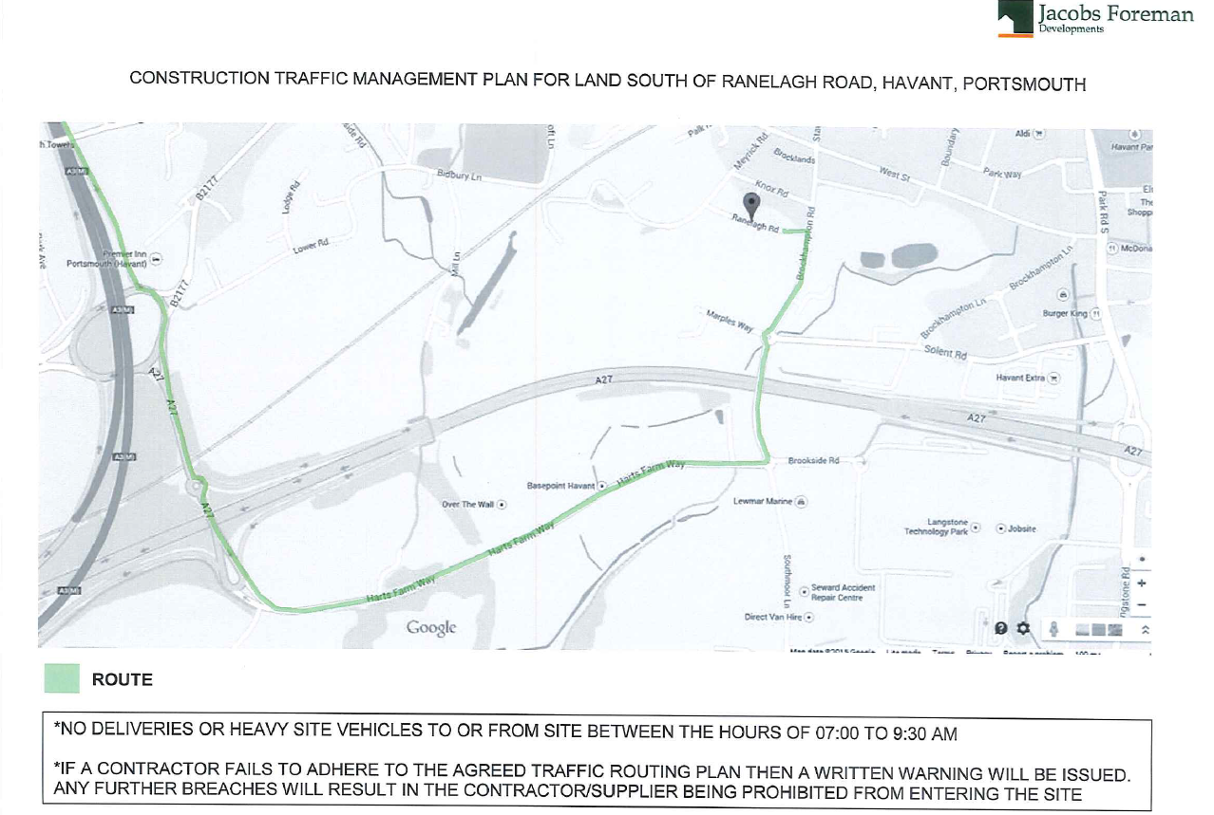

- Contractors Parking, Turning and Deliveries.
- Compound and Materials Storage.
- Welfare Facilities

A site set up drawing has been produced SS/RR/02 which shows a compound set up to the rear of the site which has been designed to accommodate contractors parking and delivery and storage of materials. Turning of vehicles will be within the site confines once the preliminary road system is in place which will be one of the early areas to be constructed.

The compound will be used to house the site cabins and welfare facilities.

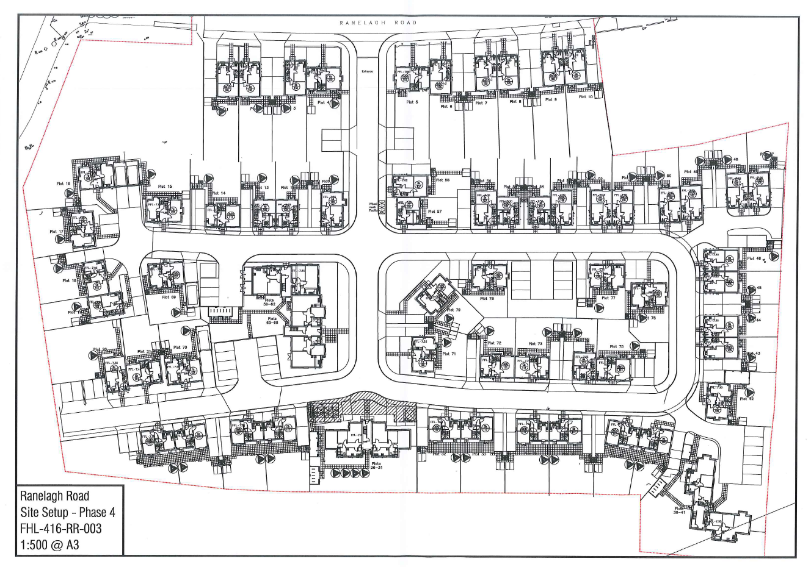

- Wheel Cleaning Facilities.

Jacobs Foreman operates a proactive approach to prevent the spread of soil outside the site boundaries. Temporary hard running surfaces or road construction to base course tarmac are installed at the earliest practical stage of construction, normally whilst the first dwelling superstructures are being undertaken. This ensures all vehicles leaving site are directed over clean surfaces. The running surfaces are subject to road cleaning at least once a week and more if necessary.

It is inevitable that a degree of soil will be deposited on vehicle wheels and each site is equipped with a pressure washer and a labourer or a contractor are assigned to clean vehicles wheels as required.

Notices will be displayed to this effect.

- Construction Programme.

The construction programme for the site is split into four phases and the programmes and phasing plan are enclosed.



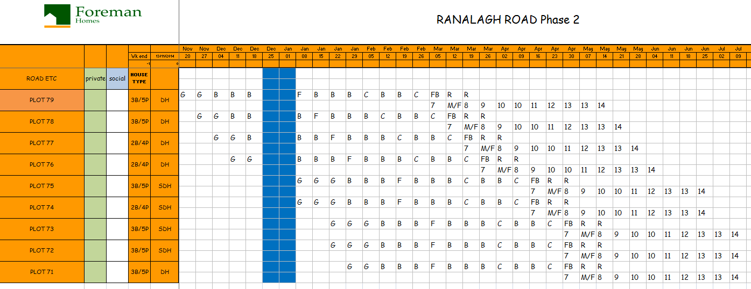

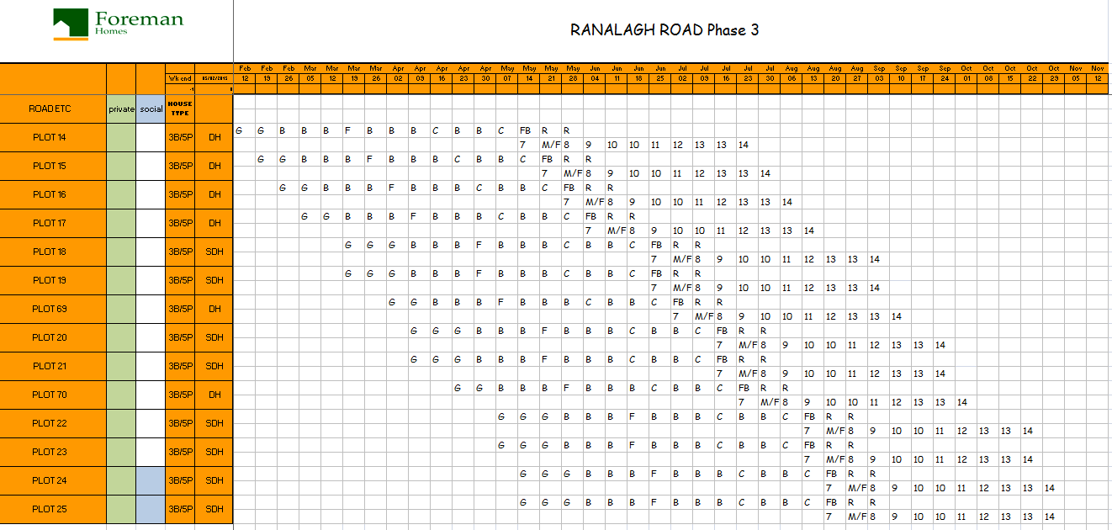

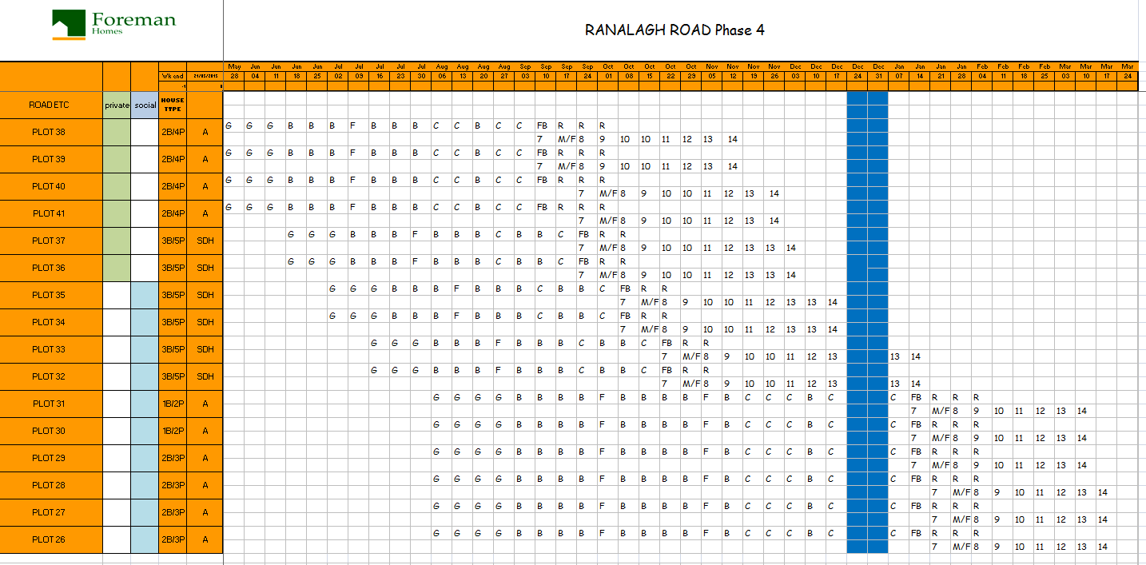

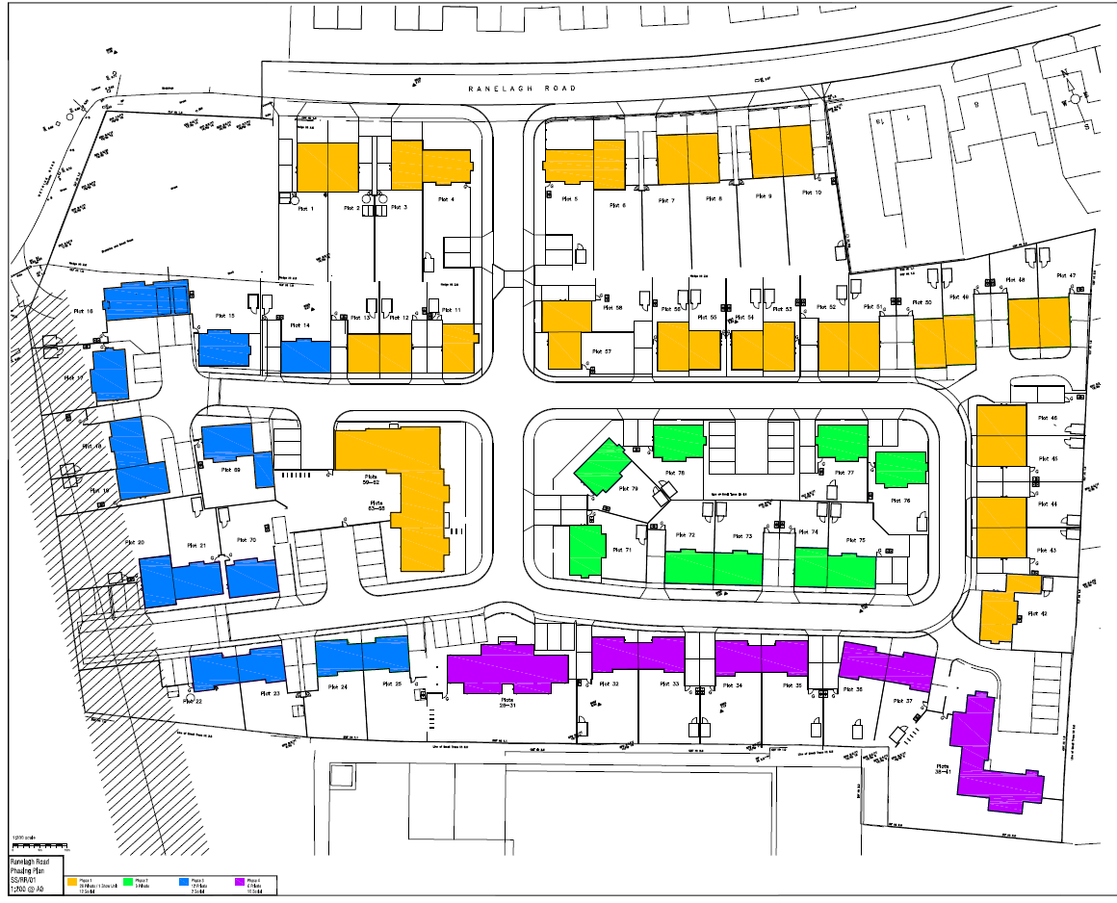

- Construction Dust method Statement

During periods of dry weather all surfaces capable of producing dust shall be dampened to minimise the spread of dust. All machinery, hand or otherwise capable of producing dust shall be fitted with adequate collection bags or fitted with a hose attachment to collect or dampen the dust produced.

Any activity likely to produce an excessive level of dust shall only take place after carrying out the necessary risk assessment and implementing any precautions to control and prevent dust from spreading.

- Burning on Site.

There shall not be permitted the burning of any materials on site during any phase of the development.

- Hours of Work

Demolition, clearance, excavation, road or construction works shall only take place between the hours of 08.00 and 18.00 hours on Mondays to Fridays and 0.800 and 13.00 hours on Saturdays and not at all on Sundays and all recognised public holidays, unless in association with an emergency.

- Management of Open Space and SUDS Scheme ( Not Receptor Area)

Establishment Maintenance
Maintain all soft landscape works for a defects liability period for 12 months from practical completion. Allow 12 visits.

Tree Plantings – Standard Planting Size.
Irrigate thoroughly during dry periods, sufficient water to be provided to ensure the tree pit reaches field capacity of 25L water per tree poured down the irrigation tube. Sufficient water to be provided to ensure growth of at least 66% previous years shoot elongation p.a.
Inspect and remove any damage leaving clean cuts.
Inspect tree ties and readjust as necessary to give sufficient room for stem thickening, ensure no chaffing. Reaffirm as necessary.
Ensure base of tree for 1m diameter is weed free at all times.
Gap up trees to original specification as necessary.

Shrub & Climber Plantings.
Weed to achieve clean ground, water to ensure good growth.
Reaffirm and prune as necessary. Remove any dead material to shrub beds.
Re tie climbers to supports as necessary.
Remove litter from beds as necessary.
Gap up shrubs and climbers to original specification as necessary.

Hedgerow Plantings.
Weed to achieve clean ground.
Reaffirm as necessary.
Lightly trim back annually until desired height and width reached.

Lawn Areas
During establishment of grass areas ensure that sufficient water is applied to maintain healthy growth using, if permitted, a fine sprinkler/ oscillating sprayer etc
Mow grass areas so height of turf does not exceed 75mm at any time. Arisings to be removed from site. Ensure no grass cuttings remain on hard surfaces.
At the time of each cut trim all grass edges
Remove litter where necessary.

Handover at end of 12 months maintenance period
Tree pits to be weed free, clean and tidy, mulch topped up, stakes removed. Trees thriving with no dead, diseased or damaged material. All works complete.
Shrub beds to be weed free, clean and tidy, fully gapped up, organic bark mulch topped up. All works complete. Hedges to be freshly trimmed and climbing plants firmly attached to supports.
Turf to be freshly mown and all edges trimmed,
Hard surfaces to be swept and cleaned.
All works to be complete and in a well maintained clean and tidy condition.
All planted areas to be weed free, tidy and free of litter.
Organic bark mulch to be topped up as necessary to maintain 75mm depth.
All existing trees to be kept clear of dead wood and diseased wood.

Note
The 12 month maintenance period shall commence following a satisfactory inspection and this shall be once all works have been completed and there is full grass cover on seeded

SUDS Pond Maintenenace

Regular maintenance, that is sympathetic to wetland biodiversity interests, is an important part of any management plan. Ponds need to be periodically cleaned out to prevent them becoming gradually in-filled by sediment and accumulated vegetable detritus.

The aim of the management which is targeted at maintaining the wildlife value of the pond is to maintain a number of habitat types and a high diversity of plant and animal species.

Due to the position of this pond consideration should be given to non mechanical maintenance. The pond should be maintained once a year to ensure continuation of the plant and animal species and should be carried out one bank at a time with one week intervals between any bank works. The pond should be cleared with long –tined forks and the banks thinned only to ensure any plant life depth is maintained. Grass areas should not be cut short adjacent to the banks. Any removal of sediment should be considered on a five yearly basis due to the size of the ditch and only carried out if water levels are falling due to sediment build up.

