Staunton Farm – Planning Support Statement

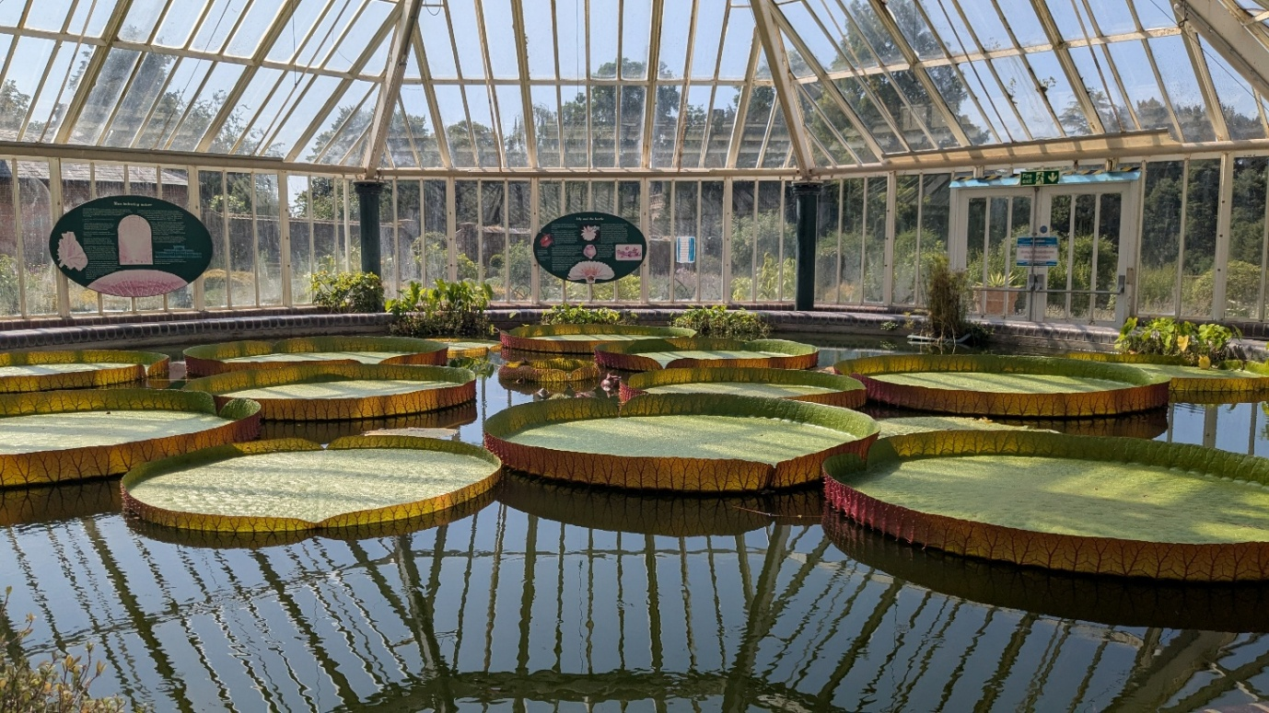

Works Proposed to Lily Pond and Potting Shed
P14474
July 2025
Please read in conjunction with Heritage Statement

Prepared by:
Corporate Estates Team, HCC Property Services,
Elizabeth II Court, Winchester, Hampshire, SO23 8UD
Planning application – Design, Access & Supporting Statement, Rev A.

Property Name: Staunton Farm

Property Address: Middle Park Way, Havant, PO9 5HB
Works: Careful Demolition of Potting Shed and Sympathetic Repairs to Lily Pond

- Existing Building and Site
Site Description
Staunton Country Park and Farm covers 400 hectares of land and is divided in two by Middle Park Way. It is a conservation area deemed to be of national importance and is registered Grade II* in the English Heritage Register of Historic Parks and Gardens. Within the park there are ten listed structures (of Grade II and II*).
The area South of Middle Park Way is the paid farm attraction which includes an ornamental farm (Ferme Ornee), walled garden, glasshouse, Gothic Library and Regency Farmhouse.

Historical Context
In 1819 the Estate was purchased by Sir George Staunton, with whom it has become chiefly associated. He added to the land and began the process of designing the Pleasure Grounds, remodelling the landscape on a grand scale. He renovated and extended the house, adding the Gothic Library to accommodate the many books and Chinese manuscripts collected on his travels.
The structure of the landscape is in the tradition of the 18th century natural landscapes overlaid with a picturesque approach, which reflects the new aesthetic concepts which emerged in the early 19th century. Of particularly high quality is the lake and its adjoining landscape. The lake has retained its character of water, tree belts woodland and undulating grassland, with the beauty of the grouping of its remarkable natural and man-made features unchanged. Over time, most of the follies have been lost, and only the Chinese Bridge, the Shell House, the Beacon and the Island Fort survive today. Present proposals for the demolition of the potting shed and sympathetic repairs to the lily pond seek to accentuate the original beauty of the grounds.
Following the death of Sir George Staunton in 1859 the estate was purchased by William Stone. He demolished Staunton's Georgian mansion and built a new Gothic style mansion overlooking the lake, which in turn was demolished in 1959. However, the terrace remains and occupies the most stunning location in the Pleasure Grounds. The handsome Victorian coach house also remains intact and is a lasting reminder of the Stone period.
Stone sold the estate to Sir Frederick Fitzwygram in 1875. Fitzwygram's high standards ensured that the estate was very well maintained. Following Sir Frederick's death in 1904 the Estate remained within the Fitzwygram family until it was purchased by Portsmouth City Council in 1944. Prior to this the Estate had been requisitioned by the Admiralty Mines Department (1940 to 44). By this time most of the original range of glasshouses had disappeared and large tracts of estate land had already been sold to Portsmouth City Council for development (West Leigh and Leigh Park (1936)). By the 1950's the South Gardens were separated from the North Pleasure Grounds by the construction of Middle Park Way.
In 1987 Sir George Staunton Country Park was officially opened to the public. The Park was managed as a partnership between Hampshire County Council, Portsmouth City Council, Havant Borough Council, Portsmouth Water Company and East Hampshire District Council. During this time a series of restoration projects were undertaken. These included the Terrace (1988); footpaths and gates (1990); the Coach House and some of the glasshouses (1992); Tea Rooms and the Regency Farmhouse (1994); and the Gothic Library roof (1995). In 2003 Portsmouth City Council withdrew from the partnership arrangement selling its freehold interest to Hampshire County Council. A grant from the Heritage Lottery Fund in 2001 enabled the restoration of the South Gardens and the Ferme Ornee.
The potting shed is located to the rear of the glasshouse structure within an area that is currently not accessible to the public. The lily pond is located within the glasshouse structure itself, having hosted the Giant Amazon Waterlily displays each year; a tradition founded by Sir George Staunton.

2.0 Brief
The potting shed, which incorporates a corrugated asbestos sheet roof, is in a poor state of disrepair and is currently structurally propped to prevent the risk of imminent collapse. This poses a threat to staff operating in the area. The shed is only used for storage and is not accessible by the public, so bears no profitable use to the site and does not add significant historical interest to the grounds. The proposed removal of the shed will remove the immediate health and safety risk, as well as provide the opportunity to exhibit more of the Grade II Listed garden wall.

The Lily Pond is located within the glass house of the gardens. It is predominantly brick built (circular masonry pond retaining dwarf wall) on a concrete slab. Although the existing brickwork does not appear to be original, the pond has been present since the glass house’s development, where Sir George Staunton first displayed the giant Amazon Waterlily on the site, which had previously not been seen outside of Kew Gardens by the British public. This tradition is upheld by grounds staff each year, sourcing the seeds from South America and propagating them in order to display them to the public. The pond is now showing signs of leaking, causing concern for the welfare of the vegetation and tropical fish inhabiting it, in addition to creating a significant slip-risk to visitors to the building.

3.0 Design Principles
To reduce the risk posed to staff operating near the potting shed, whilst respecting the importance of the Grade II Listed garden wall.
1. Improve access surrounding the potting shed, by eliminating the structural risk.
2. Allow for the Grade II listed wall to be restored to its original aesthetic.
3. To improve upon existing features of the neighbouring structures to the potting shed.
4. Remedy leaks to the lily pond by carrying out sympathetic (like-for-like) repairs.

4.0 Design Solutions
The proposals are as indicated on drawings P14474-HCC-03 and can be summarised as follows;
1. Careful removal and safe disposal of the existing corrugated asbestos roof, along with the doors, electrical services, and any brickwork not a part of the Grade II Listed wall.
2. Stripping of the paint to the remaining Grade II Listed Wall and completing sympathetic repointing and repairs in like for like materials. All services obstructing the remaining wall will be relocated.
3. The 2no remaining doors will be replaced with weather-proof, timber alternatives in like-for-like colours.
4. Carry out sympathetic mortar repairs to the lily pond in like-for-like materials.

5.0 Access and Inclusion Principles
The Country Park generally consists of an ancient woodland, a landscape parkland, a lake, a series of heritage buildings and structures, a visitors farm, a series of connecting walkways / footpaths, a playground, a series of gardens for growing plants and food and car parking facilities. The proposed works are not expected to have an impact on the accessibility of any of the above-named features.
Legal position: The Equality Act 2010 brings together, harmonises and in some respects extends the current equality law. It aims to make it more consistent, clearer and easier to follow in order to make society fairer. The Equality Act replaces the Disability Discrimination Acts 1995 and 2005 (DDA). The changes include new provisions on direct discrimination, discrimination arising from disability, harassment and indirect discrimination. The Equalities Act 2010 and the duties of the owner and service provider will take into account of factors such as the nature of the site, its historic status, and what is ‘reasonable’ in terms of a fixed budget.
The Building Regulations (2010) Approved Documents M (2013) & K (2013) are the minimum standards of construction that should be achieved in terms of accessibility as part of this project, BS8300: Design of buildings and their approaches to meet the needs of disabled people, offers some alterative and higher standard design solutions which may also be referred to.

7.0 Buildings & Plant/Servicing
As shown in drawing P14474-HCC-03, the proposed works will lead to an existing internal distribution board being located on a now exposed external wall. This board serves rooms outside of the existing potting shed, so would need to be removed or relocated as part of the works. Upon consulting with our in-house electrical engineer, it was confirmed that this board powers the lighting and sockets within the rooms to be demolished and sockets within rooms 60 and 70. The electrical engineer confirmed the sockets within 60 and 70 are unused and in very poor condition and thus condemned them. Our proposal after this advisory notice is to remove these sockets and the distribution board, which has been confirmed by the site management team as acceptable to remove the risk associated.

8.0 Highways
Due to the nature of the existing potting shed’s use, its proposed demolition will not influence the public highway or visitor numbers to the site.

9.0 Environmental Protection Including Ecology and Biodiversity
The park features a wonderfully diverse range of ecological habitats, and the environment is home to many difference plants and animals including several protected species.
A comprehensive ecological consultation was commissioned at the start of the previous application to ensure that the ecology within the park will be protected and enhanced where possible.

10.0 Landscape Design
Although external works are proposed as part of this application, no trees or hedgerows will be affected.

11.0 Economic Impact Assessment
The farm, based on the 1830s style ferme ormeé (ornamental farm), is home to many different animals. Ranging from the everyday farm animal, like pigs, sheep, Shetland ponies, and chickens, to a selection of other animals such as llamas, a Poitou donkey and alpacas. Staunton farm provides an important visitor attraction for families to visit. The potting shed bears no financial value at present; the site would like to explore the opportunity of turning the disused area into a café terrace in years to come, allowing the Listed Garden walls to be adequately showcased. The Lily Pond holds a notable economic impact on the site, attracting visitors every year when the lily is in bloom, to which the sympathetic repairs would allow.

