11 Record Road,
Emsworth,
PO10 7NS

PHASE 1 BAT SURVEY
(Provisional roost assessment)

July 2025



Dr.Jonty Denton (Chartered Ecologist) FRES FLS MCIEEM CECol

Prepared by
Dr. Jonty Denton BSc (Hons) D(Phil) FRES, FLS, MCIEEM, CEcol
(Chartered Ecologist)
31 Thorn Lane, Four Marks, Hampshire, GU34 5BX
Phone: (01420) 565647 mobile: 07935594093
EXECUTIVE SUMMARY
Consultant Chartered Ecologist Dr.Jonty Denton FRES FLS MCIEEM CEcol was commissioned to undertake a Daytime Bat Assessment (Phase 1) of 11 Record Road, Emsworth, PO10 7NS. (GR: SU742060))

The Daytime Bat Assessment / Phase 1 Bat Survey was undertaken in accordance with the Bat Conservation Trust Guidelines (Collins, 2023) on 20th July 2025.

There was no evidence of historic bat activity in the property, and there are no accessible spaces for crevice roosting species. Therefore, the property has negligible potential and a Phase 2 bat survey is not required.

INTRODUCTION
This report presents the results of a phase 1 bat survey at of 11 Record Road, Emsworth, PO10 7NS. (GR: SU742060)).

Site Setting and Description
The property is a detached house dating to early 20th century situated to the east of Record Road in Emsworth (See figure 1). The plot is orientated west to east and is flanked to the north and south by other properties with small gardens (see figure 2). There are no large mature trees within 25m of the garden.
Chichester harbour SSSI/SPA lies 520m to the southeast and there is one woodland within 500m included on Priority Habitats Inventory (see figure 2).
The area supports habitats suitable for common bat species.

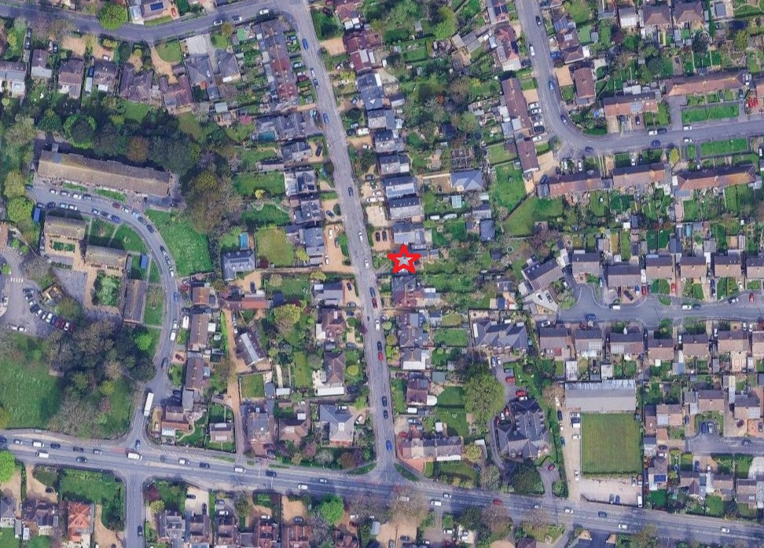
Figure 1. Site location. Courtesy of Google images

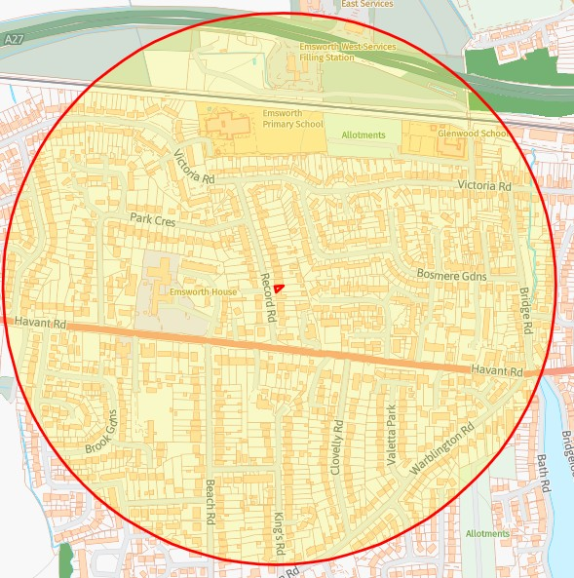
Figure 2. Priority habitats and designated sites within 500m. Courtesy of Magicmaps

Phase 1 Bat Survey Methods
The Daytime Bat Assessment / Phase 1 Bat Survey was undertaken in accordance with the Bat Conservation Trust Guidelines (Collins, 2023).

The Phase 1 Bat Survey was carried out on the morning of the 20th July 2025, and comprised of a daytime walkover of the site, internally and externally, to record evidence of any protected bat species.

Details of the survey methods are given below.

The property was investigated externally to identify potential bat access/egress locations and roosting areas such as gaps or holes between roof tiles, fascias and soffits and to record direct evidence of bat presence such as droppings and urine staining. This was followed by a detailed investigation of all accessible internal spaces to record evidence of bat roosting activity such as droppings, feeding remains, live animals, corpses, urine staining and fur staining. The building was assessed as to its suitability for supporting roosting bats. The survey conformed to current Bat Conservation Trust guidelines (Collins, (2023) Bat surveys for professional ecologists: Good practice guidelines 4th edition).
The details of the assessment criteria used to determine the ecological value of on-site attributes is outlined below. During the Phase 1 survey the assessment criteria are based on the potential for the site to support the species considered. However, in many cases Phase 2 surveys will be required to confirm presence /absence of any bat species and hence the importance of a population at the site, therefore the assessment of value should be considered as provisional.
Where possible, a provisional assessment of potential will be made although this may well require Phase 2 surveys to confirm status.

High Potential- High potential buildings are those that have features highly suitable for use by roosting bats, including gaps around soffits, hanging tiles, extensive roof spaces etc. High potential buildings are often, but not always, buildings of more historic construction. Further Phase 2 surveys will be required to confirm the presence/absence of bats.
Medium Potential- Medium potential buildings have a moderate number of features that may be utilised by bats for roosting, these may include loose fascias, roof spaces etc. Further Phase 2 surveys are likely to be required to confirm the presence/absence of bats.
Low Potential- Low potential buildings are those that provide limited bat roosting potential although some features that may be utilised by bats may be present. Further Phase 2 surveys are likely to be required to confirm the presence/absence of bats.
No/Negligible Potential – These are buildings that are extremely unlikely to support roosting bats due to the absence of suitable features. Further Phase 2 surveys are unlikely to be required for buildings with negligible potential.

Phase 1 Survey Timing and Weather Conditions
The Phase 1 bat survey was carried out on the evening of the 20th July 2025 which was calm and clear with 20% cloud cover, and an ambient temperature of approx. 18˚C.

Phase 1 Survey Equipment
During the Phase 1 survey the surveyor was equipped with 10 x 42 close focus binoculars and a high-powered torch.

RESULTS
Bats are fully protected under the Wildlife and Countryside Act 1981, as amended, and also receive additional protection via The Conservation of Species and Habitats Regulations (2010) from intentional killing and injury and from intentional damage, destruction or obstruction of access to a place of shelter. It is an offence to kill or injure a bat or interfere with any roosting or resting site. A bat roost is interpreted as "any structure or place used for shelter or protection" whether or not bats are present at the time or not. Barbastelle Bats, Bechstein’s Bat, Noctule, Soprano Pipistrelle, Brown Long-eared Bat, Greater Horseshoe Bat and Lesser Horseshoe Bat are also UK BAP Priority Species and SPI.

According to the DEFRAs MagicMap, no bat licences have been granted for properties within 500m; the closest is from 1km to the west issued in 2015 covering Soprano Pipistrelles.

External Assessment
The property has a single pitched roof faced with slates which are in good order. The soffits are of wood and closed off and the walls are of plain brick with no holes climbing plants etc. (see figures 3-6)

The rear has a flat-roofed extension face with felting which his attached to the walls with bitumen with no fascia (see figure 6). There were no enclose voids and the interior spaces permanently illuminated by side windows.

Internal assessment
The loft was accessed via a hatch on the landings. The roof is unlined, and the floor boarded out and used for storage (see figure 7). Daylight is visible in the under-eaves but there was no sign of historic bat activity. The timber frames are of sawn softwood nailed together leaving no crevices or gaps.

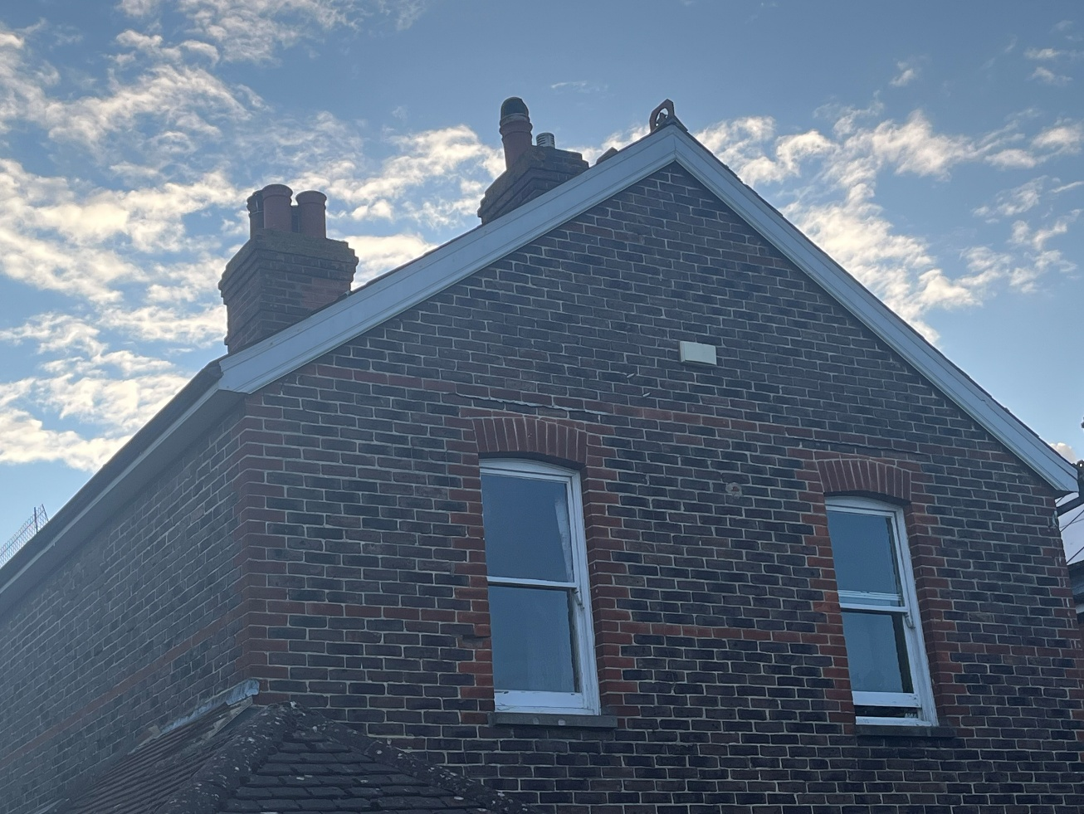
Figure 3. Eastern and southern elevations looking northwest.

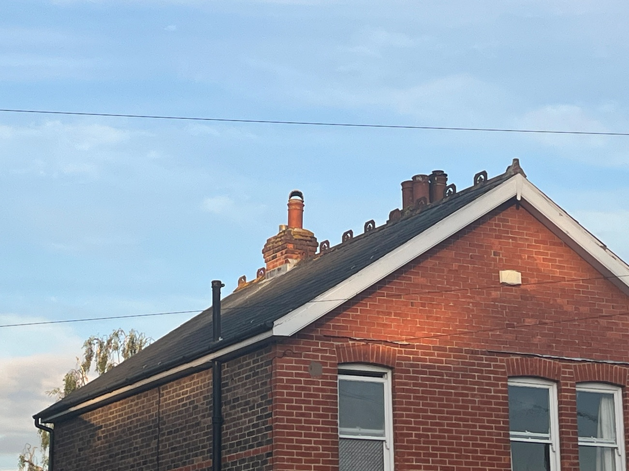
Figure 4. Northern and western elevations looking east.
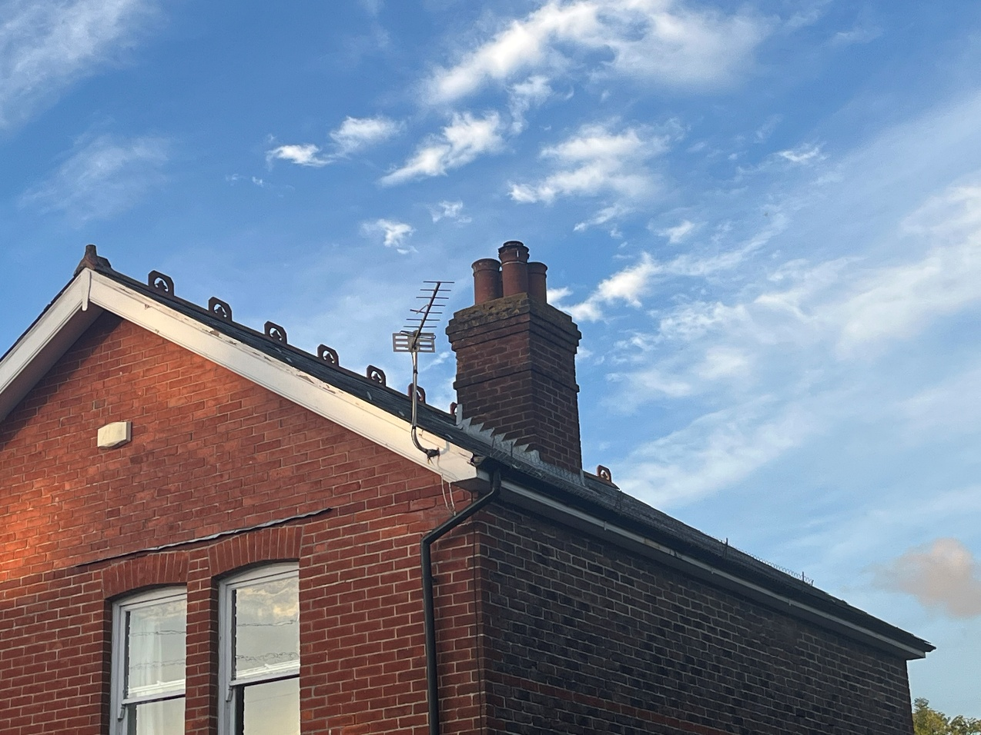
Figure 5. Southern face of roof looking northeast.

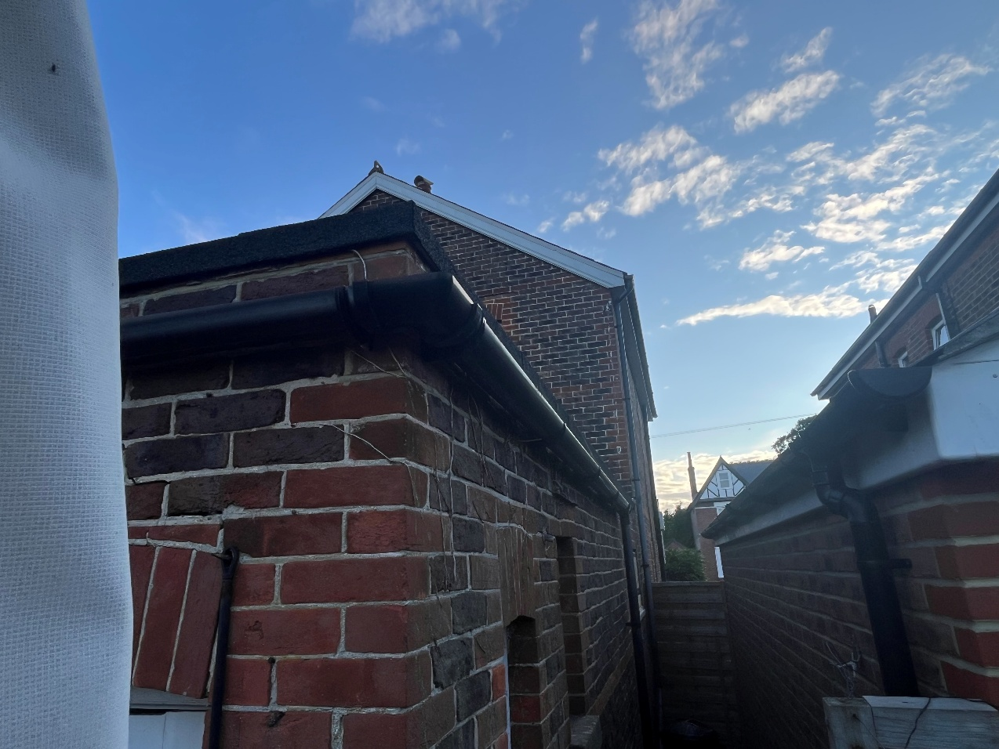
Figure 6. North face of rear extension looking west.
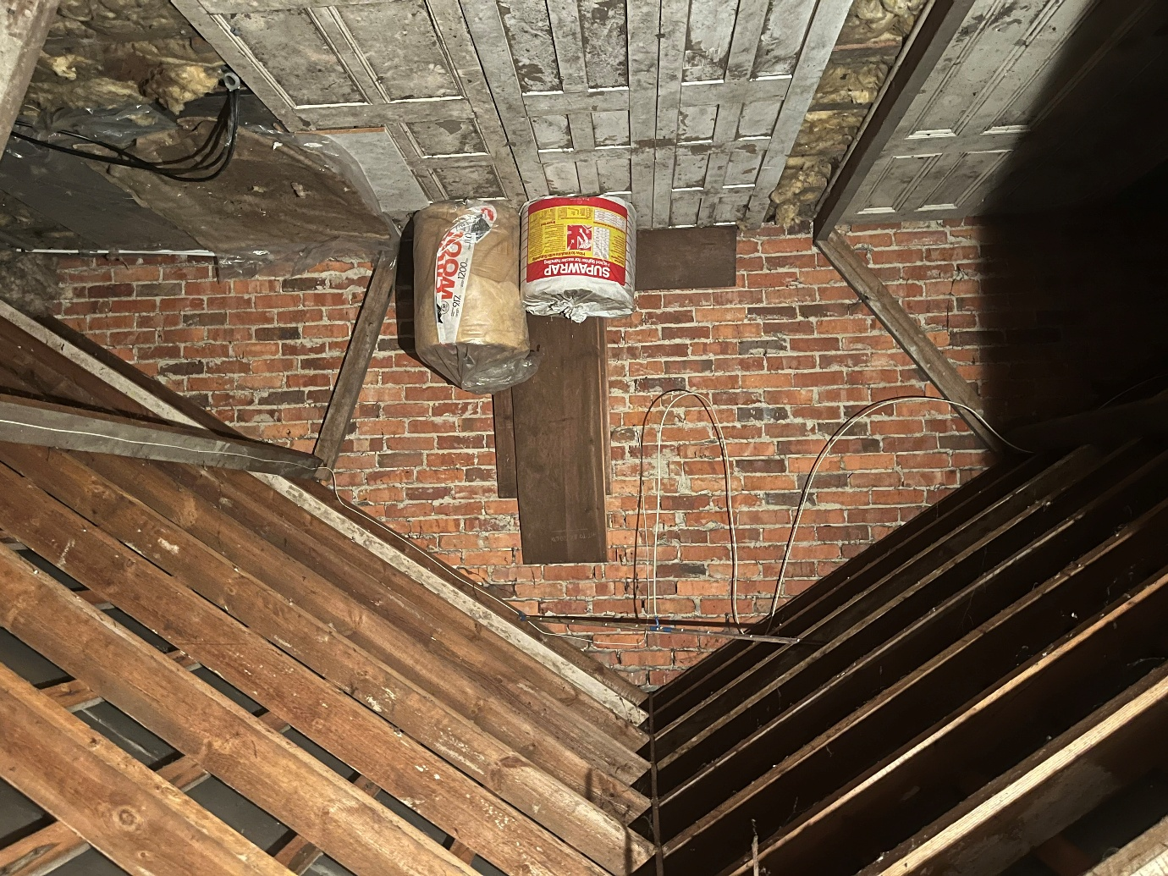
Figure 7. Interior of loft

Birdlife
All wild birds are protected under Wildlife and Countryside Act 1981, as amended, from damage or destruction of their nest whilst in use or construction, some birds listed on Schedule 1 receive additional protection from disturbance during nesting.

There was no evidence of bird nesting on or near the property.

EVALUATION
There was no evidence of historic bat activity in the property, and there are no accessible spaces for crevice roosting. Therefore, the property has negligible potential and a Phase 2 bat survey is not required.

In the unlikely event of any bats being found during demolition or construction, all work must stop immediately, and Natural England must be called. Additional information is available on the Bat Conservation Trust website at https://www.bats.org.uk/advice/imworking-on-a-building-with-bats/ive-found-a-bat-during-works.
New exterior lighting should be avoided, but if necessary for security purposes, then the latest updated lighting guidance note (GN08/23) should be followed. This is available at Guidance Note 8 Bats and Artificial Lighting | Institution of Lighting Professionals (theilp.org.uk) and supersedes all previous guidance.

REFERENCES
Collins, J. (ed.) (2023) Bat Surveys for Professional Ecologists: Good Practice Guidelines (4th Edition). The Bat Conservation Trust, London

Reason, P.F. and Wray, S. (2023). UK Bat Mitigation Guidelines: a guide to impact assessment, mitigation and compensation for developments affecting bats. Chartered Institute of Ecology and Environmental Management, Ampfield.

INTERNET RESOURCES
Google Maps: www.maps.google.co.uk
Magic Interactive Map: www.magic.gov.uk

