Proposed Highway Works to form a Continuious Footway at the northern access to
Havant & South Downs College
Barncroft Way
Havant

Client: Client reference:
Scott White and Hookins 304559

Fenley
2 Blaenant
Emmer Green
READING
RG4 8PH

E: office@fenley.co.uk
www.fenley.co.uk

Report Status 2
Job no | RSA-25-085 | Issue no | 2 | Date | September 2025
Prepared by | JJF | Verified by | ZB | Approved by | JJF
Filename and Path | Fenley/Road Safety Audits/RSA-25/RSA-25-085-2

- PROJECT DETAILS

Report Title: |  | Stage 1/2 Road Safety Audit
Date: |  | August 2025
Document reference and revision: |  | RSA-25-085-2
Prepared by: |  | Fenley Road Safety Limited
County Highway Authority: |  | Hampshire County Council
Design Organisation: |  | Scott White and Hookins
Project Sponsor: |  | Landmark Development Consultants
REV | ISSUE PURPOSE | AUTHOR | CHECKED | APPROVED | DATE
0 | Stage 1/2 Road Safety Audit drafted for Audit Team discussions. | ZB |  |  | 11th September 2025
1 | Stage 1/2 Road Safety Audit finalised and issued to the Design Organisation | ZB | JJF | JJF | 15th September2025
2 | Design Organisation/Project Sponsor Response incorporated within the Decision Log at Appendix B3 | Tim Killingback on behalf of  Scott White and Hookins |  |  | 17th September2025
3 | Overseeing Organisation Response incorporated within the Decision Log at Appendix B3 | Xxxxxx Xxxxxxx on behalf of  Hampshire County Council |  |  | XXth September2025

Contents:
1.0 Project Details 1
2.0 Introduction 2
3.0 Items Raised in any previous Road Safety Audits 3
4.0 Items Raised in this Stage 1/2 Road Safety Audit 4
B.1 Alignment
B.2 General
B.3 Junctions
B.4 Walking, Cycling and Horse Riding
B.5 Traffic Signs, Carriageway Markings and Lighting
5.0 Audit Team Statement 7

Appendices:
Stage 1/2 B1 Documents and Drawings provided for this Road Safety Audit
B2 Item Location Plan
B3 Road Safety Audit Response Report with RSA Decision Log

- INTRODUCTION
- This report has been prepared by Fenley Road Safety Limited and results from a Stage 1/2 Road Safety Audit of proposed highway works to increase the width of the existing northern access to Havant & South Downs College, off Barncroft Way in Havant. The existing bellmouth allows access to a carriageway that is just circa 3.5 metres wide and serves as both an ingress and egress to a parking facility that accommodates circa 71 parking spaces as well as an overflow facility and allows for deliveries to the college. The proposed works amend the bellmouth to a continuous footway with a vehicular crossover and increase the width of the access to 7 metres to allows for two-way traffic, to include large service vehicles. The proposed vehicular crossover is to be accessible via a ramp and give-way markings to highlight the pedestrian and cyclist priority. It is understood that the works are to facilitate improved access to the car park and service entrance only, with no increase in the number of existing parking spaces.

- The Audit Brief identifies that the proposals do not include any Departures from Standard, whether related to strategic decisions or otherwise.

- This Road Safety Audit was undertaken during September 2025 in accordance with the Road Safety Audit Brief provided on the 13th August 2025 by the Design Organisation, Scott White and Hookins, on behalf of the Client Organisation, Peter Marsh Construction. The Road Safety Audit comprised of a site visit as well as an examination of the documents provided which are identified in Appendix B1. The Audit Team were satisfied that the Audit Brief was sufficient for the purpose of the Audit instructed.

- This Road Safety Audit has been undertaken by an Audit Team whose qualifications as well as experience accord with the requirements of GG119 and have been approved by Hampshire County Council to undertake Road Safety Audits of all stages within the County. The Audit Team consists of the following members:

Audit Team Leader
Jamie Fenning BSc(Hons), MIHE, MCIHT, MSoRSA, National Highways RSA Certificate of Competency
Road Safety / Highway Engineer
Audit Team Member
Zane Beswick MSoRSA, MCIHT
Road Safety / Highway Engineer

- The site has been visited on two occasions; once during the morning of Friday 11th October 2024 between the hours of 09:30 and 10:00 and again during the afternoon of Tuesday 2nd September 2025. The site visits involved walking and driving around the local highway network for 45 minutes whilst observing local infrastructure and current off-peak traffic conditions. During the site visits, the sky with scattered clouds and sunshine as well as overcast, the road surface was observed both dry and wet and visibility was good. A number of pedestrians and cyclists were observed during the site visits. Vehicular traffic was also observed, to include cars, passenger service vehicles and light as well as heavy goods vehicles.

- The terms of reference of this Road Safety Audit are as described in GG119. The scheme has been examined and this report compiled, only with regard to the safety implications for road users of the scheme as presented. It has not been examined or verified for compliance with any other standards or criteria. However, in order to clearly explain a safety problem or the recommendation to resolve a problem, the Audit Team may on occasion have referred to a design standard for information only. All comments and recommendations are referenced to the design drawings supplied with the Audit Brief and the location of road safety concerns raised have been illustrated beneath the items along with relevant photographs for clarity, where appropriate, as well as on the Location Plan attached at Appendix B2.

- ITEMS RAISED IN ANY PREVIOUS ROAD SAFETY AUDITS
- Fenley Road Safety Limited undertook a Stage 1/2 Road Safety Audit of a previous proposal to widen the existing bellmouth, in October / November 2024. That Road Safety Audit raised a number of road safety concerns, however, the scheme has subsequently been revised to a vehicular crossover which is fully assessed within this Stage 1 Road Safety Audit.

- ITEMS RAISED AT THIS STAGE 1/2 ROAD SAFETY AUDIT
B.1 | LOCAL ALIGNMENT
 | No Road Safety Concerns regarding LOCAL ALIGNMEMNT have been raised at this stage
B.2 | GENERAL
B.2.1 | PROBLEM
Location: | Barncroft Way
Summary: | Edge of carriageway may not generate a smooth alignment
Acc Type: | Vehicle loss of control type collision
The existing northern access to HSDC Havant is just circa 3.5 metres wide and taken off Barncroft Way at a bellmouth that accommodates 6 metre radii. The access is formed in a concrete surface that meets the tangent of each radii and allows for a smooth edge of carriageway. The proposals include highway works to remove the existing bellmouth and provide a vehicular crossover to allow access to a 7 metre carriageway that allows for two-way traffic. The continuous footway and access road are to be provided at existing levels and therefore a ramp is to be provided to the east, immediately adjacent to give-way markings that highlight the need for motorists to slow and give priority to pedestrians. The scheme drawings illustrate the area of the 3.7 metre wide continuous footway and identifies that the western edge, along Barncroft Way, will not meet the tangent of the southern radius. The Audit Team have concerns that this does not generate a smooth edge of carriageway which could lead to loss of control type collisions should a motorist suddenly become aware of the and swerve.
RECOMMENDATION:
It is recommended that the proposed works allow for a smooth edge of carriageway.

Location Plan:
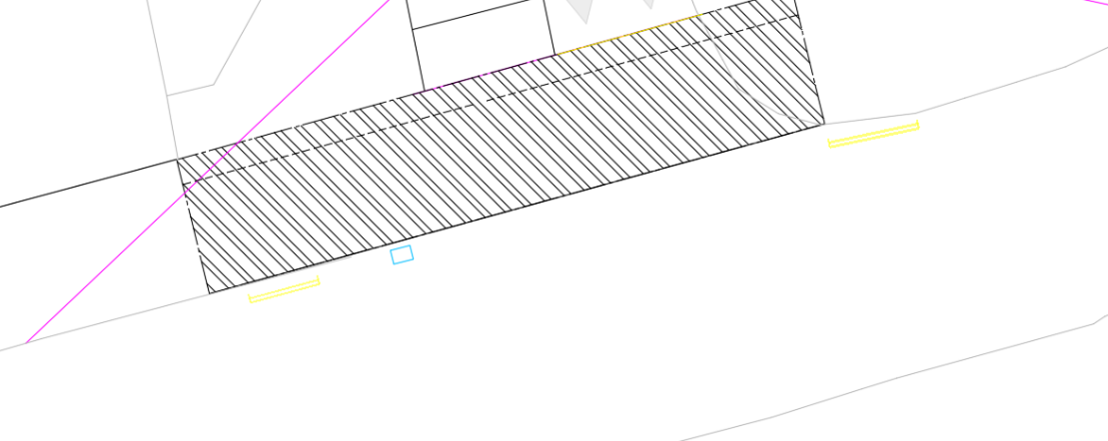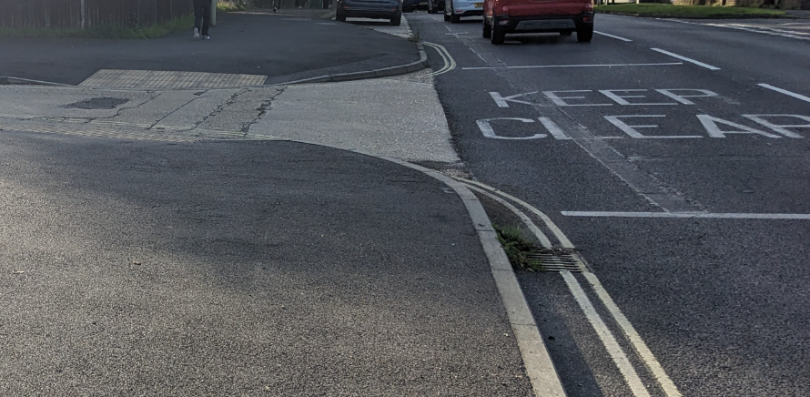
B.2.2 | PROBLEM
Location: | Barncroft Way
Summary: | Proposed ACO drain is likely to become blocked by debris
Acc Type: | Vehicle sideswipe type collision
Barncroft Way is mostly cambered which forces surface water to fall towards the channels where it drains through a network of road gullies. The proposals include the removal of an existing road gully that is situated immediately to the north of the existing northern access to HSDC Havant and replacement with an ACO channel drain. Whilst the surface area of a linear drains will generally exceed that of a road gully and therefore could drain an excess amount of surface water, the Audit Team have concerns that the debris that collects within a channel could block a linear drains due to the narrow nature of the grills which could have an impact on the drainage of surface water resulting in ponding and loss of control type collisions.
RECOMMENDATION:
It is recommended that the linear drain is replaced with strategically located road gullies
Location Plan:
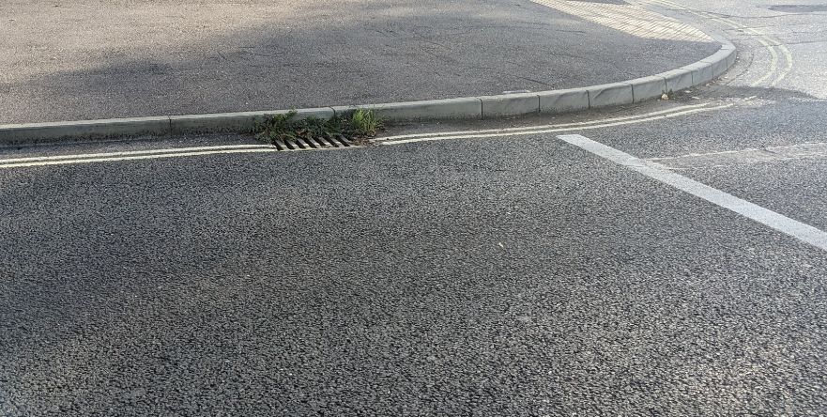
B.3 | JUNCTIONS
 | No Road Safety Concerns regarding JUNCTIONS have been raised at this stage
B.4 | WALKING, CYCLING AND HORSE RIDING
B.4.1 | PROBLEM
Location: | Barncroft Way
Summary: | Intervisibility is limited
Acc Type: | Cyclist to vehicle type collision
Barncroft Way benefits from a shared footway cycleway along the northern side of the carriageway and allows access to the northern parking and servicing facility associated with HSDC Havant. The existing access takes the form of a bellmouth that accommodates an uncontrolled crossing. The proposals include works at the existing access to form a vehicular crossover, creating a continuous shared footway cycleway and providing priority for pedestrians and cyclists. The proposed vehicular crossover is to be accessed from the HSDC Havant parking and servicing facility via a ramp that accommodates give-way markings at the bottom. The scheme drawing illustrates the visibility splays that are achievable and identifies that an exiting motorist will be able to see cyclists and pedestrians at a distance of 17 metres. It is noted, however, that this splay extends to the channel line and not the back edge of the shared footway cycleway. The achievable intervisibility splay between the driver of a vehicle exiting and the back edge of the shared footway cycleway is limited to circa 10 metres. Whilst a pedestrian can stop almost instantly, the stopping sight distance of a cyclist approaching the proposed vehicular crossover at a speed of 20kph equates to 17 metres. The Audit Team have concerns that the achievable level of intervisibility is limited which may result in a motorist not becoming aware of an approaching cyclist and lead to cyclist to vehicle type collisions.
RECOMMENDATION:
It is recommended that the give-way line is brought forward to maximise intervisibility.
Location Plan:
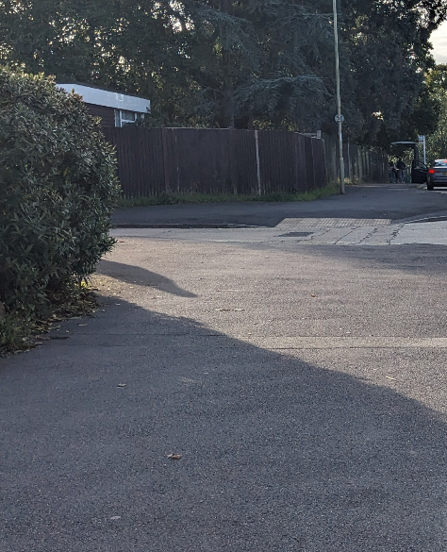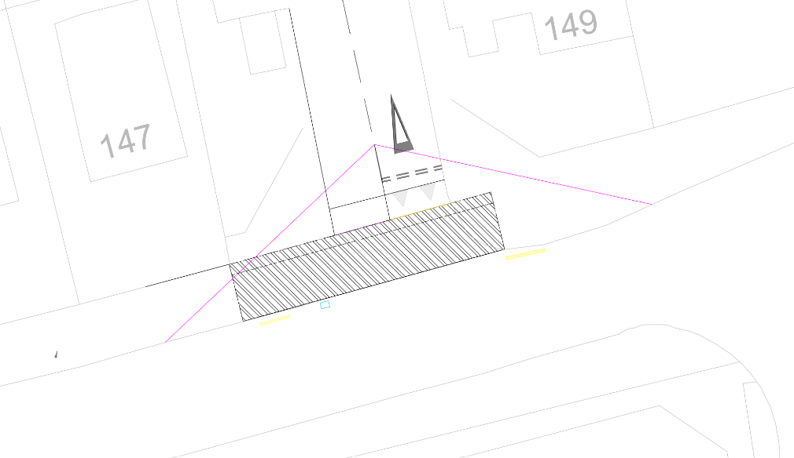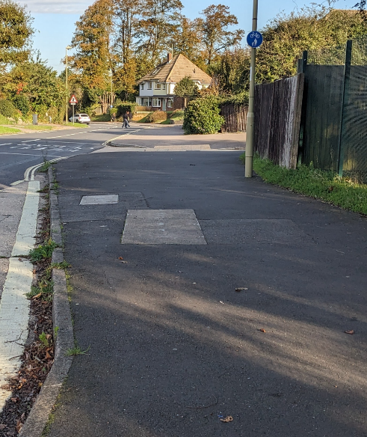
B.5 | TRAFFIC SIGNS, CARRIAGEWAY MARKINGS AND LIGHTING
 | No Road Safety Concerns regarding TRAFFIC SIGNS, CARRIAGEWAY MARKINGS AND LIGHTING have been raised at this stage

- STAGE 1/2 ROAD SAFETY Audit Team Statement

5.1 We certify that this Road Safety Audit has been carried out in accordance with GG119.
Audit Team Leader
Name: | Jamie Fenning BSc (Hons), MIHE, MCIHT, MSoRSA, NH RSA Certificate of Competency
Signed:
Position: | Road Safety / Highway Engineer
Organisation: | Fenley Road Safety Limited
Date: | 15th September 2025
Audit Team Member
Name: | Zane Beswick MSoRSA, MCIHT
Signed:
Position: | Road Safety / Highway Engineer
Organisation: | Fenley Road Safety Limited
Date: | 15th September 2025

Appendix B1
Documents and Drawings provided for this Stage 1/2 Road Safety Audit

Audit Stage | Doc. No. | Rev | Title
Stage 1/2 | Email dated 13th August 2025 |  | Stage 1 Road Safety Audit Brief
Stage 1/2 | Dwg No. | Rev | Title
Stage 1/2 | 304559-SWH-XX-XX-DR-C-8000 | P07 | S278 – General Arrangement

Appendix B2
Item Location Plan

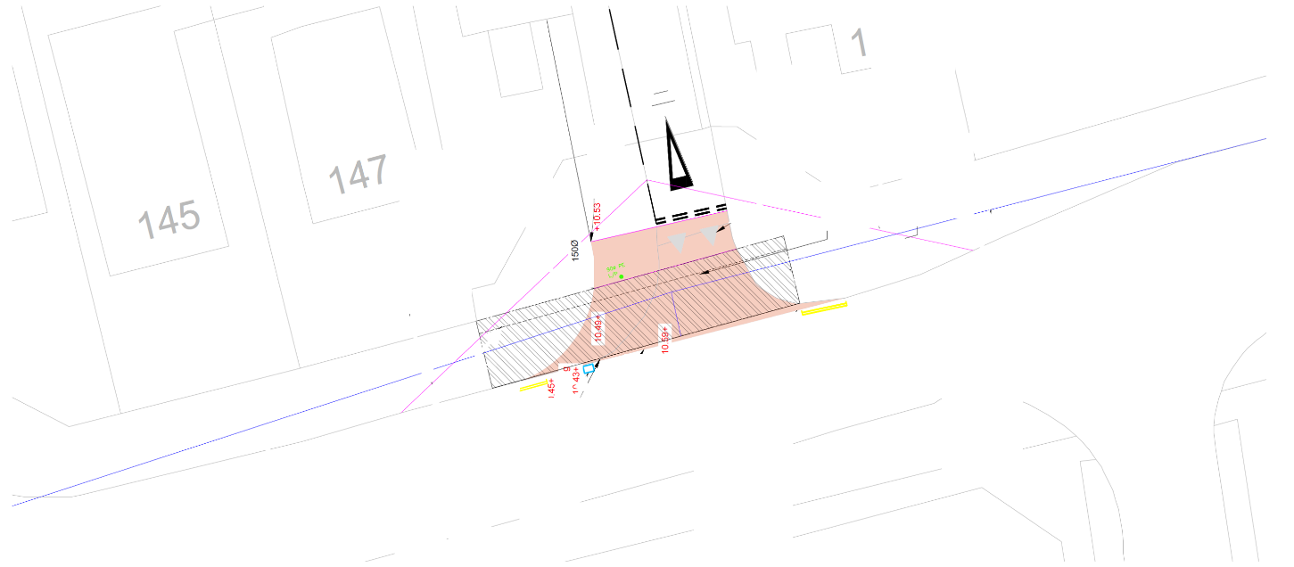

B.4.1

B.2.1
B.4.1

B.2.2

Appendix B3
Road Safety Audit Response Report with RSA Decision Log

- Road Safety Audit Response Report
- In accordance with national standards, this Road Safety Audit was finalised and issued to the Design Organisation / Project Sponsor as per the Road Safety Audit report template within Appendix D of GG119, which can be provided upon request from either the Audit Team or Design Organisation / Project Sponsor. The format of the Audit Report was subsequently revised to incorporate these paragraphs under Appendix 3 and the following Table which details the RSA Recommendation, a Design Organisation Response, an Overseeing Organisation Response and Agreed RSA Action.

- This is generally contained within a separate Road Safety Audit Response Report but is included within this document in order for the Audit Team to maintain a single record of all problems, recommendations, responses and agreed actions for the benefit of a concise Road Safety Audit trail to be held on file for Quality Assurance purposes as these are not provided as a matter of course.

- The following statements should be signed below following completion of the relevant sections.

Design Organisation / Project Sponsor and Overseeing Organisation statements

- On behalf of the Design Organisation / Project Sponsor, I certify that:
- the RSA actions identified in response to the road safety audit problems in this road safety audit have been discussed and agreed with the Overseeing Organisation.

Name: | Tim Killingback
Signed
Position: | Civils Team Leader
Organisation: | Scott White and Hookins
Date | 17th September 2025

- On behalf of the Overseeing Organisation, I certify that:
- the RSA actions identified in response to the road safety audit problems in this road safety audit have been discussed and agreed with the design organisation; and
- the agreed RSA actions will be progressed.

Name: | …………………………………...
Signed | ……………………………………
Position: | ……………………………………
Organisation: | Hampshire County Council
Date | XXth September 2025

Stage 1/2 Road Safety Audit (RSA) Decision Log
Item | RSA Summary | RSA Recommendation | Design Organisation | Overseeing Organisation Response | Agreed RSA Action
B.2.1 | Edge of carriageway may not generate a smooth alignment | It is recommended that the proposed works allow for a smooth edge of carriageway. | Accept – The scheme references that the proposed continuous footway is to be provided in accordance with the example on page 18 of TG10 published by Hampshire County Council. The standard detail identifies that PC3 kerbs are to be provided along the edge of the carriageway. These will replace the corner radii and meet the existing kerbline generating a smooth alignment along the edge of carriageway.
B.2.2 | Proposed ACO drain is likely to become blocked by debris | It is recommended that the linear drain is replaced with strategically located road gullies. | Accept – The proposals will not adjust the existing levels of Barncroft Way and therefore the existing road gully will be retained. This existing road gully is situated outside of the proposed vehicular crossover, adjacent to the transition kerbs, according to the topographical survey. The grate should therefore not be situated along the desire line of a cyclist turning left onto the proposed vehicular crossover, however, if considered necessary the grate can be exchanged for a cyclist friendly type.
B.4.1 | Intervisibility is limited | It is recommended that the give-way line is brought forward to maximise intervisibility. | Accept – The give-way line has been relocated to the foot of the proposed ramp where an intervisibility envelope extending 12 metres is achievable between a driver at an offset of 2 metres and an approaching cyclist. This is extended to 17 metres at an offset of 2 metres from the top of the ramp to an offset 0.75 metres to the south and 1.2 metres to the north. It must be noted that the shared footway cycleway is straight in alignment forward visibility to the vehicular crossover, for a cyclist, significantly exceeds the 17 metres. A cyclist will therefore become aware of a vehicle exiting the vehicular crossover at a safe distance to slow accordingly.



