Hayling Fair Utilities Assessment 1 Sea Front Hayling Island

INTRODUCTION
Havant Borough Council, through their Local Information Requirements, require a Utilities Assessment for the application for the redevelopment of the the Hayling fair site.

We have provided utility maps from the relevant providers in the appendices of this document.
The site is well connected to the local utility infrastructure.

SURFACE WATER
This site is served by Southern Water for surface water. Traditionally the buildings don’t have surface water connections as this water drains directly onto the surrounding beach. This reduces the amount of surface water drainage entering the local system and thus is a very sustainable solution. Details of how the surface water is to be dealt with on site is within Ardent’s Flood Risk and Drainage assessment. Details of Southern Waters Utility mapping is in Appendix A.

FOUL WATER
This site is served by Southern Water (SW) for foul drainage. There is a 150mm Drainage connection from the site running north and into SW’s foul drainage infrastructure. As part of their work on the site, within Ardent’s Flood Risk and Drainage assessment, a proving design has been completed concluding that the existing connection is sufficient for the proposed re-development of the Hayling Fair Site. Details of Southern Water’s Utility mapping is in Appendix A.

WATER SUPPLY
This site is served by Portsmouth Water (PW). PW’s asset map does not show a water connection to the site, however this is not the case as the current site has water connections for the fair site.
However, the asset map does show that at the roundabout on Seafront/Beach Road there is a 300mm diameter Truck Main serving local branches. The 3” connection southwards from the roundabout is likely to be renewed as part of this development. This new connection should be sized to be able to supply the future development sites to the west.
Details of Portsmouth Water Utility mapping is in Appendix B.

GAS SUPPLY
This site is served by SGN. SGN’s asset map shows a 63mm Dia gas low pressure mains pipe supplying existing buildings on the site. Locally there are medium pressure mains to the north. It is hoped that the new site will not be heated with gas as a sustainability credit and therefore no upgrade of the gas supply is required for this re-development.
Details of SGN’s Utility mapping is in Appendix C.

ELECTICITY SUPPLY
This site is served by SSEN. SSEN’s asset map shows a 4 seperate LV mains cables supplying the existing Hayling fair site. We are aware that (via the neighbouring application,) discussions with SSEN are ongoing to consider the ability to supply the whole site.
Details of SSEN’s Utility mapping is in Appendix D.

SUMMARY
This site is a re-development of a previously developed site with existing connections to all utilities. At present no new or upgraded connections are required, however if required to do so all utilities have local capacity to satisfy the proposed development.

Appendix A
Southern Water’s Utility mapping

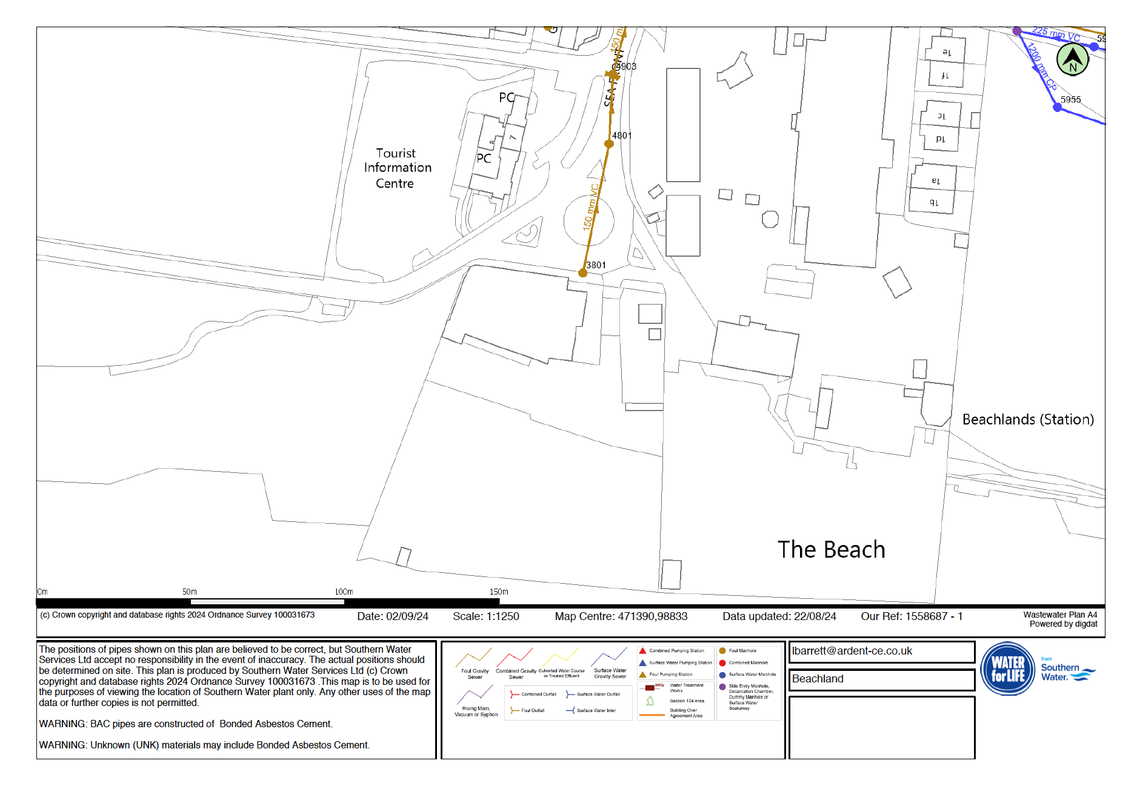
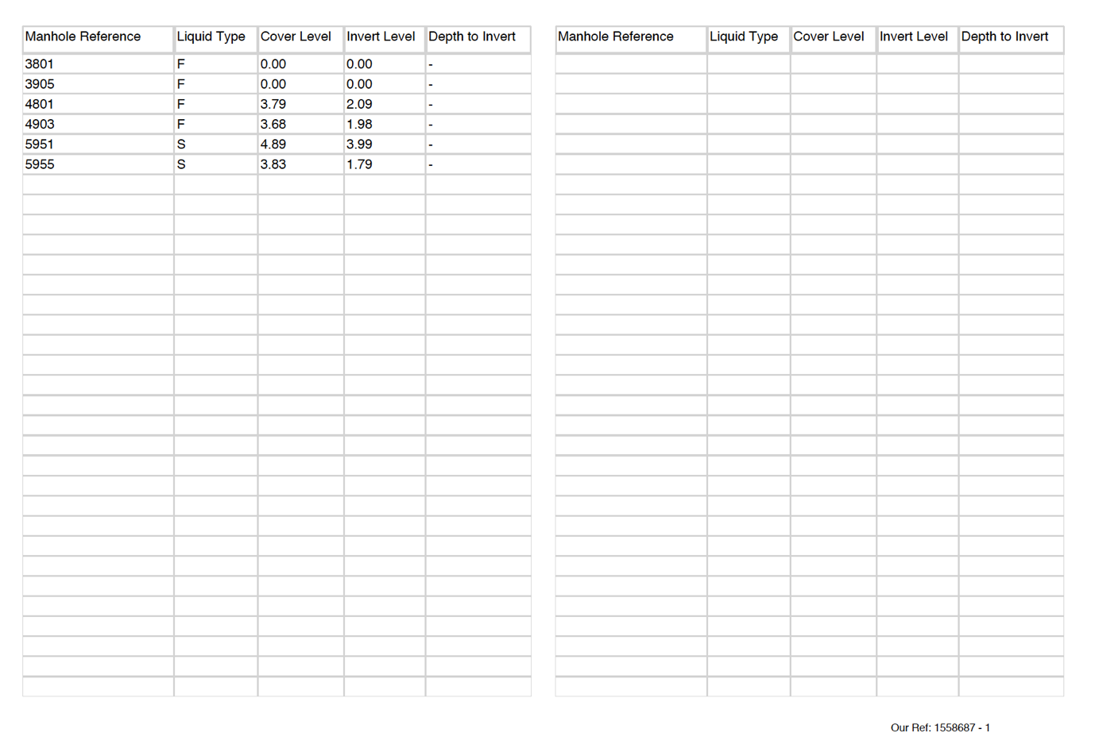

Appendix B
Portsmouth Water Utility mapping
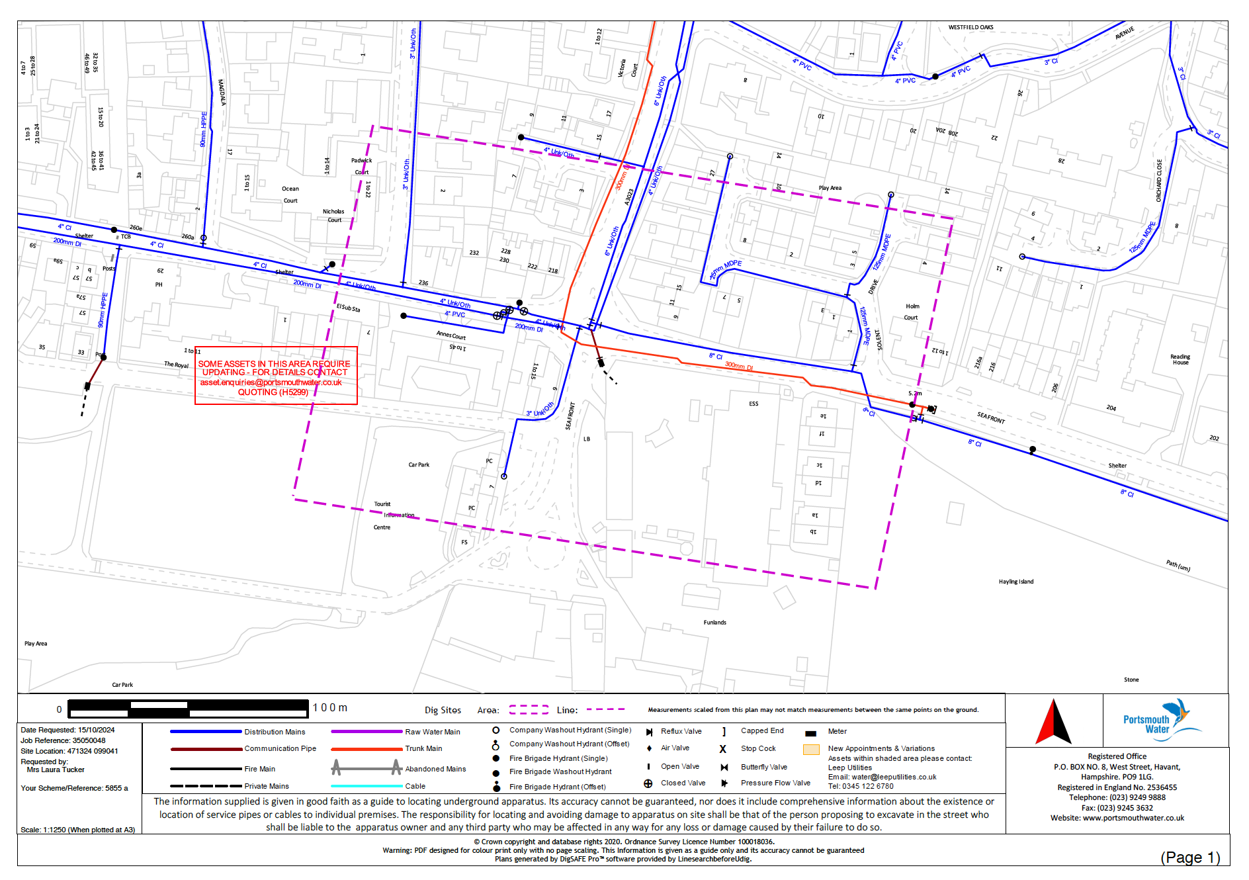
Appendix C
SGN Utility mapping
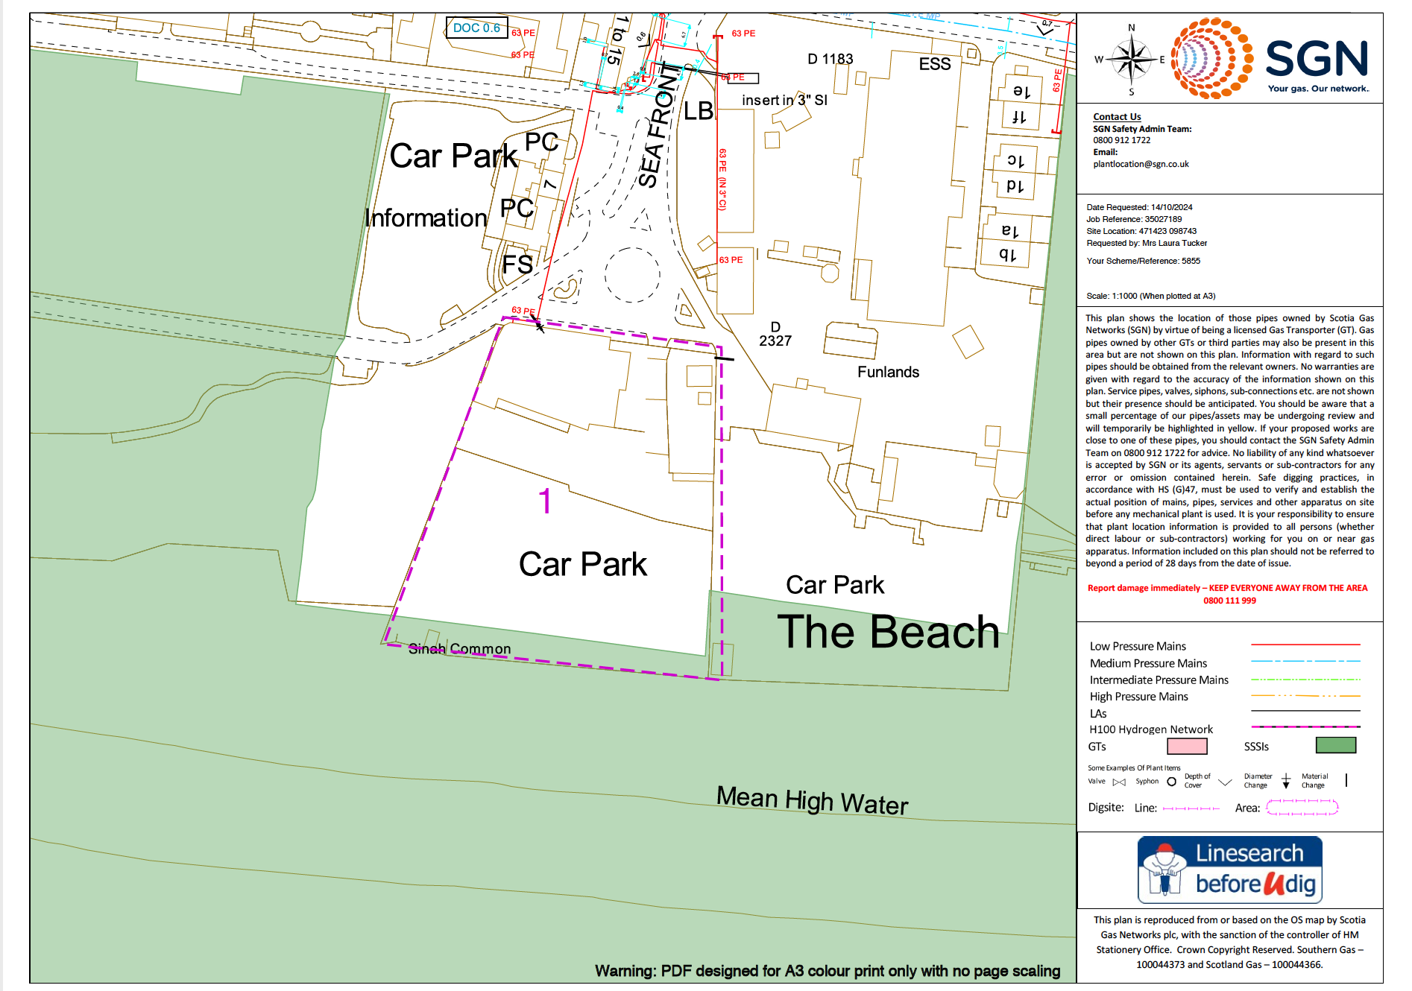

Appendix D
SSEN Utility mapping

