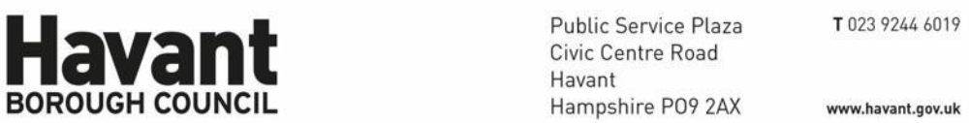
For Applicant:

Forsa Energy Gas Holdings Ltd
Riverside Business Park Greenock PA15 2UZ
For Agent:

Clive Fagg Planning
9 Dairy Lane Hose Melton Mowbray LE14 4JW

The Town and Country Planning Act 1990
Notification of Decision: Approve with Conditions

Application Number: APP/24/00237
Site Address: Land at Hermitage Park, Harts Farm Way, Havant
Proposal: Proposed gas fuelled capacity mechanism embedded generation plant to support the National Grid. A resubmission of previously approved applications (APP/21/00809) in order to secure changes to the site layout and technology following transfer of ownership of the site (Permitted 26/07/2024). Request to Discharge Conditions 3, 4, 6 & 7 (Received 28/03/2025).

Further to your application received on 19 March 2024 (which was valid from 19 March 2024 Havant Borough Council , as Local Planning Authority APPROVES the submitted application as meeting the information requirements of the following Conditions of Planning Permission APP/24/00237 in accordance with the submitted plans and particulars as detailed below.

The conditions in respect of which information has been submitted are:
Conditions:

6 |  | Prior to the commencement of development activities, a Landscape & Ecological Management Plan shall be submitted to an approved in writing by the Local Planning Authority. The Plan shall be in accordance with the ecological avoidance, mitigation, enhancement and management measures as detailed in the Ecological Assessment (The Ecology Co-op, May 2024) unless otherwise agreed in writing by the Local Planning Authority. It shall include, but not necessarily be restricted to: full details of all ecological avoidance and mitigation measures, to include timings, methods and responsibilities; full details of all ecological compensation and enhancement measures, including location, area, composition, establishment and ongoing management, monitoring and responsibilities.  Reason: to provide ecological protection and enhancement in accordance with the Environment Act 2021, Conservation Regulations 2017, Wildlife & Countryside Act 1981, NPPF, NERC Act 2006 and Policy CS 11 of the Havant Borough Core Strategy March 2011. It is considered necessary for this to be a pre-commencement condition as these details need to be agreed prior to the construction of the development and thus go to the heart of the planning permission.  Details submitted:  Landscape and Ecological Management Plan by The Ecology Co-Op. V2 received 21 August 2025  Reasons for approval:  The details hereby approved are considered to be in accordance with the relevant adopted policies of the Council, in particular the policies contained within the Havant Borough Local Plan (Core Strategy) 2011 | Fully Discharged | 10/10/2025

Other Important Information:

This notice only relates to the decision of Havant Borough Council as Local Planning Authority under the Town and Country Planning Acts. It does not relate to any other application that may be required under the Building Regulations or under any other Act, Regulation, Byelaw or Order where the Council's approval may be needed. For further guidance as to the need for consent under the Building Regulations please phone 023 9244 6571.

Any failure to adhere to the details of the approved plans , and other documents or to comply with any conditions listed above may lead to enforcement action being taken by the Council. If you wish to depart from the approved details or conditions in any way you should contact the Planning and Development service at the Plaza or by telephoning 023 9244 6015.

Steve Weaver﻿
Steve Weaver
Development Manager

Havant Borough Council
10 October 2025

