Proposed Hedge for inside Fencing at Havant Nursery

We would plant a Cherry Laurel Hedge inside the Fence. Starting height would be 30 – 40 cm on initial planting with approx. 2-3 plants every meter to provide adequate cover.

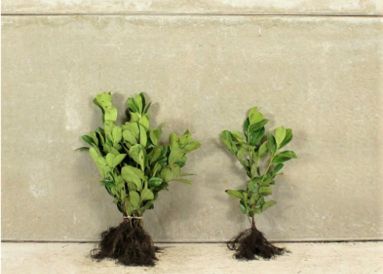
Example of mature hedge.
