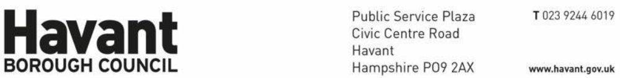
For Applicant:

Hargreaves
Rustington House Worthing Road Rustington BN16 3PS
For Agent:

Harris Lamb Planning Consultancy
75-76 Francis Road Edgbaston Birmingham B16 8SP

The Town and Country Planning Act 1990
Notification of Decision: Approve with Conditions

Application Number: APP/21/00399
Site Address: Land at Waterloo Park, Elettra Avenue, Waterlooville
Proposal: Full application for erection of discount foodstore, drive through coffee shop and drive-through restaurant with associated car parking, service yard, landscaping, means of access and associated infrastructure.(04.10.24). Request to discharge condition 6 (31.03.25). Request to discharge conditions 4, 11, 12, 19, 20, 23 (27.06.2025).

Further to your application received on 1 April 2021 (which was valid from 24 May 2021 Havant Borough Council , as Local Planning Authority APPROVES the submitted application as meeting the information requirements of the following Condition of Planning Permission of Planning Permission APP/21/00399 in accordance with the submitted plans and particulars as detailed below.

The condition in respect of which information has been submitted are:

Condition 20  20 Construction of the development shall not commence until details of the proposed  means of foul and surface water sewerage disposal have been submitted to, and approved in writing by, the Local Planning Authority in consultation with Southern Water.  Reason: To safeguard the amenities of the locality and ensure that all such drainage provision is constructed to an appropriate standard and quality and having due regard to policies and proposals CS16 and DM10 of the Havant Borough Local Plan (Core Strategy) 2011, and the National Planning Policy Framework.  Details submitted:  Cover Letter uploaded 17/09/2025  Drawing Number:010 P03: Drainage on site by BP CIVILS: Uploaded 17/09/2025  Drawing Number: 301 P02: Construction details 2 by BP Civils: Uploaded 17/09/2025  Modelling by SITE3D: Uploaded 17/09/2025  Drawing Number: 009 P02: Impermeable areas on site by BP Civils: Uploaded 17/09/2025  Drawing Number: 300 P01: Construction details 1 by BP Civils: Uploaded 17/09/2025  SURFACE WATER MANAGEMENT AND MAINTENANCE REPORT by BP CIVILS: Uploaded 17/09/2025  Drawing Number: 011 P04: LEVELS AND CONTOURS ON SITE by BP CIVILS: Uploaded 17/09/2025  Drawing Number: 302 P02: Construction details 3 by BP Civils: Uploaded 17/09/2025  Drawing Number: 303 P01: Construction details 4 by BP Civils: Uploaded 17/09/2025  Reasons for approval:  The details hereby approved are considered to be in accordance with the relevant adopted policies of the Council, in particular the policies contained within the Havant Borough Local Plan (Core Strategy) 2011. | Fully Discharged | 16/10/2025

Other Important Information:

This notice only relates to the decision of Havant Borough Council as Local Planning Authority under the Town and Country Planning Acts. It does not relate to any other application that may be required under the Building Regulations or under any other Act, Regulation, Byelaw or Order where the Council's approval may be needed. For further guidance as to the need for consent under the Building Regulations please phone 023 9244 6571.

Any failure to adhere to the details of the approved plans , and other documents or to comply with any conditions listed above may lead to enforcement action being taken by the Council. If you wish to depart from the approved details or conditions in any way you should contact the Planning and Development service at the Plaza or by telephoning 023 9244 6015.

Steve Weaver﻿
Steve Weaver
Development Manager

Havant Borough Council
16 October 2025

