Project Name | Havant Academy |  | Address |  | Havant Academy  Wakeford's Way  Havant  PO9 5JD
Project Number | 742167 |  |  | Project Lead | Graham Rumsey
Wates Approval  (Construction Manager) |  | Paul Nimmo |  |  |  | Date Approved | 08/09/2025
Signature |  | Paul Nimmo

This plan may be supported by the following specific plans:-
Attached where applicable
PrS-002A | Asbestos Management Plan | ☒
PrS-002E | Electrical Management Plan | ☒
PrS-002E-WPS | WPS Electrical Management Plan | ☒
PrS-002EP | Working at Height and Edge Protection Plan | ☒
PrS-002F | Emergency Preparedness and Response Management Plan | ☒
PrS-002L | Logistics Management Plan | ☒
PrS-002L-LSM | Logistics Management Plan | ☒
PrS-002G | Gas Management Plan | ☒

Review and Amendment Record
This CPP must be reviewed each quarter and amended whenever there is a change in major project risks, site conditions, personnel or accountability. This includes review of each relevant attached specific plan. All changes affecting project risks must be communicated to the supply chain. The date of each review and description of any amendments to the CPP must be recorded.
Amendments to the contents of this Construction Phase Plan (CPP) arising from a review are to be recorded below.
Examples include changes to site management personnel, changes or additions to significant site risks. Following planned reviews any amendments are to be recorded here including reference to the date of the review and location of the review records.
Review Date (select from drop down calendar) | Review Outcome - What has Changed?  If there has been a change identified by review provide brief details. If no changes enter No changes | Reviewed By

12/08/2025 | Initial Draft for approval | Graham Rumsey
26/08/2025 | Information Updated | Graham Rumsey
08/09/2025 | Pre-Start Review | Paul NImmo
Select date | Type brief description of amendment | Type Name
Select date | Type brief description of amendment | Type Name
Select date | Type brief description of amendment | Type Name
Select date | Type brief description of amendment | Type Name
Select date | Type brief description of amendment | Type Name
Select date | Type brief description of amendment | Type Name
Select date | Type brief description of amendment | Type Name
Select date | Type brief description of amendment | Type Name
Select date | Type brief description of amendment | Type Name
Select date | Type brief description of amendment | Type Name
Select date | Type brief description of amendment | Type Name
Select date | Type brief description of amendment | Type Name

1. Wates Zero Harm – We Are Safer Together

OUR COMMITMENT
We are committed to improving our health and safety performance and having the right behaviours to achieve a positive culture.

OUR ASPIRATION
Everybody is empowered and confident to champion appropriate behaviours and challenge inappropriate ones to achieve a positive health and safety culture.

OUR TARGET
All those who work for us champion behaviours and actively contribute to sustained, improved health and safety performance

2. Health and Safety in the Wates Operating Framework
The purpose of this Construction Phase Plan (CPP) is to describe how Wates Health and Safety Policy and Zero Harm strategy is implemented on site. It is specific to the project in this Construction Phase Plan (CPP).
The management of Health and Safety in Wates is based on the CITB GE700 and Wates Professional Standards contained in our Operating Framework detailing the specific management and technical processes. The processes applicable to this project are described in this CPP.
3. Objectives and Targets
How We Define Zero Harm |  | Business Unit Goals
Zero fatalities to workers or third parties  Zero permanent disabling injuries  Zero new cases of long term harm to health  Eliminating the realistic likelihood of serious harm  Our sites are as safe as an office environment  A ceiling LTIFR of 0.10 across the Group |  | Our SHEQ strategy will focus on 4 key pillars:  1. The Core 4 – Competence, Supervision, RAMs, and Site Standards.  2. Visible Leadership – Continue to support our project teams via the VMR process and to engage with our supply chain partners’ nominated directors to undertake VMRs alongside our leadership team.  3. Observational Reporting – Continue with our stop/go reporting but with a key focus on encouraging our supply chain partners to focus on stops. We will also make better use of the data provided to identify any action trends.  4. Bold Commitments – We have chosen our bold commitments based on the data we have reviewed from 2022 and targeted them on key themes that will improve our overall performance in these areas and support in achieving our strategy, the headlines for each bold commitment are:  a. Safety – We will reduce the number of first aid injuries by half, targeting no more than 6 first aids in the year.  b. Quality – We will place the same importance on the management of quality as we do safety, reducing the impact of defect rectification to the Smartspace business.  c. Environment – We will create a sustainable culture – reducing waste and carbon emissions whilst positively impacting on the environment and community
Project Objectives
To complete quality project within programme and budget, whilst maintaining a safe environment for workers and others in a live school environment. Demonstrate full compliance to Wates Operational Framework and the specific agreed methodology for the following key activities
- Protection of staff/public and 3rd parties
- Working at height
- Demoilition and asbestos removal
- Quality in hoarding installation
- Management of deliveries and vehicle movement on site.
- Management of plant and machinery
- Delivering a good standard on Dalux View
- To provide and maintain exacting standards of welfare facilities for our workforce and consult with our teams on Health & Safety matters
- Implementation of DTP (Designing the Promise) and TQP processes. All works are completed to specifications and standard ensuring in a safe occupancy of the building, including maintaining life safety systems throughout the works.
- To deliver the project without significant risk to health and safety of our own client staff, public, contractors, visitors, and any others who may be affected by our work.
- Implement and encourage the use of Wates stop/go app on site to prevent any accidents / incidents
- All works packages will be covered by the key 5.
-Plan Right
-Supervisor Interview
-RAMS
-Start Right
-Stop/Go

Project Health and Safety Goals
To comply with all Wates and DfE standards where applicable and practicable – to account for 10 Stop/Go reports per week on this project and aim for Zero Harm to all
To work with stakeholders to recognise standards associated with the scope of work and eradicate or control the associated H&S risk. To achieve this specific riask assessments and method statements will be produced by each contractor working on the project, regularly reviewed by Wates Managers on RAMS challenge templates and communicated to persons considered to be at risk.
To carry out the works embracing our zero-harm campaign, ensuring all operatives who come to site return home safely each day following work.
The project is to be planned and organised specifically to reduce any risk to health, safety and welfare, or damage to property / equipment or plant.
All works will be planned considering workload, team, resources, working hours and travel to ensure we have zero cases of work – related stress.
No occupational ill health / injuries to employees, subcontractors and other, including the public.
The procedure used for selecting and controlling the activities of contractors and subcontractors is a combination of process:
-The procedure for the production and approval of risk assessments and method statements is as per the Wates WPS, RAMS challenge and Subcontractor professional standards all located on the wates operating framework.
-This will be achieved through use of pre works plan right and daily pre task start right planning processes. The latter task being completed daily by the contractor supervisor in conjunction with Wates SM as a form of dynamic risk assessment.
We will plan works to eliminate the risk of injury or incidents from working at height activity through the correct selection of equipment and having the correct controls in place.
A 5 point PPE requirement will be enforced on site to include Safety Hat – Eye protection -Hi-Vis – Gloves and Safety boots. Additional requirements such as RPE or sleeve protection will be job specific.
Establish a site set up that excludes unauthorised persons from the construction site.
To maintain life safety protection throughout the project works.
To adhere to Wates guidance and any NPS protocols including H&S and security

4. Project Description and Management of Works
Project Location | Havant Academy, Wakeford Way, Havant PO9 5JD
Project Description | Demolition of RAAC affected areas whilst maintain safe access and use in other areas of the school.  Remove Slabs and replace with soft and hard landscaping.  Variation works to the Sports Hall gable end.
Start Date | 11/09/2025
Key Dates | PC December 5th 2025
Duration (weeks) | 14
Projected no. of Operatives | 10-15
Projected no. of Contractors | 5-6

Duty Holder | Contact Details
Duty Holder | Name | Telephone
Client | DfE  David Evans  David3.EVANS@education.gov.uk | 07876 875765
Principal Designer | Safer Sphere  Daniel Dacre  daniel.dacre@safersphere.co.uk | Enter phone no.
Principal Contractor | Wate Smartspace  Graham Rumsey  graham.rumsey@wates.co.uk  Paul Nimmo  paul.nimmo@wates.co.uk | 07784 297984  07519 997159

Designers | Contact Details |  | Area of Design Accountability
Designers | Name | Telephone | Area of Design Accountability
Architect | Box Architects  Chris Marlow  @Chris Marlow | 020 8092 6170 | Senior Architect
Structural Engineer | Sutcliffe Structural Engineers  Sean James | 07538 826511 | Structural Engineer
Temporary Works Engineer | Craig Dolby | 07799 680453 | Temporary Works
M & E Engineer | Centrum  Arron Terry  Gareth Evans | 07593 138455  07938 485732 | Senior Project Manager  Senior Project Manager
Contractor Designers | Wates Smartspace  Sandra Weerasinghe  Sandra.weerasinghe@wates.co.uk | 07511 210690 | Senior Design Manager
Fire Engineers | Socotec  Wayne Sommana | +353 83 202 9165 | Principal Fire Engineer
Other (specify) | Type Name | Enter phone no. | Type Name
Other (specify) | Type Name | Enter phone no. | Type Name
Other (specify) | Type Name | Enter phone no. | Type Name
Emergency Contacts
Role | Contact Name | Telephone
Director | Mark Bridges | 07799 336923
Construction Mgr/Project Dir | Stephen Duke – Operations Manager  Paul Nimmo – Construction Manager | 07901 515419  07519 997159
Project Leader | Graham Rumsey  Graham.rumsey@wates.co.uk | 07784 297984
SHE Advisor | Brain Odiawa  Brain.odiawa@wates.co.uk | 07709 839880
Client | Department for Education | Enter phone no.
Principal Designer | Safer Sphere  Daniel Dacre | 07590 839352
Hospital | Queen Alexandra Hospital  Southwick Hall  Cosham, Portsmouth  PO6 3LY – Accident & Emergency | 023 9228 6000
Police | Havant Police Station  Civic Centre Road  Havant  PO9 2AN | 999 in emergency  101 for non-emergency enquiries
Fire Authority | Hampshire and Isle of Wight Fire & Rescue Service  Leigh Road  Eastleigh  Hampshire SO50 9SJ | 023 8064 4000
Health and Safety Executive | Priestley House  Priestley Road  Basingstoke  RG24 9NW | 0300 003 1647
Environment Agency | National Information Line  National Emergency Line | 08708 506506  0800 807060
Gas | National Emergency Line | 0800 111999
Electric | National Grid Emergency Line | 0800 404090
Water | Portsmouth Water – Provider  Southern Water - Sewerage | 02392 499 666  03303 030 277
Telephone | BT National Fault Reporting Line | 154
Local Authority | Hampshire County Council  Havant Borough Council | 023 9244 6019F1
UK Monitoring | Reference No: | 01274 387300
Enter required details. | Enter required details. | Enter phone no.
Enter required details. | Enter required details. | Enter phone no.
Enter required details. | Enter required details. | Enter phone no.
Enter required details. | Enter required details. | Enter phone no.
Enter required details. | Enter required details. | Enter phone no.
Enter required details. | Enter required details. | Enter phone no.
Enter required details. | Enter required details. | Enter phone no.

Initial Records
F10 Notification to the Health and Safety Executive refer to the filing location
F10 to be displayed on site notice boards, also to be held electronically with Site Management
Existing Health and Safety Records
The Pre-Construction Information Package (PIP) forwarded by the Principal Designer will be used to determine control measures for the construction activities and information contained within this plan. A copy of the PIP will be retained on site and filed with this CPP.
All existing design recorded within tender docs and drawings folder.
Structural reports provided to show extent of safe working areas within building. No structural risk within surveyed areas provided on report.
Asbestos surveys undertaken and shared within tender docs and drawings folder

Welfare, First Aid and Security Provision
Detail the welfare provision for the project which must be appropriate for the number of people and the geographic spread of works.
The Welfare/Site Office will be established in the Visitor Car Park.
There will be 3 units to accommodate the Site Office/Meeting room – Welfare Cabin including drying room and toilet block with both Male and Female facilities
The security hoarding and turnstile access to the site will prevent unauthorised access. All visitirs will be accompanied. Anyone requiring access within the school grounds and outside of our demise will require enhanced DBS. This will be recorded and available for inspection should it be required
A first aid kit will be provided within the site office to attend to any incidents on site. Nominated First Aiders will be appointed and introduced in Plan Right meetigs and listed on site notice boards.
Signage will be installed to inform and direct people to the first aid point and it will be denoted on emergency plans.
Wireless Fire Alarm and first aid call points will be positioned around the site in specific locations for notification of any incidents. These will also be marked on the emergency plan.
All site personnel will be directed through the Biosite turnstile. The turnstile will be operated by a facial recognition system which will provide access and record what operatives are on site and what operatives have left the work area. The system will be linked to the fire roll call which in the event of an emergency a print off will be produced.
The vehicle gate will be manned by a site traffic Marshal, the vehicle gate will be maintained strictly for vehicle access.
Visitors will have to call a member of the management team to gain access..

Project Monitoring and Standards
Safety, Health and Environmental Advisor (SHE Advisor)
Projects will have a SHE Advisor assigned to coach, enable and assist Operational Managers and Directors with project monitoring and relevant technical advice.
SHE Advisor – Brain Odiawa
Asbestos – A full R&D survey has been carried out prior to any works starting. A watching brief will be employed during all demolition works
Demolition – A soft strip phase will commence and required propping will be installed prior to structural demolition commencing. SHE team to review RAMS and sign off before Demolition works commence.
On-site training will be given by the Wates project team by way of site inductions, weekly toolbox talks. Particular attention to be given to the Client and Wates requirements with regards to the H&S. Implementation of the Wates Stop / Go system via the online app, and work with all stakeholders to recognise new hazards associated with the works.
Weekly site IMS will be carried out by Wates site managers.
Zero harm to all members of the public necessitate daily Start rights and end of shift checks around the enclosed work face.
We will, via TBTs and Induction ensure all involved with the project have been made aware of the site-specific risks & rules

Wates have a zero tolerance to alcohol and drugs and can perform on the spot tests by our emergency call out service or via the selection of random drugs and alcohol testing done at a group level.

Project Lead Daily Monitoring
The Project lead will monitor the project and its contractors on a daily basis and take the required action for failure to comply with Wates Code of Conduct and relevant legislation
In line with Wates Compliance Checklist
Daily Diary / regular conversations between PM / SM & Contractor Supervisors.
Weekly reports to be the key means of monitoring that will be carried out by the Project Lead / PM and issued to the Client / team every Friday. This report will include progress photos.
Wates's code of conduct to be discussed at all Plan Right meetings / daily start right sessions.
Site manager to monitor works and contractors

Project Monitoring Arrangements
The Construction Manager will monitor the project and its contractors on a monthly basis utilising Wates iMS system and take the required action to comply with Wates Code of Conduct and relevant legislation. The Project team will monitor the project and its contractors on a weekly basis utilising Wates iMS system and take the required action to comply with Wates Code of Conduct and relevant legislation
The Construction Manager will monitor the project and its contractors monthly utilising Wates IMS system and take the required action for failure to comply with Wates values, beliefs and required legislation. All monitoring and recording processes are logged on a Wates software system (Field view) – for the CMs immediate access to records if required
The Project team will monitor the project and its contractors on a weekly basis utilising Wates IMS system and take the required action for failure to comply with Wates values, beliefs and required legislation.
Wates Site Team are responsible for the weekly integrated monitoring systems and procedures put in place.
Visiting managers will carry out a VMR with the Wates Site Team.

Client Specific Requirements
Client still to confirm. Wates will provide an update on progress against programme, risk, H&S and commercial performance via online or site meetings on a weekly basis. Further to the weekly update a Monthly report will be issued to the Client on or around the 1st day of the calendar month
.

Client Safeguarding Requirements
TBC - Any works requiring access to the school or any other area outside of the site boundary will require operatives to hold Enhanced DBS clearance which will be recorded on site and certificates will be available for inspection
Communication Between Parties
Exchange of Information - Operatives
A minimum of 1 weekly trade coordination meetings will be held each week. Subcontractors will be given the opportunity to raise any issues of concerns for their works and the interface of others.
Daily start rights will be held with all subcontractor supervisors to allow for coordination in safety aspects. Each supervisor will use their own field tool to individually communicate with their operatives about their specific risks.
Weekly TBT will help address information and changes to the entire site e.g. safety bulletins, site adaptations and Wates’s expectations.
After completing the Wates online induction all operatives will attend and in person site specific induction which will be read off a PowerPoint produced by the site team.
All records of attendance to inductions, Start right's and so forth will all be captured via field view.

Exchange of Information - Contractors
Plan Right Meetings & Supervisor Interviews will be carried out before the contractor commences works on site. This is the opportunity to ensure the supply chain fully understand the Wates standards and requirements, and discuss high risk issues (Safety, quality, programme) – with mitigations to be fully discussed and agreed.
​ There will be weekly co-ordination meetings between all contractors’ managers / supervisors that will cover all aspect / issues on the project. Minutes will be produced and circulated.
​ Start Right meetings to be attended by all operatives & managers on site before every shift commences. This is a pre-shift safety, environmental, wellbeing and quality check before they start work and this also co-ordinates all trades. It also presents an opportunity to update the operatives with any changes – or landlords’ issues.
​ All information will be uploaded and exchanged on Wates SharePoint portal if required and / or kept on the Wates Field view system.
​Communication tools to be utilised which are SharePoint & emails and any other web portals as directed by the client. ​​

Exchange of Information – Client, Designers, Fire Consultant, Fire Services and Principal Designer
​​​All information to be communicated on site where applicable.
​To ensure everyone can attend the meeting agreed Teams calls will be an applicable option. Use of Teams will allow for SharePoint information or other data to be easily shown to the entirety of the attendance clearly.
​Project information will be relayed to site teams through trade coordination meetings, TBT and start rights

Handling Design Changes During the Project
​​​​​All onsite records regarding health and safety / quality will be compiled on Field view/Dalux​​​​. To ensure everyone has accessibility to this information PDFs can be exported from the tool and captured in emails or SharePoint files. Snags, design changes or issues can be flagged and pinned on a GA to ensure problems raised are evaluated and amended.
Design changes or issues can be raised and instructed by the client on email to ensure records are kept of changes throughout the project.
Design changes will be dealt with by the PCP process – Project Change Proposal
When change occurs – Wates to request written confirmation and complete EWN impact assessments (H&S / programme / cost) and the findings Client representatives.

5. Arrangements for Controlling Significant Site Risks and Accountabilities
Extent and Location of Existing Records and Plans
Complete the following details provided in the Pre-Construction Information Pack (PIP). Where such information is not available action must be taken to identify required details.
Hazard | Known Details or Action to be Taken to Ascertain Them  (e.g. drawing numbers, file locations, etc. for any relevant surveys | Action to Mitigate Risk
Above ground services (e.g. power, fluids, telecoms) | Some live services within demoilition scope | All live services to be isolated and removed prior to any works starting on site.
Buried / underground services (e.g. power, gas, telecoms) | Possibility of incharted services underground | Full CAT scan to be carried out as part of the permit to dig prior to any excavation works commencing,  There has been a GPRS survey from Survey Solutions filed on ShartePoint.
Existing structures (e.g. buildings, towers, etc.) | Existing Structures adjacent to area to be demolished | Existing structures to be protected during demolition works. This to included and reviewed in all RAMS
Existing ground conditions (e.g. contamination, stability, etc.) | Access through to site across grassed area. | Trak Matting to be laid out on vehicle transi route across site
Public interfaces (e.g. Safeguarding of Pupils or building users) | Site entrance in visitor car park,  1 delivery entrance with school domain | Hoarding erected around whole site with BioSite access control, vehicle gates will be monitored and no access allowed without authorisation.  Note: Site deliveries have constraints , please refer to the lates TMP.
Dust | Dust arising from demolition | Dust will be monitored and supressed using a water mist system during all demolition or other works likely to create a hazard.
Asbestos | A full R&D survey has been undertaken and filed. A copy of which will be readily available in the Wates Site Office | A “watching brief” will be on site during all demolition works and in the event of discovery of any suspect materials works will immediately cease.  The Schools Asbestos register must be reviewed prior to any works being undertaken in an occupied area.  Refer to the Asbestos Management Plan.
Noise | No Noisy works to be undertaken outside of permitted hours | All noisy works will be restricted within normal site working hours Which are 08:00 – 17:00 Mon-Fri
PPE | 5 Point PPE will be required at all times Safety Helmet/Gloves/Eye Protection/Hi-Vis/Safety Boots | Additional task specific PPE/RPE may be required
Existing Environment (e.g. adjacent property, activities, occupied premises, highways, footpaths, bridle and byways, condition surveys etc.) | Known Details or Action to be Taken to Ascertain Them | Action to Mitigate Risk
Existing School Buildings Inc. Gym nearby to be protected and access routes secure.  A housing estate is adjacent to school | Hoarding boundary around whole site with BioSite access only. | All site personell to have completed Biosite and Site specific induction before unsupervised access to site will be allowed,  Permission to access via vehicle gates to be monitored and only authrised by Wates Management
Restrictions on Work (e.g. working hours) | Known Details or Action to be Taken to Ascertain Them | Action to Mitigate Risk
Working Hours 08:00am – 17:00pm Mon- Fri | Working hours agreed at Plan Right and assessed daily | Should working be required outside of the stipulated hours, permission will be requested from the Academy Site management
Deliveries | All deliveries to be booked 48 hours in advance | No deliveries will be allowed between 07:30am – 09:30am and 14:30pm – 4:30pm  All materials to bo delivered on a Just in Time basis. Not excessive material storage on site

Aspect | Role | Name
AI Reporting & Investigation | Person with overall responsibility for reporting any incident on site | Graham Rumsey
Induction | Person responsible for coordinating inductions and updating content | Graham Rumsey/ Site Manager TBA
Pre-start Subcontractor Management | Project Leader | Graham Rumsey
Excavations, Piling and Ground Penetrations | Buried Services Coordinator | Graham Rumsey
Scaffold Management | Scaffold Coordinator | Graham Rumsey
Asbestos Preconstruction Phase | Project Leader  Asbestos Coordinator | Paul Nimmo
Asbestos Construction Phase | Project Leader  Asbestos Coordinator | Graham Rumsey
Asbestos Emergency Procedure | Project Leader | Graham Rumsey
Cranes and Lifting | Project Leader  Project Lifting Coordinator  Appointed Person  Lifting Supervisor  Slinger/Signaller | N/A
Fire and Emergency | Fire Coordinator  Fire Marshall(s) – list name | Graham Rumsey
Temporary Works | Senior Temporary Work Coordinator  Project Temporary Work Coordinator | Craig Dolby  Graham Rumsey
Traffic Management | Traffic Management Coordinator | TBC/Graham Rumsey
Demolition | Project Leader  Site Manager | Graham Rumsey  Shakib Bacherisaleh
Public Protection | Project leader | Graham Rumsey
Gas | Gas Coordinator | Andy Drummond [BSM]
Electricity (LV) | Nominated Electrical Qualified Supervisor BSM Wates SS. | Andy Drummond [BSM]
First Aid – Located in Site Office | Project Leader  Site Manager | Graham Rumsey  TBA
Defribillator | Located in Site Office
6. Health and Safety File
The Construction Design and Management Regulations (2015) require that all projects collate a file of health and safety information related to the buildings or structures. The content, format and layout of the file are normally dictated by the client or their representative.
Provision of Information for the Health and Safety File
Health & Safety File stored on Share Point and managed by Wates
Arrangements for Collection and Storage of Information
Include details of the site arrangements for the collection of health and safety file information and site specifc storage arrangements
Wates employ a specialist company to provide Health & Safety files. They will follow the brief and collate the files into a format requested by the Client.
All documentation will be issued electronically with printed versions issued if requested.

Appendices;
- Fire Plan
- Hoarding Plan
- Traffic Management plan – showing parking

- Fire Plan

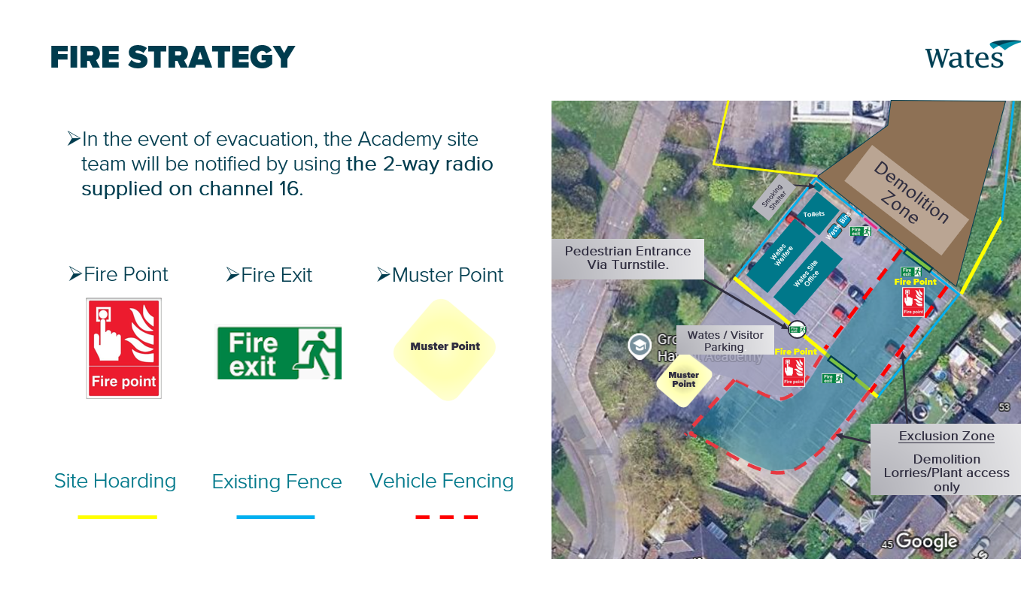

- Hoarding Plan
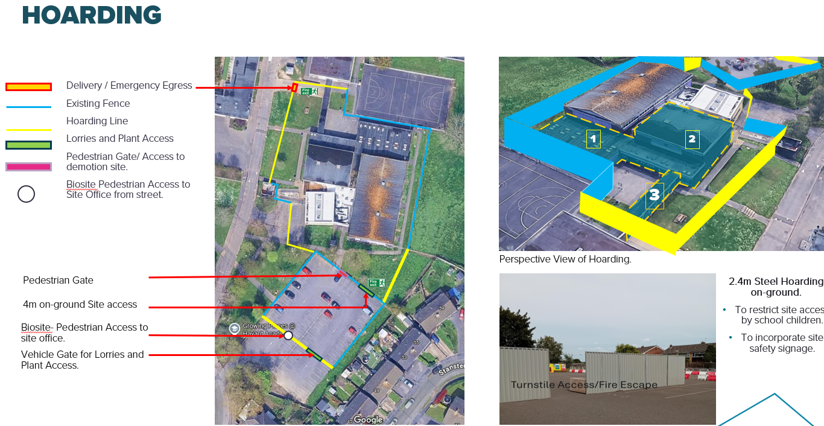

- Traffic Management Plan
