Heritage statement for Two storey side extension to provide annex accommodation at 108A London Road Widley Waterlooville PO7 5AA Case Reference: APP/25/00724

Background,
The proposed property is on London Road in Widley Waterlooville, to the
South of the property is open allotment land and to the north of the property is a grade 2 listed building as below.

Listing entry number 1092124
Listing Entry name The Old Rectory
Statutory address The Old Rectory 108 London Road
Listing date 14/1/1986

The Listing states
House. Of mid C18 origin, enlarged early and late C19. Painted brick walls
of header bond with later Flemish bond, other walling rendered. Tiled roof
of double pile brick dentil eaves. 2 storeys. This small house with a
symmetrical front was widened and extended at the rear in two phases. North
front elevation has 3 windows. Casements mostly of the early C19 with reeded
frames and some cambered openings. 1st floor band and plinth. Late C18 doorcase
(replaced from its original position) open pediment with modillion cornice, half round
reeded Doric columns, arched opening with radiating fanlight and 6 panelled door.

The Proposal
The proposed side extension has been designed to ensure no increased impact on the listed asset,
The extension is fully on the south side of the house and does not exceed the profile of the existing building in any way, it is not deeper to the rear or extend further to the road in any way and is no higher than the existing building. The 13.7m gap between the buildings is fully retained as is the extensive planting between the properties to the front and rear as shown in the two images below

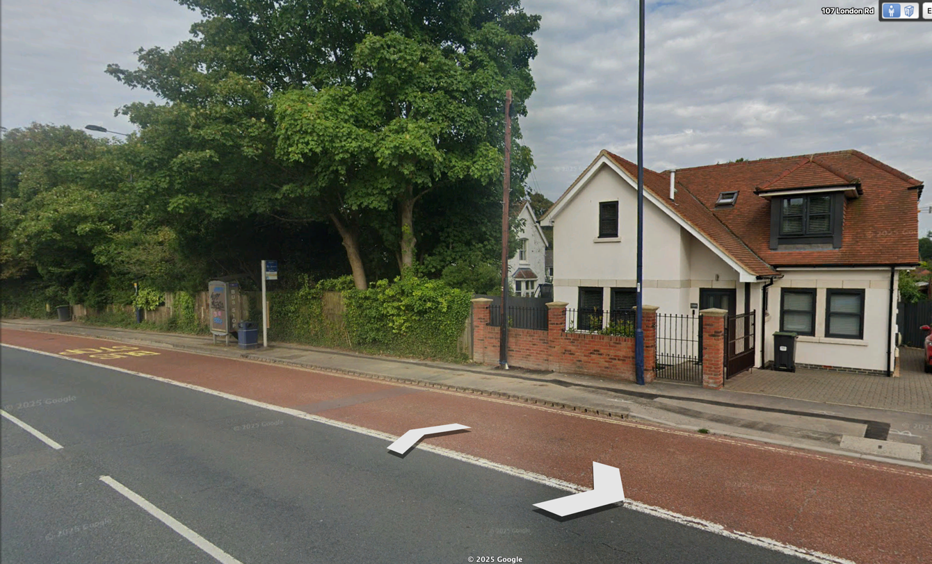

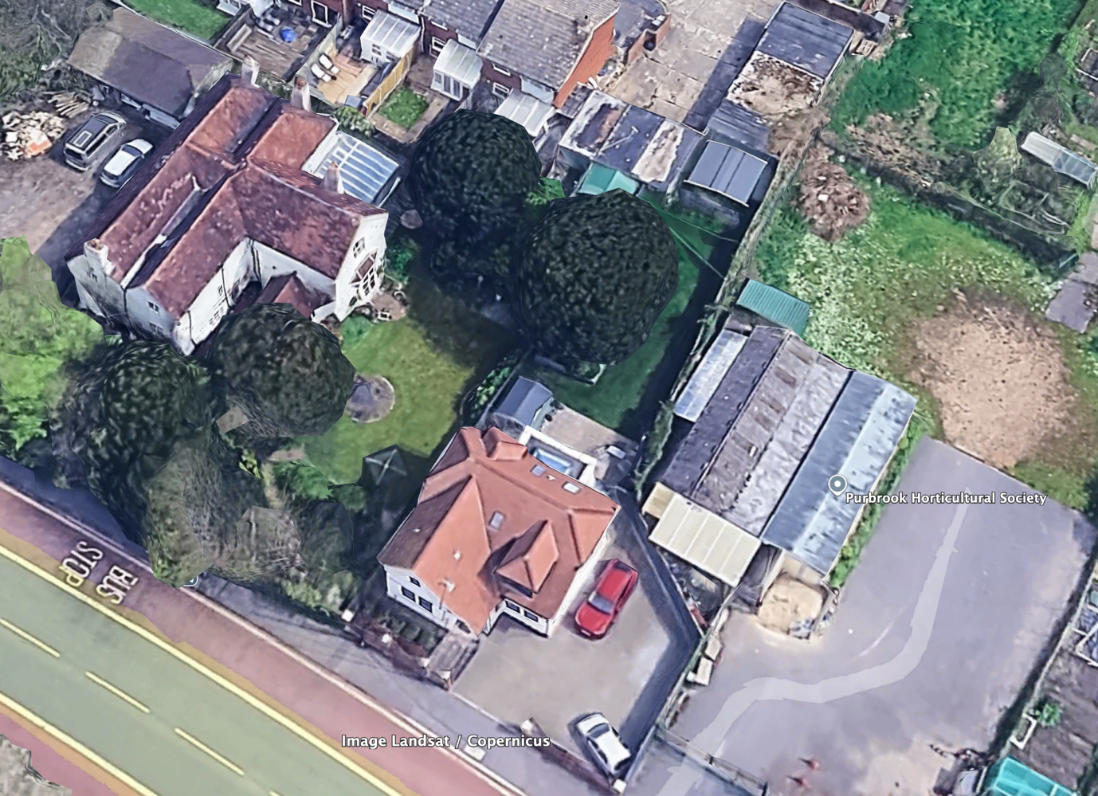

In terms of scale the proposed extension would still make the listed building footprint almost twice the size of the extended building. The materials of the extension match exactly the existing buildings materials which were chosen to be sympathetic to the heritage asset.

Conclusion
Due to the points made above, we do not believe that the proposal would impact the Heritage asset in any way.

