Realigned Footpath Cyclepath across
the proposed Continuation of
Coldharbour Farm Road
Emsworth

Client: Client reference:
Doswell Projects 23339

Fenley
2 Blaenant
Emmer Green
READING
RG4 8PH

E: office@fenley.co.uk
www.fenley.co.uk

Report Status 3
Job no | RSA-25-066 | Issue no | 3 | Date | September 2025
Prepared by | JJF | Verified by | ZB | Approved by | JJF
Filename and Path | Fenley/Road Safety Audits/RSA-25/RSA-25-066-2

- PROJECT DETAILS

Report Title: |  |  | Stage 1/2 Road Safety Audit
Date: |  |  | September 2025
Document reference and revision: |  |  | RSA-25-066-2
Prepared by: |  |  | Fenley Road Safety Limited
On behalf of the Overseeing Organisation: |  |  | Hampshire County Council
Design Organisation: |  |  | Ridge
Project Sponsor: |  |  | Doswell Projects
REV | ISSUE PURPOSE | AUTHOR |  | CHECKED | APPROVED | DATE
0 | Stage 1/2 Road Safety Audit drafted for Audit Team discussions | JJF |  |  |  | 4th  July  2025
1 | Stage 1/2 Road Safety Audit finalised and issued to the Design Organisation | JJF |  | ZB | JJF | 24th  September  2025
2 | Stage 1/2 Road Safety Audit Report format amended to incorporate a row for inclusion of a Design Organisation Response in order to maintain a concise record of items raised | JJF |  |  |  | 24th  September  2025
3 | Design Organisation Response incorporated | Rob Lowe  on behalf of Ridge |  |  |  | 25th  September  2025

Contents:
1.0 Project Details 1
2.0 Introduction 2
3.0 Items Raised in any previous Road Safety Audits 3
4.0 Items Raised in this Stage 2 Road Safety Audit 4
B.1 Alignment
B.2 General
B.3 Junctions
B.4 Walking, Cycling and Horse Riding
B.5 Traffic Signs, Carriageway Markings and Lighting
5.0 Audit Team Statement 10

Appendices:
Stage 2 B1 Documents and Drawings provided for this Road Safety Audit
B2 Item Location Plan
B3 Drawings associated with the Design Organisation Response

- INTRODUCTION
- This report has been prepared by Fenley Road Safety Limited and results from a Stage 2 Road Safety Audit of a revised design to allow for the continuation of Coldharbour Farm Road to provide access to a development. As part of the works, the existing footpath cyclepath link between Emsworth Park to the north and Washington Road to the south, is to be diverted to cross the proposed continuation at a raised table. The uncontrolled crossing is to be for pedestrians only with tactile paving and signage provided to highlight the need for cyclists to dismount on approach to the crossing. The scheme is proposed to facilitate access to a residential development of circa 44 dwellings on a parcel of land to the west, whilst retaining all but three of the existing parking spaces in the vicinity. It is understood that the alignment of the carriageway has been approved and that the revisions include the realignment of the existing footpath cyclepath that intersects the proposed continuation and therefore this Stage 1/2 Road Safety Audit only assesses the road safety implications of the revised realignment.

- The Audit Brief identifies that the proposals do not include any Departures from Standard, whether related to strategic decisions or otherwise.

- The Road Safety Audit was undertaken during June through to September 2025 in accordance with the Road Safety Audit Brief and updated / revised drawings provided on the 22nd June 2025 by the Project Sponsor, Doswell Projects. The Road Safety Audit comprised of a site visit as well as an examination of the documents provided which are identified in Appendix B1. The Audit Team were satisfied that the Audit Brief was sufficient for the purpose of the Audit instructed.

- The Road Safety Audit has been undertaken by an Audit Team whose qualifications and experience accord with the requirements of GG119 and have been approved to undertake Road Safety Audits of all stages within Hampshire. The Audit Team consists of the following members:

Audit Team Leader
Jamie Fenning BSc(Hons), MIHE, MCIHT, MSoRSA, National Highways RSA Certificate of Competency
Road Safety / Highway Engineer
Audit Team Member
Zane Beswick MCIHT, MSoRSA
Road Safety / Highway Engineer

- The site has been visited on two occasions; once as part of previous Road Safety Audits in May 2022 during school pick up between the hours of 14:35 and 15:15 and again with the latest being on associated with this Stage 2 Road Safety Audit was undertaken during the morning of Wednesday 2nd July 2025 between the hours of 11:00 and 11:30. The site visit involved walking and driving around the local highway network for a total period of 70-minutes whilst observing the local infrastructure and current off-peak traffic conditions. The weather during the site visits was overcast, the road surface was dry and visibility was good. A number of pedestrians and cyclists as well as skateboarders and scooter riders were observed during the site visits. Vehicular traffic was also observed to include cars and light goods vehicles. The traffic flow was light and free flowing. It was noted during the first site visit, that the existing perpendicular parking spaces at the end of Coldharbour Farm Road, are utilised by parents / guardians to drop-off and pick-up pupils from local schools and that the shared footpath cyclepath to the west of Coldharbour Farm Road forms a link between the residential area of Emsworth to the south and Emsworth Park to the north which incorporates numerous sports facilities.

- The terms of reference of this Road Safety Audit are as described in GG119. The scheme has been examined and this report compiled, only with regard to the safety implications for road users of the scheme as presented. It has not been examined or verified for compliance with any other standards or criteria. However, in order to clearly explain a safety problem or the recommendation to resolve a problem, the Audit Team may on occasion have referred to a design standard for information only. All comments and recommendations are referenced to the design drawings supplied with the Audit Brief and the location of road safety concerns raised have been illustrated beneath the items along with relevant photographs for clarity, where appropriate, as well as on the Location Plan attached at Appendix B2.

Design Organisation Response
- In accordance with national standards, this Road Safety Audit was finalised and issued to the Design Organisation as per the Road Safety Audit Report Template within Appendix D of GG119, which can be provided upon request from either the Audit Team or Design Organisation. The format of the Audit Report was subsequently revised to incorporate these paragraphs under the sub-heading as well as sufficient space beneath the items and recommendation, within Section 4, for the inclusion of a Design Organisation Response. This is generally contained within a separate Design Organisation Response Report but is included within this document in order to maintain a single record of all problems, recommendations and responses for the benefit of a concise Road Safety Audit trail to be held on file for Quality Assurance purposes.

- The Design Organisation Response has been prepared by:
Name: Rob Lowe
Position / Organisation: Associate Civil Engineer, JUBB

- Any drawings or documents associated with the Design Organisation Response are listed at Appendix A3, if applicable.

- ITEMS RAISED IN ANY PREVIOUS ROAD SAFETY AUDITS
- Fenley Road Safety Limited undertook the previous Stage 1 and Stage 2 Road Safety Audit associated with the current proposals which raised a number of concerns. It is noted, however, that the scheme has been revised and therefore this Stage 1/2 Road Safety Audit reassesses all elements of the scheme and raises any road safety concerns that the Audit Team consider are present.

- ITEMS RAISED AT THIS STAGE 2 ROAD SAFETY AUDIT
B.1 | LOCAL ALIGNMENT
B.1.1 | PROBLEM
Location: | Coldharbour Farm Road
Summary: | Proposals generate a reverse curve
Acc Type: | Sideswipe type collisions
The western end of Coldharbour Farm Road accommodates a turning head that allows access to a number of perpendicular parking bays and is situated immediately after an ‘S’ bend formed with circa 14 metre centreline radii. The proposals include the continuation of Coldharbour Farm Road to form a 4.8 metre wide development access road. The proposed continuation is to be taken off the existing carriageway following the first existing bend in the road and continues straight for circa 26 metres. It is noted, however, that a minor reverse kerb is formed along the northern edge of carriageway. The Audit Team have concerns that the proposed reverse curve could result in late and sudden swerves which may lead to sideswipe type collisions.
RECOMMENDATION:
It is recommended that the proposed access road meets the existing bend tangential.
Location Plan:
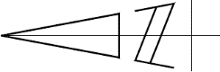
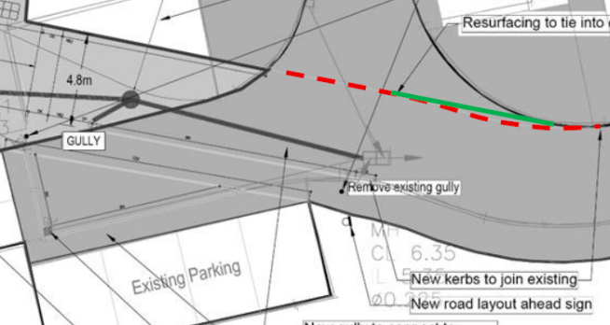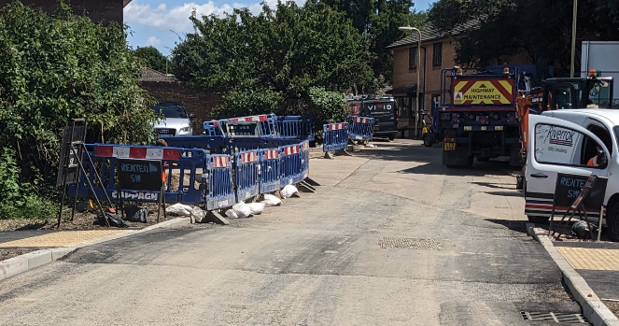

DESIGN ORGANISATION RESPONSE provided by Ridge on the 25th September 2025 following formal issue of this Stage 2 Road Safety Audit on the 24th September 2025
Agree – The reverse curve is minimal and cannot be removed without reducing the carriageway width. The edge of carriageway will be clearly visible with the provision of a broken edge of carriageway marking that is to be installed in response to item B.3.1.
B.2 | GENERAL
B.2.1 | PROBLEM
Location: | Coldharbour Farm Road
Summary: | Inappropriate ramp will be formed to access the parking bays
Acc Type: | Loss of control type collisions
Coldharbour Farm Road is a cul-de-sac that accommodates a turning head at the western end that allows access to a number of parking bays that have been observed to be utilised to facilitate drop off and pick up at the local primary school to the south. The proposals include the continuation of Coldharbour Farm Road through land that formerly accommodated three parking bays. The scheme drawing identifies that the remainder of the parking were to remain unchanged. The scheme was partially constructed at the time of the site visit associated with this Stage 1/2 Road Safety Audit when it was noted that the parking bays immediately adjacent to the footpath cyclepath link, were formed at the same level as the link. Whilst edging is present to highlight the edge parking bay and motorists that utilise the parking bay should not encroach outside the designated bay, the Audit Team have concerns that the bay is provided at a level circa 300mm above the aisle with a minimal margin. Motorists accessing the bay are therefore required to bump up a very steep ramp when accessing the bay which could result in vehicles overshooting the bay and loss of control type collisions.
RECOMMENDATION:
It is recommended that works are undertaken to ensure that the parking bay is easily accessible.
Location Plan:
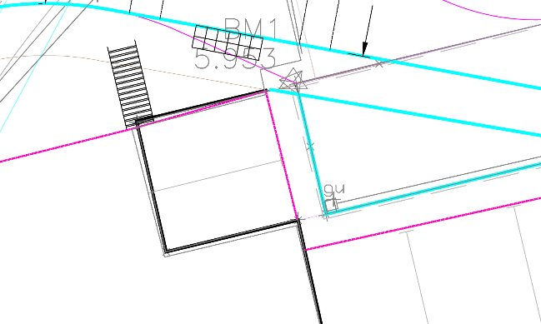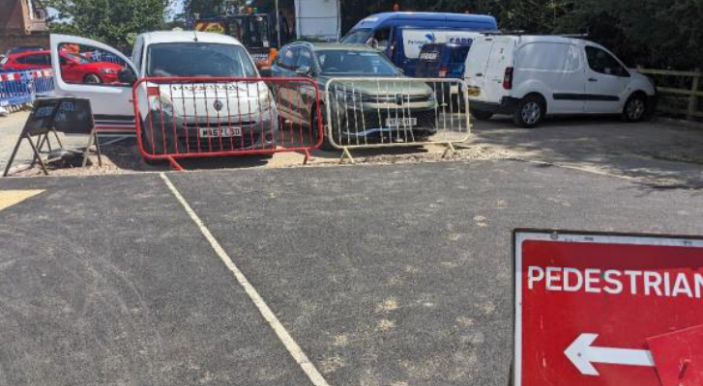
DESIGN ORGANISATION RESPONSE provided by Ridge on the 25th September 2025 following formal issue of this Stage 2 Road Safety Audit on the 24th September 2025
Agree – This will need further review as the proposals were to keep levels to existing so as to not adjust the existing drainage arrangements.
B.2.2 | PROBLEM
Location: | Raised Table Priority Crossing
Summary: | Area south of the proposed access road may not be surfaced
Acc Type: | Non-motorised user trip fall and personal injury
A public footpath cyclepath is present to the west of the Coldharbour Farm Road cul-de-sac that provides a link between Emsworth Park to the north and the residential areas to the south. The proposals include the continuation of the Coldharbour Farm Road cul-de-sac to form a 4.8 metre wide development access which intersects the existing footpath cyclepath. An uncontrolled crossing is to be provided on a raised table which should slow traffic to an appropriate speeds and encourage caution. The scheme drawing includes kerb type details and identify that dropper kerbs are to be provided both sides of the uncontrolled crossing which appeared to have been installed at the time of the site visit. Whilst dropper kerbs are common at uncontrolled crossing points as they allow for the upstand of full height kerbs to be reduced to a maximum of 6mm, the Audit Team have concerns that the dropper kerbs will result in a very slack ramp either side of the raised table. A slack ramp is unlikely to encourage low speeds and caution at the proposed uncontrolled crossing which could lead to inappropriate speeds and vehicle to pedestrian type collisions.
RECOMMENDATION:
It is recommended that the proposed ramps are adequate to slow traffic and encourage caution.
Location Plan:
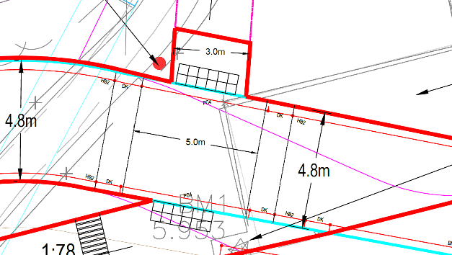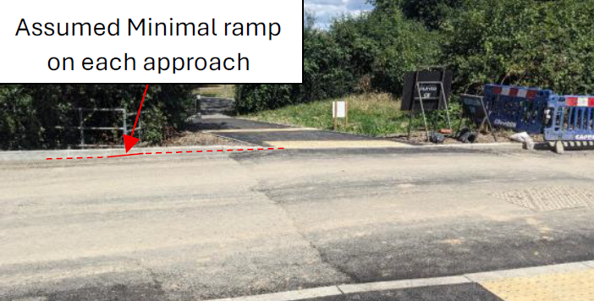

DESIGN ORGANISATION RESPONSE provided by Ridge on the 25th September 2025 following formal issue of this Stage 2 Road Safety Audit on the 24th September 2025
Agree – Levels will be maintained as required.
B.3 | JUNCTIONS
B.3.1 | PROBLEM
Location: | Coldharbour Farm Road
Summary: | Visibility may be limited
Acc Type: | Side / rear impact collisions
The western end of the Coldharbour Farm Road cul-de-sac accommodates a number of parking bays as well as vegetation in proximity to the existing turning head. The proposals include the continuation of Coldharbour Road to the west which forms two priority accesses that serve the existing parking aisles off the northern and southern sides of the carriageway. The scheme drawing illustrates the S278 red line boundary of the scheme but does not identify the land under control. The Audit Team have concerns that the appropriate level of visibility from each of the proposed priority accesses, extend across land that may not be under control and that items, such as vegetation or fencing could be installed. Items within a visibility envelope that are in excess of 600mm in height, above the carriageway, could result in a motorist attempting to undertake a manoeuvre when it is not safe to do so and lead to side and rear impact collisions.
RECOMMENDATION:
It is recommended that the envelope associated with the appropriate level of visibility, is cleared of all items in excess of 600mm in height and maintained as such.
Location Plan:
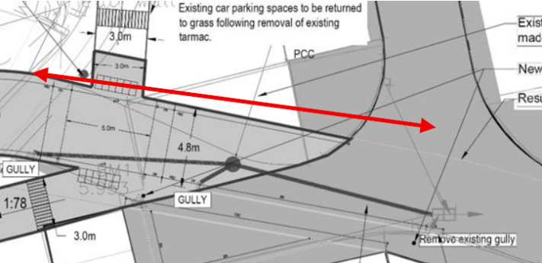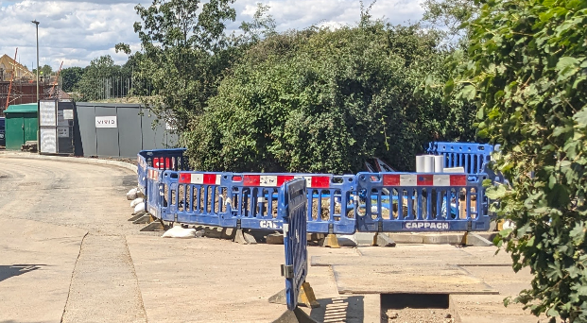

DESIGN ORGANISATION RESPONSE provided by Ridge on the 25th September 2025 following formal issue of this Stage 2 Road Safety Audit on the 24th September 2025
Agree – The land is controlled by VIVID and / or Hampshire County Council and therefore the vegetation will be cleared and grassed to an appropriate level.
B.3.2 | PROBLEM
Location: | Coldharbour Farm Road
Summary: | No guidance is provided to highlight priorities
Acc Type: | Side / rear impact collisions
The western end of the Coldharbour Farm Road cul-de-sac accommodates a number of parking bays that are currently accessed off an existing turning head. The proposals include the continuation of Coldharbour Road to the west which forms two priority accesses that serve the existing parking aisles off the northern and southern sides of the carriageway. Whilst the scheme drawing identifies that the southern access is to be formed as a vehicular crossover which clearly indicates priorities, the access of the northern side is to tie into the existing carriageway. The Audit Team have concerns that no guidance is provided in proximity of where the northern parking aisle meets Coldharbour Farm Road which could lead to side and rear impact collisions as a motorist attempts to manoeuvre from the parking aisle when it is not safe to do so.
RECOMMENDATION:
It is recommended that a form of an edge of a broken carriageway road markings, is provided.
Location Plan:
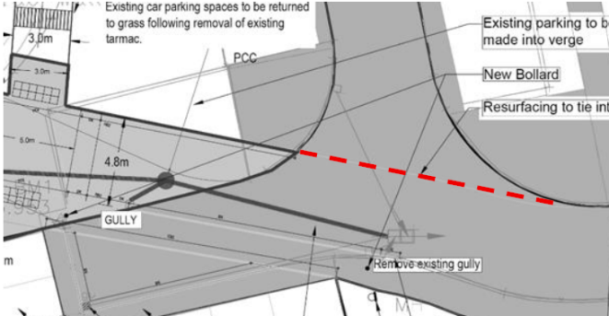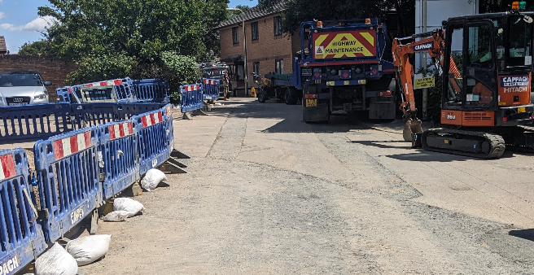
DESIGN ORGANISATION RESPONSE provided by Ridge on the 25th September 2025 following formal issue of this Stage 2 Road Safety Audit on the 24th September 2025
Agree – A broken edge of carriageway road marking will be provided as recommended.
B.4 | WALKING, CYCLING AND HORSE RIDING
B.4.1 | PROBLEM
Location: | Proposed uncontrolled crossing
Summary: | Cyclists will not dismount
Acc Type: | Vehicle to cyclist type collisions
To the west of Coldharbour Farm Road, an existing shared footpath cyclepath is present which provides access between the residential area of Emsworth to the south of the A27 and leisure facilities to the north to include Emsworth Park. The proposals include the continuation of Coldharbour Farm Road to form a development access and provide a raised table with an uncontrolled crossing. The scheme drawing includes the provision of hazard warning corduroy paving both sides of the uncontrolled crossing which would usually highlight a change in route characteristics. It is therefore understood that the paving denotes the end of the cyclepath and that cyclists should continue on foot. The Audit Team have concerns, however, that cyclists will not dismount but will proceed across the uncontrolled crossing. Motorists and cyclists approaching the uncontrolled crossing may not become aware of one another at a safe distance, particularly when vehicles are parked within the surrounding bays, which could lead to a vehicle to cyclist type collision.
RECOMMENDATION:
It is recommended that an appropriate level of visibility is achievable.
Location Plan:
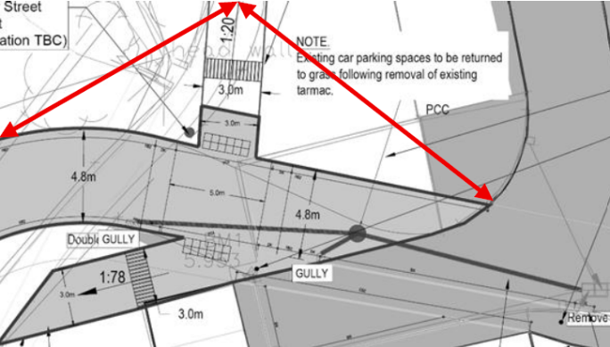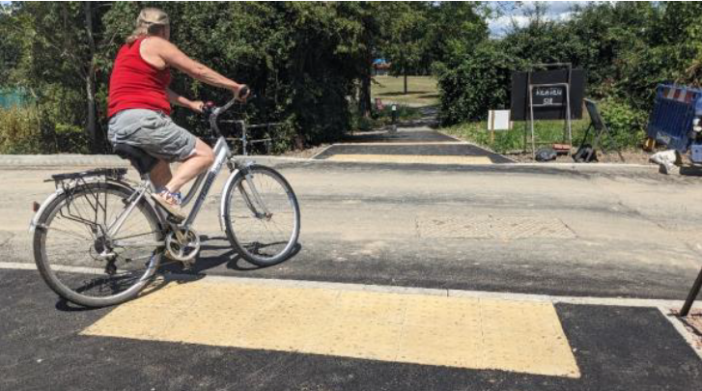

DESIGN ORGANISATION RESPONSE provided by Ridge on the 25th September 2025 following formal issue of this Stage 2 Road Safety Audit on the 24th September 2025
Agree – The land is controlled by VIVID and / or Hampshire County Council and therefore the vegetation will be cleared and grassed to an appropriate level.
B.4.2 | PROBLEM
Location: | Coldharbour Farm Road
Summary: | Pedestrians may not become aware of the live carriageway
Acc Type: | Vehicle to pedestrian type collisions
A shared footpath cyclepath is present to the west of the Coldharbour Farm Road cul-de-sac that provides a link between the facilities available at Emsworth Park and the residential areas to the south. During the site visits associated with this scheme, numerous pedestrians to include joggers have been observed. The proposals include the continuation of Coldharbour Farm Road to the west severing the existing footpath cyclepath. As part of the works, the existing footpath cyclepath is to be realigned to meet the northern side of Coldharbour Farm Road perpendicular where an uncontrolled crossing is to be provided on a raised table. The proposed uncontrolled crossing is to benefit from tactile paving, however, it is noted that just two rows of slabs are to be provided equating to a depth of 800mm. The Audit Team have concerns that the depth may not provide adequate warning for a visually impaired pedestrian walking with a stick pedestrians before encroaching the live carriageway or for joggers / pedestrians with large strides who could overstep the tactile warning into the path of a vehicle leading to a vehicle to pedestrian type collision.
RECOMMENDATION:
It is recommended that an additional row of tactile paving is installed.
Location Plan:
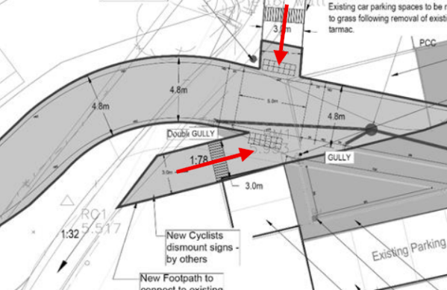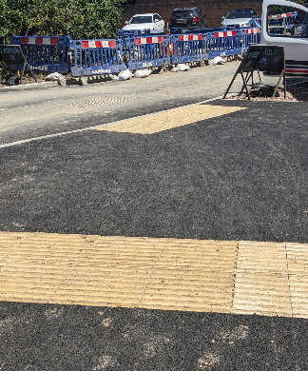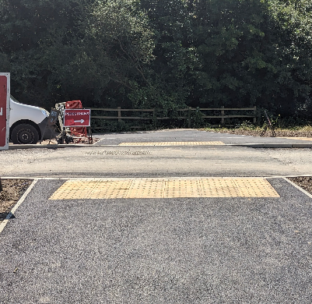

DESIGN ORGANISATION RESPONSE provided by Ridge on the 25th September 2025 following formal issue of this Stage 2 Road Safety Audit on the 24th September 2025
Agree – The additional row will be installed as recommended.
B.5 | TRAFFIC SIGNS, CARRIAGEWAY MARKINGS AND LIGHTING
 | No Road Safety Concerns regarding TRAFFIC SIGNS, CARRIAGEWAY MARKINGS AND LIGHTING have been raised at this stage

- STAGE 1/2 ROAD SAFETY Audit Team Statement

5.1 We certify that this Road Safety Audit has been carried out in accordance with GG119.
 | Audit Team Leader
 | Name: |  | Jamie Fenning BSc (Hons), MIHE, MCIHT, MSoRSA, HE RSA Certificate of Competency
 | Signed:
 | Position: |  | Road Safety / Highway Engineer
 | Organisation: |  | Fenley Road Safety Limited
 | Date: |  | 24th September 2025
 | Audit Team Member
 | Name: |  | Zane Beswick MCIHT, MSoRSA
 | Signed:
 | Position: |  | Road Safety / Highway Engineer
 | Organisation: |  | Fenley Road Safety Limited
 | Date: |  | 24th September 2025

Appendix B1
Documents and Drawings provided for this Stage 1/2 Road Safety Audit

Audit Stage | Doc. No. | Rev | Title
Stage 1/2 | Email dated 22nd June 2025 |  | Stage 1/2 Road Safety Audit Brief
Stage 1/2 | Dwg No. | Rev | Title
Stage 1/2 | 23339_JUBB_XX_XX_DR_C_100 | C2 | S278 Combined
Stage 1/2 | 23339_JUBB_XX_XX_DR_C_105 | C3 | S278 General Arrangement

Appendix B2
Item Location Plan

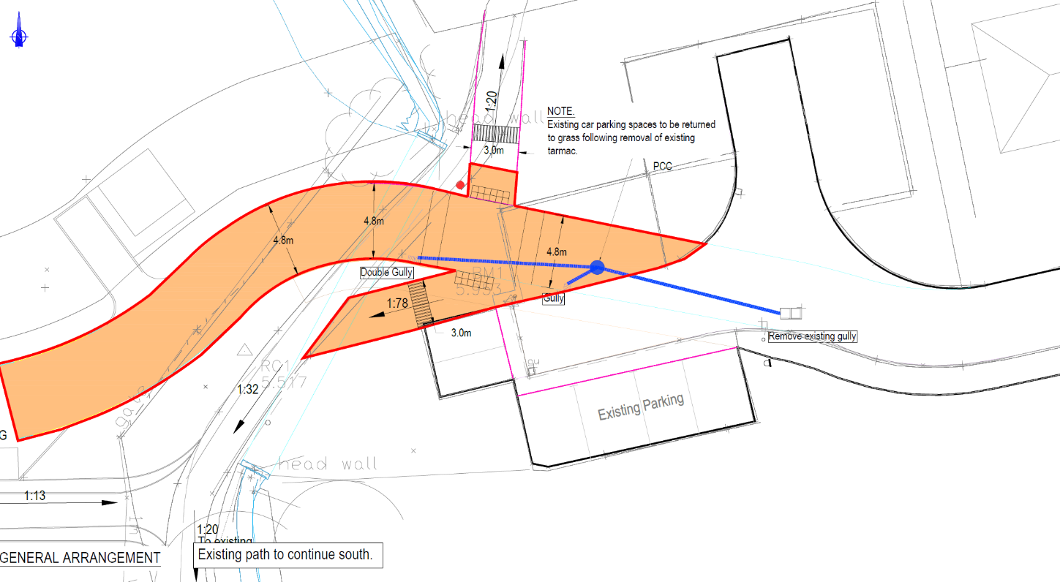

B.2.2
B.4.1
B.4.2

B.1.1B.3.1
B.3.2

B.2.1

Appendix B3
Drawings associated with the Design Organisation Response

Audit Stage | Drawing No. | Rev | Title
Stage 1/2



