

Habitats Regulations Assessment (HRA)
Screening and Appropriate Assessment (AA)

PLEASE NOTE: Undertaking the HRA process is the responsibility of Havant Borough Council as the Competent Authority for the purpose of the Habitats Regulations. However, it is the responsibility of the applicant to provide the Competent Authority with the information that they require for this purpose.

HRA drafting date: | 16/02/26
HRA completion date:
Application reference: | APP/21/00601
Application address: | Land north of Solent Road (adjacent to Bosmere Medical Centre) Havant
Application description: | Proposed Portsmouth Water Headquarters building (Use Class E(g)(i) use); widened access onto Solent Road; and associated access, car parking, landscaping and works; including the felling of 7No. trees the subject of TPO No.1801 in order to improve the access and allow for the development.
Lead Planning Officer: | David Eaves
Please note that all references in this assessment to the ‘Habitats Regulations’ refer to The Conservation of Habitats and Species Regulations 2017 (as amended).
Stage 1 - details of the plan or project
European site potentially impacted by planning application, plan or project: |  | - Chichester & Langstone Harbours Special Protection Area (SPA)  - Chichester & Langstone Harbours Ramsar site  - Solent Maritime Special Area of Conservation (SAC)  - Solent and Dorset Coast Special Protection Area (SPA)  - Solent and Southampton Water SPA  - Solent and Southampton Water Ramsar  - Portsmouth Harbour SPA  - Portsmouth Harbour Ramsar  - Solent and Isle of Wight Lagoons SAC  (Hereafter known as the Solent European Sites)
Is the planning application directly connected with or necessary to the management of the site (if yes, Applicant should have provided details)? |  | No. The development consists of an increase in residential dwellings, which is neither connected to nor necessary to the management of any European site.
Are there any other projects or plans that together with the planning application being assessed could affect the site? |  | Yes. All new housing development within 5.6km of the Solent SPAs is considered to contribute towards an impact on site integrity in combination with other development in the Solent area due to increase in recreational pressure.  All new housing development that would drain to the Budds Farm or Thornham Wastewater Treatment Works due to increase in nitrogen deposition leading to a reduction in water quality.  The PUSH Spatial Position Statement (https://www.push.gov.uk/work/planning-and-infrastructure/push-position-statement/) sets out the scale and distribution of housebuilding which is being planned for across South Hampshire.
Stage 2 - HRA screening assessment
Screening under Regulation 63(1)(a) of the Habitats Regulations – The Applicant to provide evidence so that a judgement can be made as to whether there could be any potential significant impacts of the development on the integrity of the SPA/SAC/Ramsar.
Solent European Sites
Collectively, the Solent European Sites provide protection for a range of coastal and marine habitats and the species supported by them.

The application site is not within close proximity to any of the Solent European Sites and would not result in direct habitat loss. On that basis it is considered that direct impacts to the interest features of the Solent European Sites are not likely to occur.

The application site is immediately adjacent to the Brockhampton Stream, which drains directly into Langstone Harbour and Chichester & Langstone Harbours SPA/Ramsar. There is potential for construction activity to result in the introduction of inorganic substances (e.g. hydrocarbons, chemicals, fuels, oils, lubricants) into this watercourse, or for construction and operational-phase activity to result in surface water run-off entering the watercourse. On that basis, there is potential for impacts to Chichester & Langstone Harbours SPA/Ramsar via waterborne pollution.

The site is included within the Solent Waders & Brent Goose Strategy (SWBGS) as Site H11, a Low Use area. The proposed development would therefore result in the loss of SPA/Ramsar supporting habitat.

Would the proposal lead to a likely significant effect on European site integrity?

Yes, proposed works have potential to result in impacts to the Solent European Sites and the species they support via waterborne pollution and the loss of SPA/Ramsar supporting habitat.

(If yes, continue to Stage 3).
Stage 3 - Appropriate Assessment
Appropriate Assessment under Regulation 63(1) - if there are any potential significant impacts, the applicant must provide evidence showing avoidance and/or mitigation measures to allow an Assessment to be made. The Applicant must also provide details which demonstrate any long-term management, maintenance and funding of any solution.
Solent European Sites
Waterborne pollution
The submitted Flood Risk Assessment and Drainage Strategy (Ardent, October 2023) details that the proposed drainage system will entail attenuation via permeable paving and a tank with a pumped discharge at greenfield runoff rates to the Brockhampton Stream. This SuDS system will include appropriate screening prior to discharge.

Subject to the imposition of appropriate planning conditions the Environment Agency and Hampshire County Council as Local Lead Flood Authority raise no objection to the proposed development. The long term management and maintenance of surface water drainage systems would be secured through appropriate conditions or S106 Legal Agreement. Conditions are also to be imposed should permission be granted in relation to Construction Environmental Management and Piling.

Previously, the applicant Portsmouth Water has undertaken flood alleviation works within the site to ensure that flood capacity will meet the 1 in 100 years plus climate change scenario. This has been approved by statutory consultees.

Habitat Loss
The direct and functional loss of SPA/Ramsar supporting habitat (SWBGS Site H11) will require mitigation. Based on the SWBGS Guidelines for Mitigation (current at the time of application), the loss of 1.5 hectares of Low Use supporting habitat equates to a cost of £53,415 (£35,610 x 1.5ha) to be paid by the applicant.

This contribution will be used at Warblington Farm, a site owned by Havant Borough Council. A series of former arable fields at Warblington Farm were converted to permanent grassland in 2021 in order to mitigate the potential impacts of nutrient enrichment within Chichester & Langstone Harbours SPA/Ramsar. The fields are included in the SWBGS Core Site H23E.

Site H23E totals 13.73 Ha of which c.9 Ha has been included within the c.25 Ha Phase 1 of the Warblington Farm Nutrient Mitigation Scheme. The 9 Ha of H23E has been sown with a clover-rich permanent grass mix to ensure habitat suitability during the overwintering bird season. The cessation of arable cropping (which has predominantly been a maize crop and therefore unsuitable for overwintering SPA/Ramsar bird species) and the creation of permanent grassland ensures that suitable habitat is available in each year. The grassland is not however subject to regular mowing to ensure suitable sward height.

Habitat Management
Havant Borough Council is to install permanent stock-proof fencing around the boundaries of two fields at Warblington Farm and to ensure that mowing is carried out prior to the wintering season. The fencing will be installed prior to October 2026 and mowing prior to this date will ensure a sward height of c.5cm for the wintering period.

Fencing will comprise standard post-and-wire 1.15m cattle fencing. The approximate fence location is shown in Figure 1.

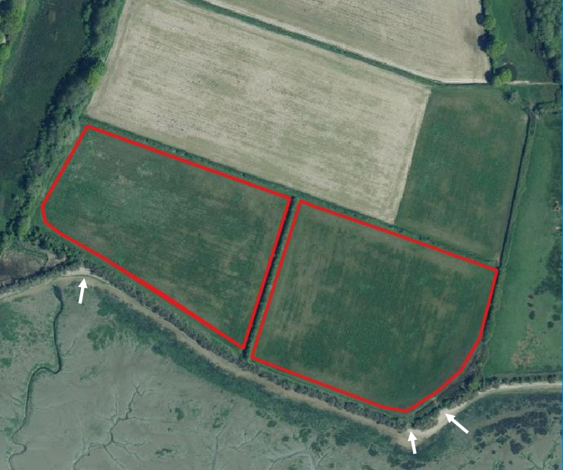
Figure 1 Location of proposed fencing and existing informal access points

Fencing will allow continued informal public access along the southern edges of the two fields. During high tide periods the adjacent foreshore is inaccessible, and walkers access the fields via the beach (Figure 1) and use the southern field edges to move along the coastline. It is considered that this regular usage is a deterrent to birds wishing to feed or rest within these fields.

The proposed new fencing will result in the restriction of informal public access to these two fields, thereby resulting in a functional uplift for overwintering bird species. Havant Borough Council is currently drafting a management statement for the proposed works.

The loss of Site H11 can therefore be mitigated by using the appropriate financial contribution to fund the proposed habitat enhancements at Site H23E.

Stage 4 – Summary of the Appropriate Assessment (To be carried out by the Competent Authority (the local planning authority) in liaison with Natural England
This assessment represents Havant Borough Council’s Appropriate Assessment as a Competent Authority in accordance with requirements under Regulation 63 of The Conservation of Habitats and Species Regulations 2017 (as amended), Article 6 (3) of the Habitats Directive and having due regard to its duties under Section 40(1) of the NERC Act 2006 to the purpose of conserving biodiversity. Consideration of the Ramsar site/s is a matter of government policy set out in the National Planning Policy Framework.
This assessment concludes that the application will have a likely significant effect in the absence of avoidance and mitigation measures on the above Solent European sites.

Based on the submitted drainage strategy and the use of Warblington Farm as an appropriate mitigation solution for the loss of SPA/Ramsar supporting habitat, it is considered that appropriate and proportionate avoidance and mitigation measures are secured. The implementation of these measures will remove the potential for impacts to the identified European sites.

Natural England Officer:
Summary of Natural England’s comments:

