BJH Property services.

42 Nobes Avenue,

Gosport, Hampshire, PO13 0HT

07787711781

bjhpropertyservices@outlook.com
126 Durley Avenue, Waterlooville, PO8 8TZ, Tree Report
12/01/2026

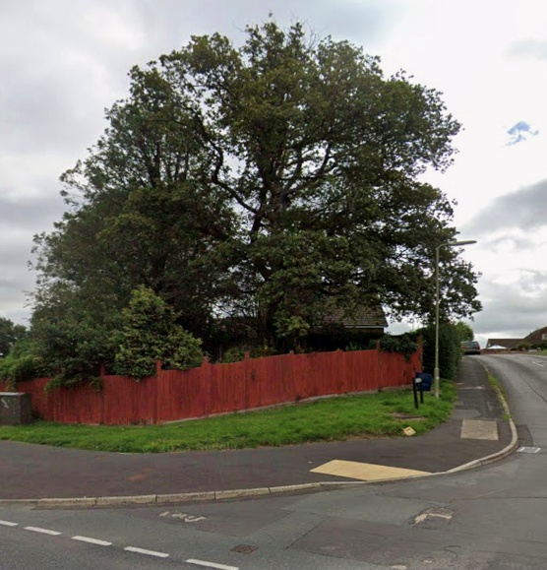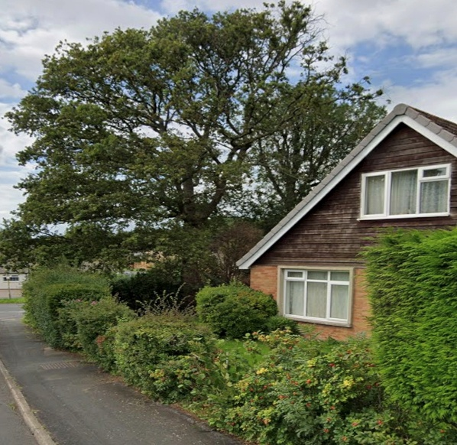

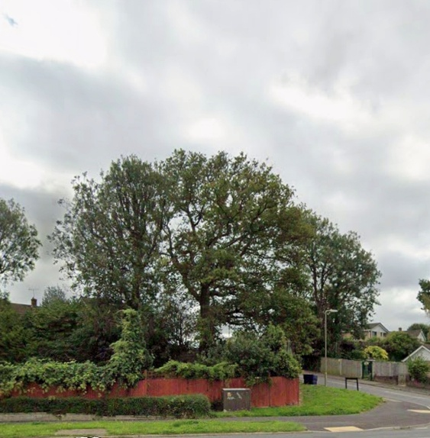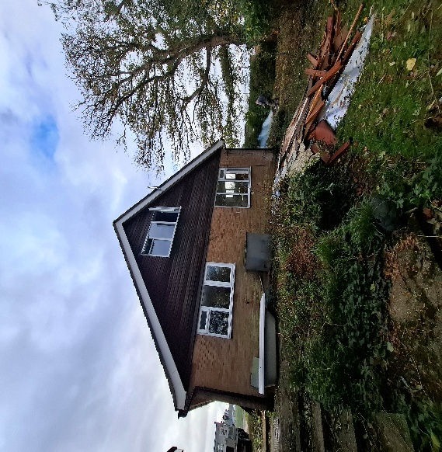

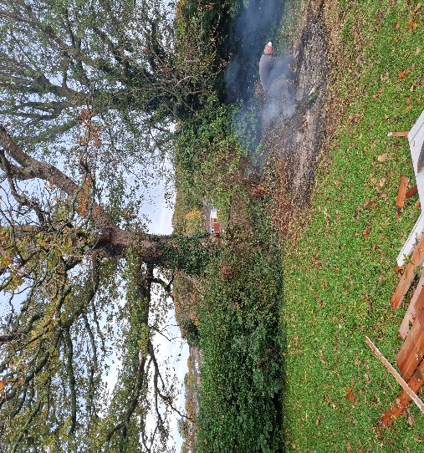

Introduction
Following the Planning application to erect a two-storey side extension to 126 Durley Avenue, Planning ref number APP/25/01000, I have been asked to provide a report on the Oak trees on site and how this will be affected and protected during construction works.

Tree Survey
The two Oak Trees (Quercus Rubor) are situated on the West boundary of the site and form part of the side boundary hedgerow. The trees are approximately 12-15m in height and have a spread of around 9.0m. Circumference at the trunks are 1750mm at 1.0m from ground level, giving an estimated age of between 85-95 years old. The crowns are around 2.60m from ground level and each tree have 4 main boughs mainly stretching out North to South. The base of the trees are cover with vegetation from an unmanaged hedgerow. There is no evidence of poor health, and all boughs and limbs appear healthy and full of bud and the trees have been pruned in the past. There are no signs of the roots penetrating the ground in any direction and are likely to be of adequate depth to not be within the area of the proposed extension. The side garden is a sunken unkempt grassed area and lies approx. 1.0m below the DPC level of the property. The tree shares the area with a mixed sparse hedgerow boundary to property and has a light covering of Ivy (Hedera Helix) from ground to above crown height, but this may be thicker during growing months.

Tree Protection.
During construction of the proposed extension the following will be adopted by the contractor to ensure no works or deliveries to the site will affect the tree in any way and that should this arise, any works will be managed to have minimum effect on the tree.
1, The immediate area under the trees will be harassed to prevent any vehicle or plant machinery making contact at any point. And all contractors on site to be made aware of the exclusion zone during induction onto site.
2, All delivery drivers will be made aware of the tree at ordering stage and delivery stage, and if they are driving high sided vehicles or operating cranes or boom arms then this is to be done outside the spread of the tree and with banksmen watching for clearance. Any skips on site will be carefully unloaded and loaded by the driver away from the immediate area around and under the tree canopy although removal of waste via smaller tipper truck would be preferred.
3, The foundation and floor to the proposed garage is to be of Raft type to minimise the impact into the ground. Excavation should be done by hand at the front (North) Elevation at the very least to avoid cutting through roots and any exposed roots be protected as the approved Plan notes. Any excavators should be monitored carefully by banksmen while digging and moving around the site paying attention to overhanging branches.
4, No spoil, building supplies or extraneous materials are to be stored near or against the tree and there will be no use of chemicals on site during the construction time.
5, Once works are complete the entire area is to be cleared of all materials and returned to how it was prior to building works.
6, All new rainwater run of will be to a new soakaway which will be hand dug and situated as far from the tree as rules allow (min 5.0m from any building) see plan. Any roots exposed during the dig will be carefully dug around and have minimum disturbance.
7, If any roots are exposed which may affect the building in a major way, then works should stop and the Architect should be contacted immediately to survey the areas effected and revise the plans to avoid any adverse contact or damage to the tree root system.
A copy of this report will be given to the contractors and agreed with the building owner or Architect prior to starting works. The building owner or Architect is to ensure all protection methods are adhered to before and during the works and a final site inspection once works have finished to be carried by the Contractor Foreman, Building Owner and Architect.
This report and photos were produced in Winter time while the tree is dormant and any obvious ill health may not be clear until the leaves have appeared and the tree is in full growth.
Produced by:
Brian Hindle.
12th January 2026.

Revision 23/03/2026

The area within 11m diameter of the trees will be hand dug to prevent major damage to the tree roots. The foundations to the extension will be on piles which will limit the impact to the ground and surrounding area. Any major roots will be worked around, and the foundations will be calculated to suit the ground conditions and any tree roots. No major roots will be removed, and every care will be taken to minimise damage or disturbance to feeder roots. All contractors will be briefed on this entire document prior to commencement of any works on site and will adhere to all protection plans as stated.

