
Charity No: 1116034. Registered Company No: 05480101
The Manor Trust Bedhampton (A company limited by guarantee)
Registered Office: The Elms, 2 Lower Road, Bedhampton, Hants, PO9 3LH.

Ref:/ APP/25/00929 Dated: 13/04/2026

The Heritage Statement accompanying Havant Borough Council’s (HBC) Planning Application APP/25/00929

Introduction

The site, known as The Elms, is situation in the Old Bedhampton Conservation Area at the west end of the ‘old village’ area of Bedhampton in Hampshire. Bedhampton is a former village and now suburb of Havant. The earliest recording of Bedhampton dates back to the Domesday Book and the present parish church, 12th century St Thomas the Apostle Church, sits a mere two-minute walk from The Elms. Local shops and amenities are situated at the centre of Bedhampton that can be reached within a five-minute walk. The major roads A27 and A3M connecting north/south and east/west traffic routes pass to the western end of Bedhampton.

Location & Building

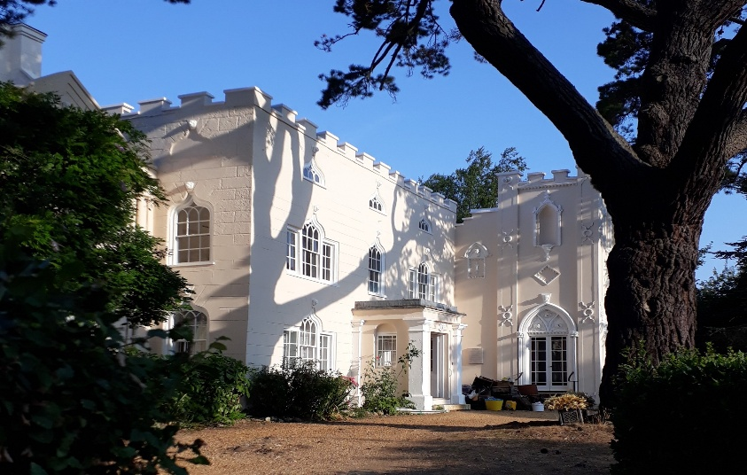
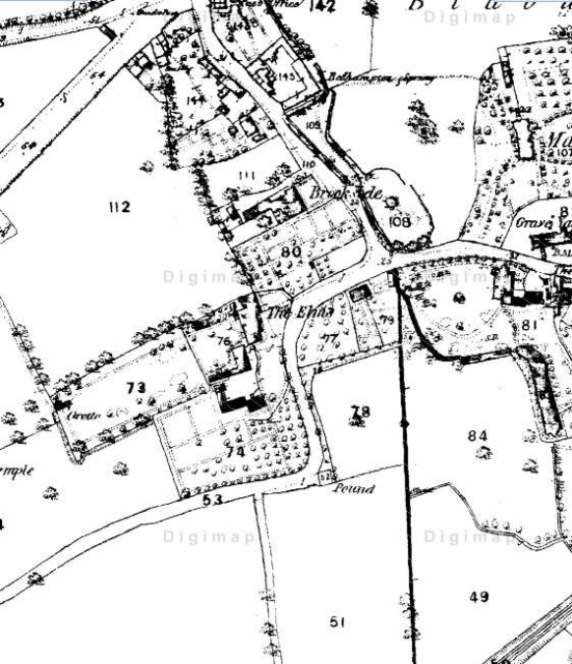
The Elms was constructed in the 17th century, originally designed as a farmhouse it underwent extensive alterations during the 18th century resulting in the building that stands today. An extract of a very early map clearly illustrates the house and curtilage that has not significantly changed since these major alterations were undertaken, at the time, by Sir Theophilus Lee who owned The Elms. The building's principal features are the 'Strawberry Hill House' style of Neo-Gothic Architecture elevations, with castellations, neo-gothic windows, featured lionhead mouldings and the Regency Banqueting Hall, The Waterloo Room.
The Elms - East Elevation with Turret

The east facade comprises three storeys with the second story featuring venetian windows, while the ground floor has a similar arrangement. The main entrance includes an enclosed porch facilitating access to all three storeys. The large extension that projects north from the original house features the grand banqueting room, colloquially known as The Waterloo Room. Sitting atop this extension is the “Turret” adorned with castellations, neo-gothic windows and lion head mouldings. A significant restoration to preserve this very impressive neo-gothic architecture was carried out in 2015, partially funded through volunteer activities and local donations.

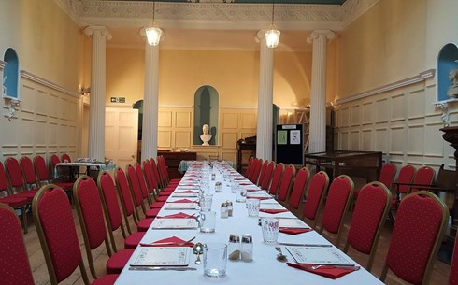
Sir Theophilus commissioned a banqueting Hall, which through time, became known as the Waterloo Room to honour of the Duke of Wellington’s success at the Battle of Waterloo on 18th June 1815. Story has it that Sir Theophilus invited his second cousin Arthur Wellesley, the first Duke of Wellington, to dine there however, it cannot be substantiated Wellington ever dined there.

Today, the Waterloo Room hosts local functions that help raise funds to contribute towards the costs of upkeep of the interior and exterior. Functions, such as talks, lunch club for the elderly, Christmas Fair and Coffee Mornings generates a true community spirit among local residents, volunteers and members of the Trust.
The Waterloo Room

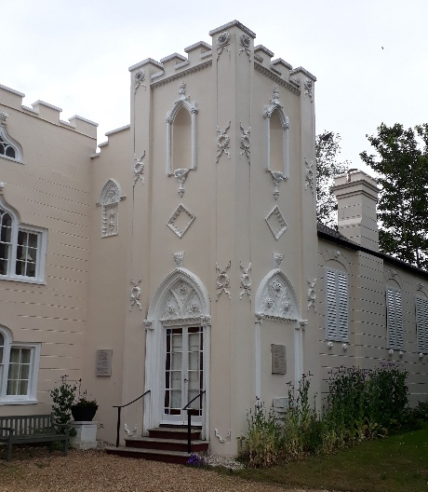
Sir John Theophilus Lee did not see out his days at The Elms as by 1841 he had moved to a new home, Lauristons (later called Lauriston Hall), at Torquay and The Elms estate changed hands once again, being bought by James Openshaw Kay. Several have owned The Elms over the years and the current owner, The Manor Trust saved it from demolition in 1970 by purchasing it from the developer and implemented a programme of restoration, an example of which is displayed in these photographs. The Trustees have entered into a programme of refurbishment and maintenance to assure the preservation of The Elms and enhance the five retirement apartments for those seeking independent living arrangements.

A significant financial investment continues to support restoration tasks including, replacement windows, roof repairs, heating and hot water systems etc. The very recent installation of full fibre broadband to all the retirement apartments has been most welcomed by the residents. Despite these notable renovations, further work is needed to address some outstanding structural issues, such as a crumbling flint and brick North boundary wall within the curtilage.
Waterloo Room entrance

Curtilage Repairs

The intended repairs to the North boundary wall will not compromise the building’s unique style or construction. These repairs do not impact any of the residents or current functions undertaken at The Elms, moreover, the restoration of this boundary wall will contribute towards improving the aesthetics of the garden and rear courtyard. Using traditional materials and methods will ensure the root damaged section of the wall will be sympathetically restored to match the existing.

Sustainability

One of The Manor Trust’s objectives is the preservation of the properties currently under its ownership, a responsibility it enthusiastically shoulders. To contribute to progressing the programme of restoration and maintenance, these planned repairs are necessary and the appropriate local authority permission is being sought to implement them.

