Wheatsheaf Mews (1-15)
Design and Access Statement

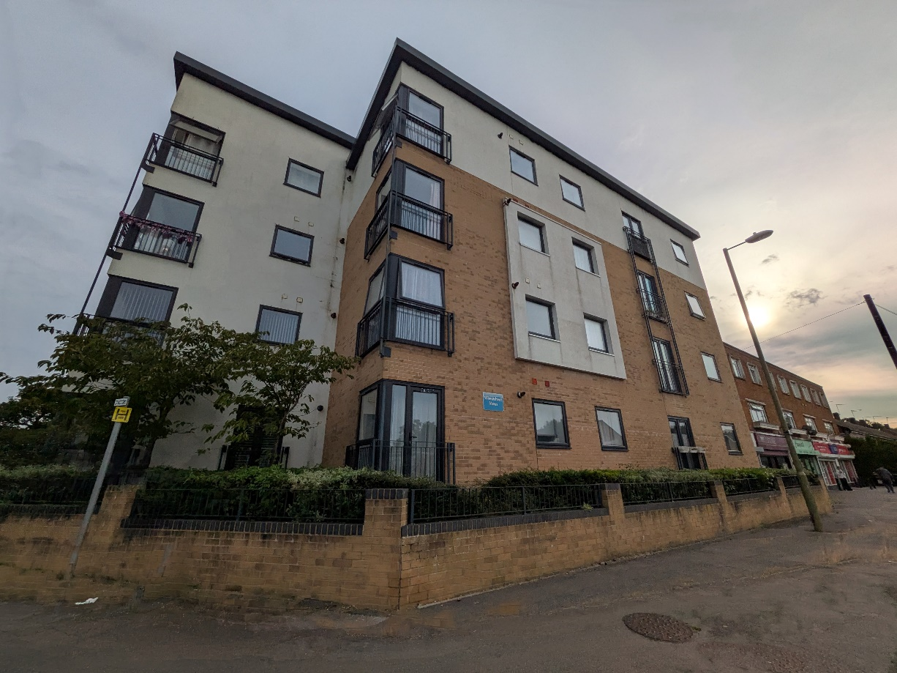

March 2026
Niamh Nocentini
Building Surveyor (Building Safety)
Housing, Neighbourhood and Building Services
Portsmouth City Council
Table of Contents
1.0 Introduction and Background to the Site 2
1.1 Document History 2
1.2 Document History 2
1.3 The Site 2
1.4 Planning and Development History 3
2.0 Proposal 4
2.1 Summary 4
2.2 Materials and Design Considerations 5
2.3 Access Statement 5
2.4 Flood Risk Assessment 5
2.5 Heritage Statement 6
2.6 Parking Provision Statement 6
2.7 Landscaping 6
2.8 Tree Survey and Arboricultural Implications 6
3.0 Planning Policy Assessment 7
3.1 Havant Borough Core Strategy (2011) 7
3.2 Havant Borough Local Plan (Allocations) (2014) 8
3.3 Building A Better Future Plan (DRAFT) 8
3.4 Havant Borough Council Design Guide Supplementary Planning Document 9
Appendices 10
Appendix I - Photographs of the Existing Property 10
Appendix II - Drawings Schedule 11

Introduction and Background to the Site

Document History

Figure 1: Record of revisions to this document.
Version | Date | Update
Draft | 26/02/2026 | N/A
Final | 13/03/2026 | Finalised version

Document History

    - The following Design and Access Statement has been prepared to support an application for fire safety remediation works involving the relocation of gas pipework at Wheatsheaf Mews (1-15), a block of flats in Havant.

    - This proposal concerns an existing, occupied residential block of flats. A CORGI Technical report carried out in November 2024 and subsequent FRA Type 4 carried out in January 2025, identified a variety of remedial measures that are required to make safe the non-compliant gas installation within the block. The current installation involves press fit copper pipe within unventilated voids throughout the communal protected corridors and stairs, and within 11 of the 15 individual flats.

    - In response to the findings, it is proposed that the flats affected by the non-compliant gas installation have their internal gas pipes removed and relocated to the front elevation of the block where the gas combi boilers are located to allow them to be directly supplied with minimal internal gas pipes. This will also involve the relocation of their associated gas meters. This installation will comply with the requirements set out within the Gas Safety (Installation and Use) Regulations 1998.

    - As a result, the risk of gas build up within unventilated voids and potential ignition, will be removed, improving the safety to residents within the building.

The Site

    - The Site is inclusive of the following residential property:

Wheatsheaf Mews (1-15), Bramdean Drive, Havant, PO9 4FB.

    - The block of flats is a four storey, low rise block of flats, constructed in 2017 of Metsec construction, comprising a mix of one and two bed flats. All flats within the block are occupied.

    - To the east, the block abuts a row of terraced housing, built as part of the same development.

    - The road facing front elevations to the north and west face onto Bramdean Drive and Botley Drive respectively. These elevations are separated from the public highway by a pavement, low rise masonry wall with metal railings and vegetation.

    - To the rear, the block wraps around a small courtyard on two sides. The courtyard is partially paved with a large raised garden bed. It is accessed from communal doors from the ground floor corridor via a paved ramp, and also from patio doors leading from flat number 4. The courtyard is enclosed on the remaining two sides by timber fencing from the neighbouring house - 16 Wheatsheaf Mews - and by a masonry wall from a neighbouring building to the south on Botley Drive. There is dedicated resident parking area to the east of the block, accessible on foot from the enclosed courtyard.

    - Within the courtyard are 15no. gas meters, separated from the paved area by metal railings. Gas pipework from each gas riser currently follows, and is attached to, two walls of the building before rising to each relevant floor level. The gas pipes then penetrate through the external wall to the ceiling void above the protected stair core. Four of the flats have boilers on the courtyard facing walls and so are directly fed by the gas meters and do not pose a risk. The remaining 11no. flats have pipework running approx. 18m in distance from the gas pipe entry point to the combination boiler within the flat kitchens.

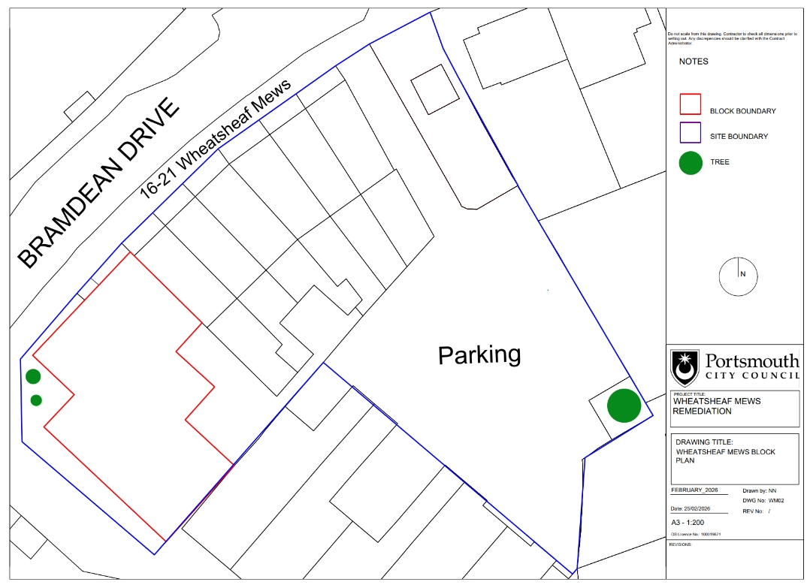
Figure 2: Block plan dictating the location of the block of flats (red outline) and the boundaries (blue line), as well as nearby trees (green).

Planning and Development History

1.4.1 The property was built in 2017 and since construction there has been no major developments or alterations to the property.

1.4.2 There have been no planning applications to the Local Planning Authority.

Proposal

2.1 Summary

    - The proposed scheme focuses on remediating the gas pipework installation issues raised within a fire risk assessment at the block. The proposed works will greatly reduce the amount of gas pipework internally and remove the current risk to residents and possibility of gas build up within the unventilated void space. The external risers will reduce the requirement for ongoing compliance checks and maintenance of the internal installation within enclosed, high level voids.

    - 4no. flats are unaffected by the internal gas pipework installation as they currently have gas pipes directly feeding combi boilers located on external walls backing onto the courtyard to the rear. It is proposed that the remaining 11no. flats with long runs of non-compliant internal gas pipework have their internal gas pipes relocated from internally to externally, removing any risk to life. This proposal involves the relocation of 11no. gas meters and associated pipework from the rear of the building to the front, to enable pipework to directly feed boilers located on the external walls.

    - It is proposed that the gas meters be moved to three locations to the front of the block to correspond with boiler locations for the 11no. flats across the four storeys. The meters will be encased within surface mounted meter boxes to the external wall, located below the boiler locations to reduce the linear meterage of gas pipework on the external walls.

    - For flats 4, 8 and 12 that face onto Bramdean Drive, the meters will be encased within bolt-on meter boxes located between the main entrance door and the bin store door. The gas pipes will rise and be connected to the yellow brick façade, penetrating the external wall to the internal within close proximity of the boiler.

    - For flats 1, 5, 9 and 13, that face onto the corner of Bramdean Drive and Botley Drive, the meters will be encased in low level Uniboxes mounted onto the yellow brick façade and white render. The gas pipes will rise and be connected to the white render, penetrating the external wall within close proximity of the boiler.

    - For flats 2, 6, 10 and 14 that face onto Botley Drive, the meters will be encased in low level Uniboxes mounted onto the yellow brick façade. The gas pipes will rise and be connected to the yellow brick façade, penetrating the external wall within close proximity of the boiler

    - The gas pipes will penetrate the external wall of the building within 2m of the boiler to comply with the Safety (Installation and Use) Regulations 1998. These penetrations will be fire stopped to ensure compartmentation and limit fire spread in line with the Regulatory Reform (Fire Safety) Order 2005.

    - To facilitate access to the gas meters that face onto the corner of Bramdean Drive and Botley Drive, vegetation will be cut back and a section of existing masonry wall will be removed and a metal gate instated. The metal gate will be of similar style to the metal railings of the masonry wall.

2.2 Materials and Design Considerations

    - All materials and colours are to be approved by planning officers prior to construction. Photographs of the external elevations and key components are included in Appendix I and within the application.

    - Gas Pipe Risers:

    - It is proposed that galvanised steel pipe will be used for the gas risers to compliment the existing vertical fixtures connected to the façade of the building. Galvanised steel is durable and corrosion resistant, ensuring suitability for this proposal.

    - Gas Meter Boxes:

    - Uniboxes are to be utilised for locations enclosed by the masonry wall due to suitability for low wall mounting and high versatility with multiple entry points. The brown finish of the boxes will aid in blending in with the surrounding vegetation.

    - Surface wall mounted meter boxes will be used for the three meters facing Bramdean Drive due to their reduced casing size and more modern design to suit to modern construction style of the block.

    - Fire Stopping:

    - Rockwool fire stopping will be used to the external walls where gas pipes penetrate to boiler location internally.

Access Statement

    - There will be no alterations made to vehicular access to the property; this will still be through Bramdean Drive only. The property features a shared resident parking area to the rear as well as on-street parking nearby.

    - Alterations will not be made to the accessibility of the property. The property currently benefits from step free access and is compliant with the requirements outlined in Approved Document M.

    - Access to current gas meters is limited for both residents and gas engineers due to the placement of the paved ramp from the rear communal door, and the addition of metal railings. This does not conform to Part C point 12 (4) of the The Gas Safety (Installation and Use) Regulations 1998, which states that no person shall install a meter except in a readily accessible position for inspection and maintenance. Moving the gas meters to a more accessible location to the front of the block with sufficient space for inspection and maintenance will ensure compliance with relevant regulation. The proposed placement of the gas meters will not adversely affect the route of escape.

2.4 Flood Risk Assessment

2.4.1 The proposal falls within Flood Zone 1 and therefore is not at risk of flooding.

2.4.2 Adaptations are not being made to existing water or drainage systems.

2.4.3 A small amount of vegetation will be removed to allow for the new gas mains connection. To facilitate safe access to the gas meters within the masonry wall area, a paved path will be installed from the proposed location of the access gate to the two separate meter locations. The front area of the block is neither in a flood risk zone nor at risk of surface water flooding, and so is unlikely to have an impact on water drainage in the area. No trees or extensive areas of vegetation are to be removed, only cut back to facilitate access.

2.5 Heritage Statement

2.5.1 The property is neither a Listed Building nor on the Local List of Buildings with Special Architectural and Historic Interest. The building is not recorded on the Historic Environment Record (HER).

2.6 Parking Provision Statement

2.6.1 The proposal does not affect occupation levels or demand for parking in the area.

2.7 Landscaping

2.7.1 Within the scope of the proposal, the landscape will have alterations to the front. At the present the building is separated from the public pavement and highway by a low masonry wall capped with metal railings. There is a small area of garden within this enclosed area that is currently inaccessible, making landscaping activities difficult.
2.7.2 To enable the works to take place, and for future inspection and maintenance of the gas meters, a section of the masonry wall will be removed and a metal access gate installed. A small amount of vegetation will be removed to allow for the new gas mains connection below ground. To facilitate safe access to the gas meters within the masonry wall area, a paved path will be installed from the proposed location of the access gate to the two separate meter locations. A small amount of vegetation will be cut back where necessary to facilitate access, but otherwise remain untouched.

2.8 Tree Survey and Arboriculture Implications

2.8.1 Within the boundary of the property three small trees have been identified. One tree is present to the rear parking area is not within proximity of the proposed works and will remain untouched. The two remaining two trees are located within the enclosed garden area to the front of the block. These trees are cherry trees, planted during construction of the block of flats in 2017, and are not under a Tree Protection Order (TPO). As the gas pipe trench route will avoid the trees; the trees will remain.

Planning Policy Assessment

Havant Borough Core Strategy (2011)
    - The Havant Borough Core Strategy (2011) has been considered when developing this proposal. The proposal has been considered against individual polices detailed within the strategy. The proposal is relevant to the following key policies:

    - Policy CS1 - Health and Wellbeing

    - This proposal meets the policy by reducing risks to residents within the borough, ensuring health and wellbeing.

    - Policy CS9 - Housing

    - This proposal ensures that the needs of existing vulnerable residents and those with accessibility needs within the block can remain within their homes safely, without needing to decant due to the current increased risk. The changes will ensure that the dwellings remain safe to occupy for future social housing residents.

    - Policy CS8 - Caring for our Borough

    - This proposal meets the policy by ensuring developments are built to a high quality standard. The works under the proposal will remediate existing issues, ensuring quality, safety for residents, and longevity of the build.

    - Policy CS14: Efficient Use of Resources

    - Local contractors will be used for the contract which ensure that transportation emissions are minimised.

    - The proposed relocation of the gas meters and gas pipework ensures that internal fit outs, including ceilings, kitchens and bathrooms aren't removed as a result of a reinstallation of a compliant internal gas installation. The external rerouting greatly reduces the risk of future gas leaks and subsequent remedial work, ensuring effective use of resources.

    - Policy CS15: Flood and Coastal Erosion Risk

    - The site is located within a low hazard area - Flood Zone 1.

    - Policy CS16: High Quality Design

    - The proposal is designed with deliberate consideration and safety of current and future residents.

    - The nature of the considerate and future-proofed design ensures that environmental impacts are mitigated through limited future remediations and construction required.

    - This proposal ensures integration with the surrounding aesthetic through the matching of construction materials to the existing building.

    - Policy CS19: Effective Provision of Infrastructure

    - This proposal will ensure existing developments are brought up to modern safety standards to prolong the life cycle of the building and minimise environmental impacts.

Havant Borough Local Plan (Allocations) (2014)

    - Alongside the Core Strategy, the Local Plan has also been referred to with individual policies having been considered. The proposal is relevant to the following key policies:

    - Policy AL1 - Presumption In Favour of Sustainable Development

    - This proposal ensures safe provision of accessible dwelling for members of the community which ensures that the development is improving the social conditions within the area.

    - Policy AL2 - Urban Area Boundaries and Undeveloped Gaps

    - The proposal sits within the current boundaries of the buildings curtilage and is within a defined sub-urban area. The proposal does not encroach upon existing green areas or protected gaps.

3.3 Building A Better Future Plan (DRAFT)

3.3.1 Despite not yet being adopted, the Havant Borough Council Building A Better Future Plan, drafted in 2025, has been considered in supplement to the 2011 Core Strategy and the Local Plan 2014. The proposal is relevant to the following key policies:

3.3.2 Policy 2 - Defined Urban Areas

3.3.3 The proposal complies with this policy ensuring that the development does not encroach upon non-urban areas. This is achieved through only developing within the boundary of the properties existing boundaries.

3.3.4 Policy 9 - New Homes For Sustainable Communities

3.3.5 The proposal ensures that the local area provides and retains a broad range of housing types including those that can be deemed accessible.

3.3.6 The proposal ensures that accessible housing remains safely available to social housing tenants.

3.3.7 Policy 12 - High Quality Design

3.3.8 As outlined in section 3.1.13.

3.3.9 Policy 15 - Low Carbon Development

3.3.10 This proposal will ensure the existing development is brought up to modern safety standards to prolong the life cycle of the building and minimise environmental impacts.

3.3.12 Policy 16 - Preventing Overheating

3.3.13 The current flats within the development have an EPC rating of B, displaying high energy efficiencies in avoiding overheating. The proposal helps to ensure the dwellings meet current safety standards and remain occupied.

Havant Borough Council Design Guide Supplementary Planning Document

    - Following the Guide's adoption in 2011, the "Extensions and Additions to Existing Residential Properties" section has been referred to. The particular relevant policies are as follows:

    - Section 6 Paragraph 5.02

    - Pre planning application engagement has been sought from Havant County Council which has not raised any initial issues to be addressed prior to submission of this full planning application.

    - Section 5.3

3.4.5 The proposed fixtures to the external of the building are sympathetic and subservient to that of the original building and does not have adverse effects upon neighbouring properties.

Appendices

Appendix I - Photographs of the Existing Property

Photograph Title
Block entrance with proposed meter location
Current external gas riser installation
Current restricted access to gas meters 1
Current restricted access to gas meters 2
Enclosed area to corner of Bramdean Drive and Botley Drive
North elevation
North west elevation
Proposed meter location
Vegetation and trees within enclosed area to front and proposed meter location
West elevation

Appendix II - Drawings Schedule

Drawing Number | Drawing Title | Scale
WM01 | Location Plan | 1:1250
WM02 | Block Plan | 1:200
WM03 | Proposed Gas Route | 1:200
WM04 | Existing Elevation | 1:100
WM05 | Proposed Elevation | 1:100
2843880-Drawing | SGN REF 2843880 | 1:500

