25 Bellair Road,
Havant,
Hampshire,
PO9 2RG

PHASE 2 BAT EMERGENCE SURVEY
May 2026

Dr.Jonty Denton (Chartered Ecologist) FRES FLS MCIEEM CECol

Prepared by
Dr. Jonty Denton Bsc (Hons) D(Phil) FRES, FLS, MCIEEM, CEcol
(Chartered Ecologist)
31 Thorn Lane, Four Marks, Hampshire, GU34 5BX
Phone: (01420) 565647 mobile: 07935594093
SUMMARY
Dusk emergence surveys were carried out on evening of 23rd May 2026. All potential openings were covered by the surveyors with Canon XA40 HD digital camcorders with IR illumination and EchotouchPro and batlogger detectors employed to monitor and record bat activity.
No bats emerged from the property and activity was low.

TIMING AND METHODS
Dusk emergence surveys were carried out on evening of 16th May 2026 . All potential openings were covered by the surveyors with Canon XA40 HD digital camcorders with IR illumination and EchotouchPro and batlogger detectors employed to monitor and record bat activity(see figure 1).
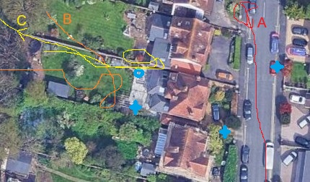
Figure 1. Location of surveyors, cameras and detectors
RESULTS
The night was suitable for bats with common pipistrelle commuting across the garden.
No bats emerged from the property.

APPENDIX 1.
23th May 2026
Project |  | Start time | 20.15 | Finish | 22.30 | Temperature | 20 C at start 17.4 C at finish
 |  | 23.5.2026 |  | sunset | 20.59 | Weather  35% cloud beaufort 0 | 4/8TH MOON
 | Bat passes heard
Station no. | Start time |  | No. | passes | comments
NE | 21.17 | Common pipistrelle | 1 | 2 | Flew in from north foraging low over garden on corner and along road (A on fig 1 )
W | 21.19-20 | Common pipistrelle | 1 | 3 | Foraging over back gardens to west (B on fig 1 )
W, NE | 21.26-7 | Common pipistrelle | 1 | 2+ | Foraging over back gardens to west (C on fig 1 )

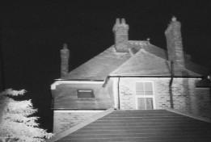
Figure 2. northwest camera dark sky 23.5.2026

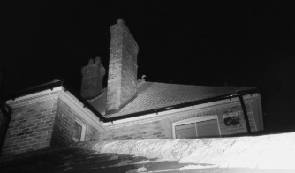
Figure 3. southwest camera dark sky 23.5.2026
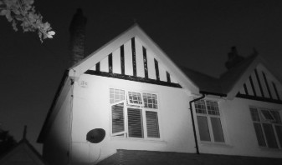
Figure 4. southeast camera dark sky 23.5.2026
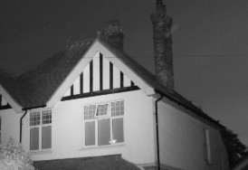
Figure 5. northeast camera dark sky 23.5.2026

